 | MINISTRY OF  EDUCATION AND TRAINING

FPT UNIVERSITY
Capstone Project Document
Applying machine learning in building an online examination support and proctoring system

SEP490.3
Group Members | Ho Kha Minh – CE150582  Tieu Anh Tho – CE150019  Doan Ngoc Minh – CE150022  Tran Khanh Toan – CE150269  Thuong Duy Khang – CE150004
Supervisor | Luong Hoang Huong
Ext Supervisor | N/A
Capstone Project code | SEP490

- CanTho, November 2022-
Table of Contents

Acknowledgement 11
Definition and Acronyms 11
I. Project Introduction 12
1. Overview 12
1.1 Project Information 12
1.2 Project Team 12
a. Supervisor 12
b. Team Members 12
2. Product Background 12
2.1 Machine Learning 12
2.2 Deep Learning 12
2.3 Convolutional Neural Network (CNN) 13
1. Convolution layer 13
2. Pooling layer 14
3. Fully connected layer 14
2.4 ResNet 14
2.5 Programming languages 15
2.5.1 C# (Framework use: ASP.NET Core) 15
2.5.2 JavaScript (Framework use: ReactJS) 16
3. Existing Systems 16
3.1 FPT University’s Exam Online System (EOS) 16
3.2 FPT University Learning Management System (LMS) 16
4. Business Opportunity 16
5. Software Product Vision 17
6. Project Scope & Limitations 17
6.1 Major Features 17
6.2 Limitations & Exclusions 18
II. Project Management Plan 19
1. Overview 19
1.1 WBS & Estimation 19
1.2 Project Risks 20
2. Management Approach 21
2.1 Project Process 22
2.2 Quality Management 22
2.3 Training Plan 23
3. Master Schedule 24
4. Project Organization 24
4.1 Team & Structures 24
4.2 Roles & Responsibilities 25
5. Project Communication 25
5.1 Communication Plan 25
5.2 External Interface 26
a. FU Contacts 26
b. Customer Contacts 26
6. Configuration Management 26
6.1 Tools & Infrastructures 26
6.2 Document Management 27
6.3 Source Code Management 27
III. Software Requirement Specification 28
1. Overall Description 28
1.1 Product Overview 28
1.2 Business Rules 29
2. User Requirements 30
2.1 Overview 30
a. Use Case Diagram 30
b. System Actors 33
c. Use Cases List 33
2.2 Authentication 34
a. UC-01 Login 34
b. UC-02 Logout 35
c. UC-03 Forgot password 35
2.3 Manage 36
a. 1. UC-04 Manage account 36
a. 2. UC-24 Create account by excel 37
b. UC-06 Manage Modules 38
c. UC-07 Manage Classes 38
d. UC-10 Manage Exams 39
e. UC-08 Manage Exams 39
2.4 View 40
a. UC-05 View deactivated account list 40
b.UC-19 View Exam Schedule 40
c. UC-22 Mark report 41
d. UC-23 View module list 42
e. UC-09 View module list 42
f. UC-12 View exam result, analysis 43
g. UC-15 View request add question bank 43
2.5 Exam taking 44
a. UC-20 Take exam 44
b. UC-21 Submit exam 45
c. UC-11 Export excel module's exam result 46
d. UC-13 Create exam paper 46
e. UC-14 Grade written question 47
f. UC-25 Export excel student's exam information 48
g. UC-26 Invigilate 49
2.6 Manage question bank 49
a. UC-16 Approve/reject to add questions 49
b. UC-17 Request add new question to question bank 50
c. UC-18 Assign teacher to process add question request 51
3. Functional Requirements 53
3.1 System Functional Overview 53
a. Screen Flow 53
b. Screen Details 54
c. Screen Authorization 55
d. Non-Screen Functions 57
e. Entity Relationship Diagram 57
3.2 Authentication 58
a. Login 58
b. Logout 61
c. Forgot password 62
3.3 Role Administrator 64
a. Manage account 64
b. View deactivated account 66
c. Create accounts by excel 67
3.4 Role Academic department 68
a. Manage modules 68
b. Manage classes 71
c. Manage exams 73
3.5 Role Teacher 75
a. Manage Exam 75
b. Grade written question 77
c. Approve/reject to add questions 81
d. Request add new question to question bank 83
e. Invigilate 87
3.6 Role Student 89
a. Take and submit Exam 89
b. Mark report 92
4. Non-Functional Requirements 93
4.1 External Interfaces 93
a. User Interfaces 93
b. Software Interfaces 93
c. Hardware Interfaces 93
d. Communications Interfaces 93
4.2 Quality Attributes 94
a. Usability 94
b. Reliability 94
c. Performance 94
d. Dependability 94
Security 94
e. Supportability 94
f. Design Constraints 94
g. Support Documents 94
5. Other Requirements 94
5.1 Appendix1 - Messages List 94
IV. Software Design Description 95
1. Overall Description 95
1.1 Assumptions 95
1.2 Design Constraints 95
2. System Architecture Design 96
2.1 Overall Architecture 96
2.2 System Architecture 97
2.3 Package Diagram 98
3. System Detailed Design 99
a. Class Diagram 99
b. Sequence Diagrams 100
1. Login 100
2. Logout 101
3. Forgot password 102
4. Create Account 103
5. View Account List 103
6. Update Account 104
7. Deactivate Account 105
8. View deactivated account list 105
9. Create Module 106
10. View Module list 107
11. Update Module 108
12. Delete Module 109
13. Create Class 110
14. View Class List (Academic Department) 111
15. Update Class (Academic department) 111
16. Create Final Exam 112
17. View Exam List 113
18. Update Final Exam 114
19. Delete Exam (Academic Role) 115
20. View module list 116
21. Create Exam 117
22. View Exam List 118
23. Update Exam 119
24. Delete Exam (Teacher Role) 120
25. Export excel module’s exam results (Teacher) 121
26. View exam result, analysis 121
27. Create exam paper 122
28. Grade written questions (Teacher) 123
29. View all requests add question bank 124
30. Approve/Reject request to add question 125
31. Request add new question to question bank 126
32. Assign teacher to process add question request 127
33. View exam schedule (Student) 128
34. View exam questions 129
35. Submit exam (Student) 130
36. Mark report 131
37. View module list by Student 131
38. Invigilate 132
4. Class Specification 132
4.1 AcademicDepartmentController Class 132
4.1.1 Class Methods 132
4.1.2 Attributes of the Class 132
4.2 AccountController Class 132
4.2.1 Class Methods 132
4.2.2 Attributes of the Class 136
4.3 AnswerController Class 136
4.3.1 Class Methods 136
4.3.2 Attributes of the class 137
4.4 AuthenticationController Class 138
4.4.1 Class Methods 138
4.4.2 Attributes of the Class 140
4.5 CheatController Class 140
4.5.1 Class Methods 140
4.5.2 Attributes of the Class 141
4.6 ClassController Class 141
4.6.1 Class Methods 141
4.6.2 Attributes of the Class 141
4.7 ClassModuleController Class 142
4.7.1 Class Methods 142
4.7.2 Attributes of the class 144
4.8 ExamController Class 144
4.8.1 Class Methods 144
4.8.2 Attributes of the class 149
4.9 ExamQuestionsController Class 150
4.9.1 Class Methods 150
4.9.2 Attributes of the Class 151
4.10 InvigilateController Class 151
4.10.1 Class Methods 151
4.10.2 Attributes of the Class 153
4.11 MarkController Class 153
4.11.1 Class Methods 153
4.11.2 Attributes of the Class 153
4.12 ModuleController Class 153
4.12.1 Class Methods 153
4.12.2 Attributes of the class 156
4.13 NotifyController Class 156
4.13.1 Class Methods 156
4.13.2 Attributes of the class 157
4.14 QuestionController Class 157
4.14.1 Class Methods 157
4.14.2 Attributes of the Class 158
4.15 StudentController Class 159
4.15.1 Class Methods 159
4.15.2 Attributes of the class 161
4.16 TeacherController Class 161
4.16.1 Class Methods 161
4.16.2 Attributes of the Class 161
4.17 TokenController Class 162
4.17.1 Class Methods 162
4.17.2 Attributes of the Class 163
5. Data & Database Design 164
5.1 Database Design 164
a. AcademicDeparment Table 165
b. AddQuestionRequest Table 165
c. Administartor Table 166
d. Answer Table 166
e. CheatingType Table 166
f. ClassModuleStudent Table 166
g. Class Table 167
h. ClassModule Table 167
i. ExamFEQuestion Table 167
j. Exam Table 168
k. ExamQuestion Table 169
l. FEAnswer Table 169
m. FEQuestion Table 169
n. Level Table 170
o. Module Table 170
p. Question Table 170
q. QuestionType Table 171
r. Role Table 171
s. Student Table 171
t. StudentAnswer Table 171
u. StudentCheating Table 172
v. StudentExamInfos Table 172
w. StudentFEAnswer Table 172
x. Teachers Table 173
V. Software Testing Documentation 173
1. Overall Description 173
1.1 Test Model 173
1.2 Testing Levels 173
1.3 Testing Types 174
2. Test Plan 174
2.1 Test Stages 174
2.2 Resources 175
a. Human Resources 175
b. Environment 175
2.3 Test Milestones 175
2.4 Deliverables 175
3. Test Cases 175
4. Test Reports 176
a. Unit Test Case 176
b. Other Test Cases 177
VI. Release Package & User Guides 177
1. Deliverable Package 177
1.1 Source codes & documents 177
1.2 Known Issues, Limitations & Restrictions 177
2. Installation Guides 178
2.1 System Requirements 178
2.2 Setup Files 178
2.3 Installation Instruction 178
3. User Manual 184
3.1 Terms and definitions 184
3.2 System requirements 185
3.3 Application Usage 185
a. Overview 185
b. Authentication 186
c. Role Administrator 192
d. Role Academic department 197
e. Role Teacher 204
f. Role Student 216
VII. Appendix 219
1. References 219

Acknowledgement
Our graduation thesis can not be completed without the help and advice from our friend in class SE1501, our teacher at FPT university, and our mentor Mr.Luong Hoang Huong. This project is motivated by the inspiration that every exam is fair and from that, improves education. Despite all the work we have done, this project may still have mistakes, we would like to receive feedback from teachers to improve the project.
Finally thanks for all the support from our family, our friends, and our enthusiastic mentor Mr.Luong Hoang Huong.

Definition and Acronyms
Acronym | Definition
SEB | Safe Exam Browser
AI | Artificial Intelligence
BR | Business Rule
ERD | Entity Relationship Diagram
ML | Machine Learning
SDD | Software Design Description
CNN | Convolutional Neural Networks
SRS | Software Requirement Specification
SDLC | Software Development Lifecycle
UC | Use Case
API | Application Programming Interface

I. Project Introduction

1. Overview

1.1 Project Information
- Project name: Applying machine learning in building an online examination support and proctoring system
- Project code: SEP490
- Group name: SEP490.3
- Software type: Web Application

1.2 Project Team

a. Supervisor
Full Name | Email | Phone Number | Title
Lương Hoàng Hướng | Huonglh3@fe.edu.vn | 0941666545 | Lecturer

b. Team Members
Full Name | Email | Mobile | Role
Hồ Khả Minh | minhhkce150582@fpt.edu.vn | 0799663689 | Leader
Tiêu Anh Thọ | thotace150019@fpt.edu.vn | 0937330716 | Member
Đoàn Ngọc Minh | minhdnce150022@fpt.edu.vn | 0704901355 | Member
Trần Khánh Toàn | toantkce150269@fpt.edu.vn | 0961498019 | Member
Thượng Duy Khang | khangtdce150004@fpt.edu.vn | 0909309195 | Member

2. Product Background
We researched and implemented many technologies for the artificial intelligence feature as well as the web application itself. In order to complete this project, we applied machine learning, deep learning and Convolutional Neural Network technology, we also used C# with the .NET framework and Javascript with the ReactJS framework.

2.1 Machine Learning
Machine learning is a field of programming concerned with creating programs that can “learn”, meaning the program can improve its performance by repeating a specific task. With each repetition, the accuracy of the algorithm will improve.
There are many approaches to machine learning, some of them are: supervised learning, unsupervised learning, reinforcement learning. There is no one approach for all problems, depending on the type of data needing to be predicted, an appropriate approach will be selected.

2.2 Deep Learning
Deep learning is a kind of machine learning that uses "artificial neural networks" to extract progressively higher-level characteristics from input, mimicking how people acquire specific sorts of information.
The biological neural networks that shape the structure of the human brain are where the phrase "artificial neural network" originates. Artificial neural networks also feature neurons that are coupled to one another in different levels of the networks, just like the human brain, which has neurons that are connected to one another. Nodes are the name for these neurons.
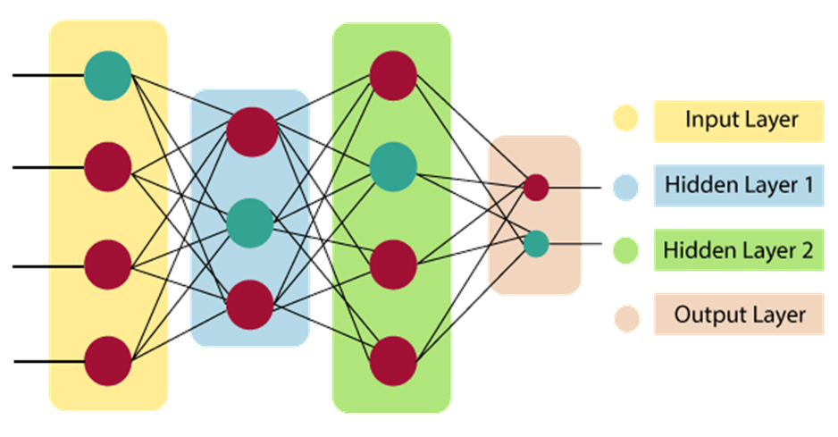
Figure 1. Neural Network architecture
Generally speaking, an artificial neural network has three layers:
- As its name implies, the input layer takes inputs from the programmer in a variety of different formats.
- The hidden layer is displayed between the input and output layers. It does all the computations necessary to uncover patterns and buried features.
- Output Layer: This layer is used to communicate the output after the input has undergone a number of alterations in the hidden layer.
Deep learning models may be used for various tasks since they process information similarly to how the human brain does. The majority of widely used voice recognition, natural language processing (NLP), and picture recognition programs presently employ deep learning. Applications as diverse as self-driving vehicles and language translation services are beginning to use these techniques.

2.3 Convolutional Neural Network (CNN)
Convolutional Neural Network (CNN or ConvNet) is a deep learning neural network widely used in computer vision. Usually, it applies to visual applications such as image classification and natural language processing. One of the benefits of CNN is that it can perform directly on a raw image and does not need any preprocessing.
CNN is a feed-forward neural network containing many convolutional layers stacked on top of each other. It has three main types of layers:

1. Convolution layer
This first layer extracts the critical features from the image and performs the convolution operation through several filters. It considers every image as a matrix of pixel values. Therefore, it slides the filter matrix with a dimension of MxM over the image and calculates the dot product between the image pixels and the filter. The result is a convolved feature matrix called a feature map or an activation map. Finally, it will feed the result to the next layer.

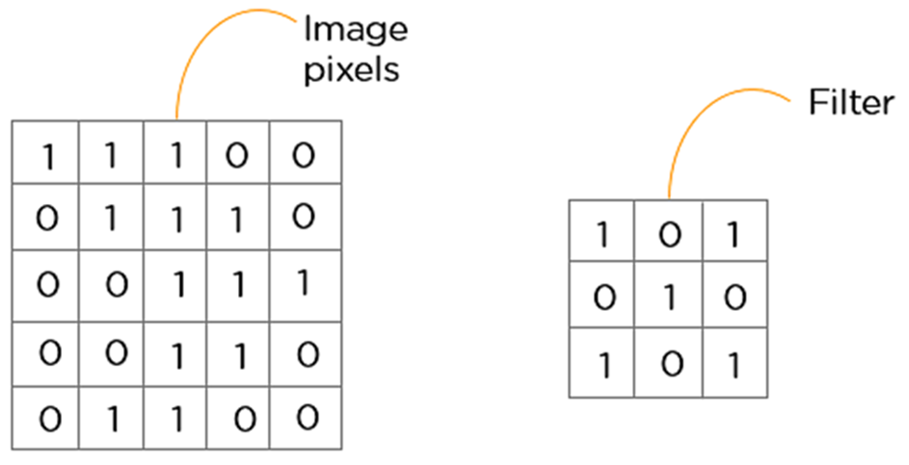
Figure 2. An example of image pixels matrix and filter matrix

2. Pooling layer
The pooling layer is used to reduce the feature map's dimensionality or size, usually applied after the convolution layer. This layer uses numerous filters to identify different parts of the image as edges or corners. Two main kinds of pooling are max and average pooling:
- Max pooling: Each time the filter slides across the image, it takes the maximum value and sends it to the output array. This approach keeps the detected features. As an aside, it is used the most commonly.
- Average pooling: Each time the filter slides across the image, it calculates the average value and sends it to the output array. This approach downsampled the feature map.

3. Fully connected layer
After going through the pooling layer, the feature map will come to the process called flattening, which is used to convert all the 2-Dimensional arrays into a single long continuous linear vector and feed as input to the fully connected layer to classify the image.

2.4 ResNet
ResNet is short for Residual Network, developed by He and his colleagues in 2015. It addressed the problem of vanishing gradients that have hindered the performance of deep neural networks. ResNet has allowed neural networks to be deeper than it has ever been. It does this by introducing Residual Block, where the activation output of previous layers is added to the computation of the activation of later layers.

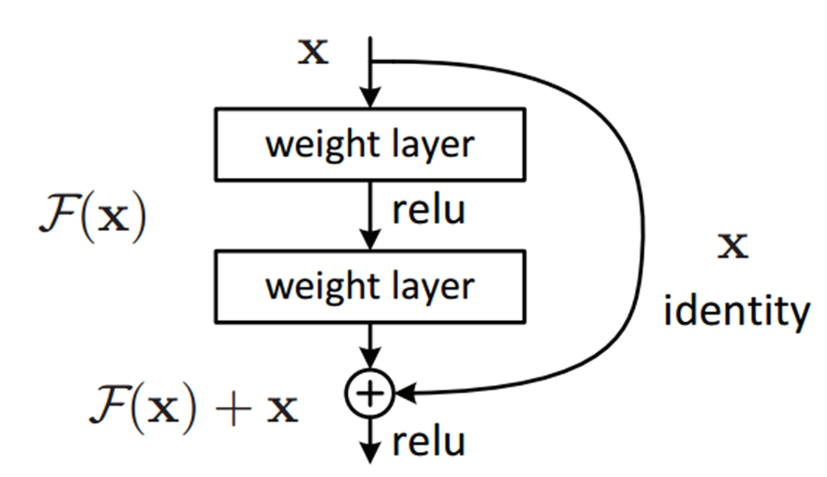
Figure 3. A single residual block
This implementation allows neural networks to easily learn an identity function. It prevents the output of zero towards the later layer in the network. Because of this, it prevents the model from performing worse as you add more layers. Aside from that, it also enables features from previous layers to reach deeper into the network, enabling an increase in accuracy.

2.5 Programming languages

2.5.1 C# (Framework use: ASP.NET Core)
C# (C-Sharp) is an object-oriented and component-oriented programming language created by Microsoft. It is a natural language for creating and using software components. As the name suggests, it has roots in the C family and is close to C++ and Java. The first version of C# was released in 2002, and the latest version, C # 10, was released in November 2021. C# is one in all the foremost popular programming languages today. It is used to develop mobile, desktop, web applications, and many more. These are several features that help C# create robust and stable applications:
- Garbage collection automatically releases memory space that is no longer used.
- Nullable types allow the user to assign a null value to a value type variable.
- Exception handling provides a structured approach to prevent the program code from crashing.
- Lambda expressions assist functional programming methods.
- Language Integrated Query (LINQ) gives a more straightforward way to work with data from any source.
To develop the back-end of our product, we use ASP.NET Core framework with C# language. ASP.NET Core is a free cross-platform, high-performance, open-source web framework developed by Microsoft so that it can run smoothly on Windows, Linux, and Mac. This framework unites the features of MVC and Web API into a single web framework. ASP.NET Core applications can run on .NET Core or the full .NET Framework. It supports side-by-side versioning so that a single machine can have multiple versions of .NET Core, and various applications target those versions.

2.5.2 JavaScript (Framework use: ReactJS)
JavaScript (JS) is a lightweight, interpreted, or just-in-time compiled programming language that conforms to the ECMAScript standard. It is a dynamic typing, prototype-based and multi-paradigm scripting language which supports object-oriented, imperative, and functional programming styles. It is the world's most popular programming language. Alongside HTML and CSS, JS is one of the core technologies of the World Wide Web. As of 2022, JavaScript is used on the client side of 98% of websites. Although JS's origin is for use in web browsers, many non-browser environments are using it now, such as Node.js or Apache CouchDB. It has many useful libraries, one of the most popular of them is React.
React (also known as React.js or ReactJS) is a free, open-source JavaScript-based UI library. It is built and maintained by Facebook and the open-source developer community. By encouraging the creation of reusable UI components, React can dramatically reduce the application's development time and better performance. In addition, with frameworks like Next.js, React can be the foundation for single-page, mobile, or server-rendered applications.

3. Existing Systems

3.1 FPT University’s Exam Online System (EOS)
With the motivation to improve the learning process, FPT Education has digitised many aspects of education. To protect academic integrity, FPT has created EOS for the student to take exams and support the proctor on the invigilate process. Developed on the ASP.NET framework, EOS can run on Windows computers. EOS prevents the student from cheating by two methods. The first method is to block all other applications from running when students start the exam. The second method is to store student answers in both local and server. By that method, local data can still be retrieved if the server is hacked.

3.2 FPT University Learning Management System (LMS)
Designed primarily for managing learning resources, LMS has many functions like uploading exercises, slides, and other resources in the teacher role, viewing resources, and submitting exercises in the student role. LMS also has great support for exam management. The teacher can add tests, add questions to the test, and the system will randomise questions and also randomise the order of choice in multiple choice questions. Make use of a safe exam browser, LMS also prevents the student from using other applications when taking the exam.

4. Business Opportunity
Since the COVID-19 pandemic, online examination has been a trend in many universities in Vietnam and the world. However, exam fraud was a serious problem of taking exams online due to the many disadvantages of proctors. Thanks to AI and machine learning, we have developed an online examination system that can solve those problems. Our system can automatically detect exam fraud of students based on their head-pose and gives proctors warning about that student. It can be used in any university that needs a system for their students to take an exam online but can still protect academic integrity. Compared to the FPT University’s Exam Online System (EOS), our system allows the student to take the exam and the proctor to monitor the student simultaneously. Moreover, it can assist the proctor in detecting fraud easier.

5. Software Product Vision
Online examinations have some serious adversities, especially integrity and cheating. The purpose of this project focuses on improving the exam-taking process and providing a handy way for the teacher to manage student records. We bring the all-in-one class management, student management and module management. Our application also developed proctoring systems that support anti-cheating to help the proctors to identify any fraud at the time of online exams.

6. Project Scope & Limitations

6.1 Major Features
FE-01: Manage user’s account including four roles (Academic department, teacher, student, head of department).
FE-02: Question bank management.
FE-03: Mark management.
FE-04: Class management.
FE-05: Module management.
FE-06: Exam management.
FE-07: Exam taking (student role).
FE-08: Exam invigilating (teacher role).
FE-09: Detect cheating when students are taking the exam.
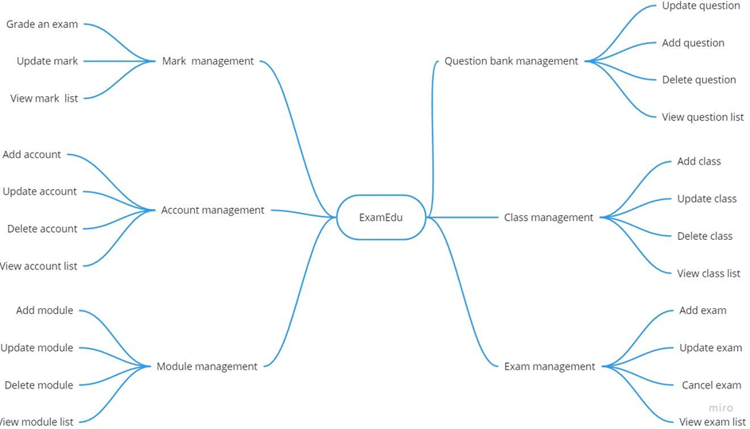
Figure 4. Features diagram of ExamEdu system

6.2 Limitations & Exclusions
LI-1: The cheating detection function only supports the student's front camera.
LI-2: Exam taking and invigilating do not work on mobile devices due to project scope and user’s use case.
LI-3: The website cannot be accessible by incognito window due to some lack of features on the incognito browser.

II. Project Management Plan

1. Overview

1.1 WBS & Estimation
# | WBS Item | Complexity | Est. Effort  (man-days)
1 | Initiate project |  | 8
1.1 | Define project goal | Medium | 3
1.2 | Define project scope | Medium | 3
1.3 | Define project risk | Simple | 1
1.4 | Choose technology | Simple | 1
2 | Design database | Complex | 10
3 | Develop website back-end |  | 20
3.1 | Manage question bank | Medium | 3
3.2 | Manage class | Simple | 1
3.3 | Manage exam | Medium | 3
3.4 | Manage mark | Medium | 3
3.5 | Manage account | Simple | 1
3.6 | Manage module | Medium | 2
3.7 | Exam taking and invigilating | Complex | 7
4 | Develop website front-end |  | 17
4.1 | Manage question bank | Medium | 2
4.2 | Manage class | Simple | 2
4.3 | Manage exam | Medium | 3
4.4 | Manage mark | Simple | 2
4.5 | Manage account | Simple | 1
4.6 | Manage module | Simple | 2
4.7 | Exam taking and invigilating | Complex | 5
5 | Develop cheating detect model |  | 23
5.1 | Collect data (find dataset) | Medium | 3
5.2 | Find suitable method for training model | Complex | 10
5.3 | Train model | Medium | 4
5.4 | Implement model | Complex | 6
6 | Testing |  | 10
6.1 | Unit test | Medium | 4
6.2 | Integrated test | Simple | 3
6.3 | System test | Simple | 3
Total Estimated Effort (man-days) |  |  | 88

1.2 Project Risks
# | Risk Description | Impact | Possibility | Response Plans
1 | Power outage | Medium | Low | Use mobile data plan to have access to the internet. Wait out the power outage.
2 | Homeworks and assignments | High | High | Form study group to help each other finish homework and assignments as fast as possible
3 | Laptop breakdowns | High | Low | Communicate quickly about the incident, and if necessary assign a new teammate to take on the task.
4 | Preparing for exams | High | High | Form study groups to help each other prepare for exams.
5 | Sick teammate | High | Low | Assign a new teammate to complete a sick teammate’s task.
6 | Requirement changes | High | Low | Start meeting as soon as possible after recognizing a change in requirements to determine which aspects are changed and how to implement the changes.

2. Management Approach
We chose Scrum as the management framework for our project. Scrum is a management methodology that follows the Agile principles. It allows teams to quickly adapt to changing requirements, speed up development and shipment of products through an iterative process, ultimately delivering higher values to customers. It accomplishes this by improving communication between team members, between teams and stakeholders, allowing them to identify pressing issues or changing requirements in time to address them accordingly. It also allows teams to properly prioritise, manage, and implement features.
We will be splitting our project into sprints. Sprints are small time-boxed windows of time where we implement a subset of features of the larger project. Tasks in each sprint are to be completed with high-fidelity, meaning that they are ready for production environments. Sprints often run for 1 to 4 weeks but no more than 1 month.
Before a sprint, the team will hold a meeting to determine the sprint backlog. The sprint backlog is a collection of tasks from the product backlog ordered on priority to ensure the team delivers the most important features first.
During a sprint, team members will perform bi-daily standups to discuss current impediments and may request assistance from other team members. Any changes to requirements that may arise during a sprint are addressed next sprint.
After a sprint is completed, we will perform a sprint review where we go through the events that have happened during the previous sprints. We will take notes of what went in our favour, what did not go well, and establish what needs to be done to address issues and, or, adopt better practices.

2.1 Project Process
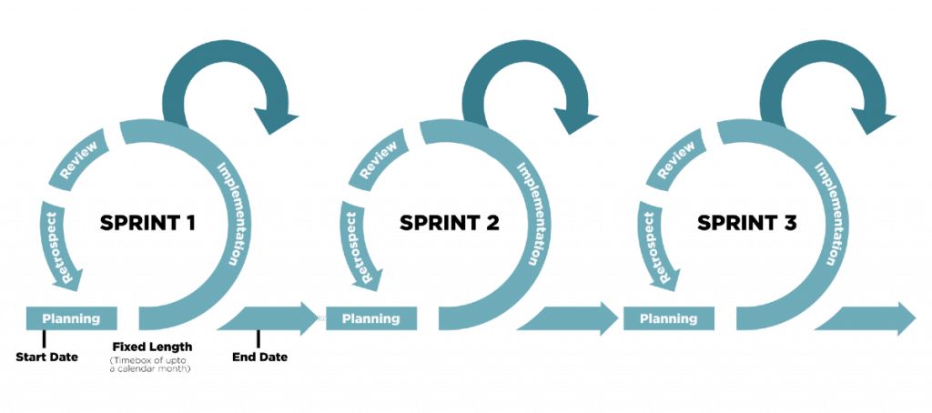
Figure 5. Illustration of Scrum framework
Our software development process model consists of the following stages:
- Organise the backlog: The product owner establishes the product backlog using feedback from users and the development team to make sure the product is towards its product vision.
- Sprint planning: The entire development team chooses tasks from the product backlog and ensures those tasks always align with the sprint goal, also agreed upon by the scrum team to create the sprint backlog.
- Sprint: This is the period when the team works together to complete all tasks in the sprint backlog. We give each sprint a week to be easier to scope.
- Daily scrum or stand up: This is a daily super-short meeting that we usually organise in the morning to assure that the team aligns with the sprint goal and to get a plan out for the day. The stand-up is also a chance for everyone to express any problem they have with meeting the sprint goal.
- Sprint review: This stage occurs after the sprint is completed. The team gets together to inspect what has been done in the previous sprint. The development team shows the stakeholders and teammates the backlog items that are done to get feedback. The product owner can decide whether to release the increment or not.
- Sprint retrospective: The team comes together to discuss what went well and what needs to be improved next time in this stage.

2.2 Quality Management
Quality management is crucial in software development. Its primary purpose is to ensure the project meets all user requirements for software, success criteria, and quality standards. Quality management impacts all aspects of a software project, so it must be done precisely and carefully.
To ensure that our project quality meets the expectation, we use the following quality management method:
- Defect Prevention: Defect prevention is a technique that must be conducted early (especially in the design and implementation phase) throughout the software development lifecycle and by every team member, regardless of role. A minor defect can lead to a significant failure of the system. To prevent defects, all team members must participate in the requirement phase and communicate effectively to point out any misunderstanding or gap between their expectations and the software requirement. The team must also establish a convention for all software development life cycles (coding convention, communication convention).

- Reviewing: Reviewing can prevent defects and errors from becoming failures and help make maintenance easier. In this phase, the team members will analyse each other's code to find any defect, error, or violation in the coding convention. Reviewing saves the project a significant amount of resources by discovering any misunderstandings in the document and design phase (which cause defects). Based on this phase, the team members can learn early on from their mistakes and improve overall project quality.

- Unit testing: Aim for testing the smallest piece of code, this stage is conducted right after the programmer finishes coding a task, and it is a condition to move to integration testing. Unit testing helps the programmer or tester find the bug in the early stage and prevent them from causing severe failure in the future, reducing the cost of fixing the bug.

- Integration testing: Integration testing is conducted after unit testing and mainly focuses on testing logically combined modules or components of the software. After unit testing, the defect may remain in the software and lead to failure. As a combination of more than one module or component, a function (which is being tested) can be the work of a variety of team members so that misunderstanding can happen, and the function may not work as expected (although each unit is working correctly).

- System testing: In this stage, the system will be tested as fully functional software. System testing is black-box testing and must include a fully integrated system including environment and external peripherals. Its aim is to test the interaction between modules in the system and the interaction between the function being tested with the system as a whole.

- User acceptance testing: It is the last test phase before moving the application to production. User acceptance testing is conducted in real environments where the software will be used by its intended user, aiming for testing end-to-end business flow.

2.3 Training Plan
Training Area | Participants | When, Duration | Waiver Criteria
Git and GitLab | All members | 5/9/2022, 1 slot | Mandatory
ReactJs | All members | 6/9/2022, 3 slot | Mandatory
CNN | All members | 7/9/2022, 2 slot | Mandatory
Flask | MinhDN | 8/9/2022, 1 slot | Mandatory

3. Master Schedule
# | Deliverable | Due Date | Deliverable Scope
1 | Project Plan | 21/8/2022 | Plan project milestone
2 | Report 1 | 10/9/2022 | Evaluate requirements
3 | Report 2 | 17/9/2022 | Architecture Design
4 | Report 3 | 24/9/2022 | SRS Document design
5 | Report 4 | 1/10/2022 | Design class diagram and sequence diagram
6 | Code | 23/11/2022 | Code
7 | Report 5 | 26/11/2022 | Test document
8 | Report 6 | 3/12/2022 | User guide
9 | Report 7 | 10/12/2022 | Final document
10 | Final Product | 10/12/2022

4. Project Organization

4.1 Team & Structures
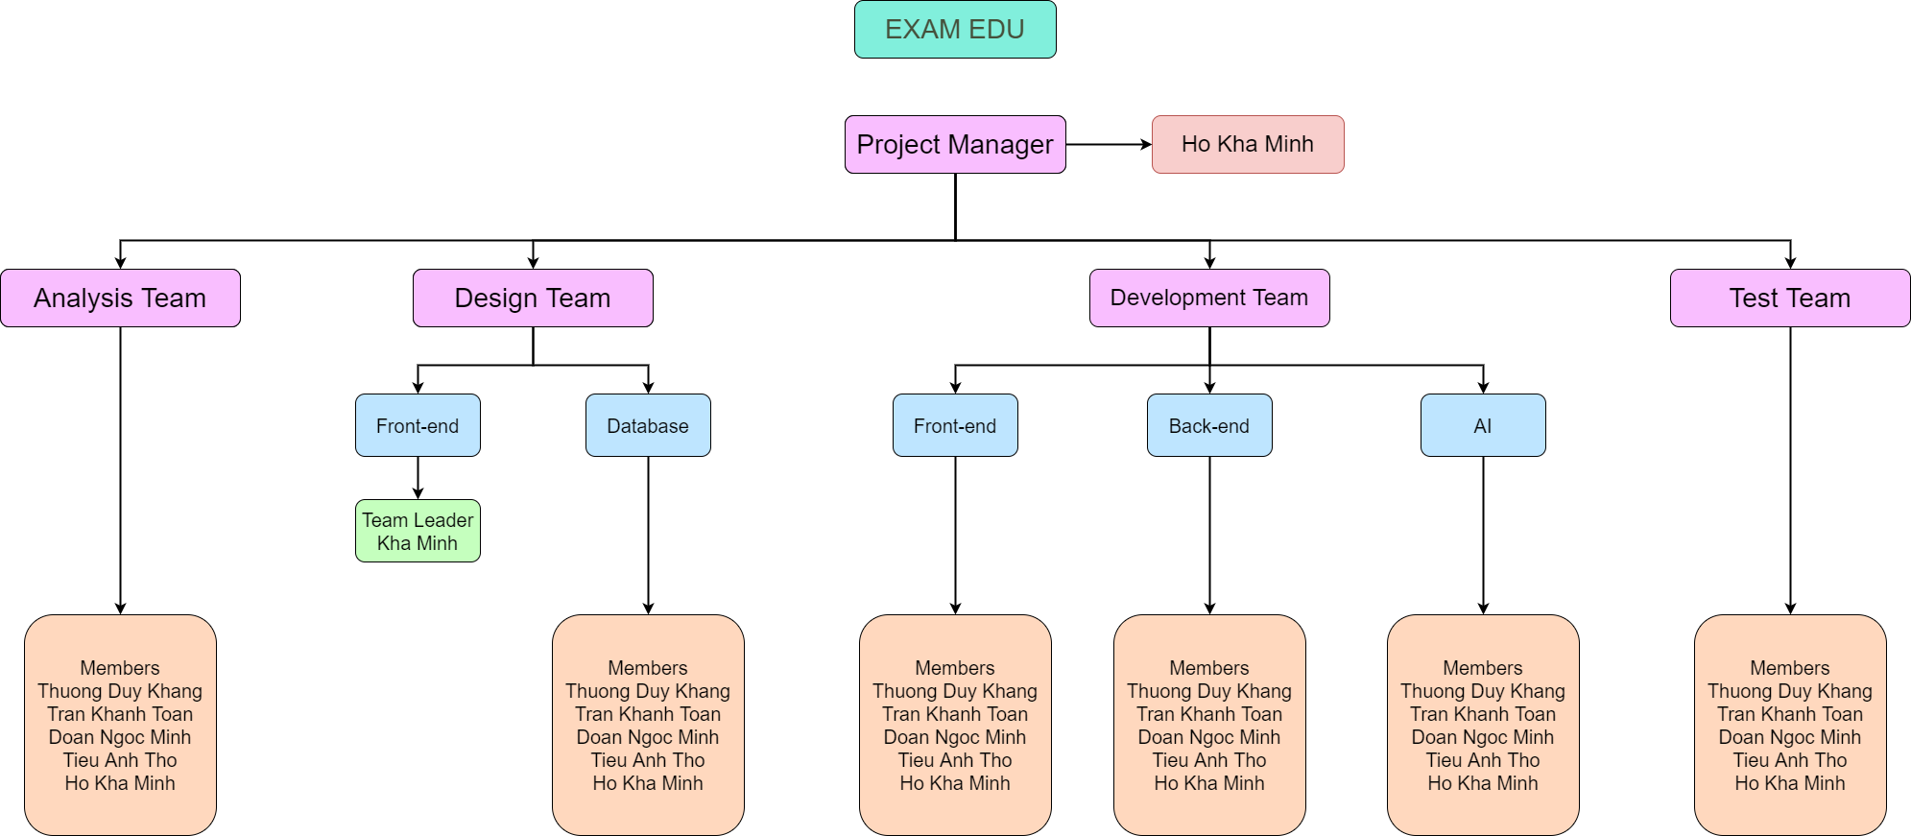
Figure 6. Team & Structures

4.2 Roles & Responsibilities
Role | Responsibility
Project Manager | - Supervise over project status  - Prepare weekly report for supervisor  - Assign document tasks for members
Analysis Member | - Analyse business requirements  - Analyse technical requirements  - Document analyses
Design Leader | - Designs user interface  - Report progresses
Design Member | - Analyse database requirements  - Analyse entity relationships
Development Member | - Choose tasks  - Develop features for the application  - Report progresses  - Assess task difficulty
Test Member | - Perform testing on application’s features  - Report bugs  - Report progresses

5. Project Communication

5.1 Communication Plan
Communication Item | Who/ Target | Purpose | When, Frequency | Type, Tool, Method(s)
Decide Capstone  Project Topic | Team  members | Confirm the thesis’s  topic and overall  information | 1/9/2022 | Discord
Assign Roles and  Tasks | Team  members | Specify roles and tasks do in the capstone project | 2/9/2022 | Discord  Messenger
Plan and schedule  milestones | Team  members | Set up milestones for the whole project | 2/9/2022 | Discord  Google Meet
Daily  communication  and conversation | Team  members | Transfer information  Support  Report status  Brainstorm ideas | Daily | Discord  Messenger  Face-to-face  Google Meet
Team meeting | Team member  Mentor | Report status  Supervisor support  Exchange information  Identify issues | Every Wednesday | Discord  Google Meet

5.2 External Interface

a. FU Contacts
Function | Contact Person  (name, position) | Contact address  (email, telephone) | Responsibility
Supervisor | Luong Hoang Huong | huonglh3@fe.edu.vn  0941666545 | - Provide documentation template  - Give instructions to project team  - Supervise project status  - Review project report  - Review deliverables  - Supervise project status  - Support team members

b. Customer Contacts
Function | Contact Person  (name, position) | Contact address  (email, telephone) | Responsibility
Customer | Luong Hoang  Huong | huonglh3@fe.edu.vn  0941666545 | - Review product stages  - Give feedback about the system  - Answer related questions about  the project

6. Configuration Management

6.1 Tools & Infrastructures
Programming languages | C#, JavaScript
Framework | ASP.NET Core, ReactJS
API | RESTful, Flask
DBMS | PostgreSQL
IDEs/Editors | Visual Studio Code
UML tools | Draw.io
Version Control | GitLab
Deployment server | Amazon Web Services, Netlify
Project management tool | Google Sheets

6.2 Document Management
Google Docs is an online word processor and a part of the Google Docs Editors suite offered by Google. Its main functions are similar to Microsoft Word but provide more useful features. Google Docs allows multiple users to create and edit documents online simultaneously. Every change is automatically saved to the cloud of Google, and a revision history is kept, so it helps prevent our documents from getting lost and allows us to revert to the previous version. Furthermore, an editor’s current position is represented by a specific colour/cursor so that other members can view the editing in real-time. In the revision history, each author is distinguished by a different colour; therefore, the team can check to see who has edited which part of the document.

Figure 7. Google Docs logo (Source: Internet)

6.3 Source Code Management
GitLab is a web-based Git repository that offers free open and private repositories, issue-following features, and wikis. We have used GitLab to manage our source code and changes. This service has lots of functions and benefits:
- Available for free
- Easy to manage source code and configure
- Unlimited public and private repositories
- Good support for CI/CD
- Security assurance
Because of our web application features, we have 2 repositories on GitLab: Front end and Back end. In our code management progress, our team must pull code from the branch Main/Master, which stores the primary code on GitLab. We also create 5 more branches for each team member, so we can code, commit and push to our own branch. After the pushing step, we have to create a merge request to merge to the branch Main/Master, check if conflicts happen, and finally merge the changed code to the elementary branch.

Figure 8. GitLab logo (Source: Internet)

III. Software Requirement Specification

1. Overall Description

1.1 Product Overview
ExamEdu is an online examination system supporting integrity. This system will help students take the exam online and teachers can manage these results along with creating exam questions. Besides that, ExamEdu also checks if students make fraud and announce the proctor using AI. The system will capture images of the student’s pose in the exam and return Cheating/Not Cheating results. The context diagram below illustrates the external entities and system interfaces for release 1.0. ExamEdu is expected to make online examinations more transparent.
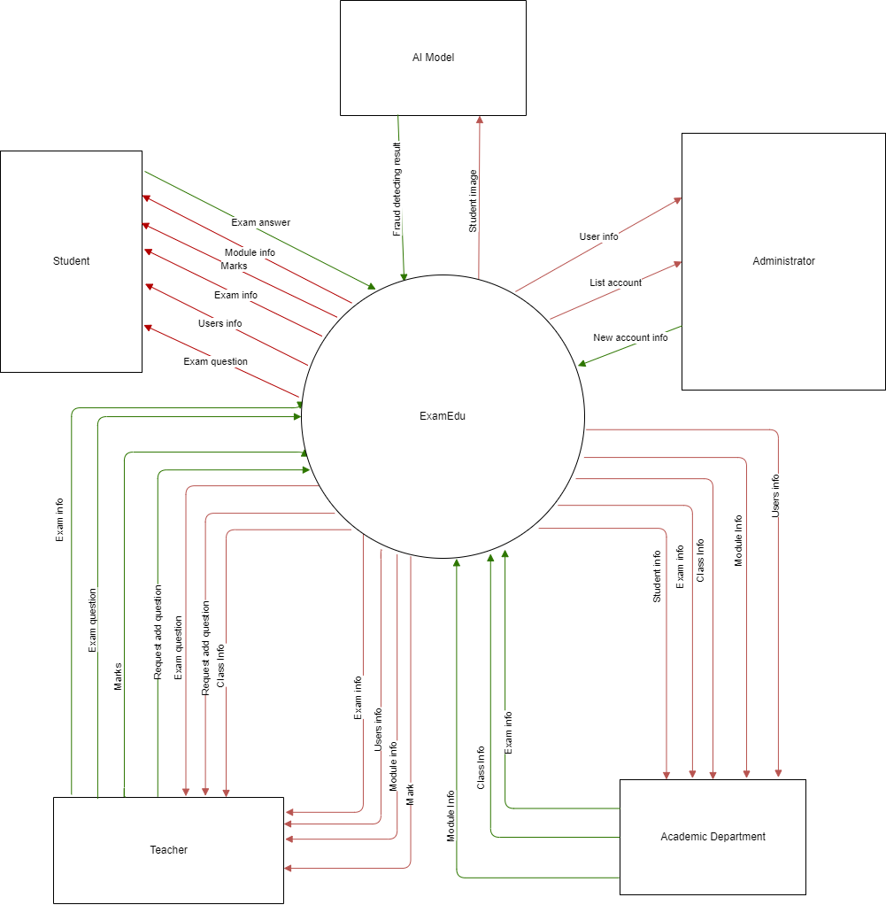
Figure 9. An ecosystem map of ExamEdu

1.2 Business Rules
ID | Rule Definition
BR-01 | Only the Administrator can create accounts for the system.
BR-02 | Only the Head of department can view and assign the add question request.
BR-03 | Only the Academic Department can create a final exam.
BR-04 | The Taking Exam feature can only work on the Safe Exam Browser.
BR-05 | The exam can only be cancelled if it has not started yet.
BR-06 | Teachers can only create exams for modules that they are responsible for.
BR-07 | The examination can only be updated with old basic information.
BR-08 | All accounts’ passwords are generated new, it can not be updated by the user.
BR-09 | The system only warns that the student may be cheating; the proctor must confirm it.

2. User Requirements

2.1 Overview

a. Use Case Diagram
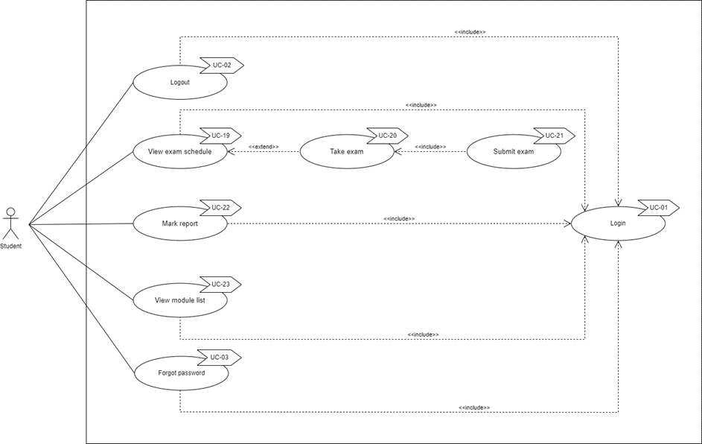
Figure 10. Use case Student

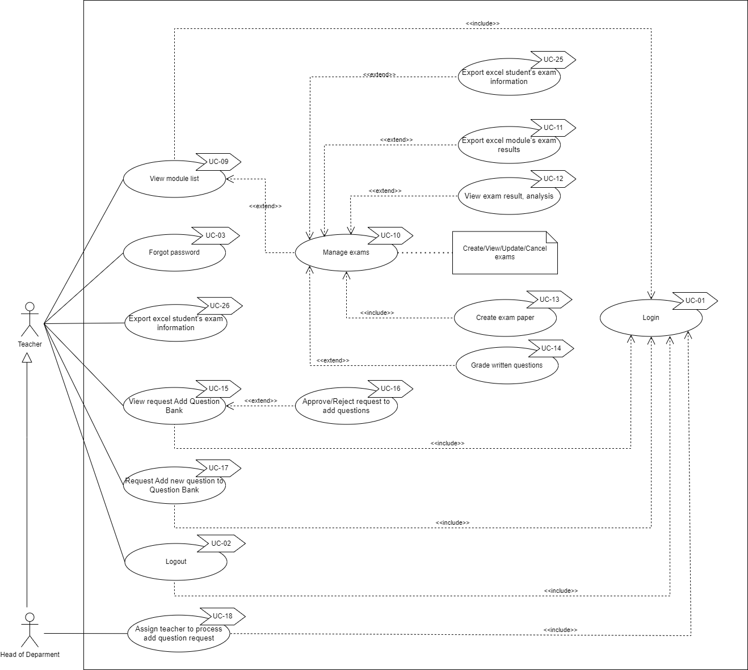
Figure 11. Use case Teacher and Head of Department

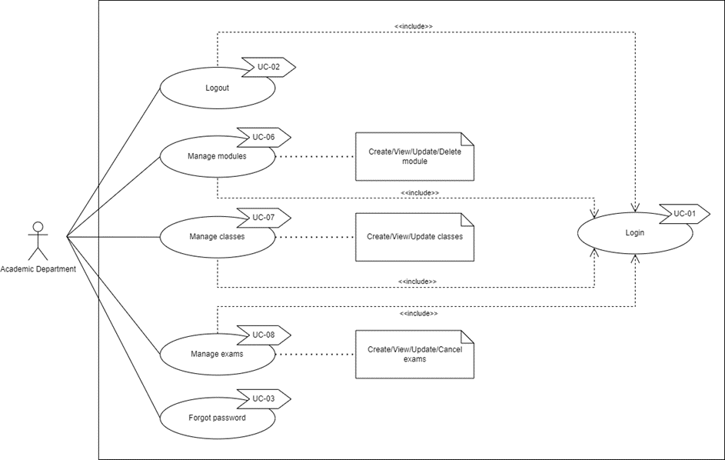
Figure 12. Use case of Academic Department

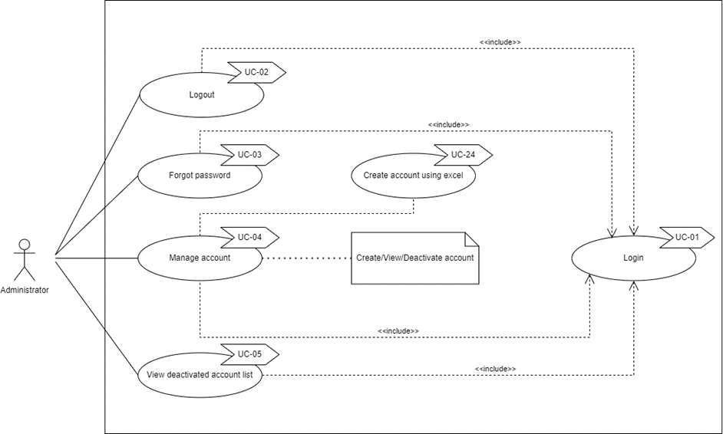
Figure 13. Use case of Administrator

b. System Actors
# | Actor | Description
1 | Administrator | Administrator can manage the system’s account.
2 | Academic Department | The Academic Department can manage classes, modules, and exams.
3 | Head of Department | The Head of Department is the same as the Teacher but is also responsible for assigning the add question bank request.
4 | Student | Students can take exams, and view mark reports.
5 | Teacher | Teacher takes responsibility for creating progress tests, grade student text answers, and requests questions.

c. Use Cases List

ID | Use Case | Primary Actors | Secondary Actors
UC-01 | Login | Administrator, Academic Department, Head of Department, Student, Teacher
UC-02 | Logout | Administrator, Academic Department, Head of Department, Student, Teacher
UC-03 | Forgot password | Administrator, Academic Department, Head of Department, Student, Teacher
UC-04 | Manage Account | Administrator
UC-05 | View deactivated account list | Administrator
UC-06 | Manage modules | Academic Department
UC-07 | Manage classes | Academic Department
UC-08 | Manage exams | Academic Department
UC-09 | View module list | Teacher
UC-10 | Manage exams | Teacher
UC-11 | Export excel module’s exam results | Teacher
UC-12 | View exam result, analysis | Teacher
UC-13 | Create exam paper | Teacher
UC-14 | Grade written questions | Teacher
UC-15 | View request Add question bank | Teacher
UC-16 | Approve/Reject request to add question | Teacher
UC-17 | Request add new question to question bank | Teacher
UC-18 | Assign teacher to process add question request | Head of Department
UC-19 | View exam schedule | Student
UC-20 | Take exam | Student
UC-21 | Submit exam | Student
UC-22 | Mark report | Student
UC-23 | View module list | Student
UC-24 | Create account by excel | Administrator
UC-25 | Export excel student's exam information | Teacher
UC-26 | Invigilate | Teacher | Student

2.2 Authentication

a. UC-01 Login
UC ID and Name: | UC-01 Login
Created By: | KhangTD | Date Created: | 2022 Sep 28
Primary Actor: | All actor | Secondary Actors: | N/A
Trigger: | User accesses the web application to log in.
Description: | Allow users to be able to use all functions of the account’s role.
Preconditions: | PRE-01. Account has been created.  PRE-02. Account is not deactivated.
Post-conditions: | POST-01. Login successfully and direct the user to the main page based on his account’s role.
Normal Flow: | - User opens the web application.  - System directs the user to the login page.  - Users input their email and password. (see EXC-01, EXC-02)  - User clicks on the “Login” button. (see EXC-03, EXC-04)  - System directs users to the main page based on their account’s role.
Alternative Flows: | N/A
Exceptions: | EXC-01. Email or password input field is leaved empty  - System shows a message informing that the user cannot leave any input field empty.  EXC-02. Invalid email format  - System shows a popup informing that the user's email format is invalid.  EXC-03. Wrong email or password  - System shows a popup informing that the user's email or password is wrong.  EXC-04. Account is deactivated  - System shows a popup informing that the user cannot log in with this account.  EXC-05. Lost connection with the server or the internet.
Priority: | High
Frequency of Use: | Medium
Business Rules:
Other Information:
Assumptions:

b. UC-02 Logout
ID and Name: | UC-02 Logout
Created By: | KhangTD | Date Created: | 2022 Sep 30
Primary Actor: | All actor | Secondary Actors: | N/A
Description: | Allow user logs out from the system and goes back to the login page.
Trigger: | User click on the logout icon.
Preconditions: | PRE-01. User has already logged in.
Post-conditions: | POST-01. Logout user from the system and direct user to login page.
Normal Flow: | - User opens the web application.  - User logs in successfully.  - User clicks on the logout icon on the top right corner of the web application.  - System directs the user to the login page.
Alternative Flows: | N/A
Exceptions: | EXC-01. Lost connection with the server or the internet.
Priority: | High
Frequency of Use: | Low
Business Rules:
Other Information:
Assumptions:

c. UC-03 Forgot password
ID and Name: | UC-03. Forgot password
Created By: | KhangTD | Date Created: | 2022 Sep 30
Primary Actor: | All actor | Secondary Actors: | N/A
Description: | Allow users to generate a new password when they forget.
Trigger: | Users click on the “Forgot Password” link on the login page.
Preconditions: | PRE-01. User already has an account in the system.
Post-conditions: | POST-01. System sends an email with a newly generated password to the user’s email address.
Normal Flow: | - User opens the web application.  - System directs the user to the login page.  - User clicks on the “Forgot Password?” link on the login page.  - System directs the user to the “Forgot Password” page to allow the user to input their email.  - Users input their email. (see EXC-01, EXC-02)  - User clicks on the “Send new password” button.  - Systems shows a popup informing that an email containing a new password was sent to the user’s email address.
Alternative Flows: | N/A
Exceptions: | EXC-01. Email input field is leaved empty.  - System shows a message informing that the user cannot leave any input field empty.  EXC-02. Invalid email.  - System shows a popup informing that the user's email is invalid.  EXC-03. Lost connection with the server or the internet.
Priority: | High
Frequency of Use: | Low
Business Rules: | BR-08
Other Information:
Assumptions:

2.3 Manage

a. 1. UC-04 Manage account
ID and Name: | UC-04 Manage account
Created By: | ThoTA | Date Created: | 2022 Sep 23
Primary Actor: | Administrator | Secondary Actors: | N/A
Description: | Allow the Administrator to perform CRUD (Create, Update, Deactivate, Read) action on account.
Trigger: | User login as Administrator.
Preconditions: | PRE-01. The account has been logged in as an Administrator account.
Postconditions: | POST-01. The message of CUD (Create, Update, Deactivate) account popup shows the success. In case of view, the system successfully shows the list of accounts.
Normal Flow: | - Open the web application.  - Log in as an Administrator.  - Action to take on the account list.  - Edit action case: Click on the [edit] button in the account the user wants to edit .  - Edit information shown on the popup.  - click on the [save change] button to save change.  - Deactivate action case: Click on [Deactivate] button in the account user wants to deactivate.  - Confirm information shown on the popup.  - Click on [confirm] button to Deactivate.
Alternative Flows: | None
Exceptions: | EXC-01. The account has been deleted after the list account loads and before the user confirms delete (maybe conducted by another user)  EXC-02. Invalid information in edit popup
Priority: | High
Frequency of Use: | Low
Business Rules: | BR-01, BR-08
Other Information:
Assumptions:

a. 2. UC-24 Create account by excel
ID and Name: | UC-24 Create account by excel
Created By: | ThoTA | Date Created: | 2022 Sep 23
Primary Actor: | Administrator | Secondary Actors: | N/A
Description: | Create accounts by uploading an excel file containing a list of email and full name.
Trigger: | User login as Administrator.
Preconditions: | PRE-01. The account has been logged in as an Administrator account.
Postconditions: | POST-01. The popup shows that create success or show the coordination of cells that have errors in the excel file.
Normal Flow: | - Open the web application.  - Log in as an Administrator.  - Click on the [Create Account] icon on the left vertical navigation bar  - Click on the [Download template] button to download the excel template.  - Fill in the excel file.  - Click the [Create by excel] button.  - Click the [Choose file] button.  - Upload excel file  - Click the [Submit] button
Alternative Flows: | None
Exceptions: | EXC-01. Exception when reading file (wrong email, full name format)  EXC-01. Exception when adding account (email exist in the database)
Priority: | High
Frequency of Use: | Low
Business Rules:
Other Information:
Assumptions:

b. UC-06 Manage Modules
ID and Name: | UC-06 Manage Modules
Created By: | MinhDN | Date Created: | 2022 Sep 23
Primary Actor: | Academic department | Secondary Actors | N/A
Description: | Provide the Academic department with methods to manage modules including creating new modules, updating modules, and viewing modules.
Trigger: | Academic department accesses the web app.
Preconditions: | PRE-01. The account has been logged in as an Academic department account.
Postconditions: | POST-01. The message of creating or updating a module popup that shows the success.
Normal Flow: | - Open the web app.  - Log in as an Academic department.  - Action to take on the module list.
Alternative Flows: | N/A
Exceptions: | EXC-01. Lost connection with the server or the internet.  EXC-02. Creating a module that already exists.
Priority: | Medium
Frequency of Use: | Low
Business Rules:
Other Information:
Assumptions:

c. UC-07 Manage Classes
ID and Name: | UC-07 Manage Classes
Created By: | MinhHK | Date Created: | 2022 Sep 23
Primary Actor: | Academic department | Secondary Actors: | N/A
Description: | Provide the Academic department with a way to manage all the classes, including creating new classes, updating classes, and viewing classes.
Trigger: | Academic department access to the web app.
Preconditions: | PRE-01. The account has been logged in as an Academic department account.
Postconditions: | POST-01. The message of creating or updating a class popup that shows the success.
Normal Flow: | - Open the web app.  - Log in as an Academic department.  - Action to take on the class list.
Alternative Flows: | N/A
Exceptions: | EXC-01. Lost connection with the server or the internet.
Priority: | Medium
Frequency of Use: | Low
Business Rules:
Other Information:
Assumptions:

d. UC-10 Manage Exams
ID and Name: | UC-10 Manage Exams
Created By: | MinhDN | Date Created: | 2022 Sep 23
Primary Actor: | Teacher | Secondary Actors: | N/A
Description: | Provide teachers with methods to manage examinations including creating new exams, updating exams, cancelling exams, and viewing exams.
Trigger: | Teacher access to the web app.
Preconditions: | PRE-01. The account has been logged in as a Teacher account.
Postconditions: | POST-01. The message of creating or updating an exam popup that shows the success.
Normal Flow: | - Open the web app.  - Log in as an Academic department.  - Action to take on the exams.
Alternative Flows: | N/A
Exceptions: | EXC-01. Lost connection with the server or the internet.
Priority: | High
Frequency of Use: | Medium
Business Rules: | BR-06, BR-07
Other Information:
Assumptions:

e. UC-08 Manage Exams
ID and Name: | UC-08 Manage Exams
Created By: | KhangTD | Date Created: | 2022 Oct 03
Primary Actor: | Academic department | Secondary Actors: | N/A
Description: | Provide the academic department with methods to manage examinations including creating, updating, viewing, and cancelling exams.
Trigger: | Academic department accesses the web app.
Preconditions: | PRE-01. User has logged in as an academic department account.
Postconditions: | POST-01. The system opens a popup showing a message about successfully creating, updating, and cancelling an exam. In the case of view, the system successfully shows the list of exams.
Normal Flow: | - Open the web application.  - Log in as an academic department.  - Take action to view, create, update or cancel exams.
Alternative Flows: | N/A
Exceptions: | EXC-01. Lost connection with the server or the internet.
Priority: | High
Frequency of Use: | Medium
Business Rules: | BR-03, BR-05, BR-07
Other Information:
Assumptions:

2.4 View

a. UC-05 View deactivated account list
ID and Name: | UC-05 View deactivated account list
Created By: | ThoTA | Date Created: | 2022 Sep 23
Primary Actor: | Administrator | Secondary Actors: | N/A
Description: | Allow the Administrator to view a list of deactivated accounts.
Trigger: | User login as Administrator and click [Account history] icon.
Preconditions: | PRE-01. The account has been logged in as an Administrator account.
Postconditions: | POST-01. Display a list of deactivated accounts.
Normal Flow: | - Open the web app.  - Log in as an Administrator.  - Click the [Account history] icon.
Alternative Flows: | N/A
Exceptions: | EXC-01. Lost connection with the server or the internet.
Priority: | Low
Frequency of Use: | Low
Business Rules:
Other Information:
Assumptions:

b.UC-19 View Exam Schedule
ID and Name: | UC-19 View Exam Schedule
Created By: | ToanTK | Date Created: | 2022 Sep 27
Primary Actor: | Student | Secondary Actors: | N/A
Description: | Allow student to view exam schedule
Trigger: | User login as Student and click [View Exam Schedule] icon on the left navigation bar
Preconditions: | PRE-01. The account has been logged in as a student account.
Postconditions: | POST-01. Display a list of exam schedules.
Normal Flow: | - Open the web app.  - Log in as a Student.  - Click on the [View Exam Schedule] icon.  - The system will show a list of the exam schedules.
Alternative Flows: | N/A
Exceptions: | EXC-01. Lost connection with the server or the internet.
Priority: | Medium
Frequency of Use: | High
Business Rules:
Other Information:
Assumptions:

c. UC-22 Mark report
ID and Name: | UC-22 Mark report
Created By: | ThoTA | Date Created: | 2022 Sep 23
Primary Actor: | Student | Secondary Actors: | N/A
Description: | Allow students to view their mark after exams have been graded.
Trigger: | User login as a Student and clicks on the [Mark Report] icon.
Preconditions: | PRE-01. The account has been logged in as a student account.
Postconditions: | POST-01. Display a list of marks of a module.
Normal Flow: | - Open the web app.  - Log in as a Student.  - Click on the [Mark Report] icon.  - The system will show a list of the module in which students have taken the exam.  - Students click on the button [View mark list] on the module the student wants to view the mark report.  - Display mark report.
Alternative Flows: | N/A
Exceptions: | EXC-01. Lost connection with the server or the internet.
Priority: | Medium
Frequency of Use: | High
Business Rules:
Other Information:
Assumptions:

d. UC-23 View module list
ID and Name: | UC-23 View module list
Created By: | MinhHK | Date Created: | 2022 Sep 23
Primary Actor: | Student | Secondary Actors: | N/A
Description: | Provide students with a way to view the modules that they are studying.
Trigger: | Student access to the web app.
Preconditions: | PRE-01. The account has been logged in as a Student account.
Postconditions: | POST-01. Display list of modules.
Normal Flow: | - Open the web app  - Login as a Student.  - Login successfully and click on the “Module” section.  - Redirect to the module list page.
Alternative Flows: | N/A
Exceptions: | EXC-01. Lost connection with the server or the internet.
Priority: | High
Frequency of Use: | High
Business Rules:
Other Information:
Assumptions:

e. UC-09 View module list
ID and Name: | UC-09 View module list
Created By: | MinhDN | Date Created: | 2022 Sep 23
Primary Actor: | Teacher | Secondary Actors: | N/A
Description: | Provide Teacher with a way to view the modules that they teach
Trigger: | Teacher access to the web app.
Preconditions: | PRE-01. The account has been logged in as a Teacher account.  PRE-02. The teacher has modules
Postconditions: | POST-01. Display list of modules
Normal Flow: | - Open the web app.  - Login as a Teacher.  - Login successfully and the teacher will be redirected to the module list page.
Alternative Flows: | N/A
Exceptions: | EXC-01. Lost connection with the server or the internet.
Priority: | Medium
Frequency of Use: | Medium
Business Rules:
Other Information:
Assumptions:

f. UC-12 View exam result, analysis
ID and Name: | UC-12 View exam result, analysis
Created By: | MinhHK | Date Created: | 2022 Sep 23
Primary Actor: | Teacher | Secondary Actors: | N/A
Description: | Provide Teacher with a way to view the result of an exam including all the students’ score.
Trigger: | Teacher access to the web app.
Preconditions: | PRE-01. The account has been logged in as a Teacher account.  PRE-02. The exam has been created.
Postconditions: | POST-01. Show full result of the exam successfully.
Normal Flow: | - Open the web app.  - Login as a Teacher.  - Select the module in the module list.  - Select the class associated with the module.  - Click on the “Result” button on the exam card.
Alternative Flows: | N/A
Exceptions: | EXC-01. Lost connection with the server or the internet.
Priority: | Medium
Frequency of Use: | Medium
Business Rules:
Other Information:
Assumptions:

g. UC-15 View request add question bank
ID and Name: | UC-15 View request add question bank
Created By: | KhangTD | Date Created: | 2022 Oct 05
Primary Actor: | Head of Department | Secondary Actors: | N/A
Description: | Allow the head of department to view all requests to add questions to the question bank.
Trigger: | The head of department logged in to the web application using their account and clicked on the “Assign Request” icon on the vertical navigation bar.
Preconditions: | PRE-01. The head of department has logged in to the web application.  PRE-02. The account is not deactivated.
Postconditions: | POST-01. System displays a list of all requests to add questions to the question bank.
Normal Flow: | - Open the web application.  - Log in as a head of department. (see EXC-01)  - Click on the “Assign Request” icon on the vertical navigation bar.  - System shows the list of all requests to add questions to the question bank.
Alternative Flows: | N/A
Exceptions: | EXC-01. User logs in with the account of a different role.  - System hides the “Assign Request” icon on the vertical navigation bar.  EXC-02. Lost connection with the server or the internet.
Priority: | Low
Frequency of Use: | Low
Business Rules: | BR-02
Other Information:
Assumptions:

2.5 Exam taking

a. UC-20 Take exam
ID and Name: | UC-20 Take exam
Created By: | MinhHK | Date Created: | 2022 Sep 23
Primary Actor: | Student | Secondary Actors: | N/A
Description: | Provide Students with a way to view exam questions.
Trigger: | Student access to the web app.
Preconditions: | PRE-01. The account has been logged in as a Student account.  PRE-02. The student has an exam that is happening.
Postconditions: | POST-01. Display all the questions of the exam.
Normal Flow: | - Open the web app.  - Login as a Student.  - Student will be redirect to the exam schedule page.  - Click on the “Start” button of the exam.  - Click on the “Join room” to start the exam.
Alternative Flows: | N/A
Exceptions: | EXC-01. Lost connection with the server or the internet.
Priority: | High
Frequency of Use: | Medium
Business Rules: | BR-04
Other Information:
Assumptions:

b. UC-21 Submit exam
ID and Name: | UC-21 Submit exam
Created By: | KhangTD | Date Created: | 2022 Oct 10
Primary Actor: | Student | Secondary Actors: | N/A
Description: | Allow students to submit the exam to the system and get the multiple choice mark after submitting.
Trigger: | Students click on the “Finish” button when taking the exam or when the examination time is up.
Preconditions: | PRE-01. User has logged in to the system with a student account.  PRE-02. The account is not deactivated.  PRE-03. Student takes the exam.
Postconditions: | POST-01. System informs that the exam has been submitted successfully and shows the multiple choice mark.
Normal Flow: | - Open the web app.  - Login as a Student.  - Students will be redirected to the exam schedule page.  - Click on the “Start” button of the exam.  - Click on the “Join room” button to start the exam.  - Click on the “Finish” button to submit the exam.  - System directs the user to the mark report page.  - System opens a popup informing that the user has submitted the exam successfully and shows the multiple choice mark.
Alternative Flows: | After step 5 of normal flow  - System automatically submit the exam when the time is up.  - Return to step 7 of normal flow
Exceptions: | EXC-01. Submit the exam when you have not answered all the questions.  - System opens a popup informing that the user has some questions not answered.  - a) If the user selects the submit option, then return to step 7 of normal flow.  b) Else if the user selects the cancel option, then the system closes the popup and allows the user to continue taking the exam.  EXC-02. Lost connection with the server or the internet.
Priority: | High
Frequency of Use: | Medium
Business Rules:
Other Information:
Assumptions:

c. UC-11 Export excel module's exam result
ID and Name: | UC-11 Export excel module's exam result
Created By: | ToanTK | Date Created: | 2022 Sep 27
Primary Actor: | Teacher | Secondary Actors: | N/A
Description: | Provide Teacher with a way to view the student's mark in all exams of a module in excel
Trigger: | Teacher access to the web app.
Preconditions: | PRE-01. The account has been logged in as a Teacher account.  PRE-02. The exam has happened.
Postconditions: | POST-01. Show full result student’s mark in all of a module successfully in excel
Normal Flow: | - Open the web app.  - Login as a Teacher.  - Select the module in the module list.  - Select the class associated with the module.  - On the exam list page, click on the red Excel button in the top right, it will download an excel file.  - Choose the location to save the file.  - Open the excel file .
Alternative Flows: | N/A
Exceptions: | EXC-01. Lost connection with the server or the internet.  EXC-02. The class associated with the module doesn’t have any exam.
Priority: | Medium
Frequency of Use: | Medium
Business Rules:
Other Information:
Assumptions:

d. UC-13 Create exam paper
ID and Name: | UC-13 Create exam paper
Created By: | ThoTA | Date Created: | 2022 Sep 23
Primary Actor: | Teacher | Secondary Actors: | N/A
Description: | Allow Teacher to create an exam paper based on question banks.
Trigger: | Users login as Teacher and click the [Create exam] icon, after creating exam successfully, the system will redirect to the Create exam paper page.
Preconditions: | PRE-01. The account has been logged in as a Teacher account.  PRE-02. The exam must be created before creating exam paper
Postconditions: | POST-01. Display a popup to show that create exam paper successfully.
Normal Flow: | - Open the web app.  - Log in as a Teacher.  - Click the [Create exam] icon.  - Create exam [UC-10]  - Set a number of multiple choice questions for each level.  - Set a number of essay questions for each level.  - Choose questions from the question bank (optional).  - Choose [Create from picked question] button to create exam paper from question that have been picked from question bank or choose [Random from question bank] to auto create exam paper based on number of questions per level.
Alternative Flows: | N/A
Exceptions: | EXC-01. Lost connection with the server or the internet.  EXC-02. Input number of questions per level is not valid number format.  EXC-03. Input number of questions per level is bigger than the number of questions in the question bank.
Priority: | High
Frequency of Use: | Medium
Business Rules:
Other Information:
Assumptions:

e. UC-14 Grade written question
ID and Name: | UC-14 Grade written question
Created By: | ToanTK | Date Created: | 2022 Sep 28
Primary Actor: | Teacher | Secondary Actors: | N/A
Description: | Allow Teacher to grade written question of student exam answer.
Trigger: | Teacher access to the web app.
Preconditions: | PRE-01. The account has been logged in as a Teacher account.  PRE-02. The exam happened.  PRE-03. Student has answered the writing question in the exam.
Postconditions: | POST-01. Student writing answer has been graded and marks has been updated.  POST-02. Popup will be showed to announce.
Normal Flow: | - Open the web app.  - Login as a Teacher.  - Select the module in the module list.  - Select the class associated with the module.  - Click on the “Result” button on the exam card.  - Click on the “Grade” icon on each row of student mark table.  - A popup appears to show student writing answer.  - Give mark in the input form.  - Click “Submit” button to submit the mark.  - An popup will be show to announce success.
Alternative Flows: | N/A
Exceptions: | EXC-01. Lost connection with the server or the internet.  EXC-02. Input mark is not valid number format.  EXC-03. Input mark is bigger than maximum mark of the writing question.
Priority: | Medium
Frequency of Use: | Medium
Business Rules:
Other Information:
Assumptions:

f. UC-25 Export excel student's exam information
ID and Name: | UC-25 Export excel student's exam information
Created By: | ToanTK | Date Created: | 2022 Sep 29
Primary Actor: | Teacher | Secondary Actors: | N/A
Description: | Provide Teacher with a way to view the students' marks in an exam by excel.
Trigger: | Teacher access to the web app.
Preconditions: | PRE-01. The account has been logged in as a Teacher account.  PRE-02. The exam has happened.
Postconditions: | POST-01. Show full result of the exam successfully in excel.
Normal Flow: | - Open the web app.  - Login as a Teacher.  - Select the module in the module list.  - Select the class associated with the module.  - Click on the “Result” button on the exam card.  - Click on the red Excel button, it will download an excel file.  - Choose the location to save the file.  - Open the excel file.
Alternative Flows: | N/A
Exceptions: | EXC-01. Lost connection with the server or the internet.  EXC-02. The exam does not have any student result.
Priority: | Medium
Frequency of Use: | Medium
Business Rules:
Other Information:
Assumptions:

g. UC-26 Invigilate
ID and Name: | UC-26 Invigilate
Created By: | ThoTA | Date Created: | 2022 Sep 29
Primary Actor: | Teacher | Secondary Actors: | Student
Description: | Provide teachers with a way to view student's cameras (with the help of AI) and create reports if they are cheating.
Trigger: | Teacher access to the web app.
Preconditions: | PRE-01. The account has been logged in as a Teacher account.  PRE-02. The exam has started.
Postconditions: | N/A
Normal Flow: | - Open the web app.  - Login as a Teacher.  - Click on the [Exam Proctor] button on the left vertical navigation bar  - Click on [Start] button on the exam list table
Alternative Flows: | N/A
Exceptions: | EXC-01. Lost connection with the server or the internet.
Priority: | Medium
Frequency of Use: | Medium
Business Rules:
Other Information:
Assumptions:

2.6 Manage question bank

a. UC-16 Approve/reject to add questions
ID and Name: | UC-16 Approve/reject to add questions
Created By: | MinhDN | Date Created: | 2022 Sep 23
Primary Actor: | Teacher | Secondary Actors: | N/A
Description: | Provide teachers with a way to approve or reject questions to be added into the question bank.
Trigger: | Teacher access to the web app.
Preconditions: | PRE-01. The account has been logged in as a Teacher account.  PRE-02. There is a request for the teacher to review a set of questions.
Postconditions: | POST-01. Question is either approved or rejected.
Normal Flow: | - Open the web app.  - Login as a Teacher.  - Select Question Process tab.  - Click on the button in the detail column for any request.  - Select questions to be approved.  - Click submit.
Alternative Flows: | N/A
Exceptions: | EXC-01. Lost connection with the server or the internet.
Priority: | Low
Frequency of Use: | Low
Business Rules:
Other Information:
Assumptions:

b. UC-17 Request add new question to question bank
ID and Name: | UC-17 Request add new question to question bank
Created By: | ToanTK | Date Created: | 2022 Sep 29
Primary Actor: | Teacher | Secondary Actors: | N/A
Description: | Provide teachers with a way to send request add new question to the question bank.
Trigger: | Teacher access to the web app.
Preconditions: | PRE-01. The account has been logged in as a Teacher account.
Postconditions: | POST-01. Request add new question has been sent.
Normal Flow: | - Open the web app.  - Login as a teacher.  - Select Add Question tab on the left navigation bar.  - On the add request question page, click on “Module” and “Bank” select option to decide the Module and Bank to add new question  (The default select option for “Question type” is “Multiple choice”).  - Click the “Add new question” button to create an input form for multiple choice questions.  - Click “Choose file” to choose the image for the question, if necessary.  - Click the “Level” select option to choose the difficulty for the question.  - Input question on the big text area for the multiple choice question.  - Input answer on the small input form.  - Click “Add new answer” to create more answers, if necessary.  - Click on small radio button of the answer to choose the right answer.  - Click “Add new question” and repeat from step 5 to create more questions.  - Click on the red “Trash” icon to delete questions or answers, if necessary.  - Click the “Send request” button to submit.  - Click “Confirm” on the confirmation modal to send the request.
Alternative Flows: | After step 4 of Normal Flow  - Click on “Question type” select option and choose “Text”.  - If you’re having question for the previous type, it will pop up a confirmation to delete all question of previous type. Click “Confirm”.  - Click “Add new question” button to create input form for text questions.  - Click “Choose file” to choose the image for the question, if necessary.  - Click “Level” select option to choose the difficulty for the question.  - Input question on text area for the text question content.  - Input on the text area under for the score barem.  - Click “Add new question” and repeat from step 3 to create more questions.  - Click on the red “Trash” icon to delete questions, if necessary .  - Click “Send request” button to submit.  - Click “Confirm” on the confirmation modal to send the request.
Exceptions: | EXC-01. Lost connection with the server or the internet.
Priority: | Medium
Frequency of Use: | Medium
Business Rules:
Other Information:
Assumptions:

c. UC-18 Assign teacher to process add question request
ID and Name: | UC-18 Assign teacher to process add question request
Created By: | KhangTD | Date Created: | 2022 Oct 10
Primary Actor: | Head of Department | Secondary Actors: | N/A
Description: | Allow the head of department assigns teacher to process the request add questions to the question bank.
Trigger: | Head of department logged in to the web application by their account, click on the “Assign Request” icon on the vertical navigation bar and click on the “Assign” icon on the appropriate request.
Preconditions: | PRE-01. Head of department has logged in to the web application.  PRE-02. The account is not deactivated.  PRE-03. The list of request to add questions to the question bank has a request need to be assigned.
Postconditions: | POST-01. System shows the popup informing the head of department has assigned a teacher successfully.  POST-02. System disables the “Assign” icon on the request.  POST-03. System changes the status of the request to “Assigned”.
Normal Flow: | - Open the web application.  - Log in as a head of department. (see EXC-01)  - Click on the “Assign Request” icon on the vertical navigation bar.  - System shows the list of all requests to add questions to the question bank. (see EXC-02)  - Click on the “Assign” icon on the appropriate request. (see EXC-03)  - Select a teacher to assign.  - Click “Confirm” on the confirmation popup to complete assign.
Alternative Flows: | N/A
Exceptions: | EXC-01. User logs in with the account of a different role.  - System hides the “Assign Request” icon on the vertical navigation bar.  EXC-02. Empty request list.  - System informs user that the request list is empty.  EXC-03. All requests has been assigned.  - System disables all the “Assign” icon on the request and changes the status to “Assigned”.  EXC-04. Lost connection with the server or the internet.
Priority: | Low
Frequency of Use: | Low
Business Rules: | BR-02
Other Information:
Assumptions:

3. Functional Requirements

3.1 System Functional Overview

a. Screen Flow
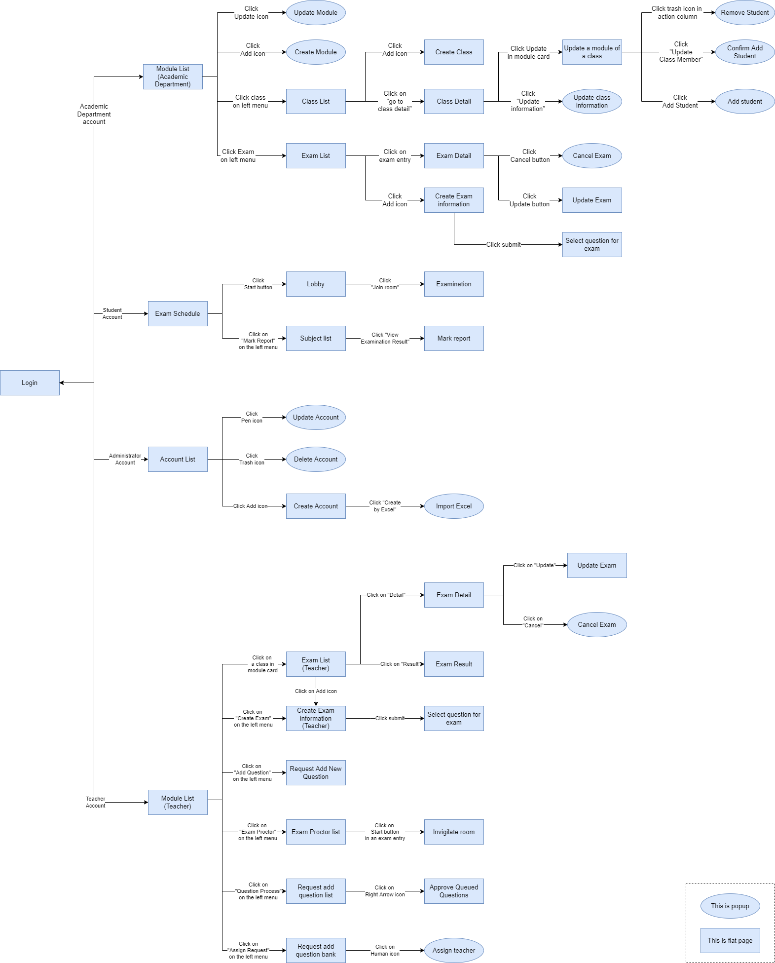
Figure 14. Screen Flow

b. Screen Details
# | Feature | Screen | Description
01 | View modules | Module List  (Academic Department) | Displays a list of modules in a table, with actions provided for each module
02 | Update Module | Update Module | Provide interface to update module’s information
03 | Create Module | Create Module | Provide interface for creating modules
04 | View Classes | Class List | Provide interface for viewing classes
05 | Create Class | Create Class | Provide interface for creating classes
06 | View Class Detail | Class Detail | Provide detailed information about classes
07 | Update class information | Update a module of a class | Provide interface to update a class’s module
08 | Update class information | Remove Student | Provide interface to remove a student from a class
09 | Update class information | Confirm add student | Provide interface to confirm adding students into a class
10 | Update class information | Add Student | Provide interface to add students into a class
11 | Update class information | Update class information | Provide interface to update class information
12 | View exams | Exam List | Provide a table listing exams
13 | View exam detail | Exam Detail | Provide detailed information about an exam
14 | Cancel Exam | Cancel Exam | Provide interface to cancel an exam
15 | Update exam | Update Exam | Provide interface to update an exam
16 | Create exam | Create Exam Information | Provide a three steps form to create information about an exam
17 | Create exam | Select question for exam | Provide interface to select questions for an exam manually, or randomise from a number of questions
18 | View upcoming exams | Exam Schedule | Provide interface to view upcoming exams of a student
19 | Taking exam | Lobby | Waiting room before entering an exam
20 | Taking exam | Examination | Provide an interface for students to take exams.
21 | View mark report | Subject List | Provide a list of subjects for student to view mark report of
22 | View mark report | Mark report | Displays mark of all exams of a subject of a student
23 | View account | Account List | Provide a list of accounts
24 | Update account | Update Account | Provide interface to update information of an account
25 | Delete account | Delete Account | Provide interface to delete an account
26 | Create account | Create Account | Provide interface to create an account
27 | Create account using excel | Import Excel | Provide interface to import accounts from an excel file
28 | View modules | Module List  (Teacher) | Provide a list of modules that the teachers teaches
29 | View exams | Exam List  (Teacher) | Provide a list of exams of a module
30 | View exam detail | Exam Detail | Display the details of an exam
31 | Update Exam | Update Exam | Provide interface to update an exam
32 | Cancel Exam | Cancel Exam | Provide interface to cancel an exam
33 | View exam result | Exam Result | Display the result of an exam
34 | Create exam | Create Exam Information  (Teacher) | Provide a four steps form to create information about an exam
35 | Create exam | Select question for Exam | Provide interface to select questions for an exam manually, or randomise from a number of questions
36 | Request Add New Question | Request Add New Question | Provide interface to post a request to add new questions into the question bank
37 | View exam proctors | Exam Proctor List | Provide interface to view a list of proctors
38 | Invigilate | Invigilate Room | Provide interface to watch over a room of examinees
39 | View Request Add Question | Request Add Question List | Display a list of add new question requests
40 | Approve questions to question bank | Approve Queued Questions | Provide interface to approve requested questions
41 | View Request Add Question | Request Add Question Bank | Provide interface to view a list of requests to add questions to question bank
42 | Assign teacher | Assign teacher | Assign a teacher to process a request to add questions

c. Screen Authorization
Screen | Academic Department | Student | Administrator | Teacher
Module List  (Academic Department) | X
Update Module | X
Create Module | X
Class List | X
Create Class | X
Class Detail | X
Update a module of a class | X
Remove Student | X
Confirm add student | X
Add Student | X
Update class information | X
Exam List | X
Exam Detail | X
Cancel Exam | X
Update Exam | X
Create Exam Information | X
Select question for exam | X
Exam Schedule |  | X
Lobby |  | X
Examination |  | X
Subject List |  | X
Mark report |  | X
Account List |  |  | X
Update Account |  |  | X
Delete Account |  |  | X
Create Account |  |  | X
Import Excel |  |  | X
Module List  (Teacher) |  |  |  | X
Exam List  (Teacher) |  |  |  | X
Exam Detail |  |  |  | X
Update Exam |  |  |  | X
Cancel Exam |  |  |  | X
Exam Result |  |  |  | X
Create Exam Information  (Teacher) |  |  |  | X
Select question for Exam |  |  |  | X
Request Add New Question |  |  |  | X
Exam Proctor List |  |  |  | X
Invigilate Room |  |  |  | X
Request Add Question List |  |  |  | X
Approve Queued Questions |  |  |  | X
Request Add Question Bank |  |  |  | X
Assign teacher |  |  |  | X

In which:
- Academic Department: The academic department is responsible for managing over students in classes, modules, and final exams.
- Student: The students of the system.
- Administrator: The people that manages over the system.
- Teacher: The teachers that uses the system.

d. Non-Screen Functions
# | Feature | System Function | Description
1 | Export marks | Export marks | Export marks of a class into an excel file

e. Entity Relationship Diagram
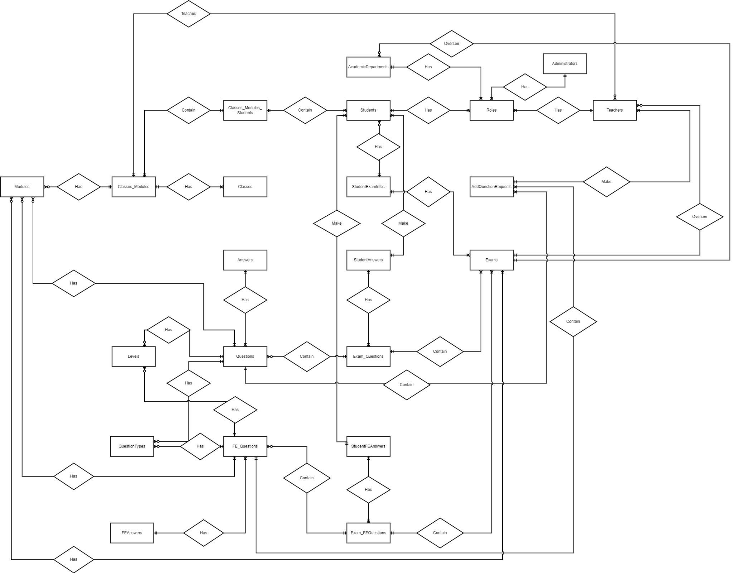
Figure 15. ERD diagram
Entities List
# | Entity | Description
1 | Academic Department | Stores information about the academic department
2 | Administrator | Stores information about the administrator
3 | Classes_Modules_Students | Stores information about which student studies in which combination of class and module
4 | Students | Stores information about the students
5 | Roles | Stores information about roles in the system
6 | Teachers | Stores information about the teachers
7 | Modules | A module is a unit of study
8 | Classes_Modules | Stores information about which class has which modules
9 | Classes | Stores information about the classes
10 | StudentExamInfos | Stores information relating to which student takes which exam
11 | AddQuestionRequests | Stores requests to add questions in to the question bank
12 | Answers | Stores the answers of multiple choice questions
13 | StudentAnswers | Stores the answer that the student gave during an exam
14 | Exams | Stores the information about exams
15 | Levels | Stores the different level of difficulty of a question
16 | Questions | Stores information about questions
17 | ExamQuestions | Stores the questions that was used for each exam
18 | QuestionTypes | Stores the types of question
19 | FE_Questions | Stores information about final exam questions
20 | StudentFEAnswers | Stores the answers that the student gave during a final exam
21 | FEAnswers | Stores the answers of multiple choice questions used specifically for final exam
22 | Exam_FEQuestions | Stores the questions that was used for final exams

3.2 Authentication

a. Login
- Triggering a function: Go to the link “https://examedu.netlify.app/” to access the login page.
- Description of the function: Allow the user to log in to the web application to be able to use all functions of the account’s role.
- Details of the function:
- Normal execution case: Login successfully and direct user to the main page based on his account’s role.
- Abnormal execution case: If the user leaves the email or password input field empty and clicks the “Login” button, an error will be displayed (Figure 17). If the user inputs invalid email format, an error will be displayed (Figure 18). If the user inputs the wrong email or password, an error will be displayed (Figure 19). If the user logs in by a deactivated account, an error will be displayed (Figure 20).
- Layout of the screen:
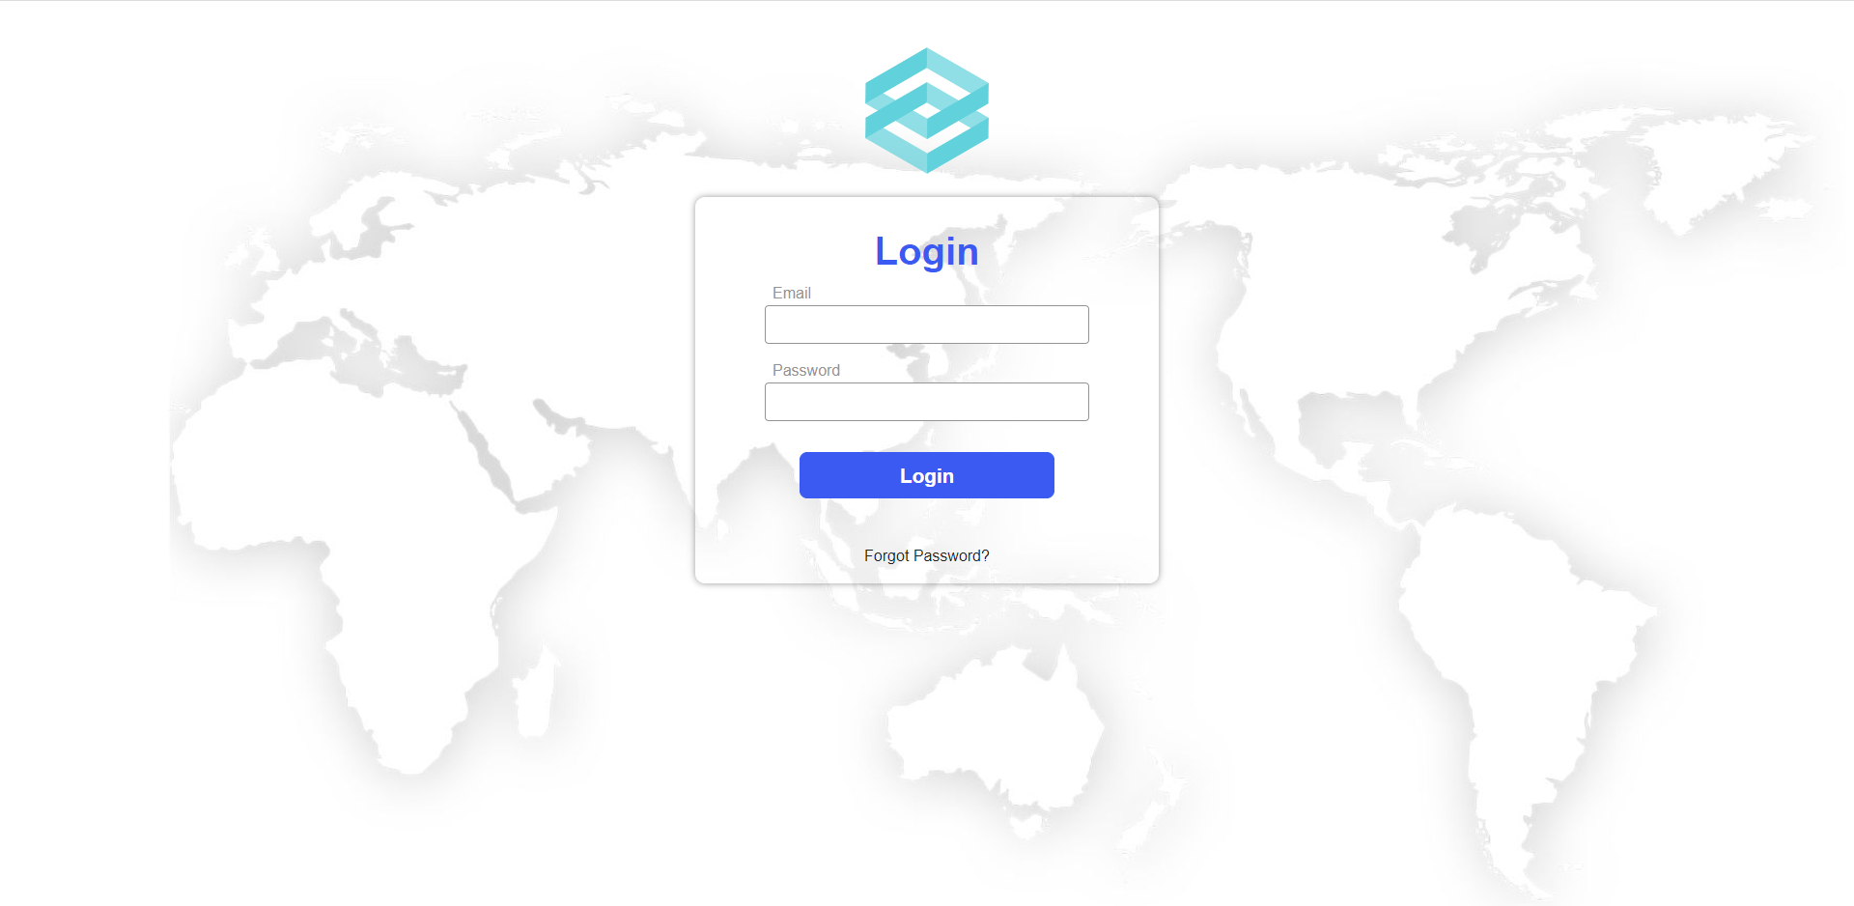
Figure 16. The login page
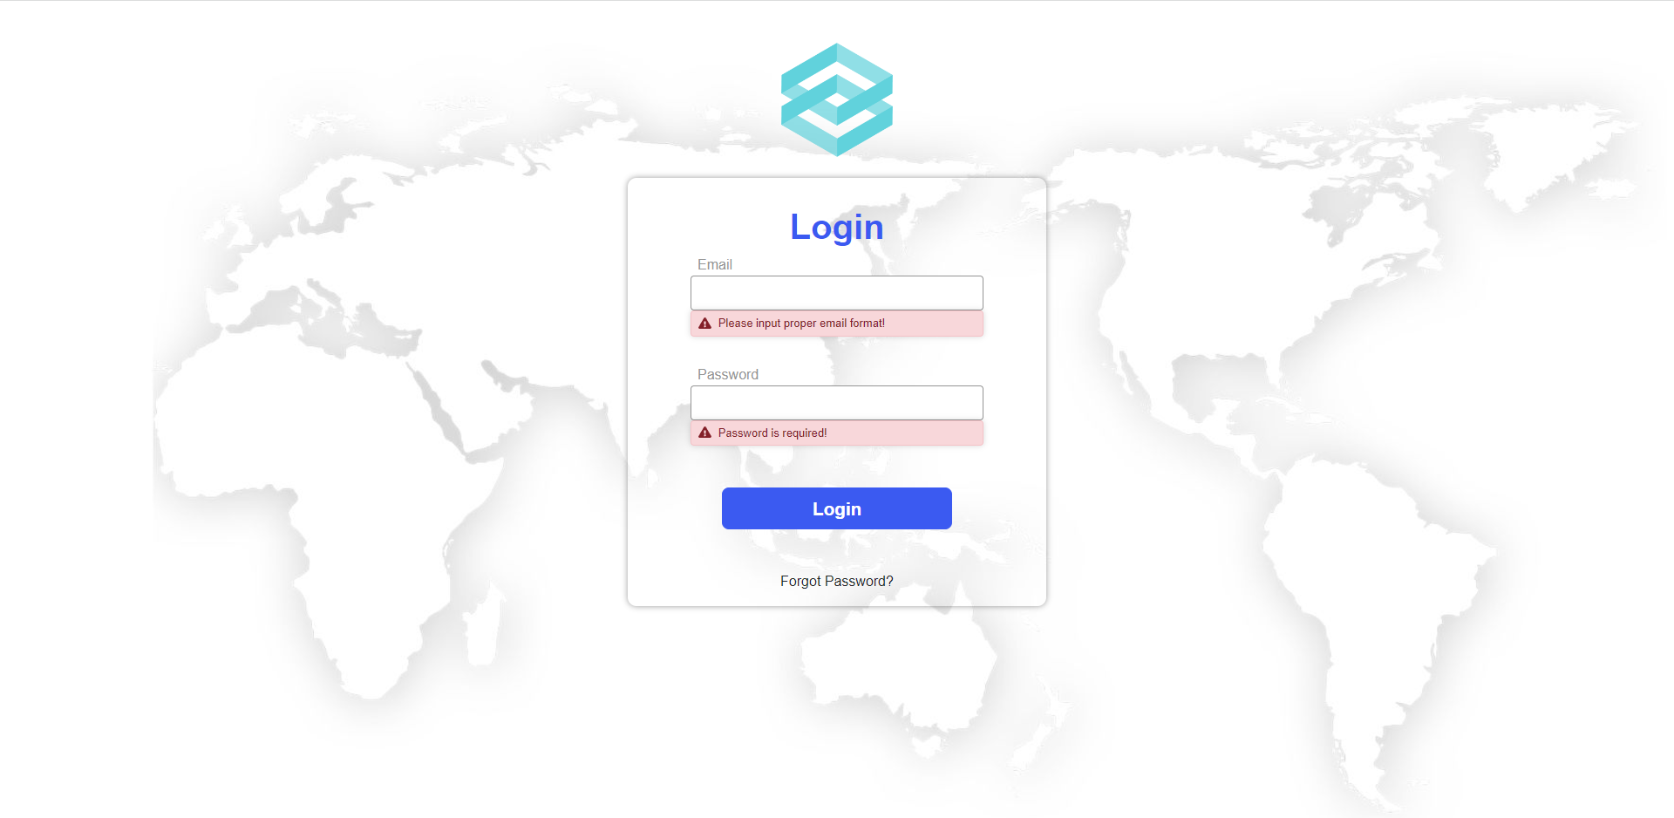
Figure 17. Error displayed when user does not inputs
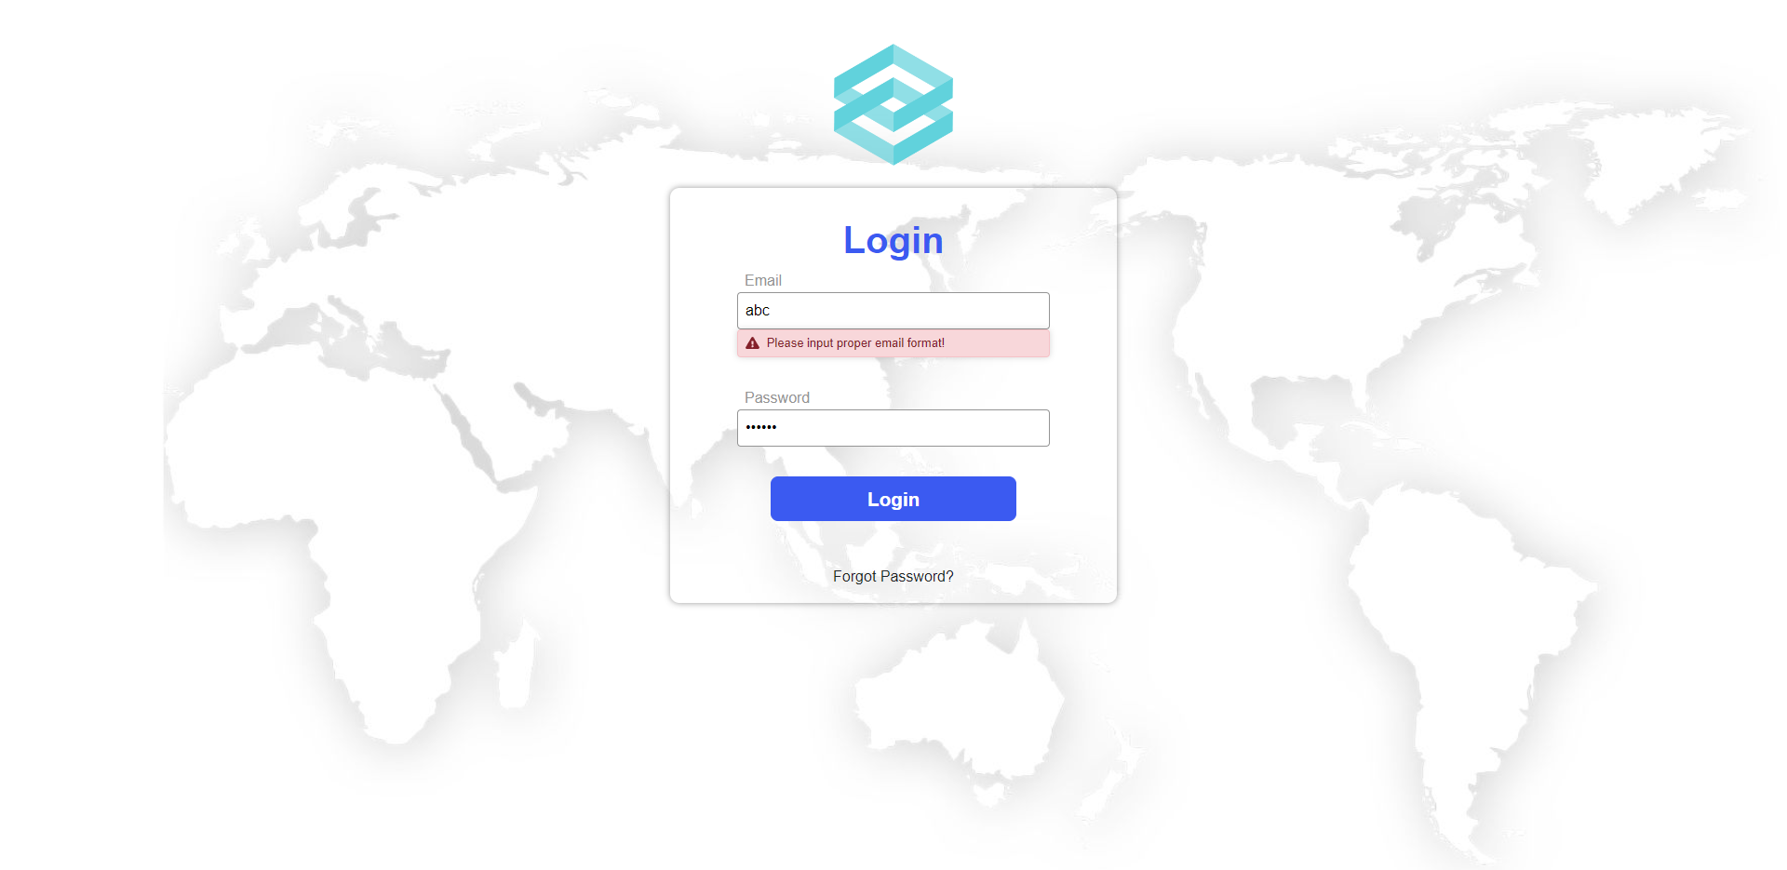
Figure 18. Error displayed when user inputs invalid email format
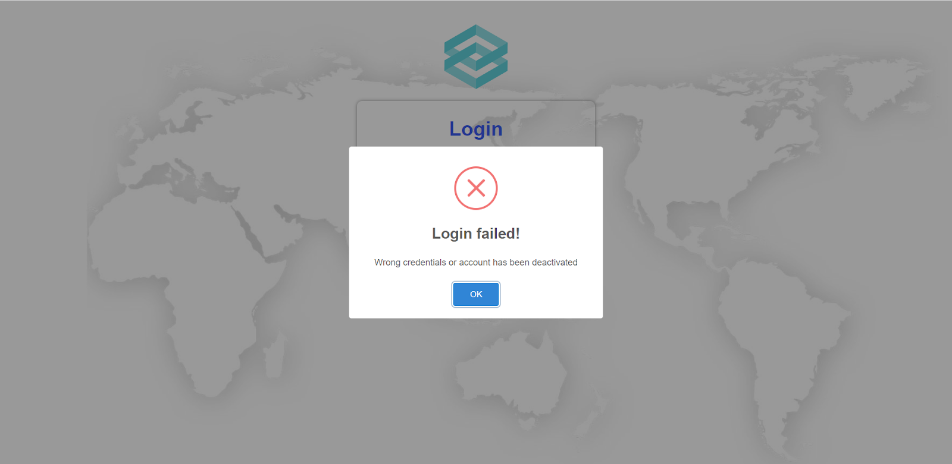
Figure 19. Error displayed when user inputs wrong email or password

Figure 20. Error displayed when user logs in with a deactivated account

b. Logout
- Triggering a function: Login successfully and click on the logout icon on the top right corner of the web application (Figure 21).
- Description of the function: Allow the user to log out from the system and go back to the login page.
- Details of the function:
- Normal execution case: Logout successfully and direct user to the login page.
- Abnormal execution case: Loss of connection.
- Layout of the screen:
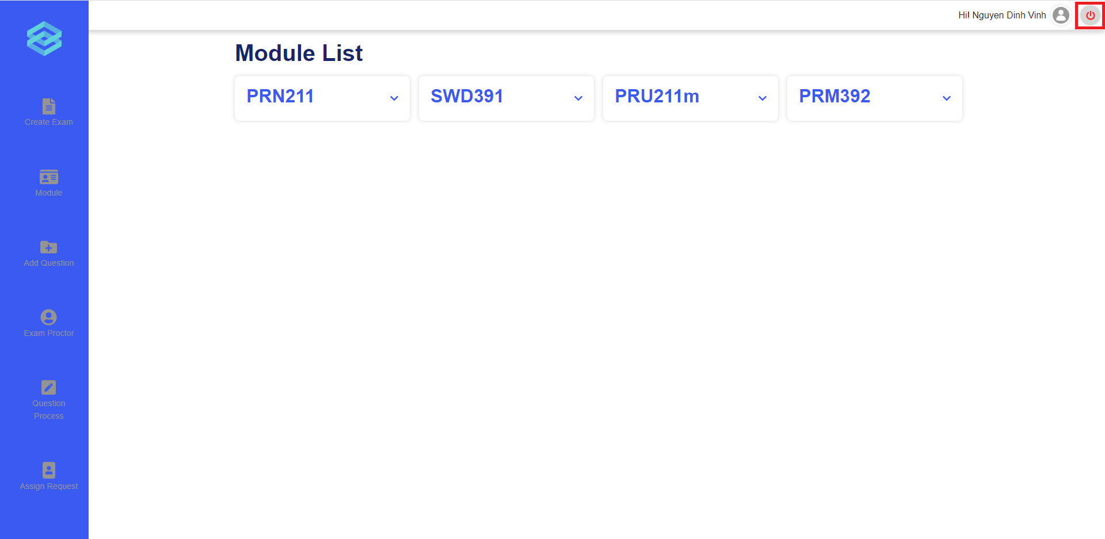
Figure 21. The logout icon

c. Forgot password
- Triggering a function: Click on the “Forgot Password?” link on the login page (Figure 22).
- Description of the function: Allow users to generate a new password when they forget the current password.
- Details of the function:
- Normal execution case: System sends an email with a newly generated password to the user’s email address.
- Abnormal execution case: If the user leaves the email input field empty and clicks the “Get New Password” button, an error will be displayed (Figure 25). If the user inputs invalid email format, an error will be displayed (Figure 26). If the user inputs email does not exist in the system, an error will be displayed (Figure 27).
- Layout of the screen:
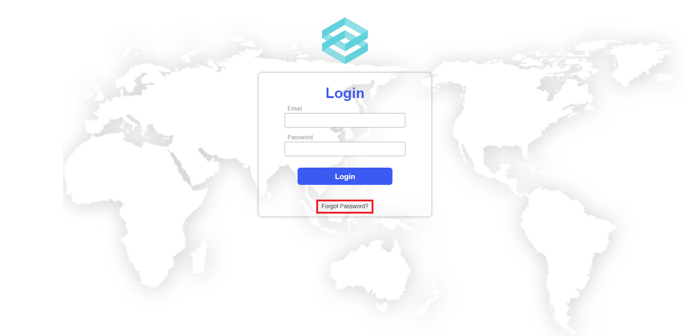
Figure 22. The “Forgot Password?” link
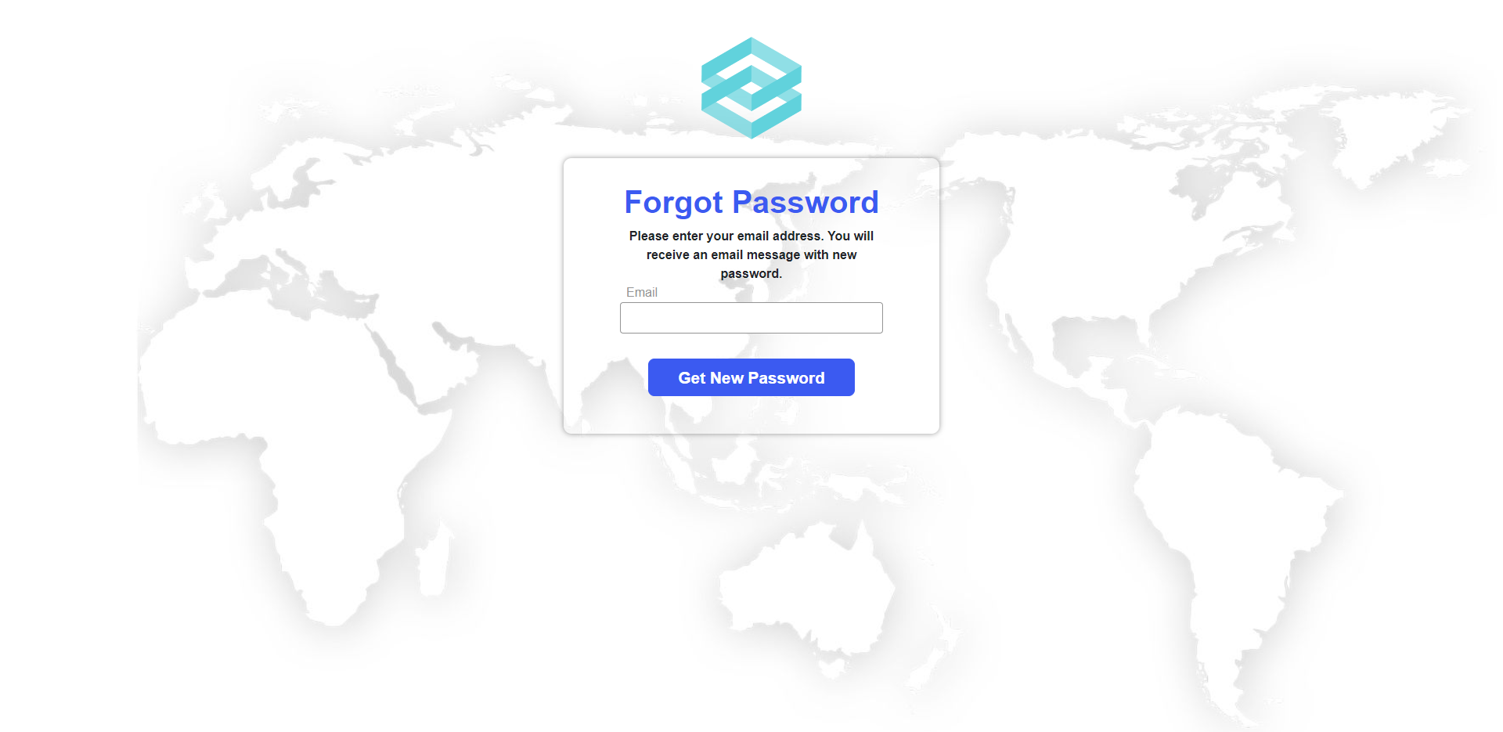
Figure 23. The forgot password page
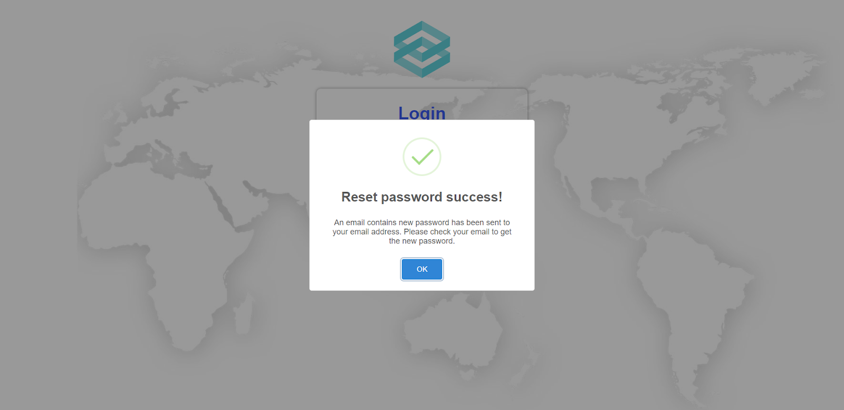
Figure 24. The reset password success message
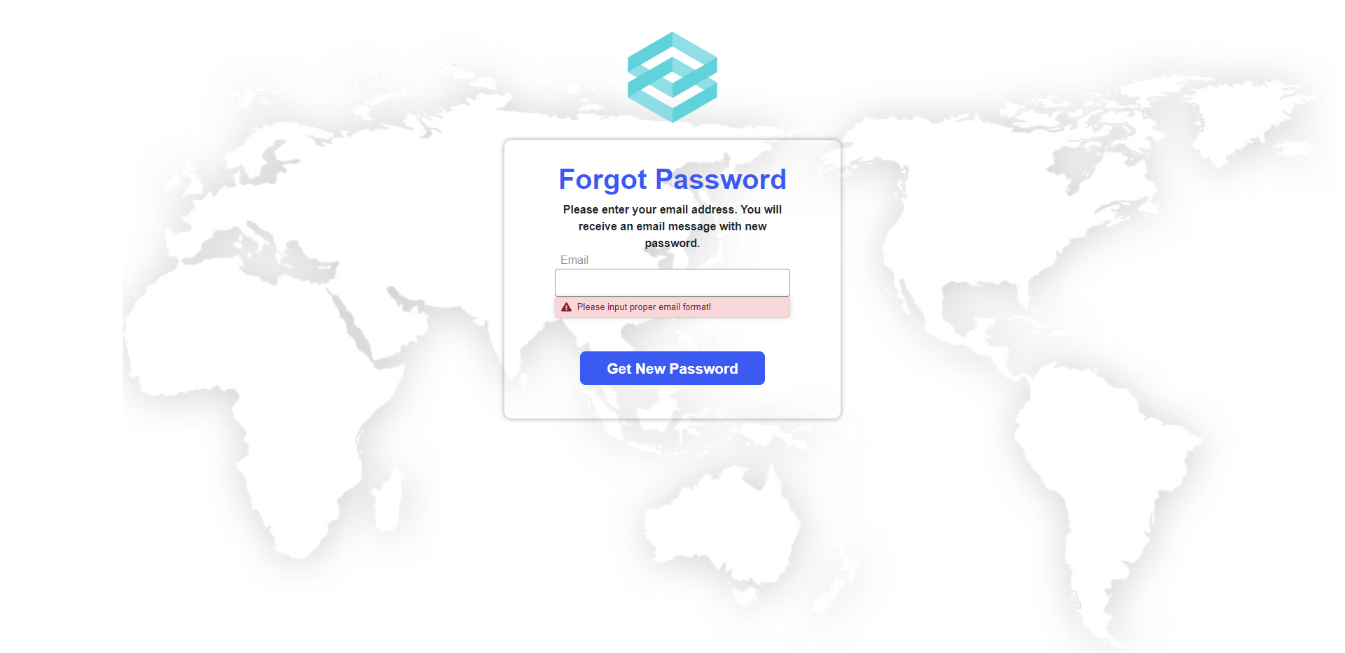
Figure 25. Error displayed when user does not input
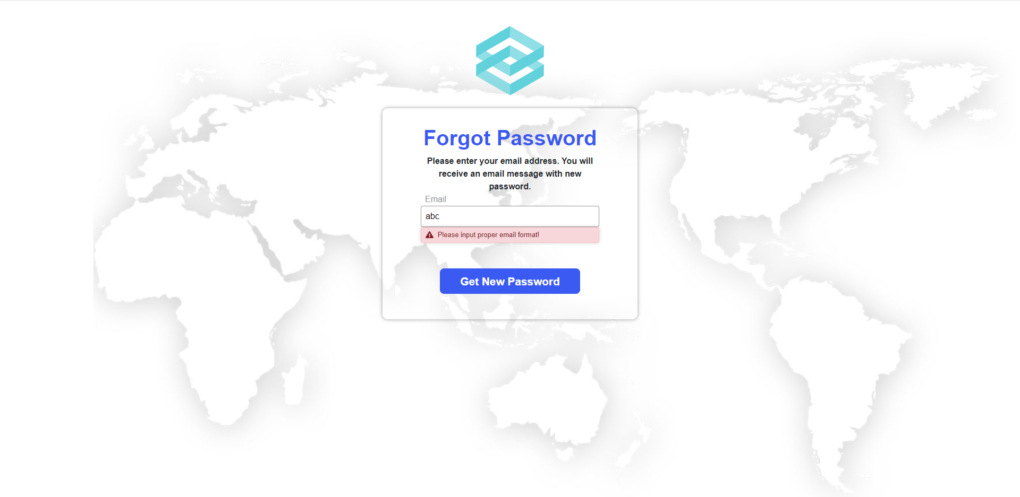
Figure 26. Error displayed when user inputs invalid email format
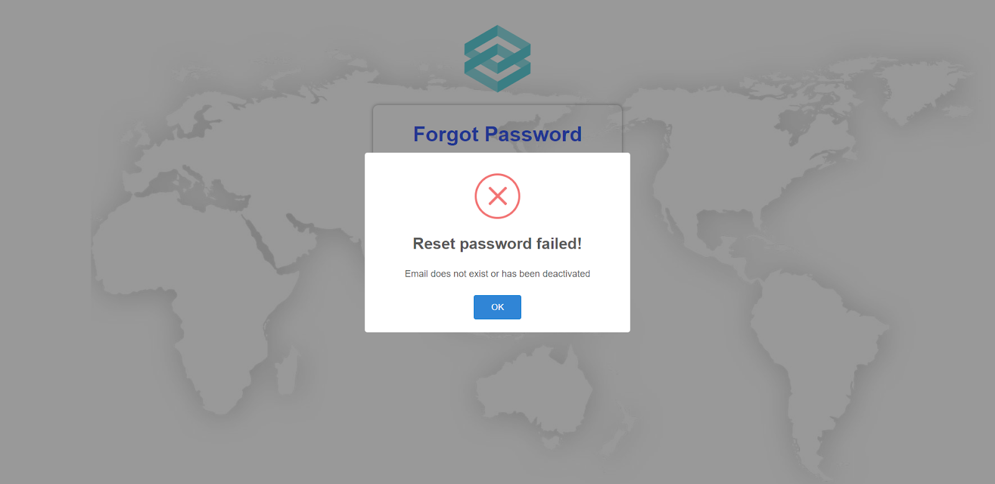
Figure 27. Error displayed when user inputs email not exist

3.3 Role Administrator

a. Manage account
- Triggering a function: Login as an Administrator successfully.
- Description of the function: An Administrator user is allowed to create accounts, edit basic account information (full name, email), deactivate account, and view account list.
- Details of the function:
  - Normal execution case: Successfully, an Administrator user has access to the account list page (Figure 28) and on each account, has access to update account information(full name, email), deactivate account. Administrator also has access to the create account page (Figure 31), has access to the create account function.
- Layout of the screen:
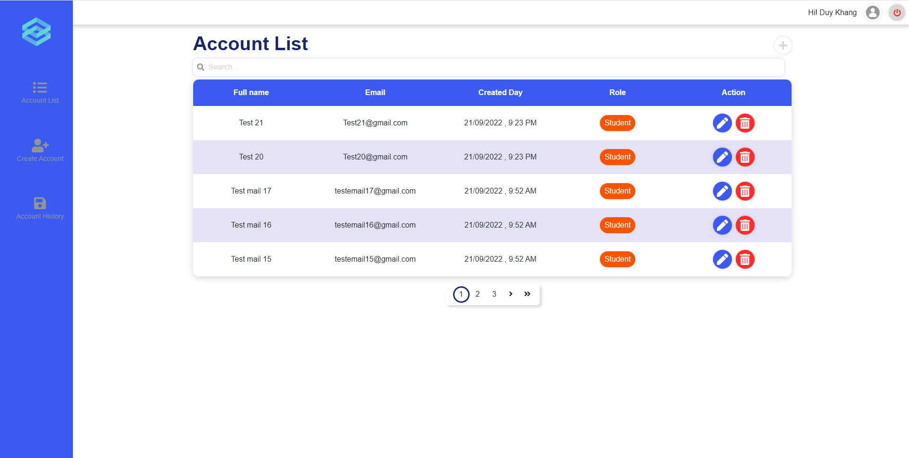
Figure 28. Manage account
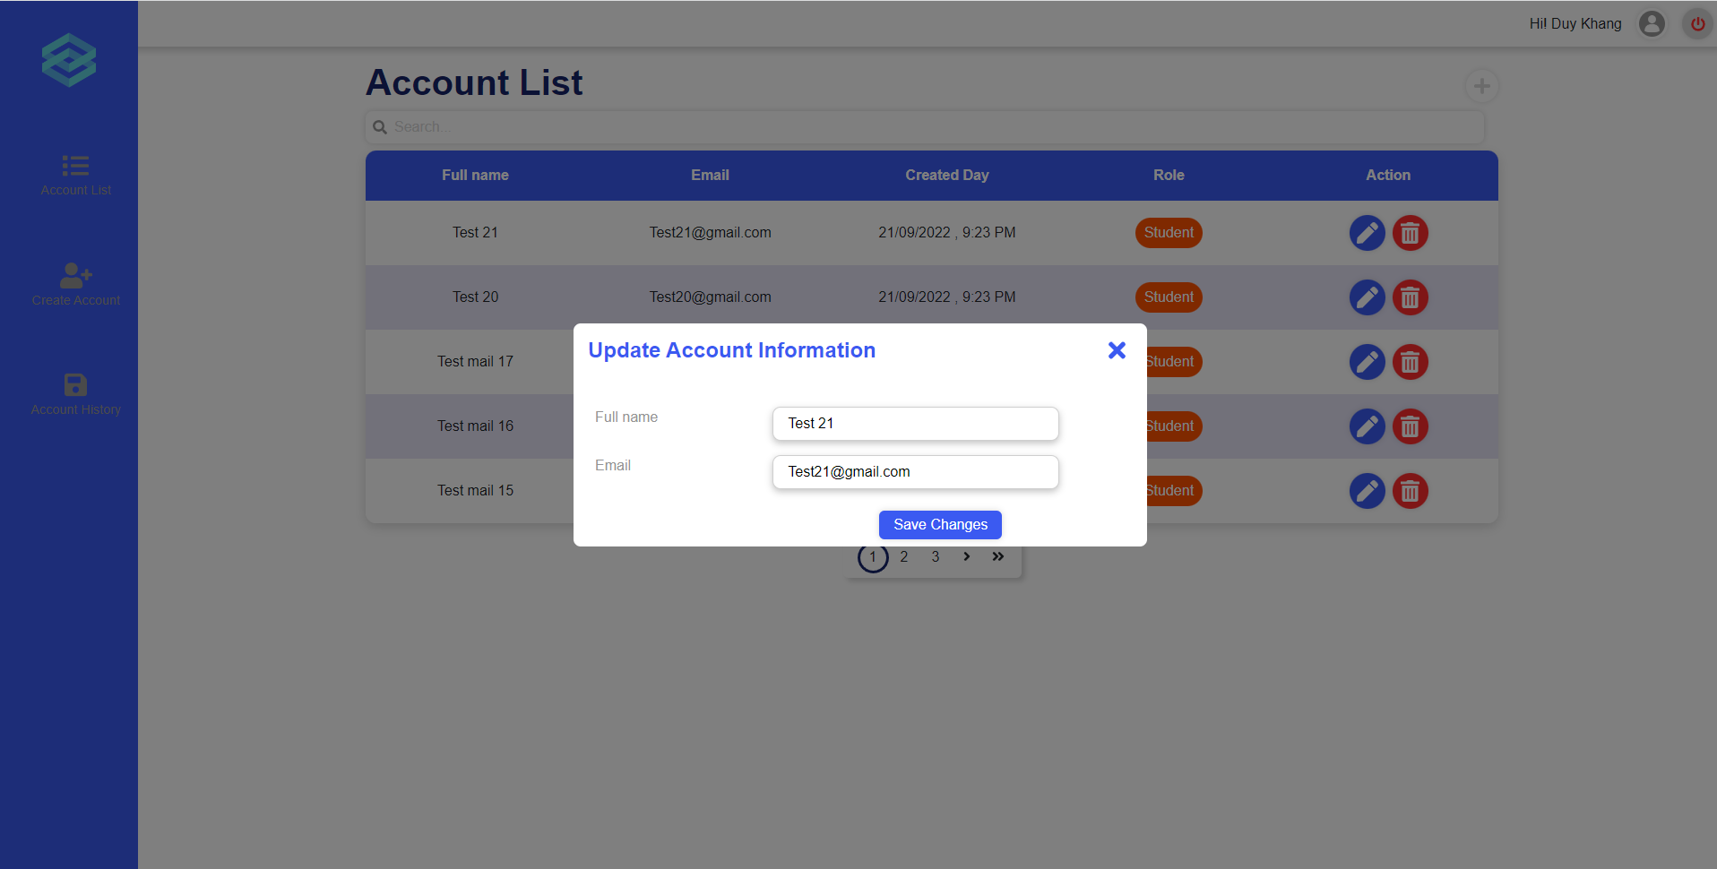
Figure 29. Update account
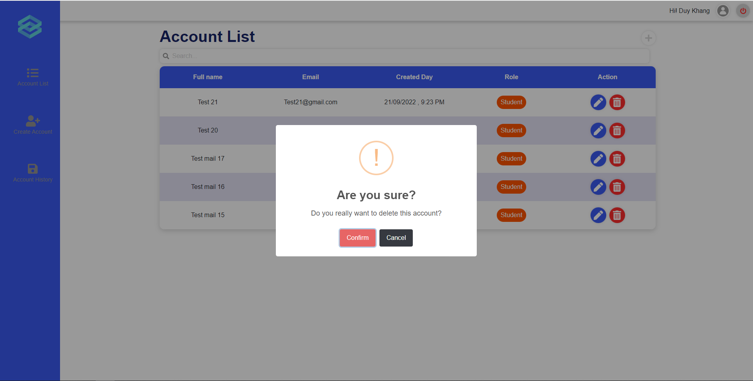
Figure 30. Delete account
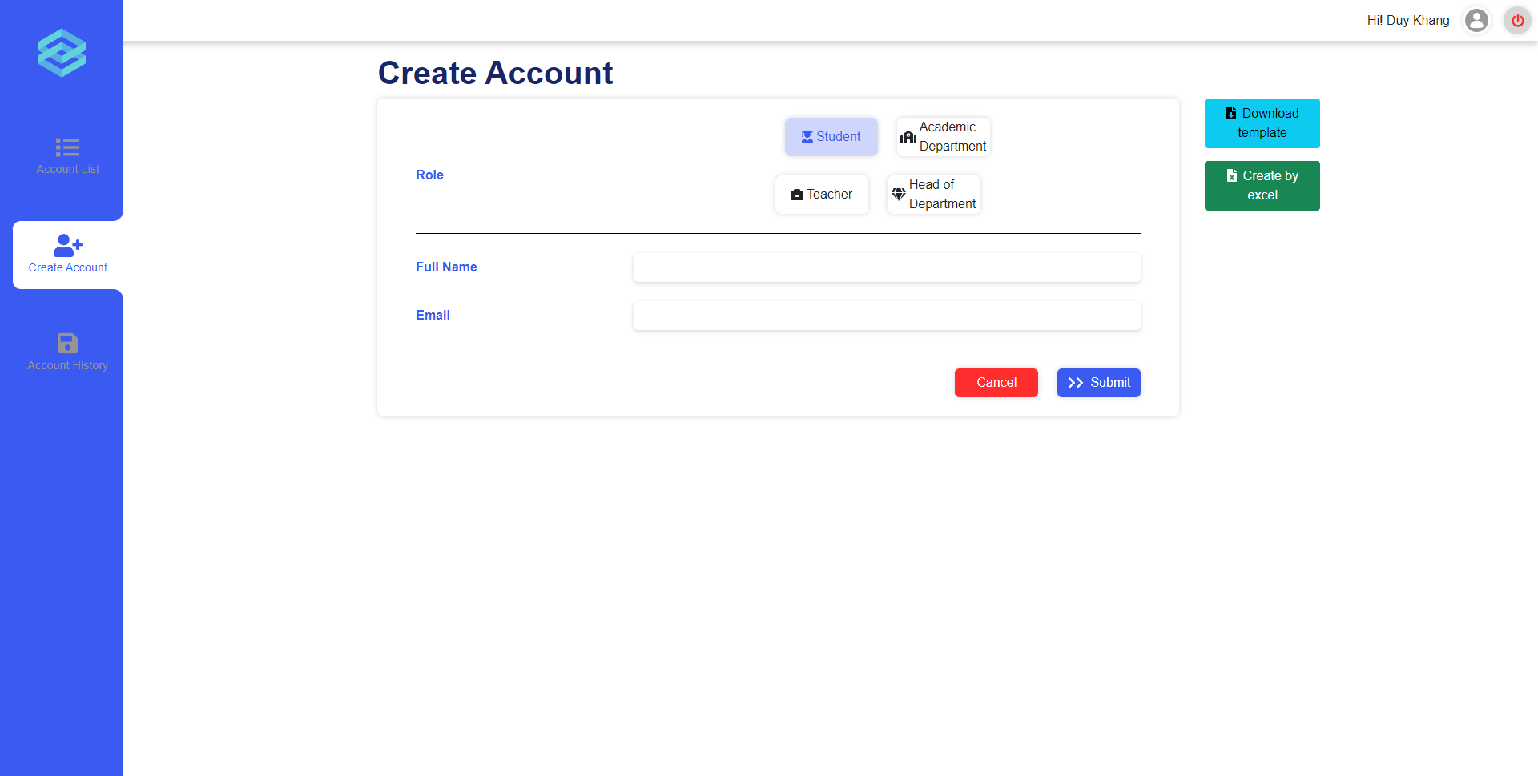
Figure 31. Create account

b. View deactivated account
- Triggering a function: Login as an Administrator successfully, click on section “Account history”.
- Description of the function: an Administrator user is allowed to view a list of deactivated accounts.
- Details of the function:
  - Normal execution case: Successfully, an Administrator user has access to the deactivated account list page (Figure 32).
- Layout of the screen:
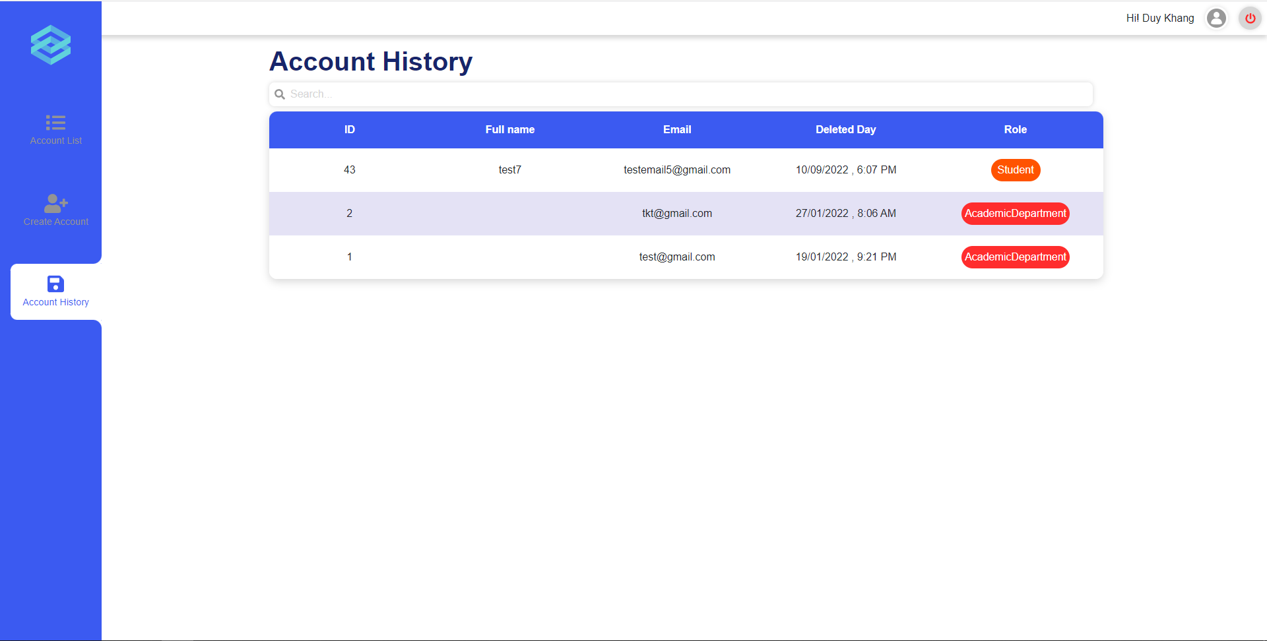
Figure 32. Deactivated account list

c. Create accounts by excel
- Triggering a function: Login as an Administrator successfully, click on section “Create account” (Figure 33), and click on the button [Create by excel].
- Description of the function: An Administrator user is allowed to create accounts by uploading excel files.
- Details of the function:
  - Normal execution case: Successfully, an Administrator user has access to the create accounts by excel function.
- Layout of the screen:
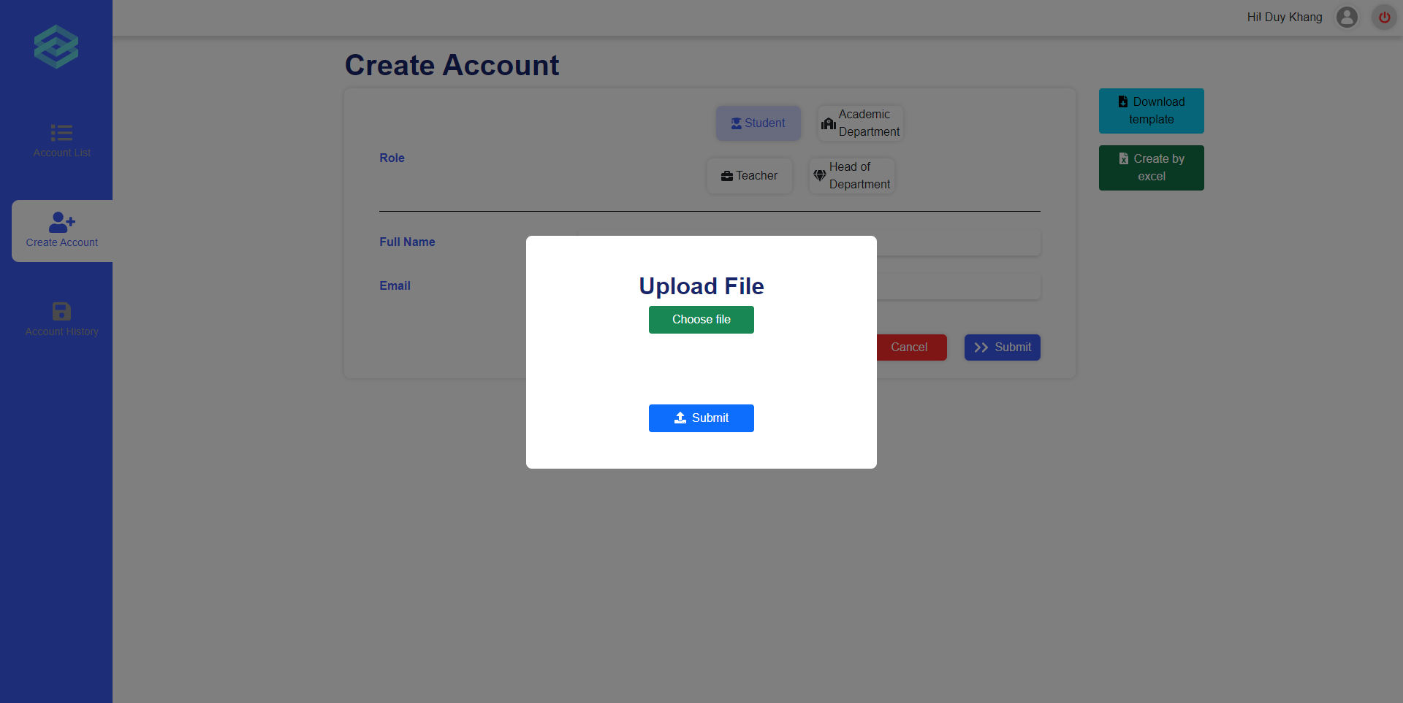
Figure 33. Create accounts by excel

3.4 Role Academic department

a. Manage modules
- Triggering a function: Login successfully, click on the plus icon (Figure 34), a popup will appear allowing you to input module’s code and name, then click on “Confirm” (Figure 35), a popup will appear asking if you want to continue or not (Figure 36), click “Yes” to create or cancel to stop the creation process. To update a module, click on the edit icon on the module you want to update (Figure 37), a popup will appear allowing you to input the updated module’s name (Figure 38), click “Confirm” (Figure 39) to continue or click cancel to stop the update.
- Description of the function: an Academic Department user is allowed to manage modules. including view module list, create, update module information.
- Details of the function:
  - Normal execution case: Successfully, an Academic Department user has access to the Module List page and on each module, has access to update module information. They also have access to creating a new module.
  - Abnormal execution case: Loss of connection.
- Layout of the screen:
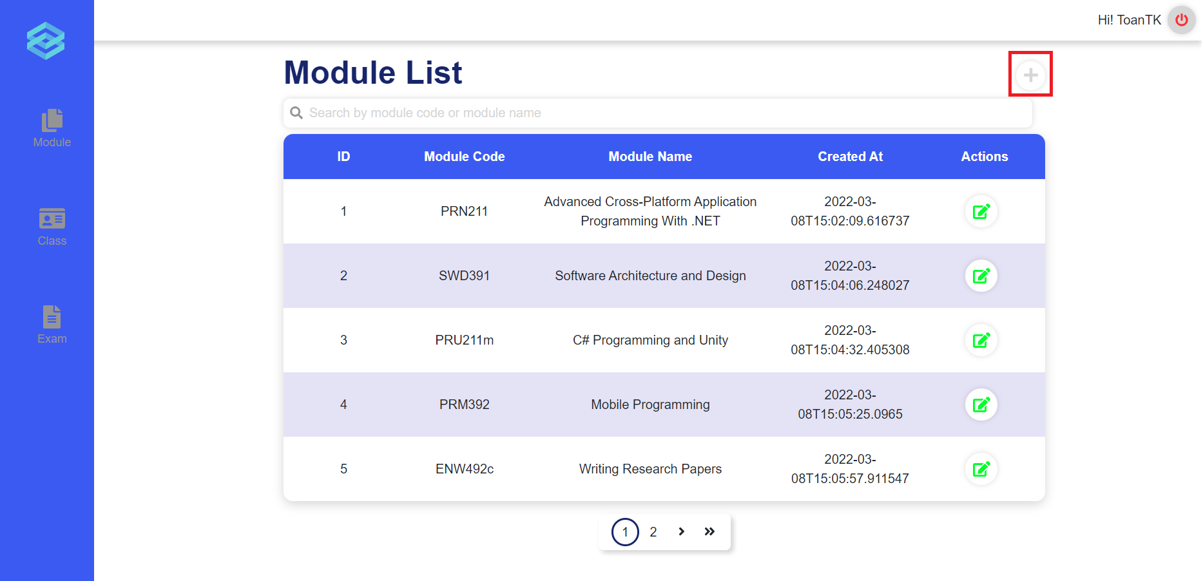
Figure 34. Module List
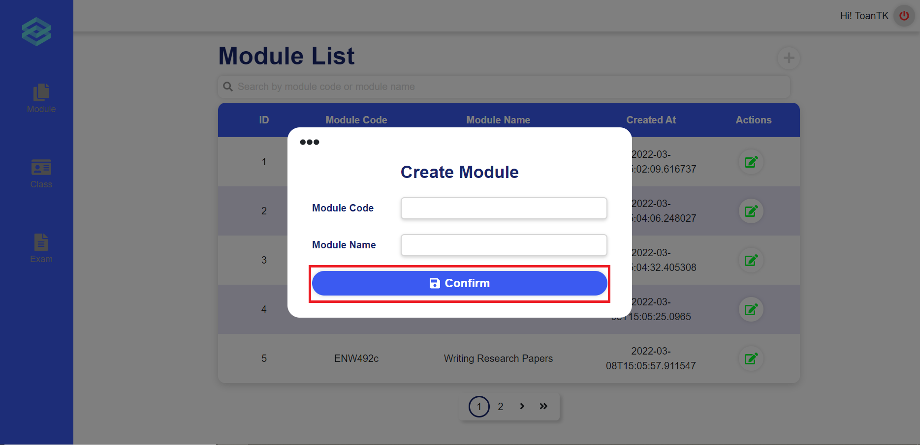
Figure 35. Create module
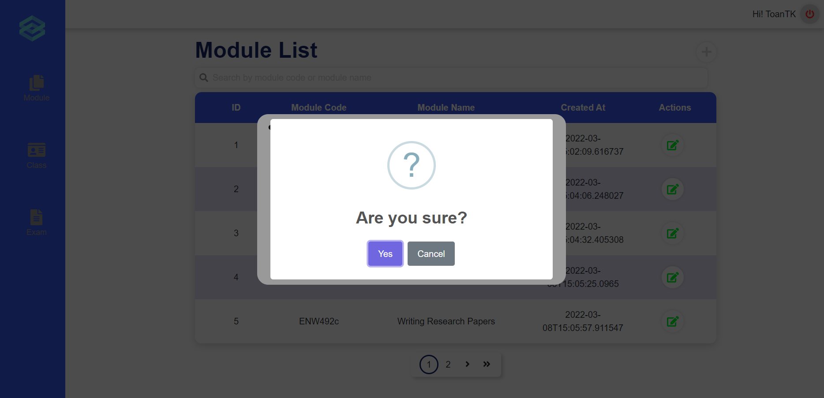
Figure 36. Confirmation message
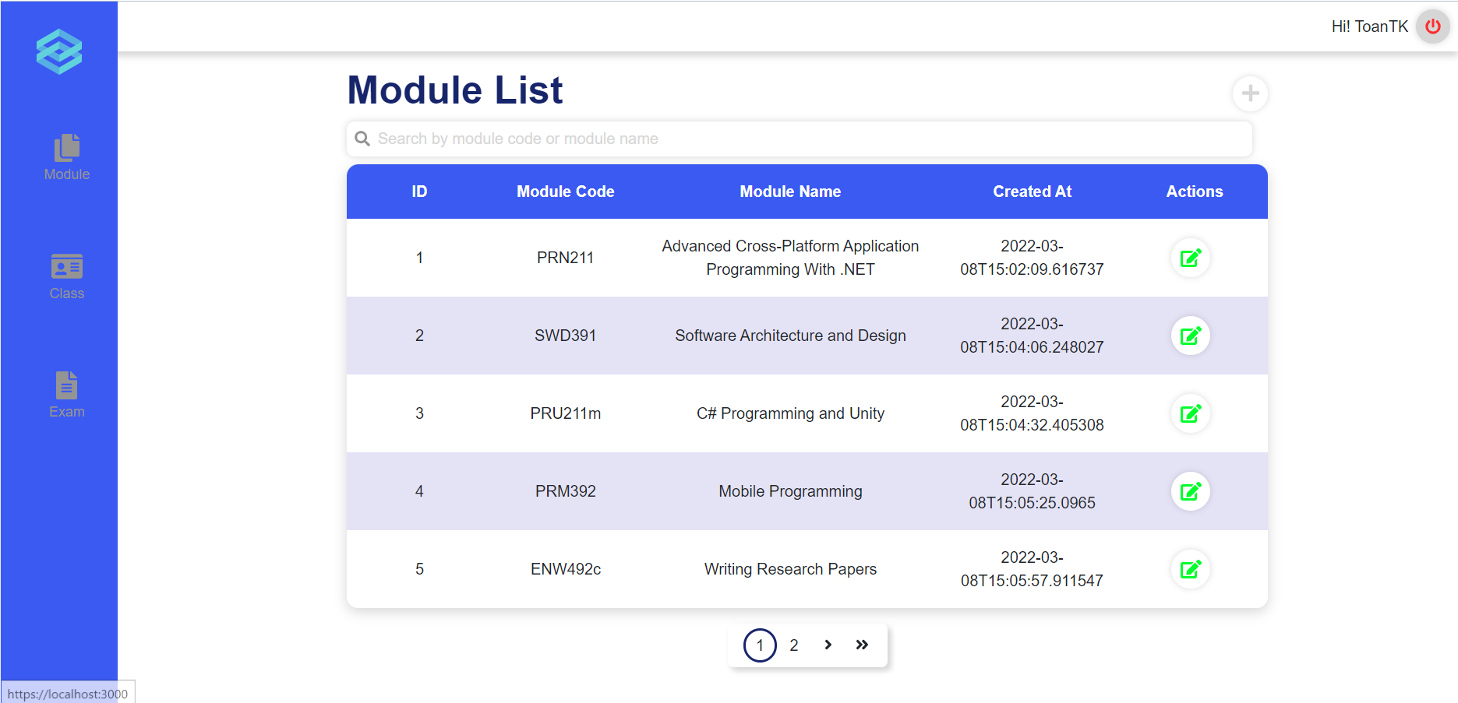
Figure 37. Module List
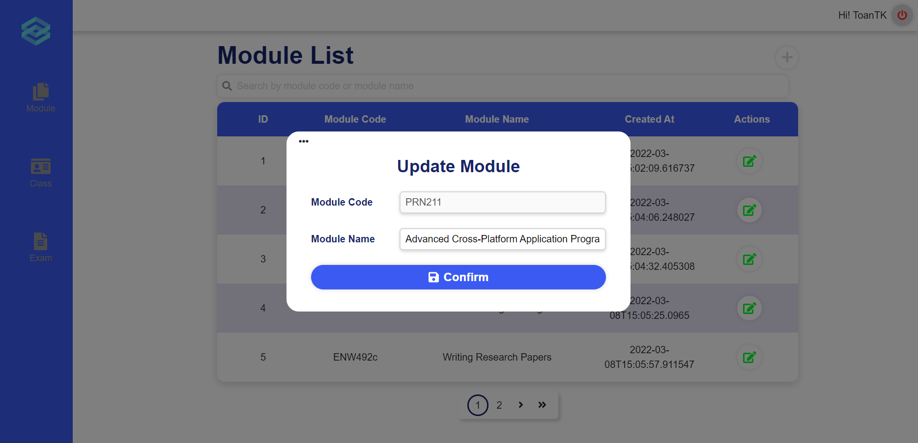
Figure 38. Update module
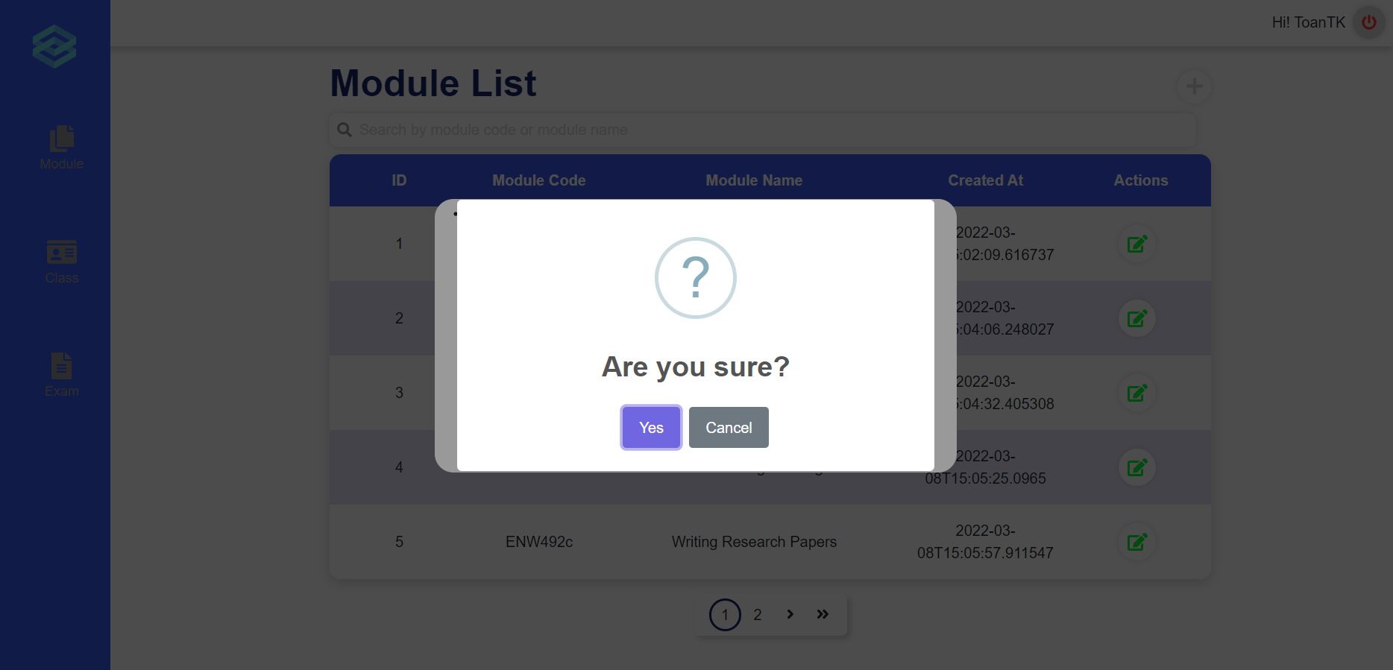
Figure 39. Confirmation message

b. Manage classes
- Triggering a function: Login successfully, click on section “Class” (Figure 40), get to the Class List Page, then click on “Go to class detail” (Figure 41) on each class.
- Description of the function: an Academic Department user is allowed to manage class. including view class list, create, update class information and update module of this class.
- Details of the function:
  - Normal execution case: Successfully, a Academic Department user have access to the Class List page and on each class, have access to update class information and update module of this class (Figure 42), or can click on the plus icon to create a new class by filling in the multi-step form (Figure 43).
- Layout of the screen:
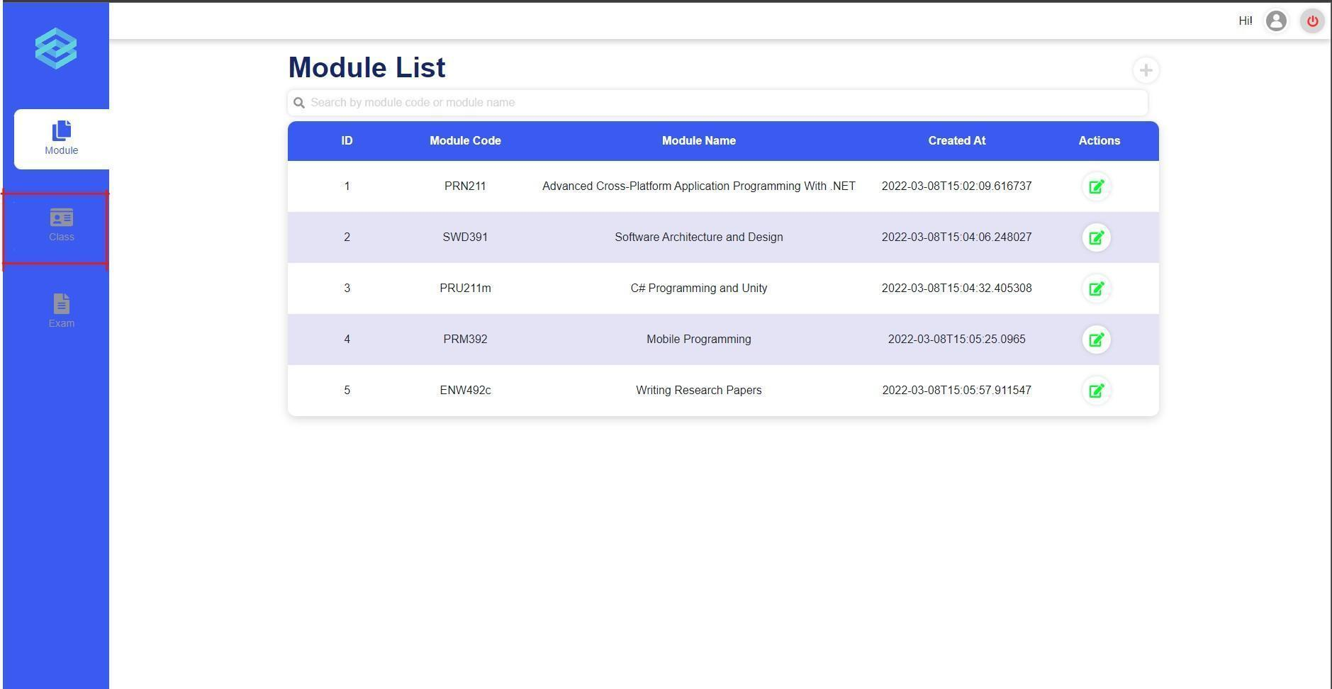
Figure 40. Manage Classes
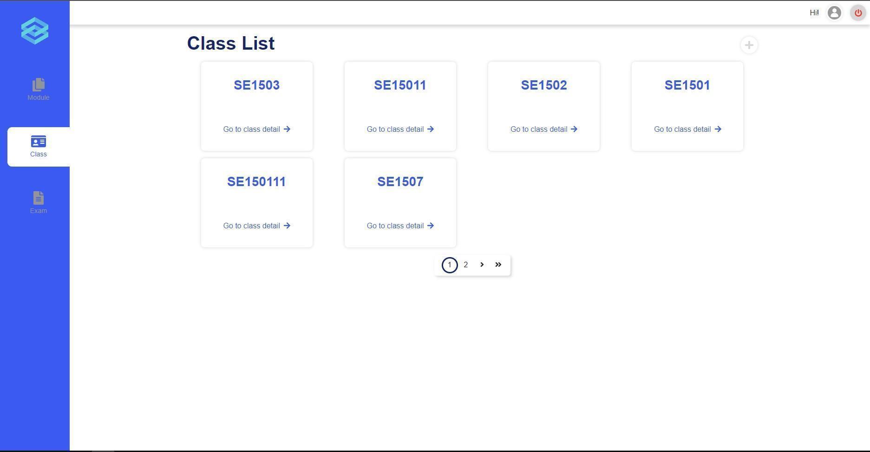
Figure 41. Class List
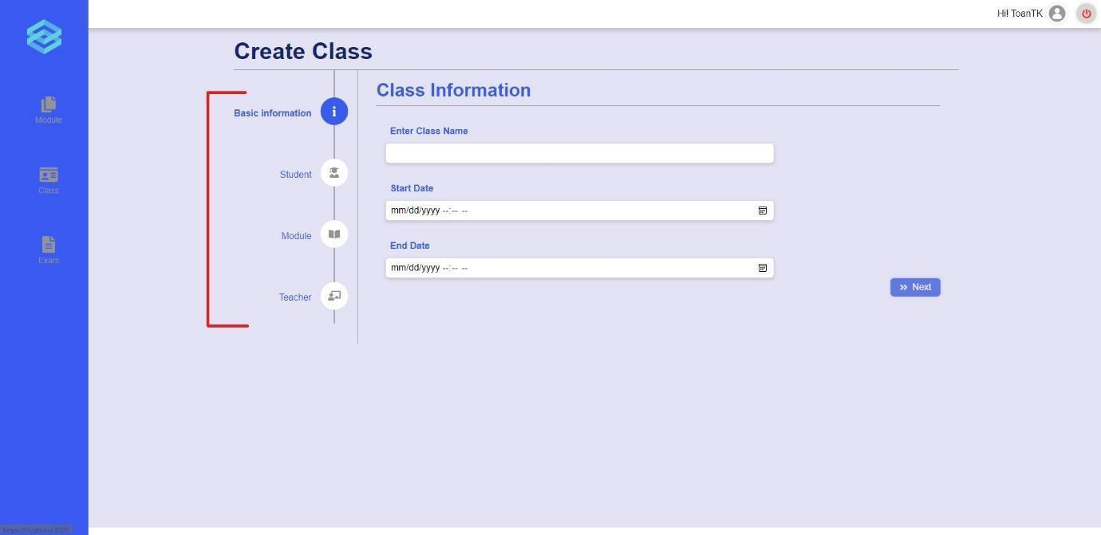
Figure 42. Create class form
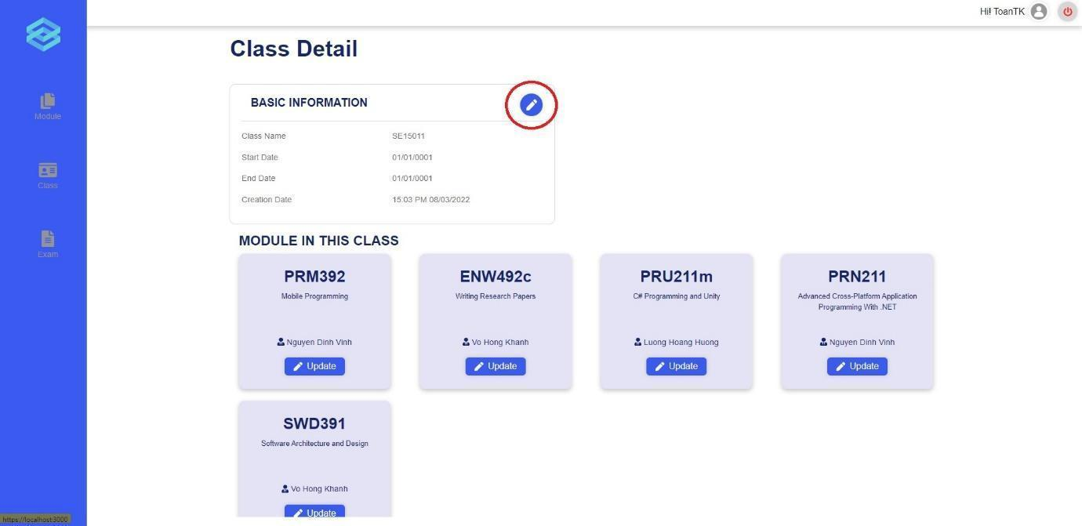
Figure 43. Class Detail

c. Manage exams
- Triggering a function: Login successfully, click on “Exam” to go to the exam list page (Figure 44), click on “Detail” on an exam to view the details of that exam (Figure 45), here, you can cancel or update the information of the exam. Returning to the exam list page, click on the “+” icon to start creating exams (Figure 46), here, you can create an exam.
- Description of the function: an Academic Department user is allowed to manage exams. including view exam list, create, update, cancel exams.
- Details of the function:
  - Normal execution case: Successfully, an Academic Department user has access to the Exam List page and on each exam, has access to viewing the details of an exam and updating or cancelling an exam, they can also create an exam.
  - Abnormal execution case: Loss of connection.
- Layout of the screen:
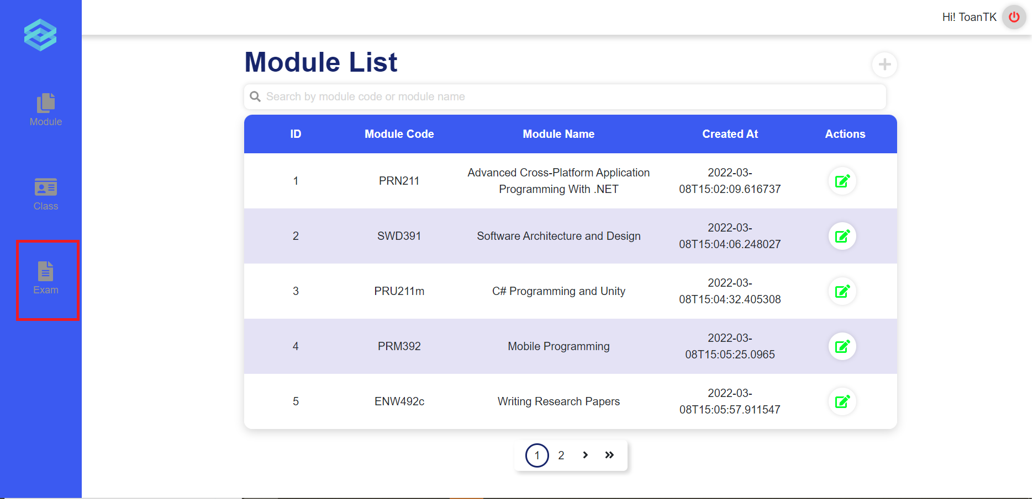
Figure 44. Module List
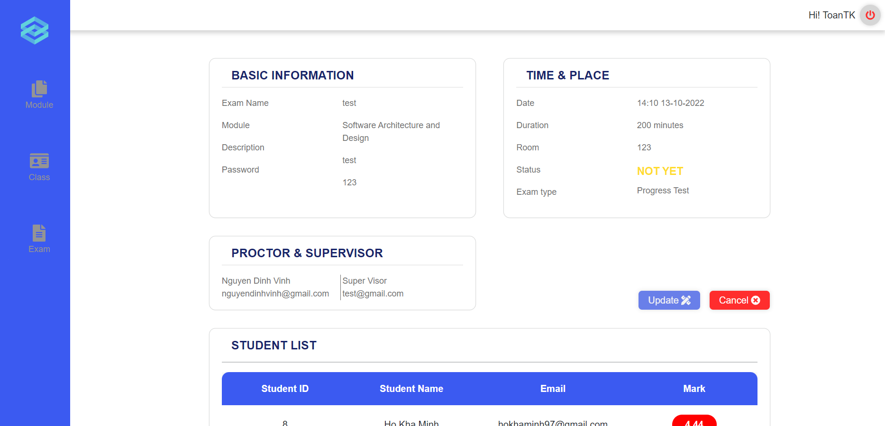
Figure 45. Exam Detail
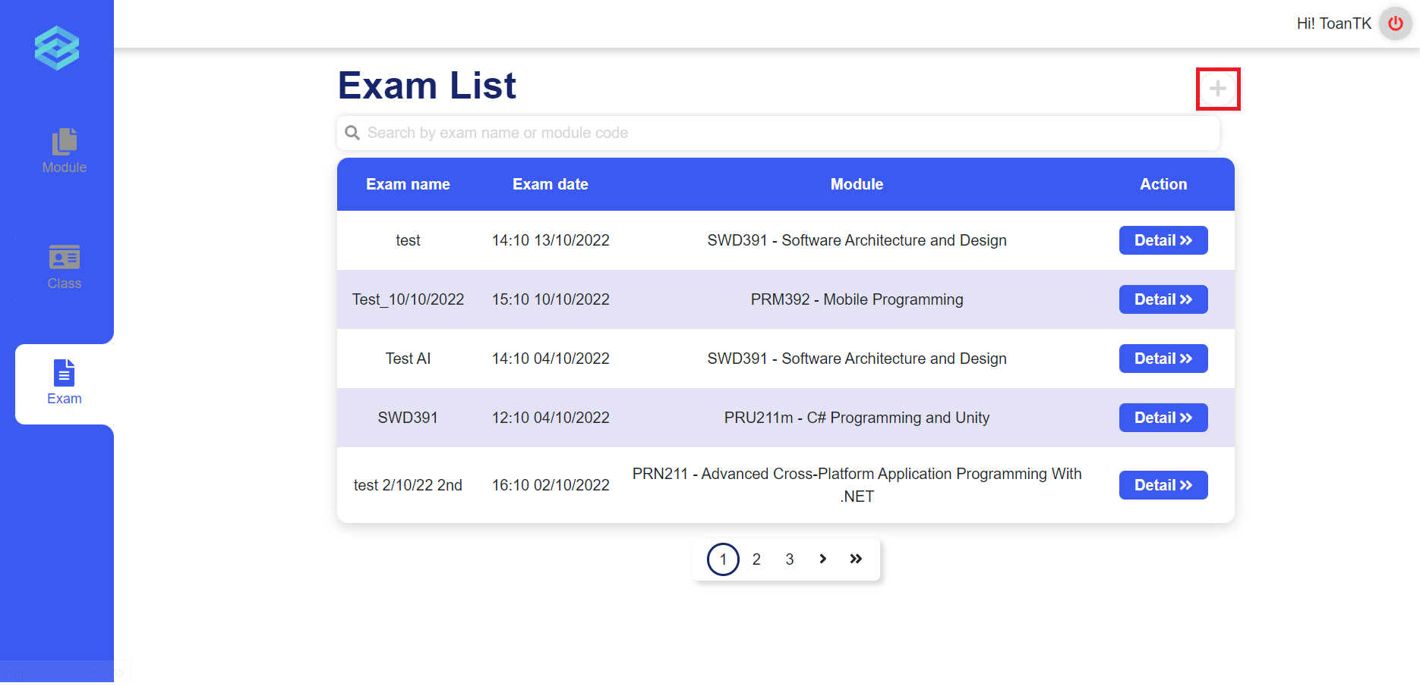
Figure 46. Exam List
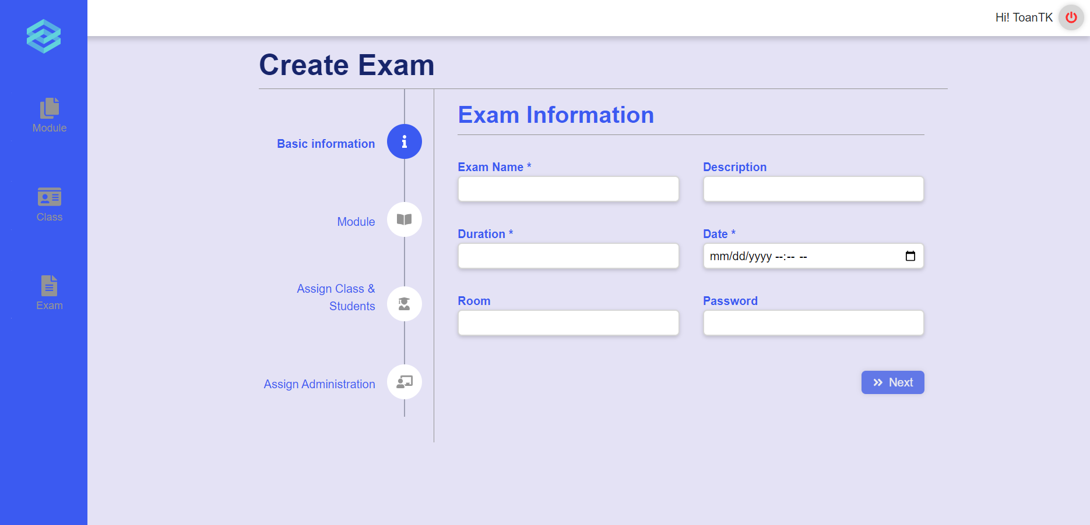
Figure 47. Create Exam

3.5 Role Teacher

a. Manage Exam
- Triggering a function: Login successfully with the teacher account. Click on the “Create Exam” icon on the vertical navigation bar to go to the create exam page (Figure 48). Click on the “Module” icon on the vertical navigation bar to go to the module list page, click on the module tab to expand it and click on the appropriate class under each module tab to go to the exam list (Figure 49). Click on the “Detail” button in the exam card to view detail, update and cancel that exam (Figure 50,51).
- Description of the function: Allow a teacher user to view the exam list, view detail of the exam, and create, update and cancel the exam.
- Details of the function:
  - Normal execution case: A teacher user can successfully access the create exam page and create a new exam. Also can successfully access the exam list page and on each exam, has access to viewing the details of the exam and updating or cancelling the exam.
  - Abnormal execution case: Loss of connection.
- Layout of the screen:
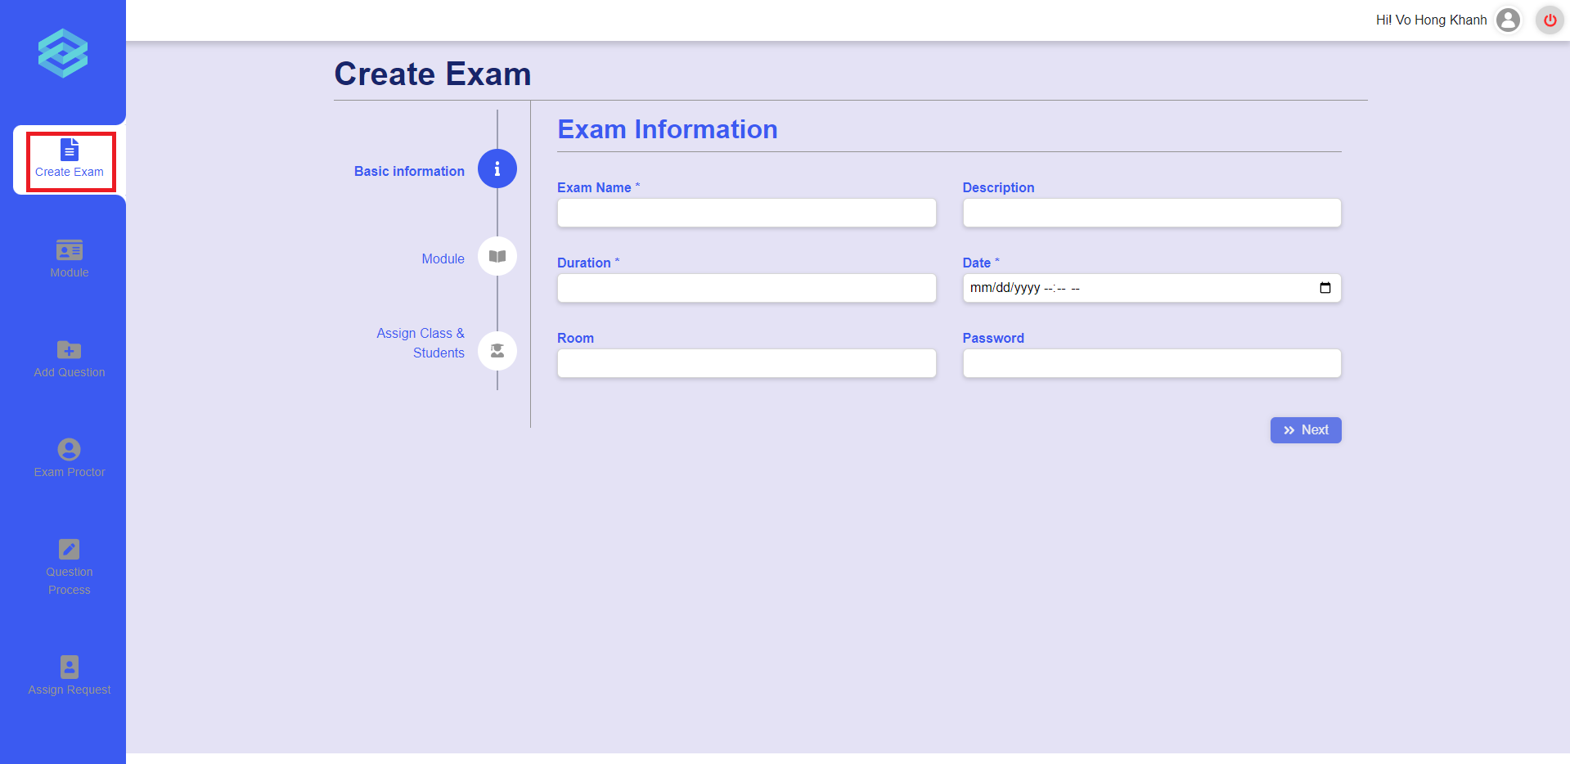
Figure 48. The create exam page
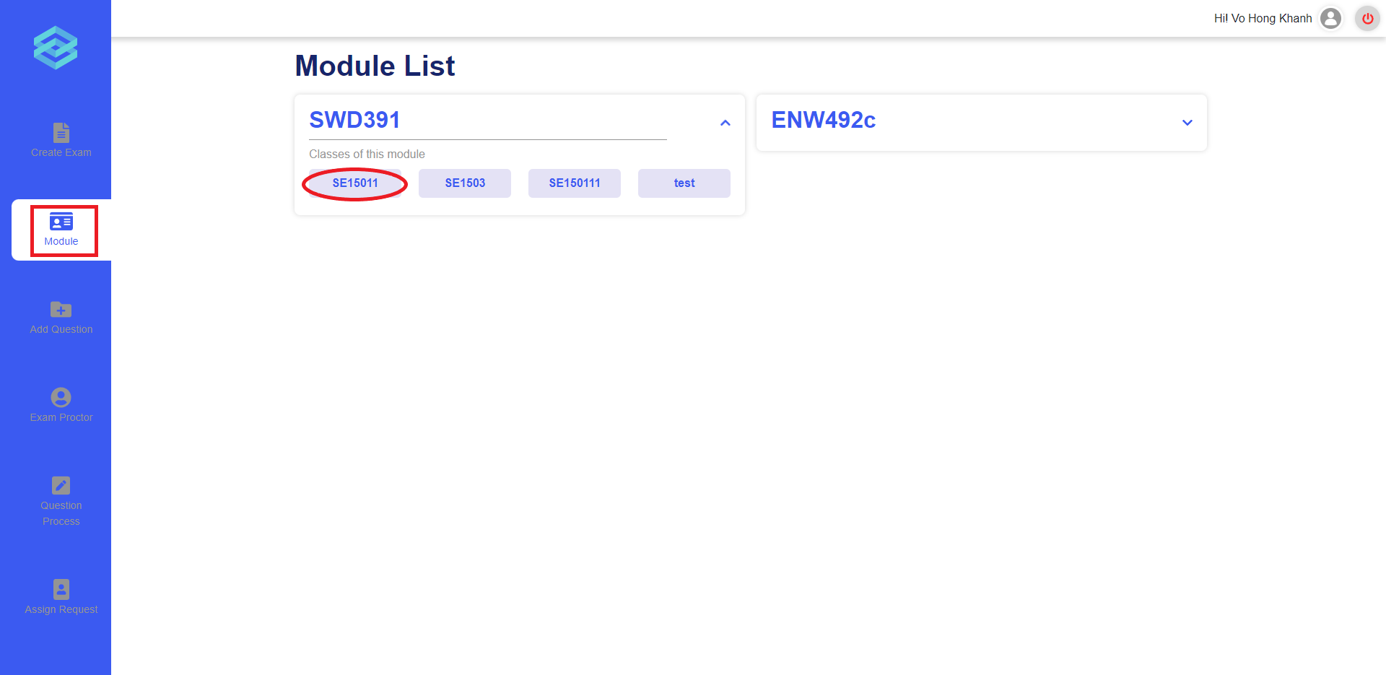
Figure 49. The module list page
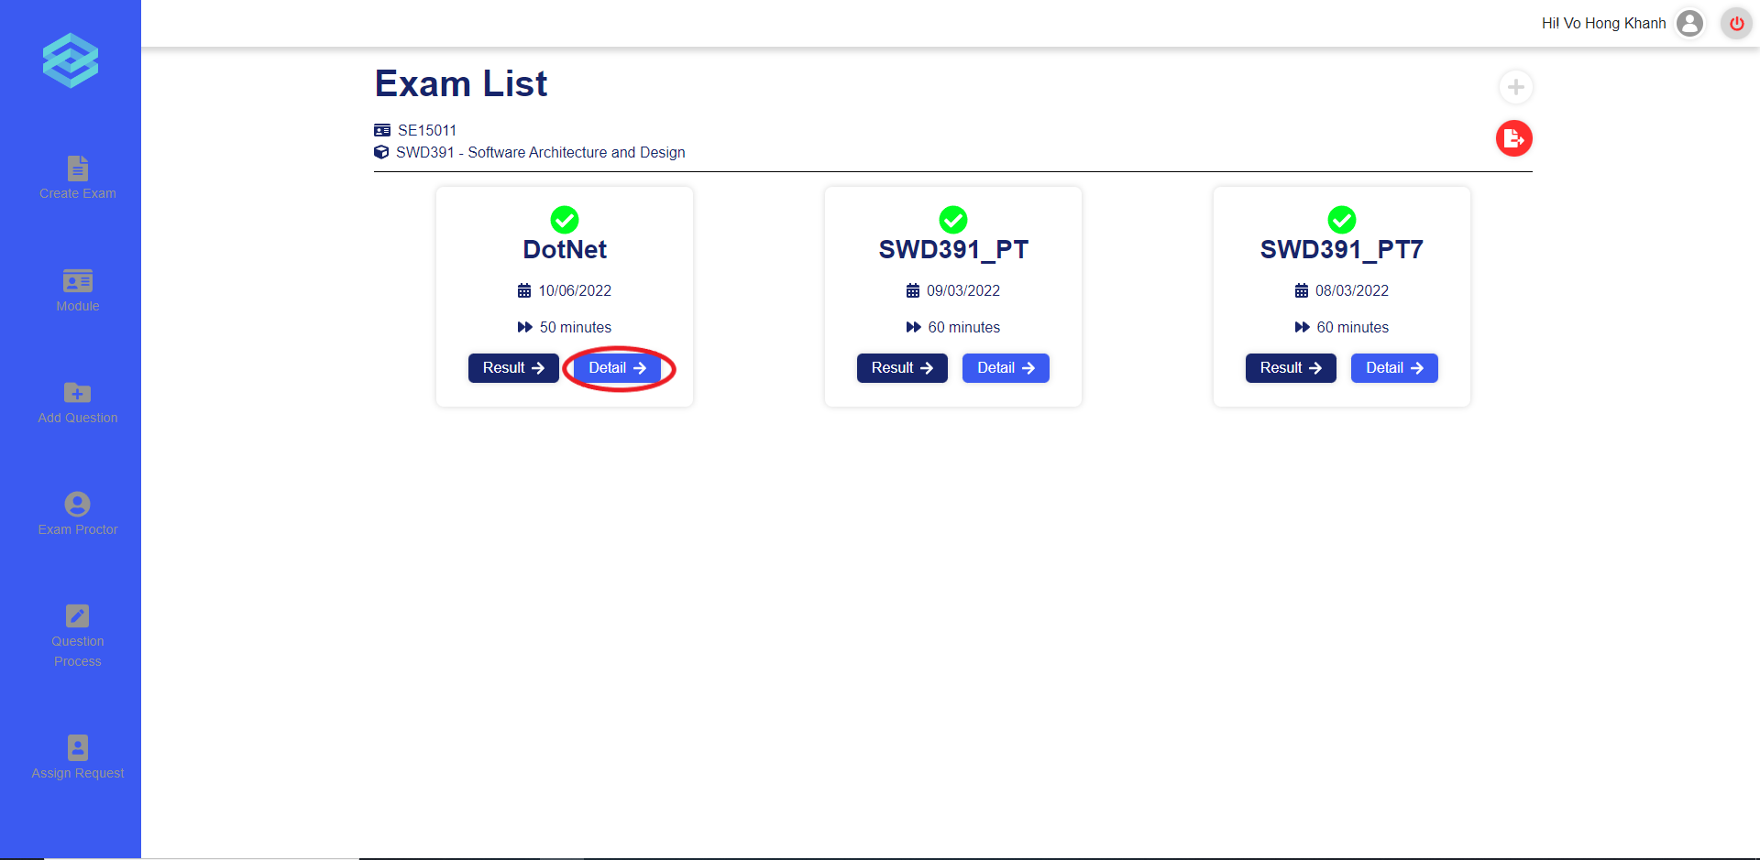
Figure 50. The exam list page
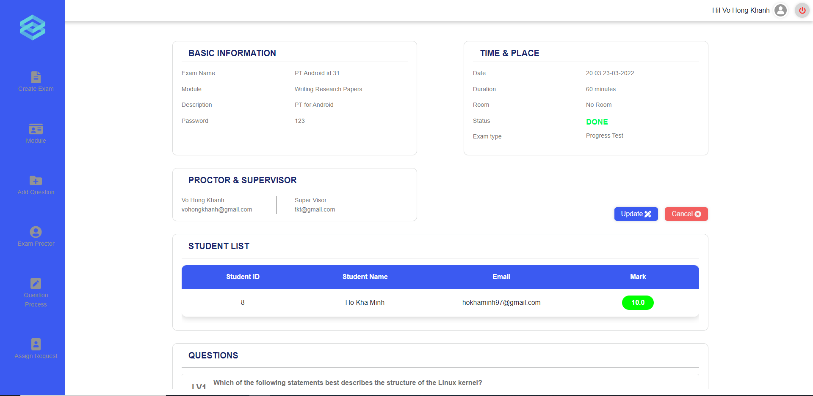
Figure 51. The exam details page

b. Grade written question
- Triggering a function: Login successfully, click on section “Module” (Figure 52), click on the right class associated with the module, then click on “Result” (Figure 53) on the right exam. In the result page, click on the “Grade” icon of each student mark row (Figure 55) to view their answers and give marks (Figure 56).
- Description of the function: a Teacher user is allowed to grade written answers of students in the exam.
- Details of the function:
  - Normal execution case: Successfully, a Teacher user submits the mark successfully.
  - Abnormal execution case: Not input or input wrong, display error message (Figure 57, 58).
- Layout of the screen:
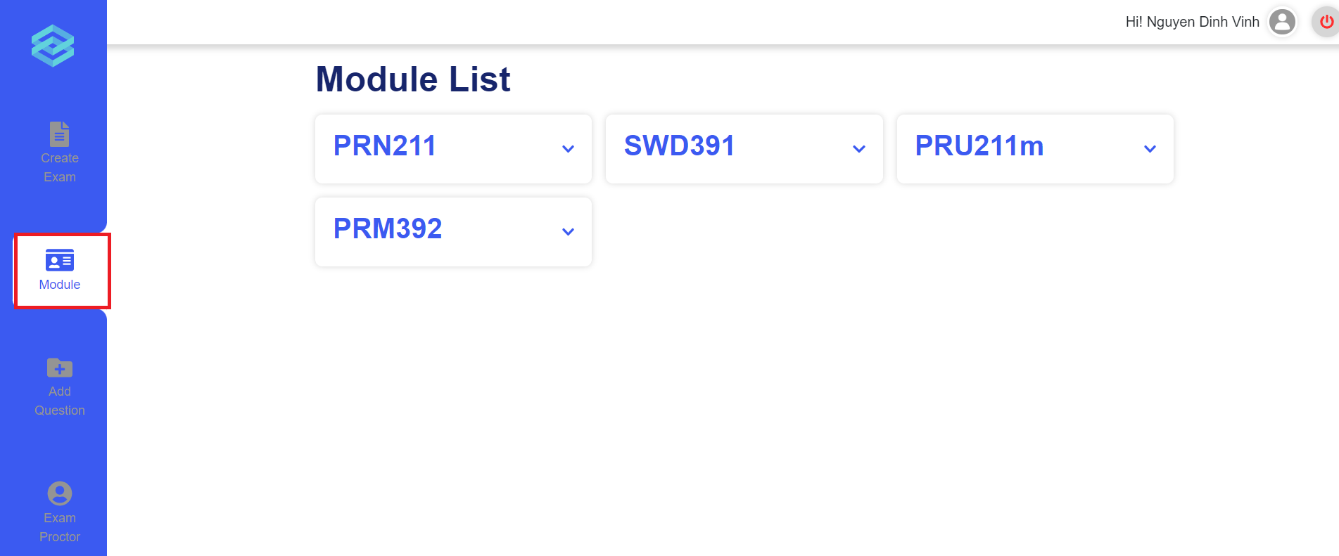
Figure 52. The module list page
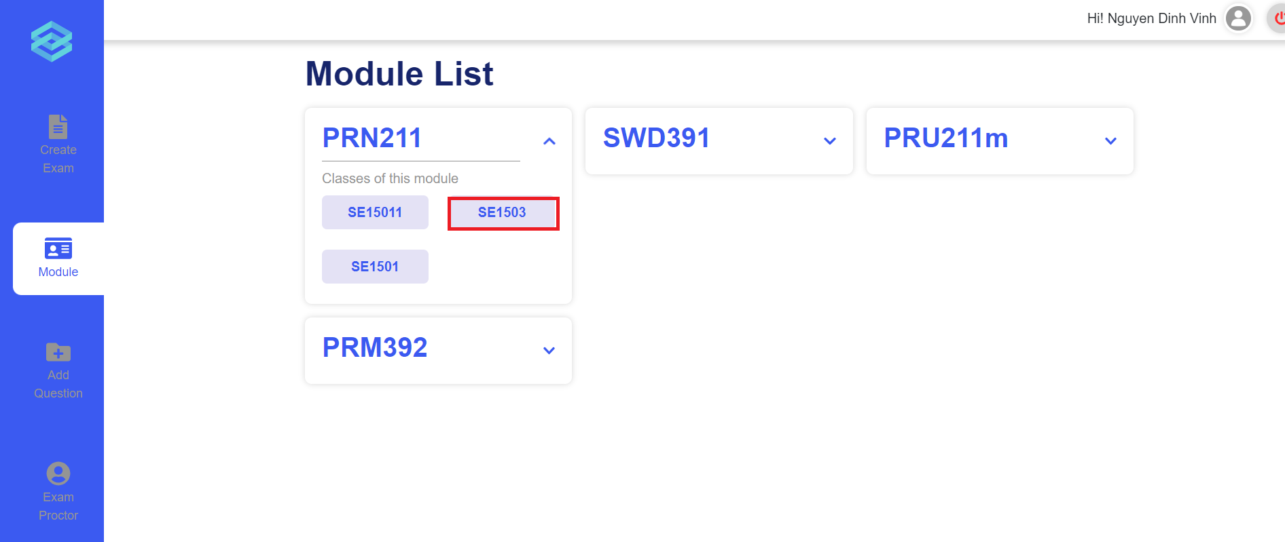
Figure 53. The class in module
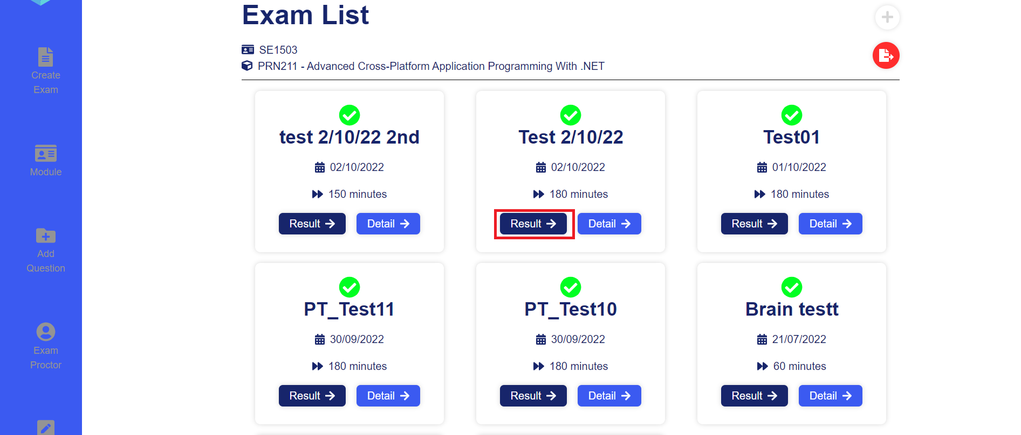
Figure 54. The Exam list page
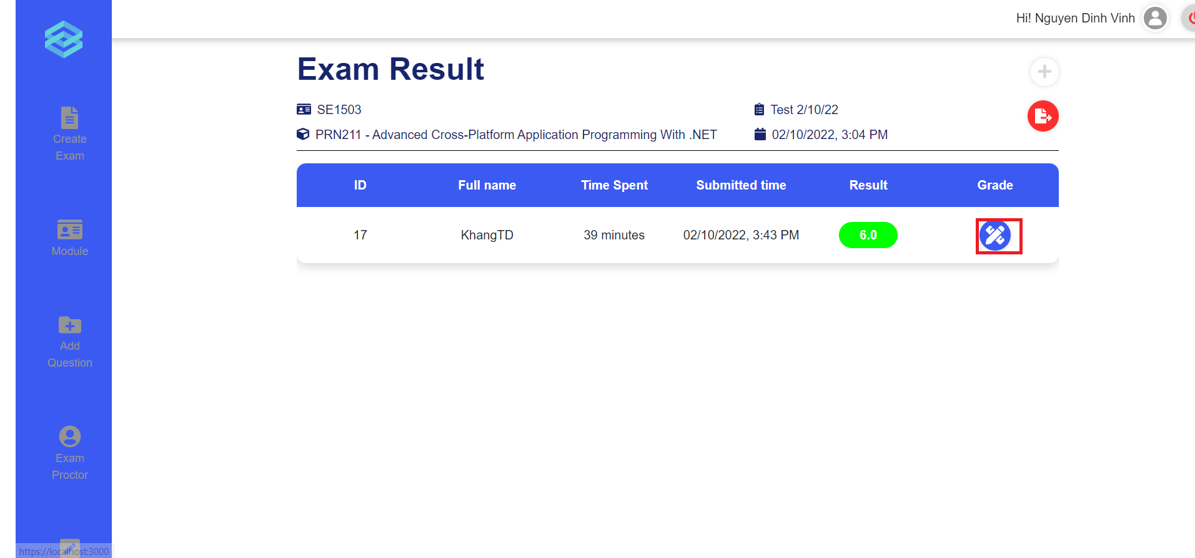
Figure 55. The exam result page
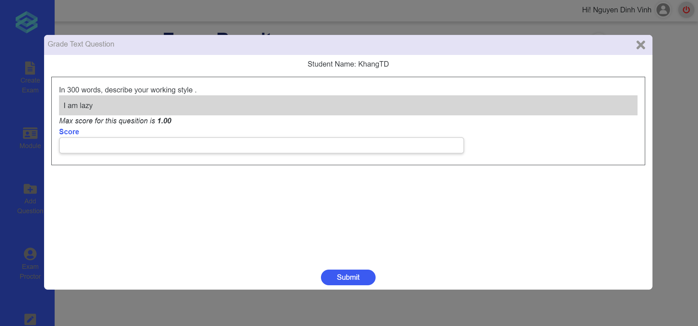
Figure 56. The Mark input modal
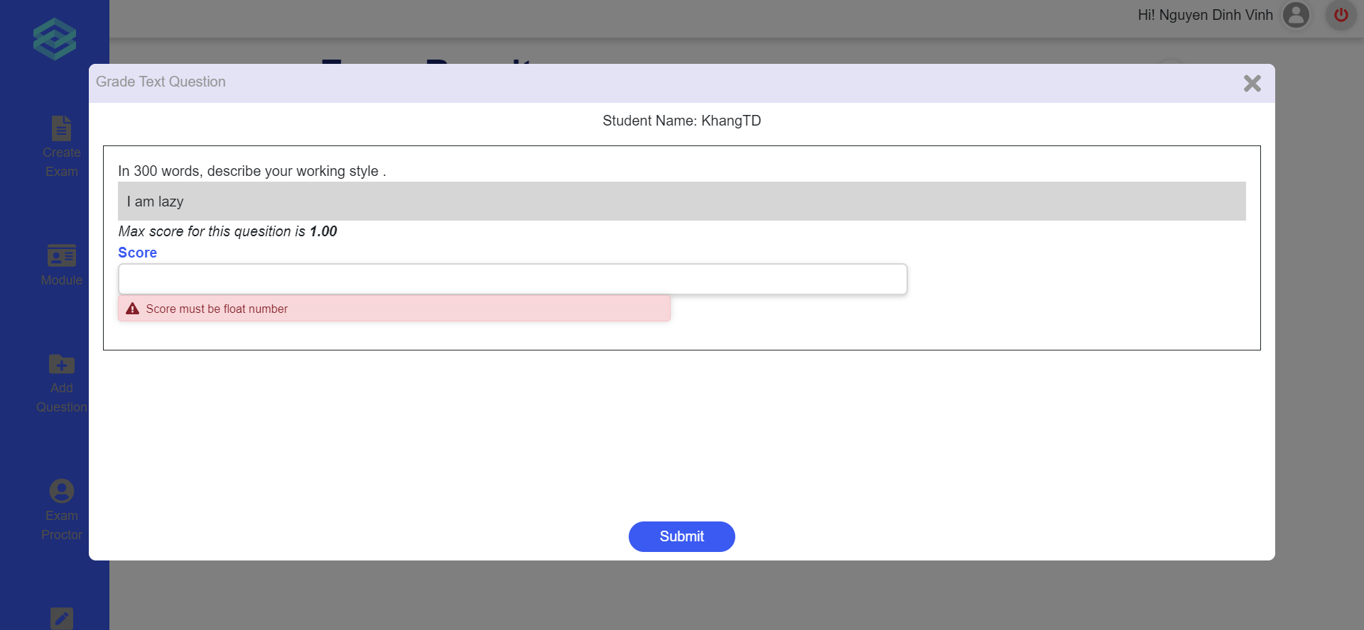
Figure 57. The mark input modal with error
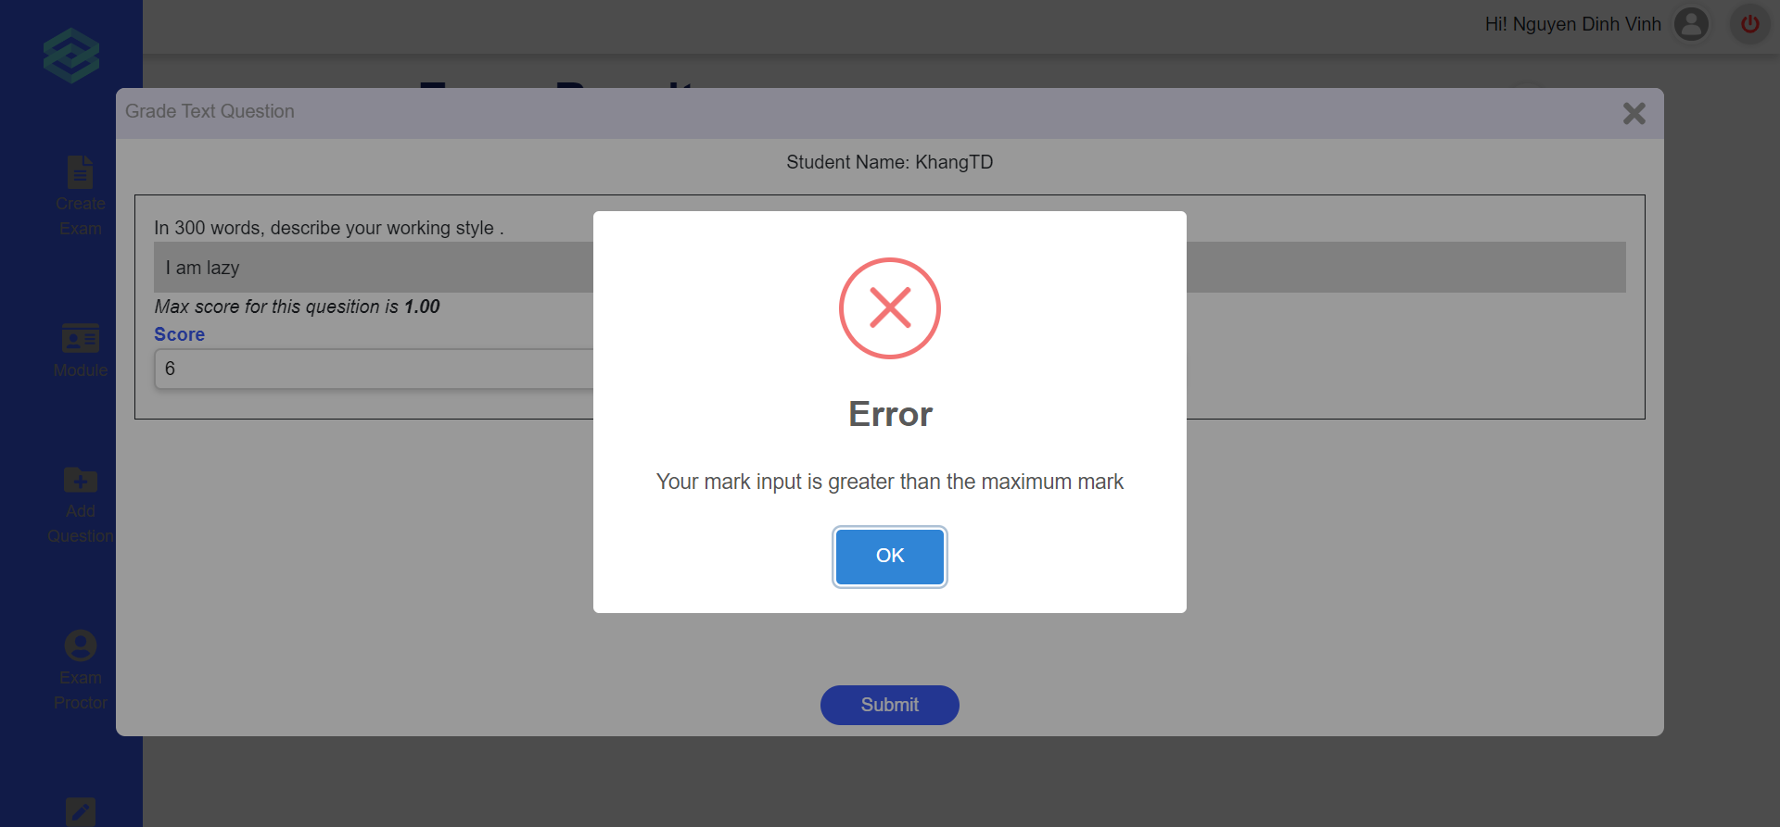
Figure 58. The error message
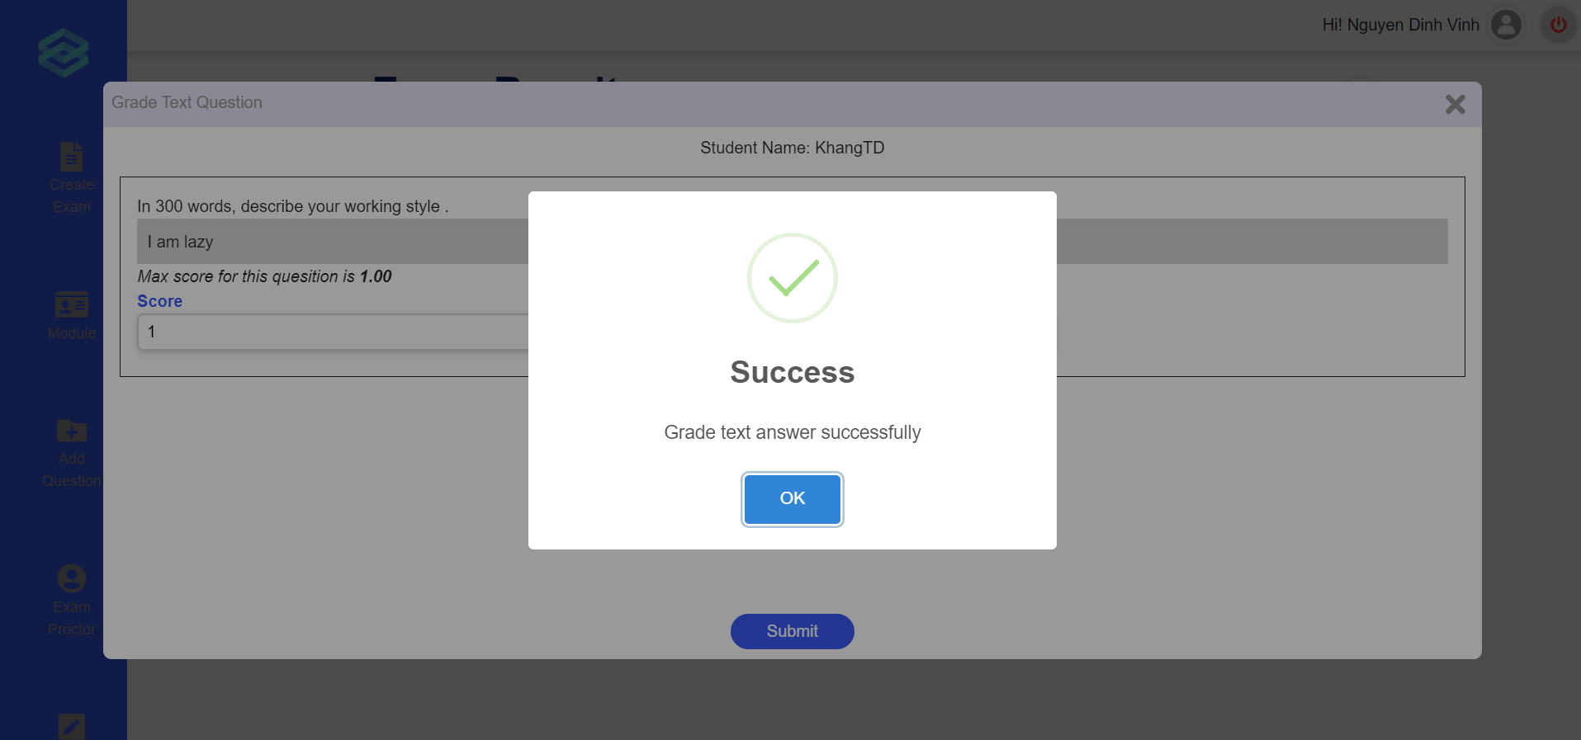
Figure 59. The success message

c. Approve/reject to add questions
- Triggering a function:
- Login successfully.
- Scroll down.
- Click on “Question Process” (Figure 60).
- Click on the arrow icon for a selected request (Figure 61).
- Tick the box on the lower right corner of each question to approve of it, leave unticked if it does not approve (Figure 62).
- Click submit to send the processed questions through.
- Description of the function: a Teacher user is allowed to approve or reject questions waiting to be added to the question bank.
- Details of the function:
  - Normal execution case: Successfully, a Teacher submits the question through.
  - Abnormal execution case: Loss of connection.
- Layout of the screen:
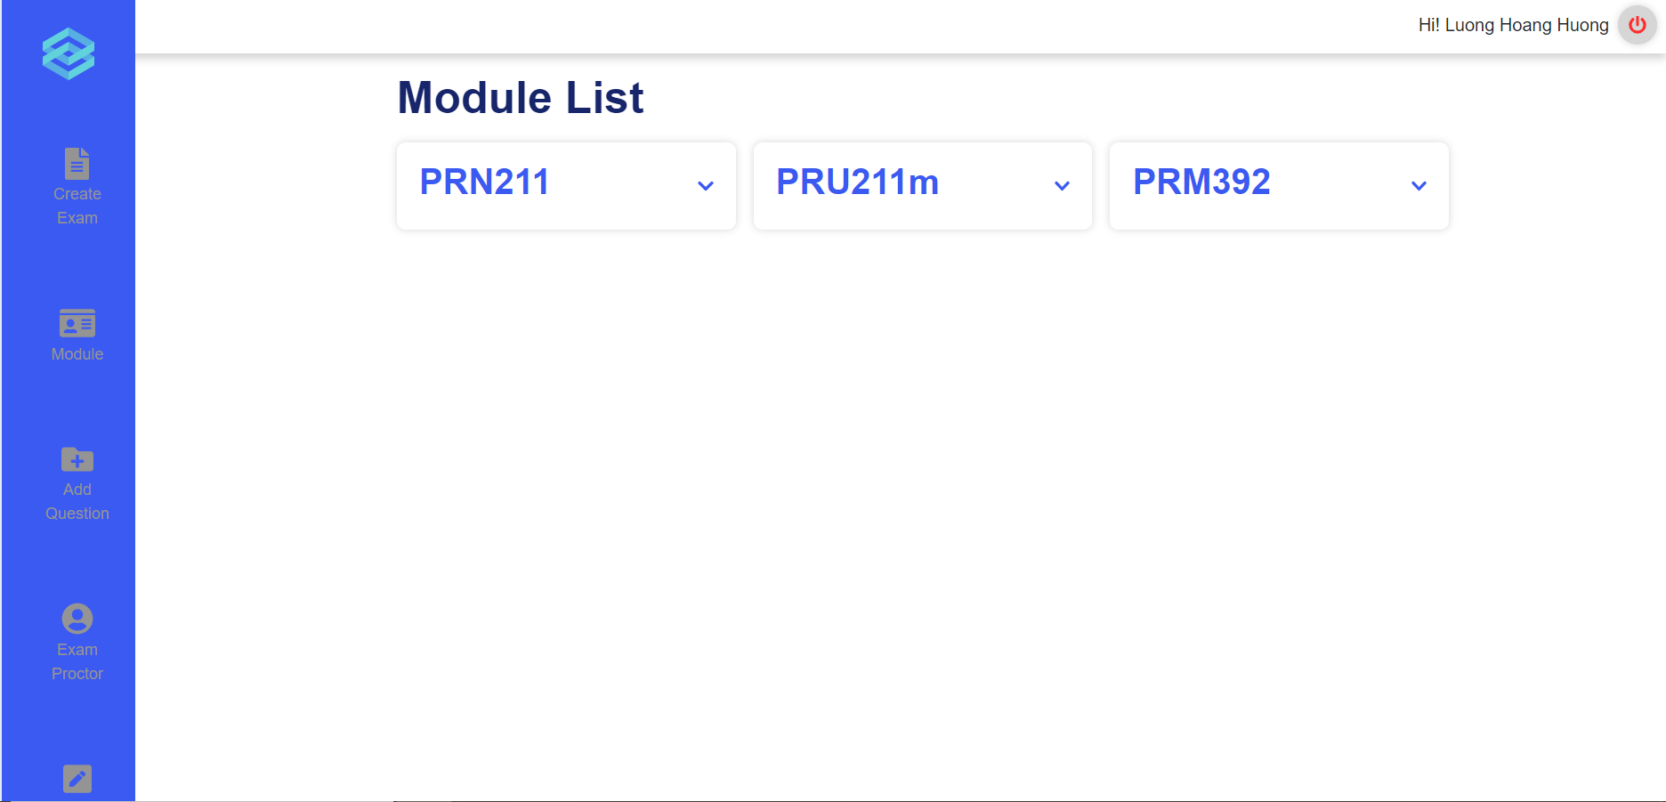
Figure 60. Module list
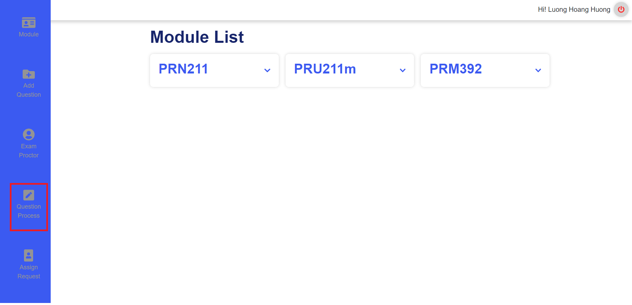
Figure 61. Scrolled down Module list
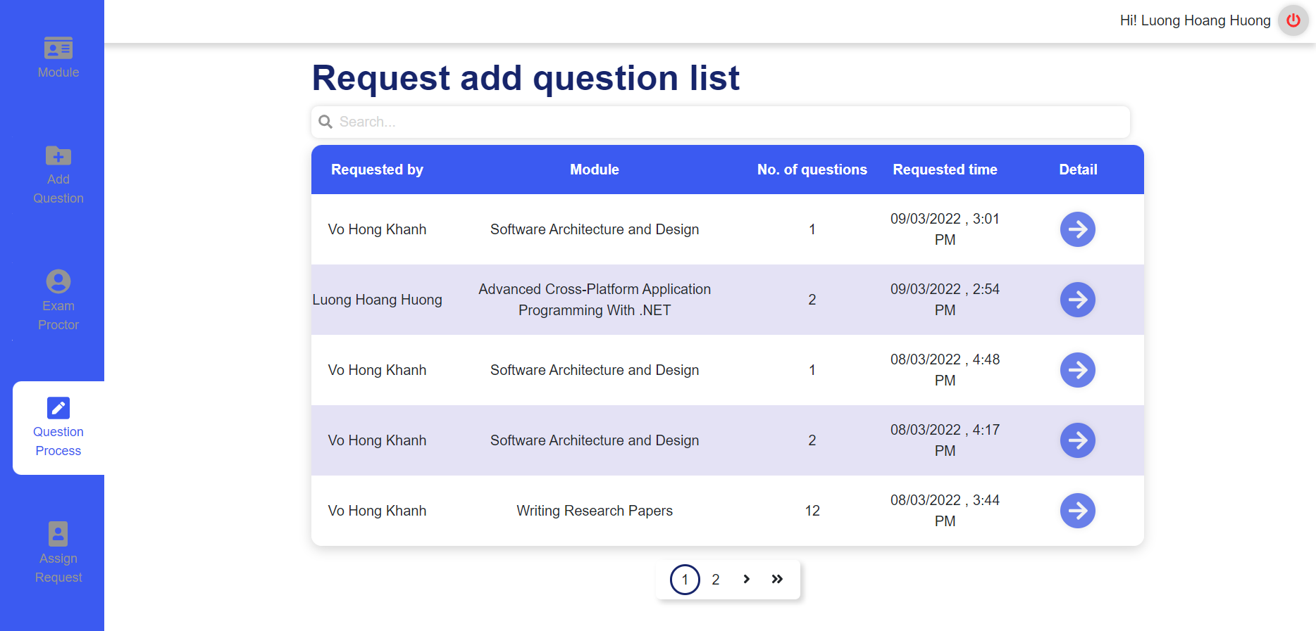
Figure 62. Request add question list
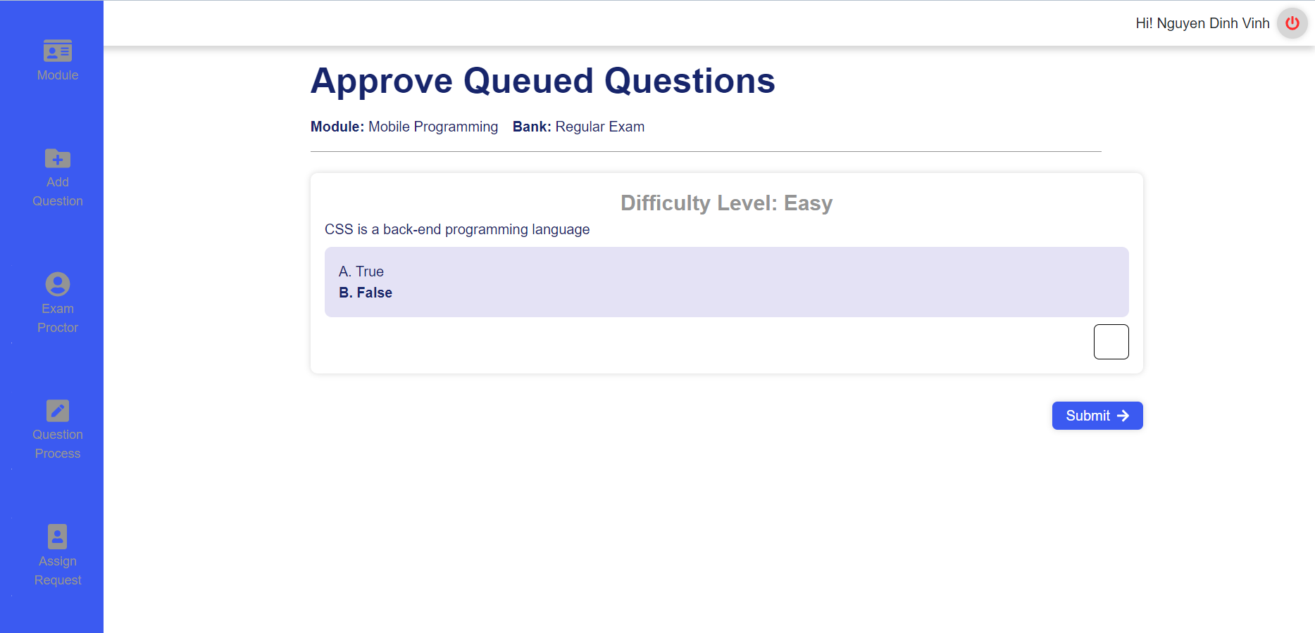
Figure 63. Approve Queued Questions

d. Request add new question to question bank
- Triggering a function:
- Login successfully.
- Click on section “Add Question” (Figure 64).
- Click on select options to choose module, bank,question type (Figure 65).
- Click on the “Add new question” button to add questions (Figure 65).
- Click on “Level” select options to choose difficulty level (Figure 66).
- Input questions and answers for multiple choice questions or text questions (Figure 67, 68).
- Click on “Add new answer” in case multiple choice questions (Figure 69).
- Click on the radio button to choose the right answer in case multiple choice questions; (Figure 69).
- Click “Choose file” to add images if necessary (Figure 70).
- Click the “Trash” icon to delete questions (both question types) or answers (in case multiple choice questions) if necessary (Figure 71).
- Click “Send request” to confirm and submit (Figure 72).
- Description of the function: a Teacher user is allowed to create new question request to add to the question bank
- Details of the function:
  - Normal execution case: Successfully, a Teacher user creates new question requests and send these questions to the question bank (Figure 73, 74)
- Layout of the screen:
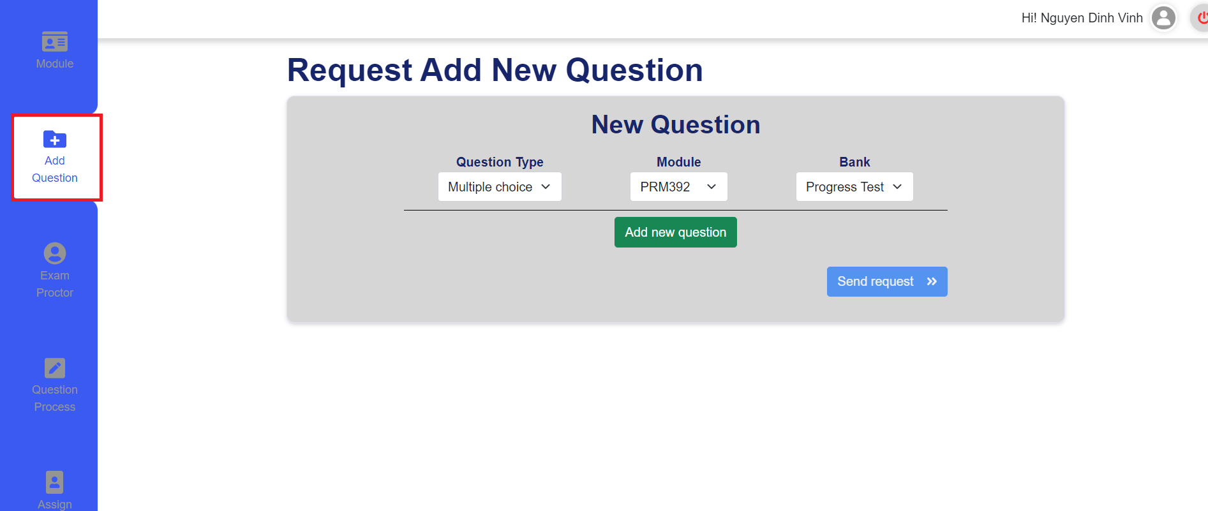
Figure 64. The add request question
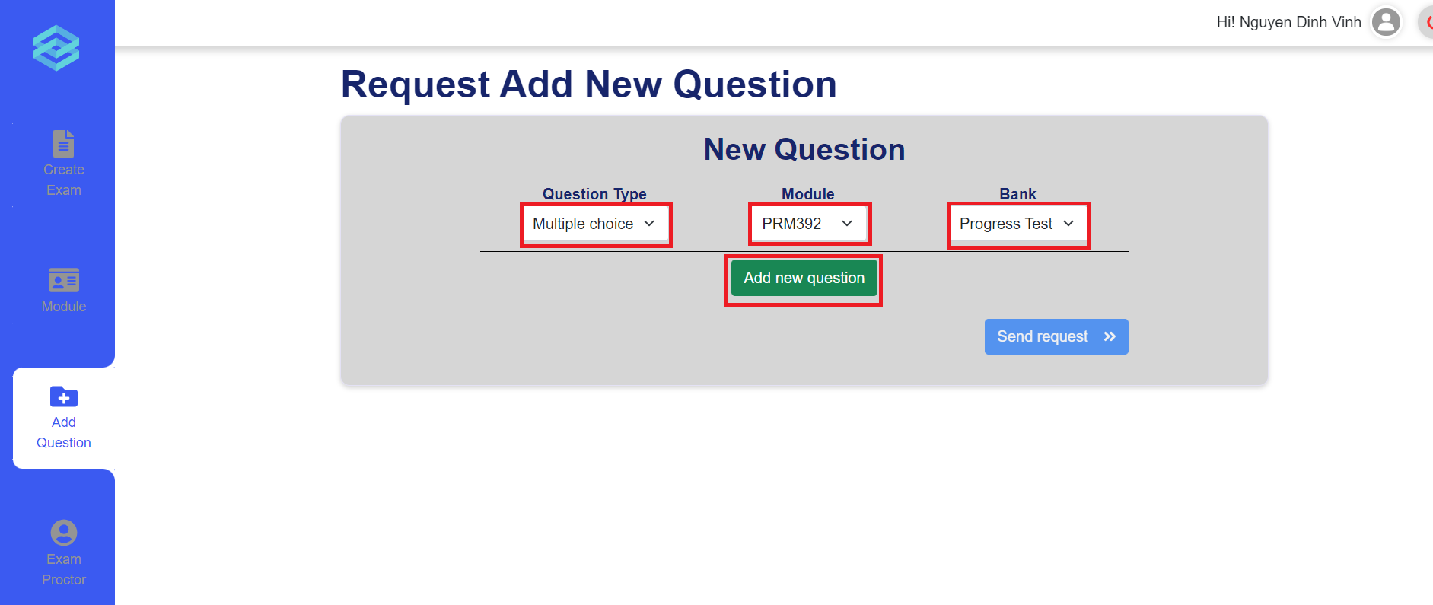
Figure 65. The add request question detail
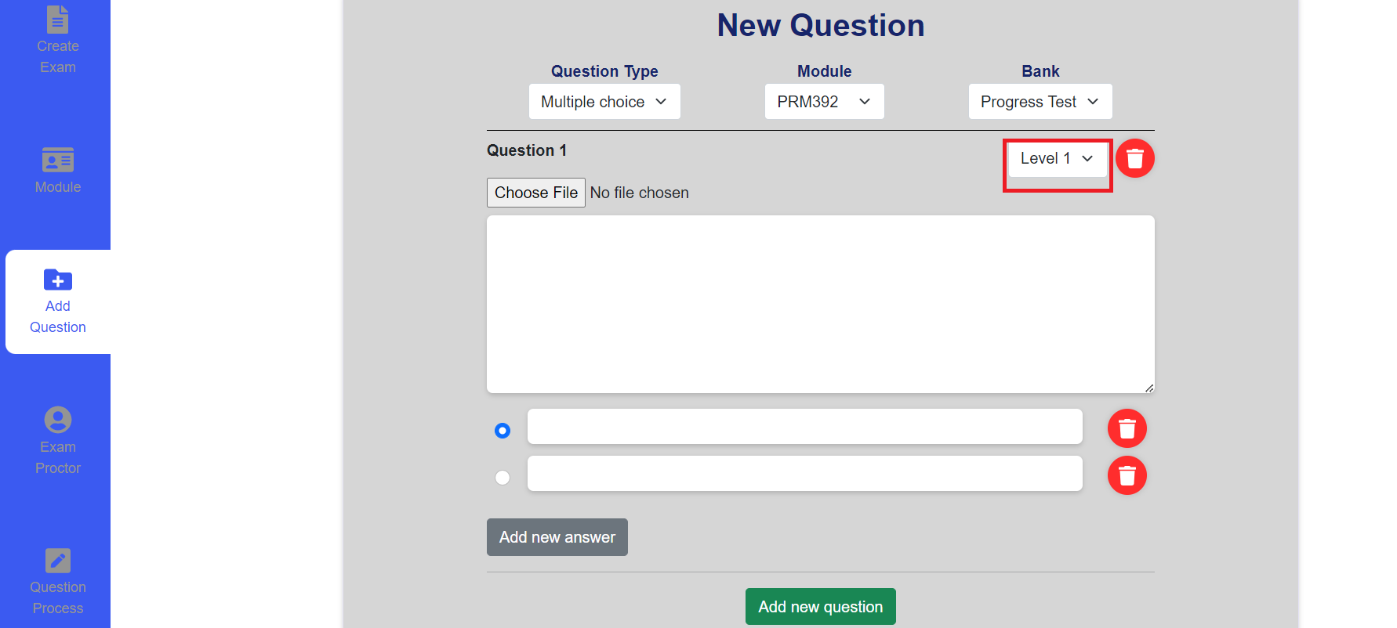
Figure 66. New multiple choices question blank for input
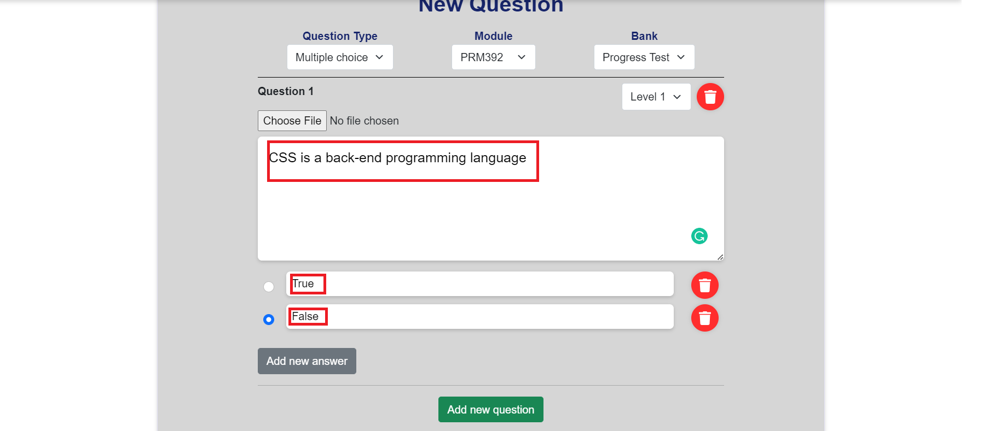
Figure 67. Input multiple choice question
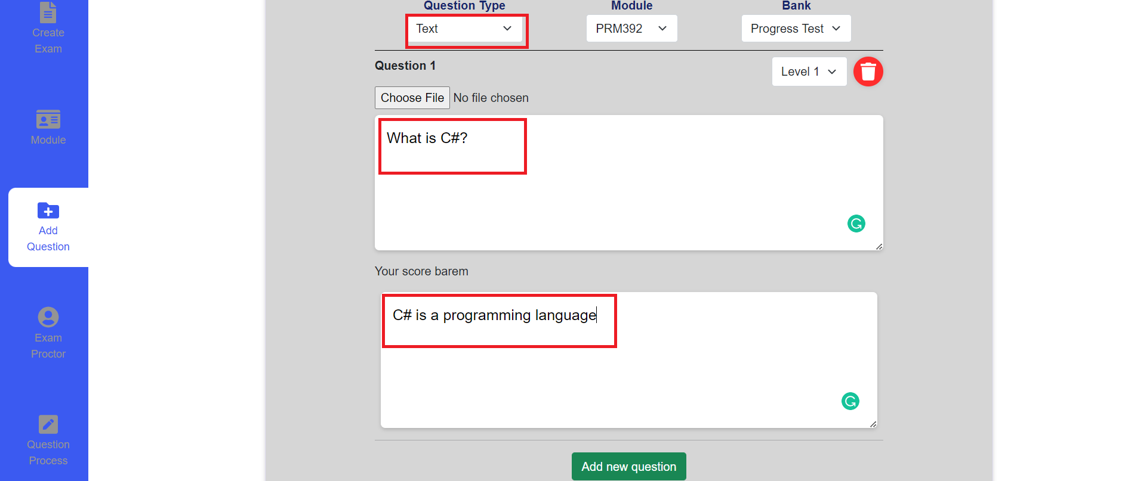
Figure 68. Input writing question
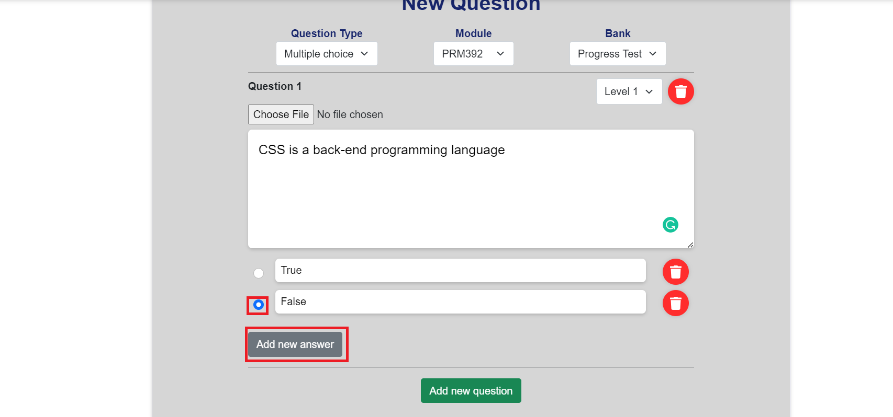
Figure 69. Add new answer
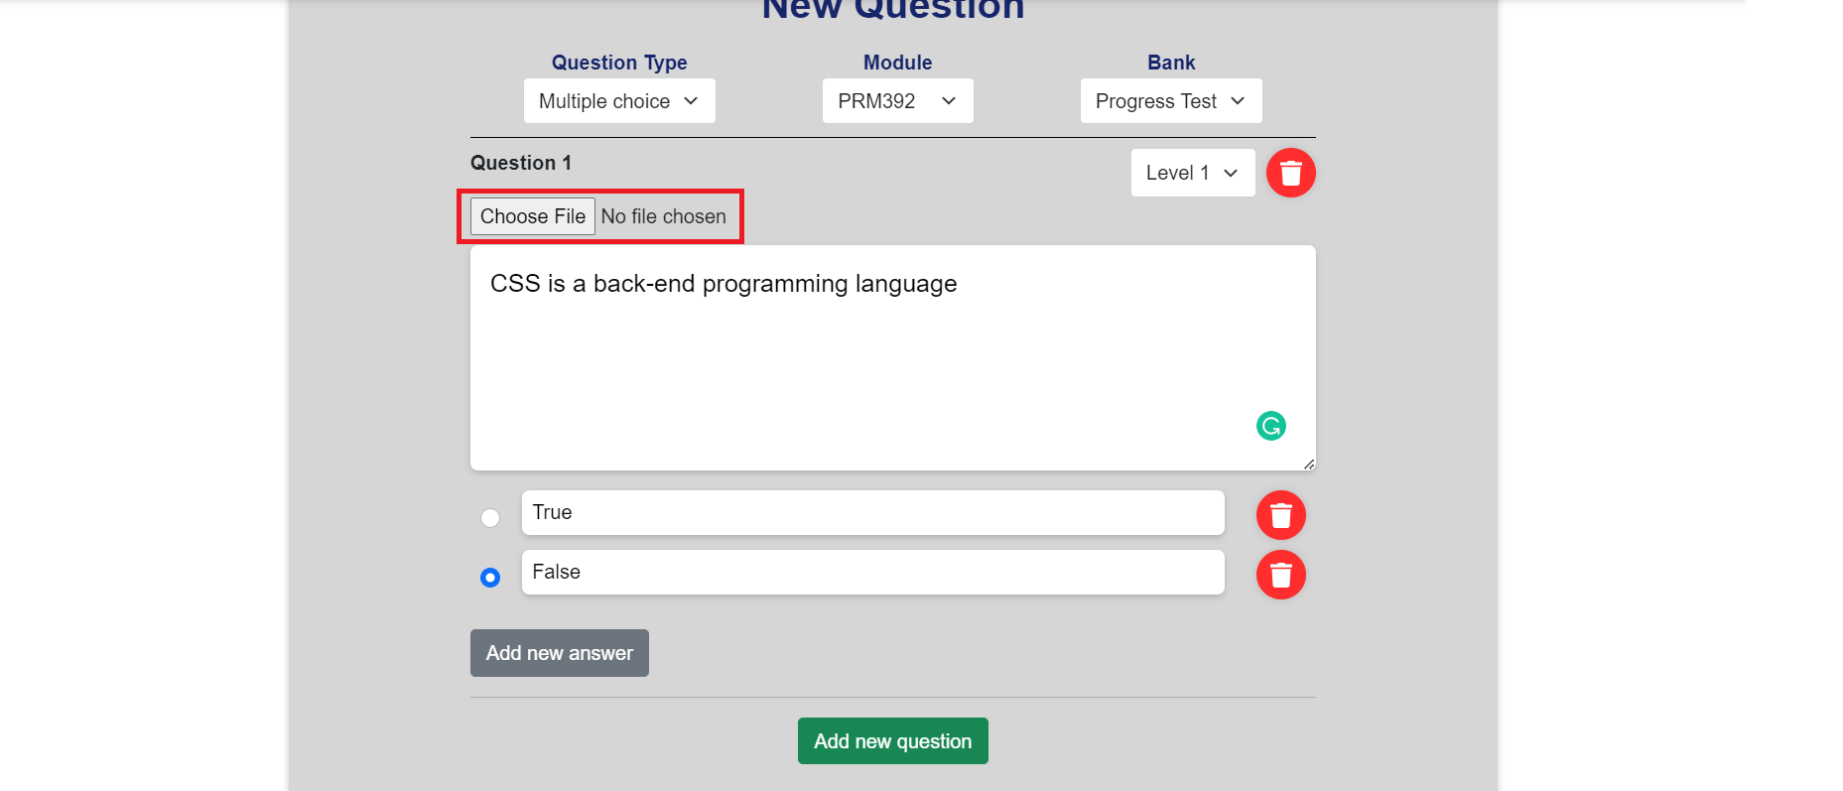
Figure 70. The Choose image button
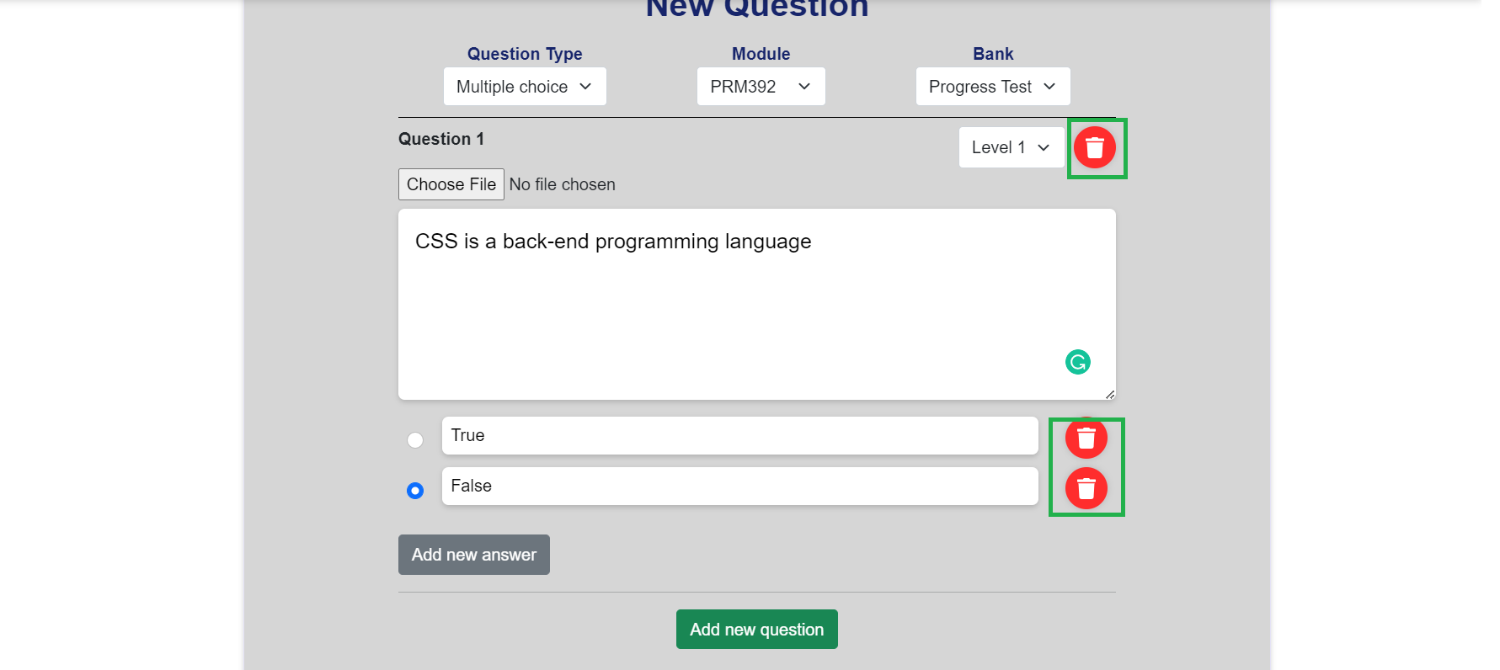
Figure 71. Delete question and answer buttons
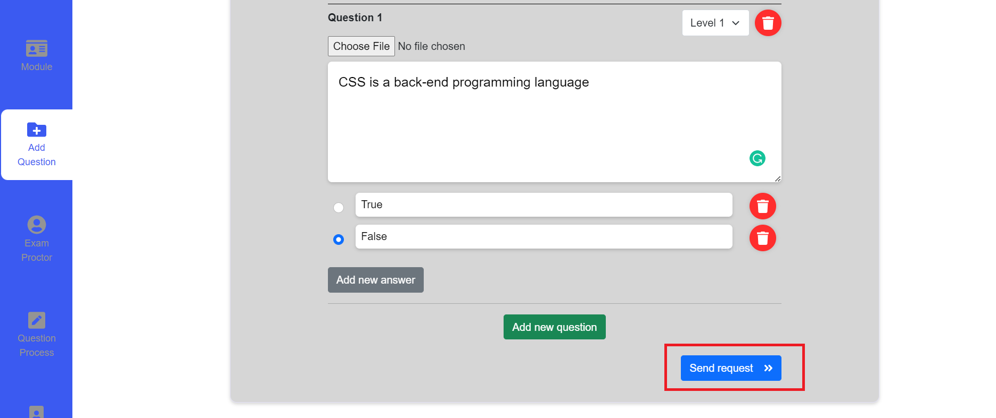
Figure 72. Send request button
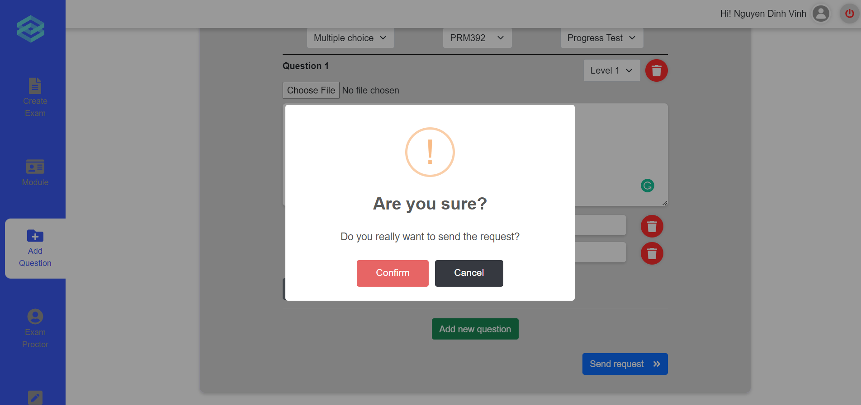
Figure 73. Confirmation message
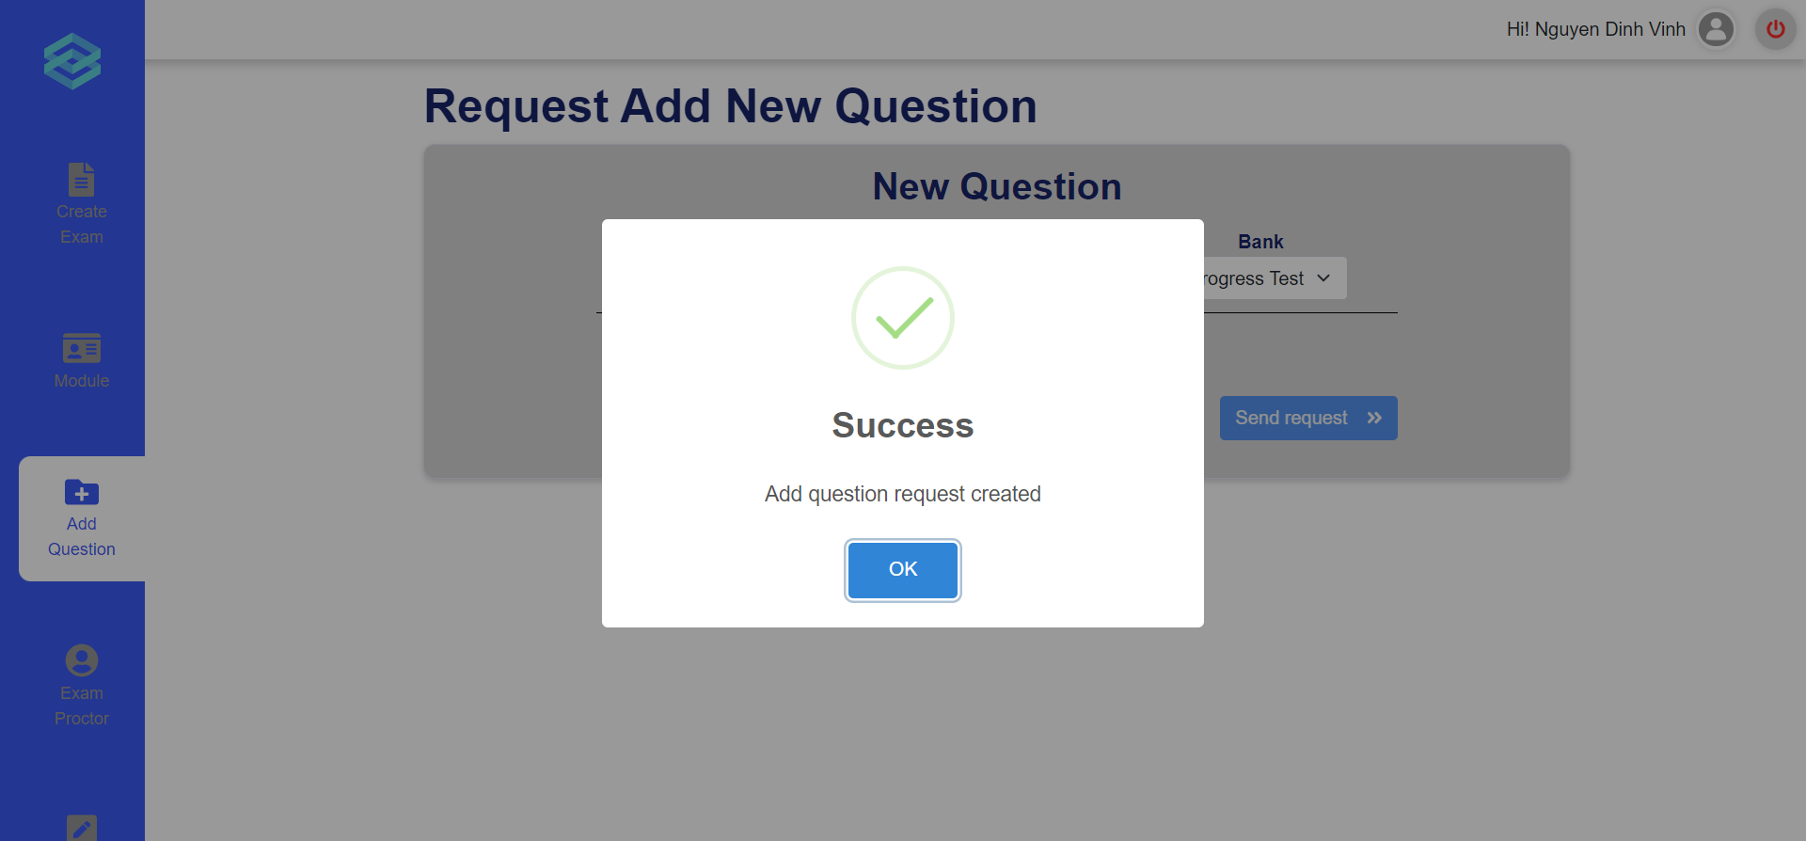
Figure 74. The success message

e. Invigilate
- Triggering a function: Login successfully with the teacher account. Click on the “Proctor list” icon on the vertical navigation bar to go to the Proctor Page (Figure 75). Click on the “Start” button on an active exam entry (Figure 76). After clicking on the start button, the proctor will be redirected to the invigilate room (Figure 77).
- Description of the function: Allow a teacher user to oversee the process of an exam by viewing the camera feed of each student.
- Details of the function:
  - Normal execution case: The teacher is able to access the invigilate page and is able to view the camera feed of all students currently taking the exam.
  - Abnormal execution case: Loss of connection.
- Layout of the screen:
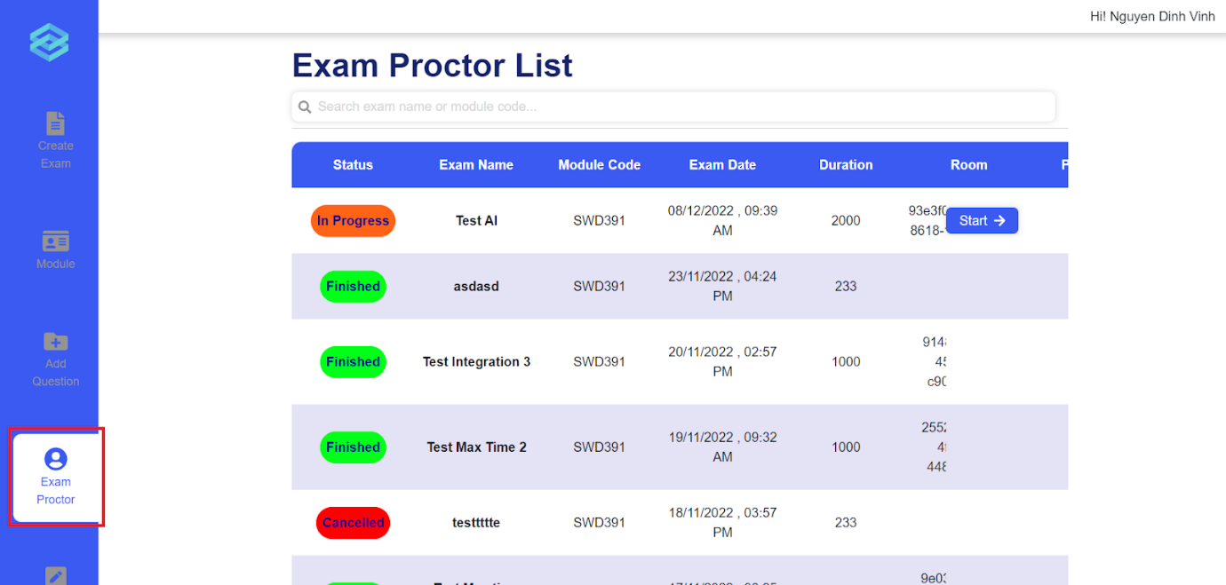
Figure 75. Exam Proctor List
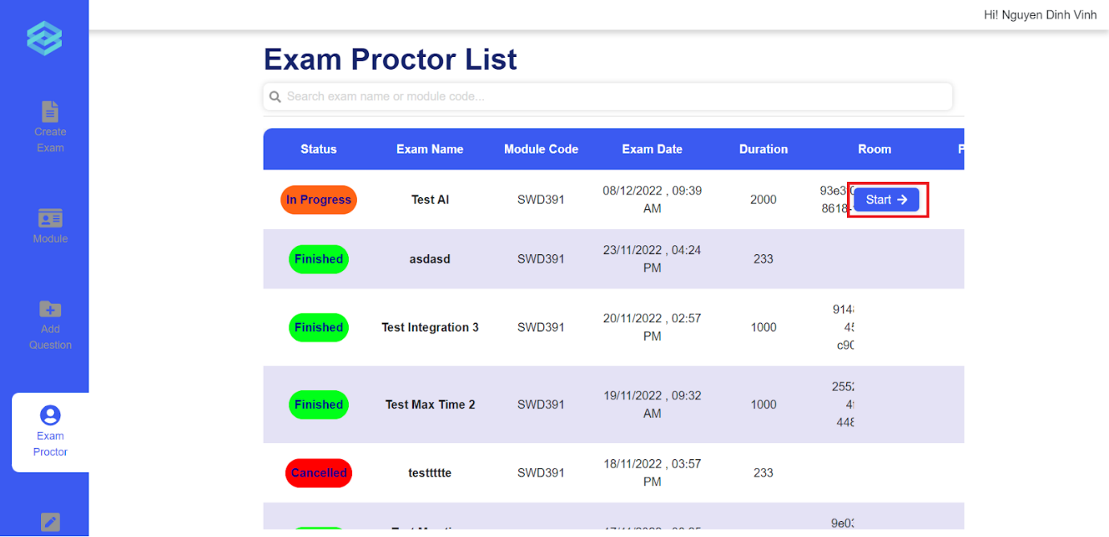
Figure 76. Clicking the Start button

Figure 77. The Invigilate room

3.6 Role Student

a. Take and submit Exam
- Triggering a function: Login successfully; On the Exam schedule page, click on “Start” button on the exam appearing on the page (Figure 78), input password (if necessary) (Figure 79); click on “Join room” button when the online exam room is ready (Figure 80).
- Description of the function: a Student user is allowed to view, do and submit the exam.
- Details of the function:
  - Normal execution case: Successfully, a Student user accesses the Exam page and views all the exam questions (Figure 81). Moreover, after done, student answers are submitted successfully and displayed the multiple choice mark the pop up modal (Figure 82).
  - Abnormal execution case: If there are questions not answered yet, display warning modal (Figure 83).
- Layout of the screen:

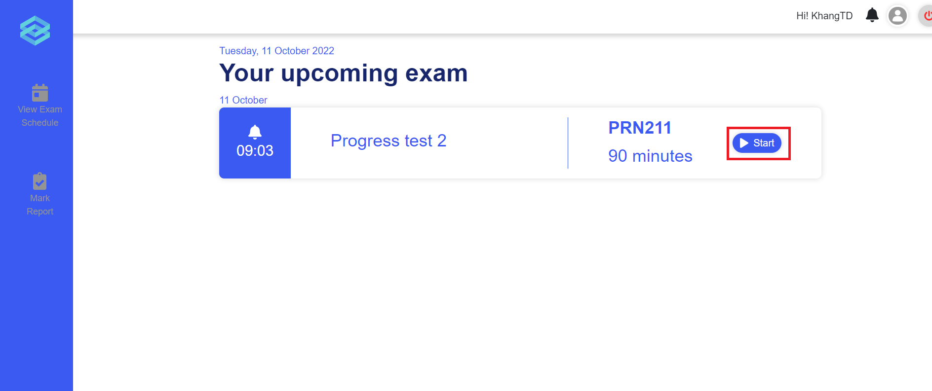
Figure 78. The exam schedule page
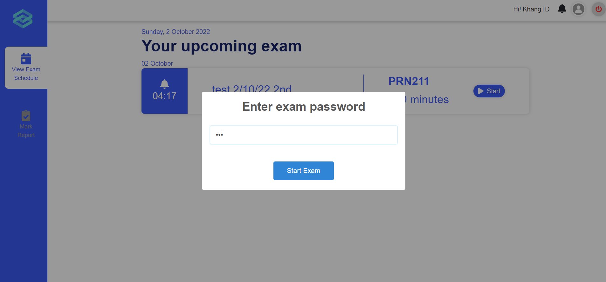
Figure 79. The password input

Figure 80. The student waiting room
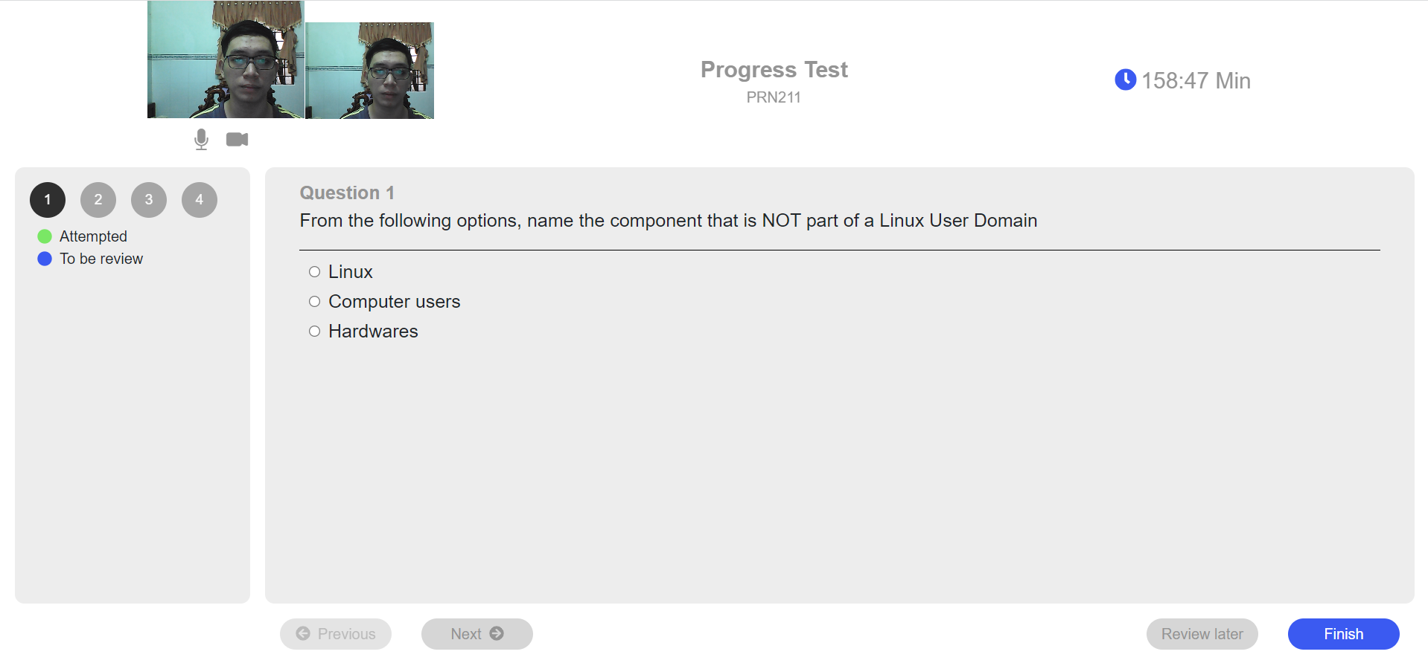
Figure 81. The exam page
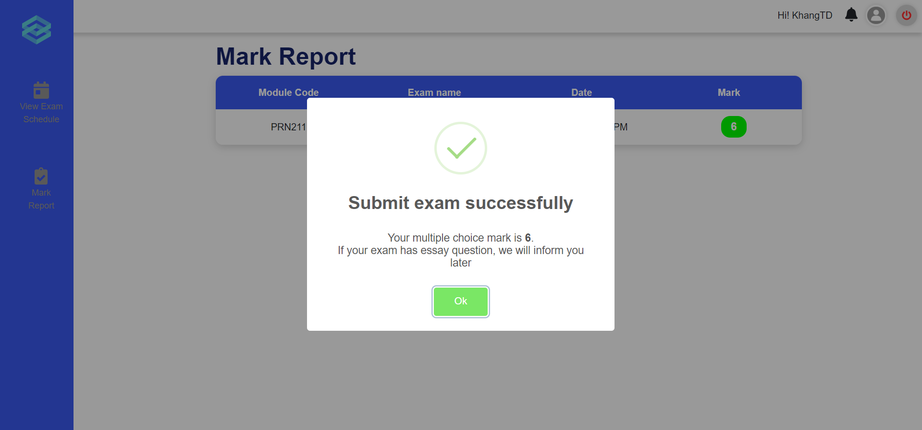
Figure 82. The mark notification pop up for multiple choice questions
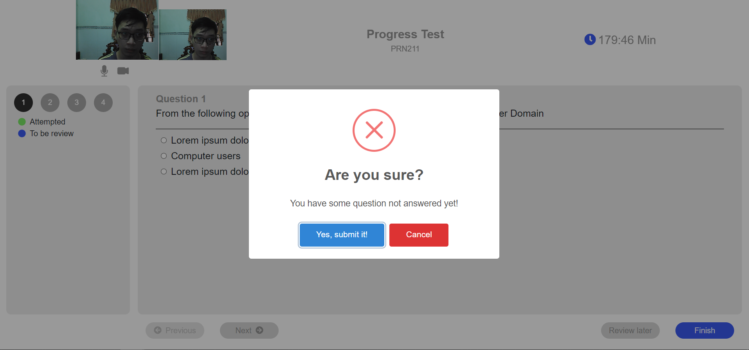
Figure 83. The warning message modal

b. Mark report
- Triggering a function: Login as a Student successfully, click on the section “Mark Report” on the left vertical navigation bar.
- Description of the function: A student user is allowed to view their taken exam list and their test result.
- Details of the function:
  - Normal execution case: Successfully, a student user has access to the taken exam list page (Figure 84) and on each module, has access to view the mark list.
- Layout of the screen:
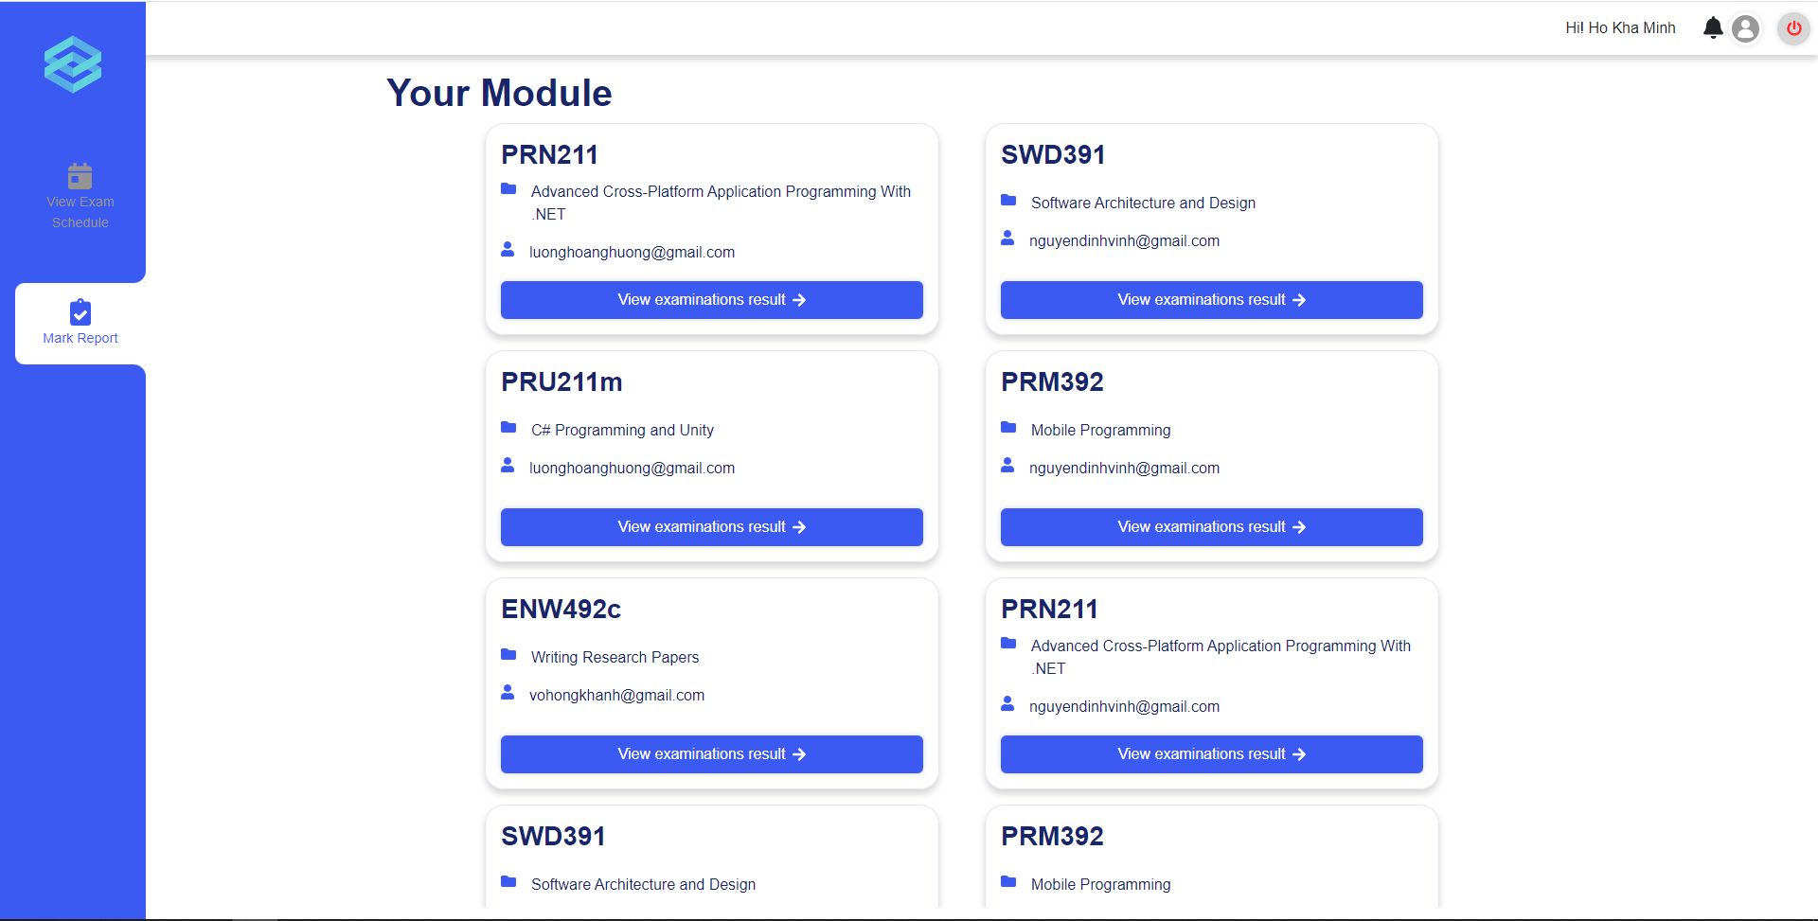
Figure 84. Taken exam list
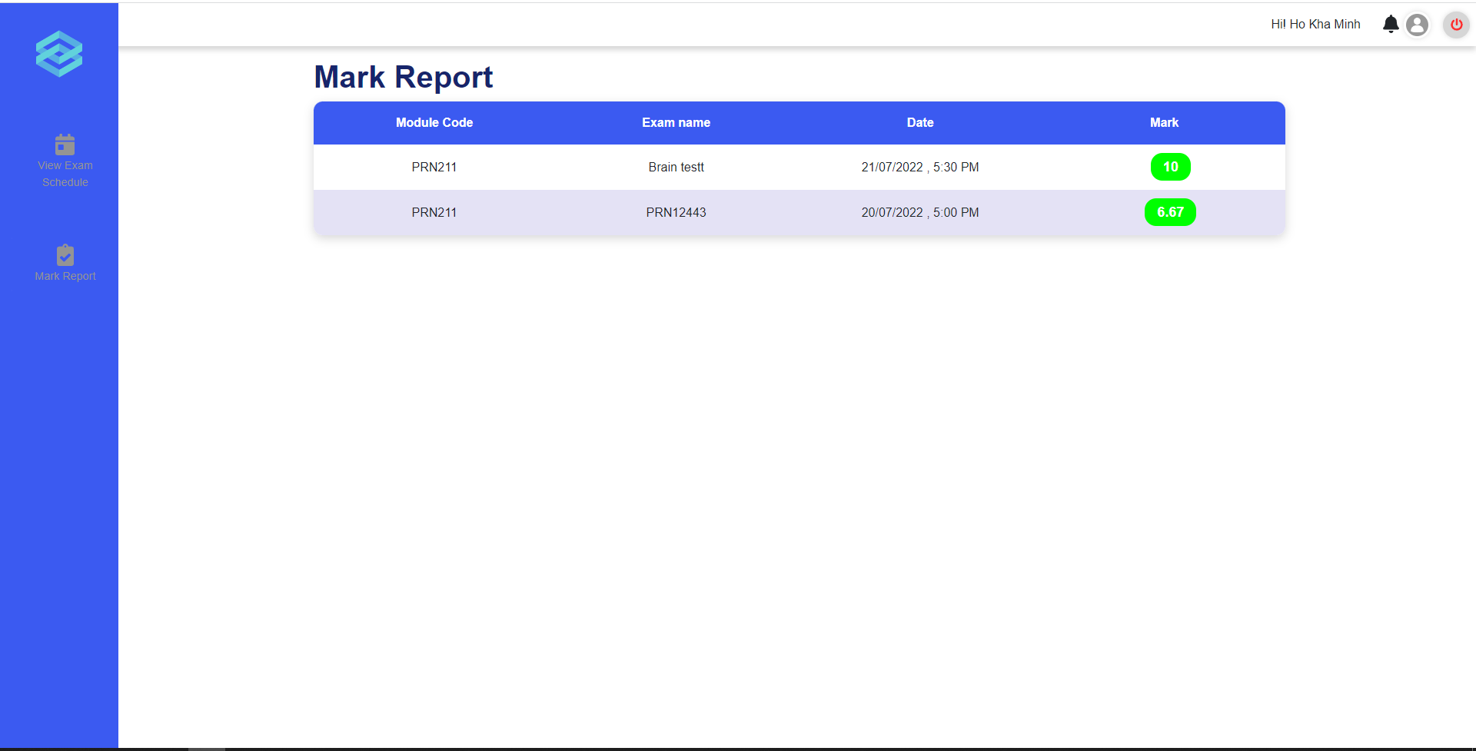
Figure 85. Mark report

4. Non-Functional Requirements

4.1 External Interfaces

a. User Interfaces
UI-1: The left vertical navigation bar always shows to navigate to another page quickly (exam taking function is exceptional).
UI-2: Users can click on the website's logo on the left vertical navigation bar to return to the website's homepage.
UI-3: Users can click the logout icon on the top horizontal navigation bar to log out (exam taking function is exceptional).

b. Software Interfaces
SI-1: The system is a web-based application.
SI-2: The system web pages must run smoothly on common web browsers (Chrome, Edge).
SI-3: Each page must load less than 5 seconds.

c. Hardware Interfaces
The system has no hardware interface.

d. Communications Interfaces
CI-1: The system will send the user's password (before encrypting) to the user's email when creating an account or when the user reset the password.
CI-2: The system will send a notification to the student when they have test results.
CI-3: The system's front-end and system's back-end is connected through HTTP Response and HTTP Request.

4.2 Quality Attributes

a. Usability
USE-1: The user interface must be easy to use by students, teachers, administrator and academic department.
USE-2: The administrator, academic department and teacher can use the system after 1 week of training.

b. Reliability
RE-1: The Mean Time Between Failures (MTBF) of the ExamEdu should be less than 24
hours.
RE-2: The Mean Time To Repair (MTTP) of the ExamEdu should be less than 3 hours.
RE-3: The availability of the ExamEdu should be more than 99%.

c. Performance
PER-1: The ExamEdu should support at least 1.000 users.
PER-2: The ExamEdu should support a maximum of 300 concurrent users.
PER-3: The ExamEdu should support at least 100.000 operations.
PER-4: The maximum response time when getting data should be 5 seconds.
PER-5: The ExamEdu should return the predicting cheating results within at most 3.0 seconds.

d. Dependability

Security
DE-1: All of the passwords stored in the database must be encrypted.
DE-2: Only administrators can view, create, update and delete accounts in database.
DE-3: Only Academic Department can create class and assign students to classes.
DE-4: The final exams must be created by Academic Department.

e. Supportability
SUP-1: The system will be improved and updated if there are problems reported through surveys.

f. Design Constraints
DC-1: The ExamEdu supports the English language.
DC-2: The ExamEdu is developed by .Net, ReactJS, TensorFlow (Python).

g. Support Documents
SD-1: ExamEdu must have a user manual to guide users, including students, academic departments, teachers and administrators.

5. Other Requirements

5.1 Appendix1 - Messages List
# | Message code | Message Type | Context | Content
1 | MSG01 | In line, under the text box | The input field is in the wrong format | The * field is in the wrong format
2 | MSG02 | In red, under the text box | Input-required fields are empty | The * field is required.
3 | MSG03 | Toast message | Username or password is incorrect when login | Login failed!  Wrong credentials
4 | MSG04 | Toast message | Create account successfully | Account created
5 | MSG05 | Toast message | Create account fail | The * is existed

IV. Software Design Description

1. Overall Description

1.1 Assumptions
This system is designed basing on these following assumptions:
- Windows 10 or higher
- Microsoft Edge 100, Chrome 100, Coc coc 106
- PostgreSQL
- C# 9.0
- DBeaver 22.2.2
- .NET Core 5.0 Framework
- React 18.2.0
- Python 3.10.70
- Bootstrap 5.0
In our system, users are divided into 5 roles:
- Administrator: are allowed to manage user accounts of the system.
- Academic Department: are responsible for managing class, module, exam,...
- Students: are allowed to take exams, view their mark report.
- Teacher: are responsible for managing their class, creating exams,...
- Head of Department: just like role teacher but also are responsible for assigning teachers to execute the add question to the question bank.

1.2 Design Constraints
This system should be complied with following items:
- Work well on Microsoft Edge browser.
- UX/UI fit for desktop and mobile devices.
- The system can be scaled up if needed.
- Most features of the system will take a maximum of 5 seconds to load.
- Obey network information security laws.

2. System Architecture Design

2.1 Overall Architecture
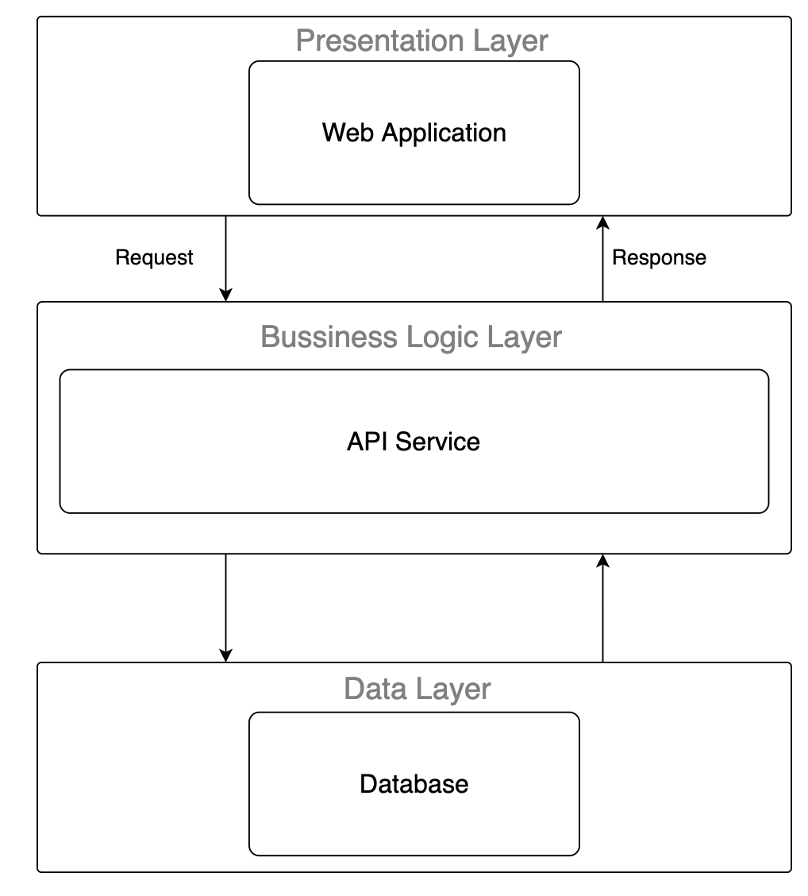
Figure 86. Overall Architecture
The first layer is the presentation layer which can show the user interface, receiving input from the user and performing local validation. Based on the user's action, the Presentation layer will send appropriate HTTP Requests to the Business Logic Layer and display data (or error message) which is HTTP Response sent by the Business Logic Layer.
The second layer is the business logic layer. This layer is responsible for handling the incoming request from the presentation layer, process data which is sent by the Data Layer.
The last layer is the Data Layer which stores all data of the system. This layer only communicates with the Business Logic Layer, perform appropriate action which Business Logic Layer need and have no direct interaction with the Presentation Layer.

2.2 System Architecture
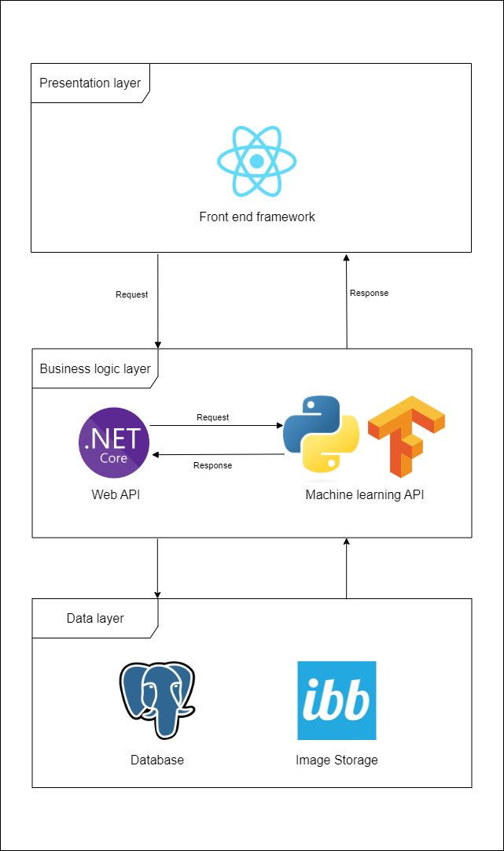
Figure 87. System architecture

2.3 Package Diagram
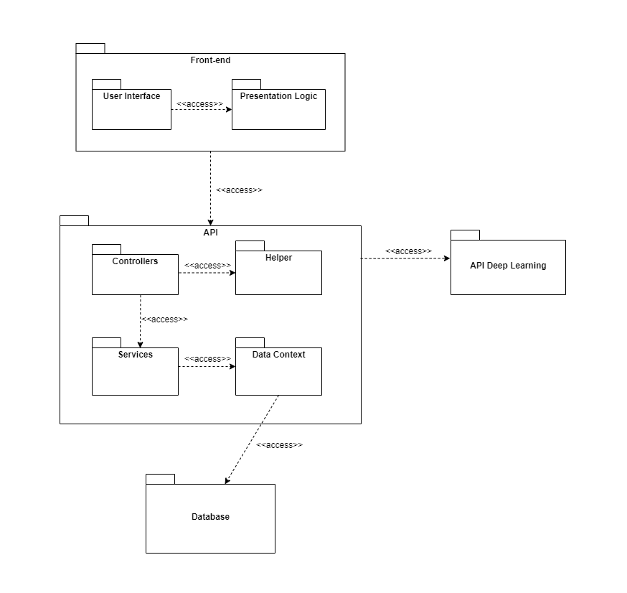
Figure 88. Package Diagram
Code Packages
No | Package | Description
1 | Front-end | Containing the user interface and the programming logic that makes user interface functions
2 | User Interface | Containing all the user interfaces of system
3 | Presentation Logic | Containing all the programming logic that makes user interface functions
4 | API | Containing all packages and classes that handle request and response from front-end
5 | Controllers | Containing all classes that handle the input and output of the API
6 | Services | Containing all packages and classes that handle the business logic of the API
7 | Data Context | Handling getting data into and out of the database
8 | Helper | Containing all packages and classes that handle all the other logic
9 | Database | Containing all datas of the system
10 | API Deep Learning | Containing all deep learning functions that handle the cheating detection

3. System Detailed Design

a. Class Diagram
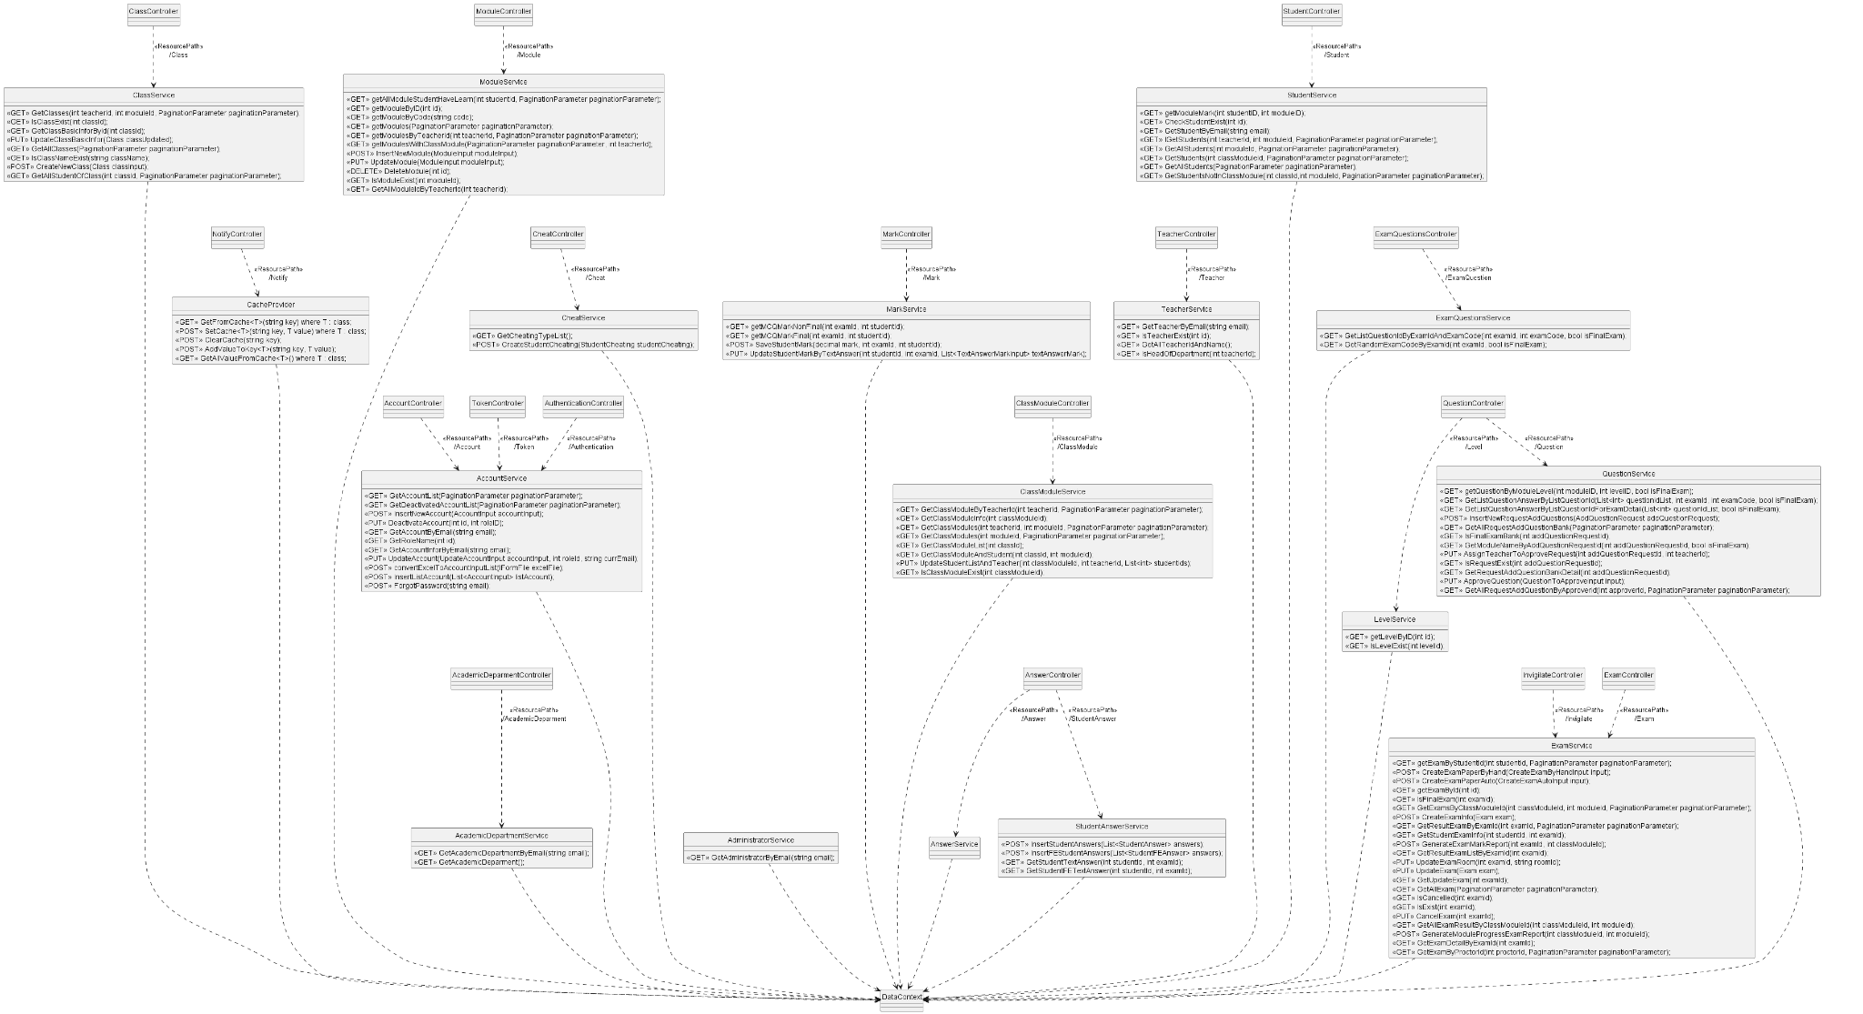
Figure 89. Class diagram

b. Sequence Diagrams

Login
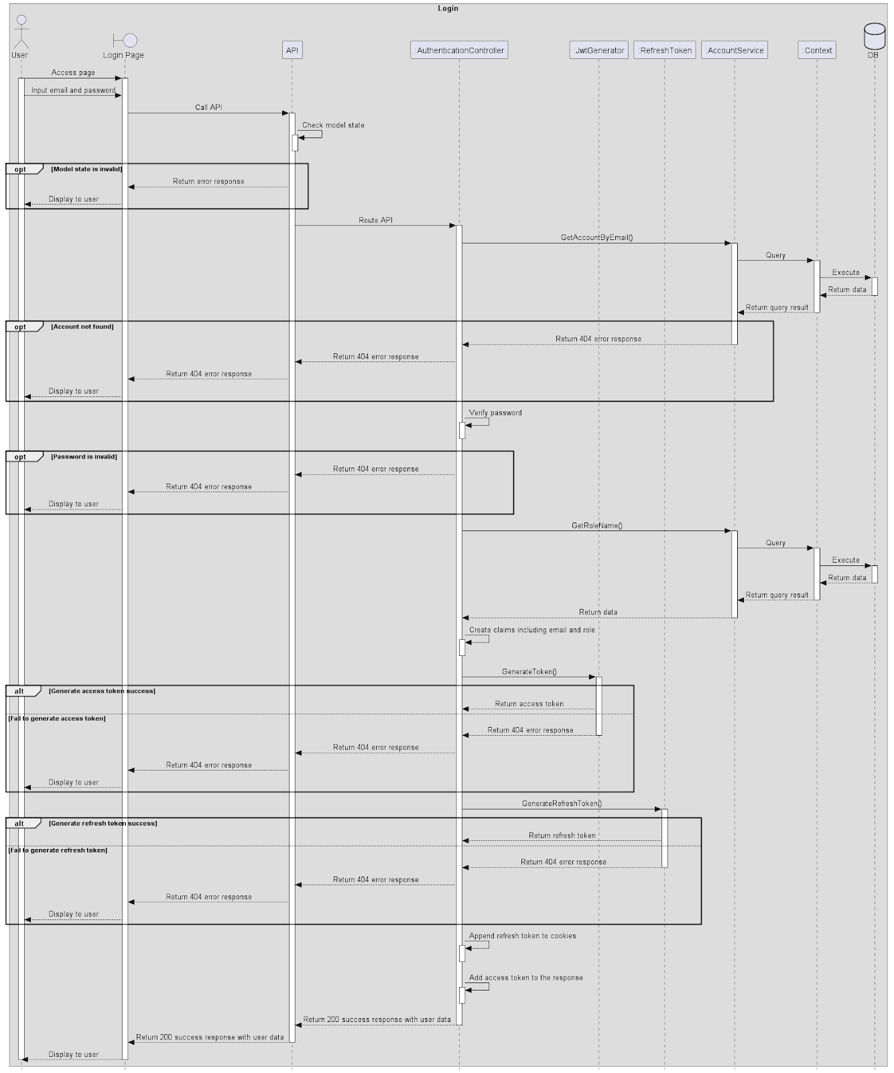
Figure 90. Login

Logout
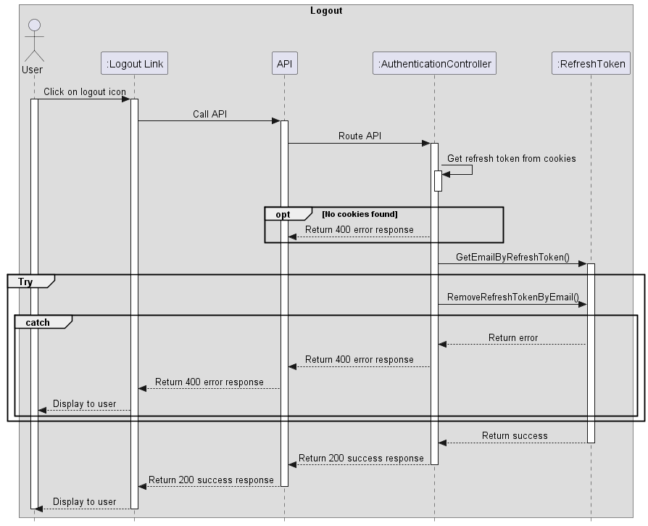
Figure 91. Logout

Forgot password
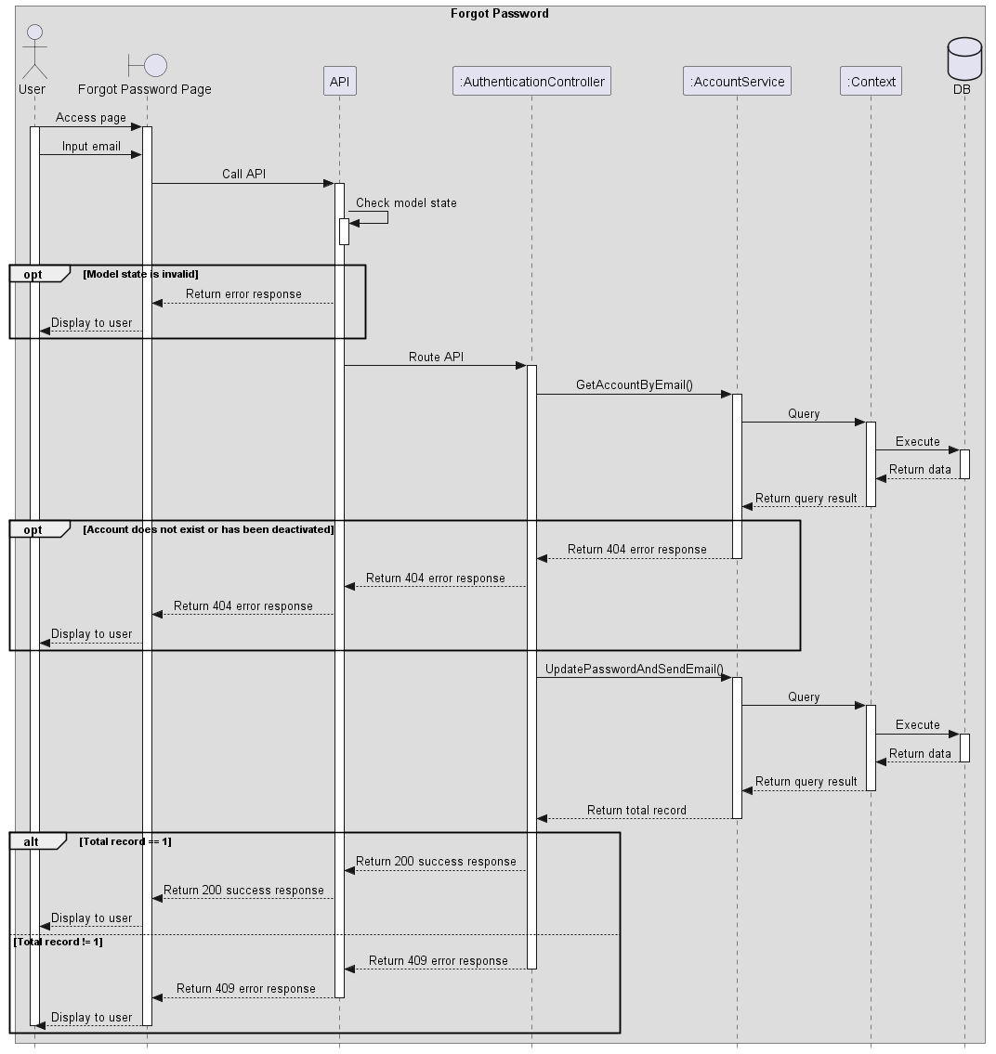
Figure 92. Forgot password

Create Account
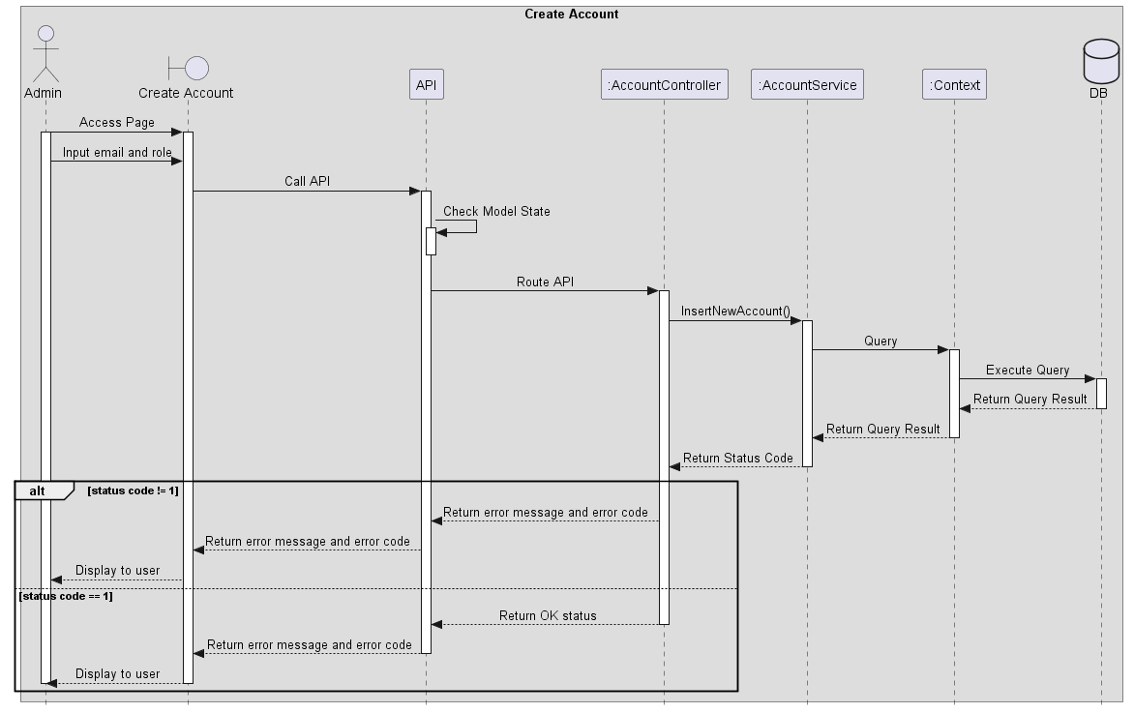
Figure 93. Create Account

View Account List
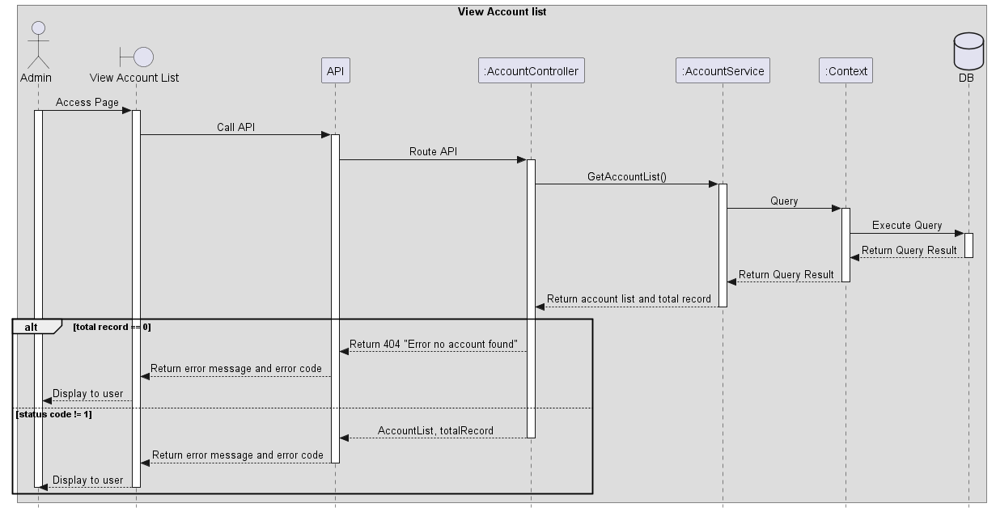
Figure 94. View Account List

Update Account
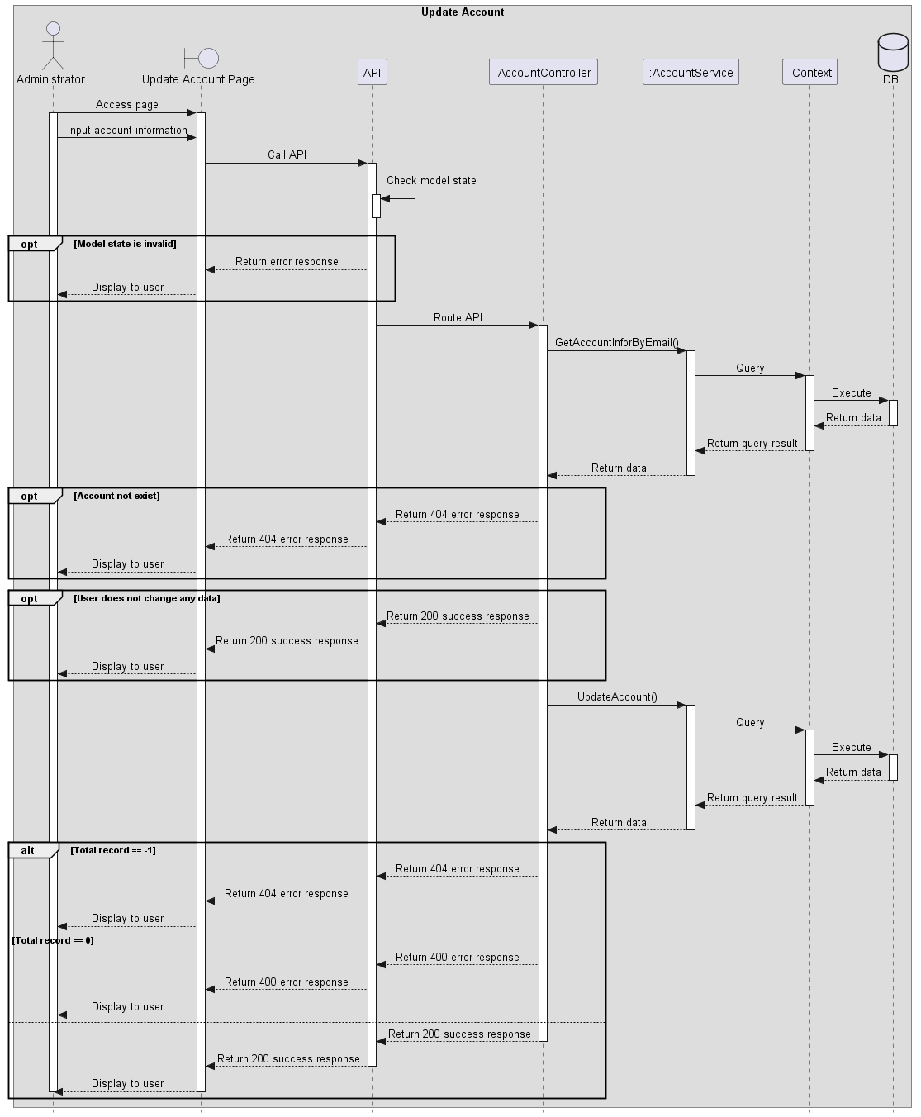
Figure 95. Update Account

Deactivate Account
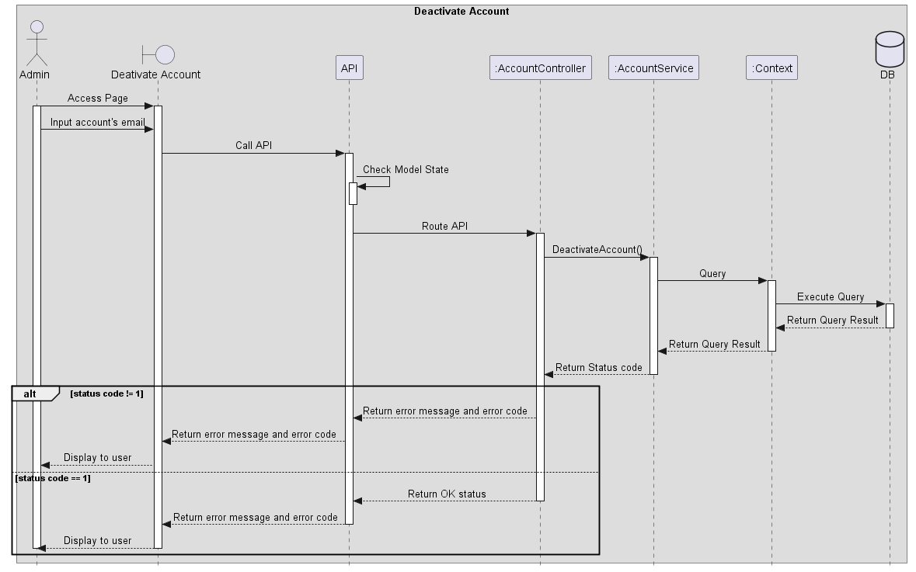
Figure 96. Deactivate Account

View deactivated account list
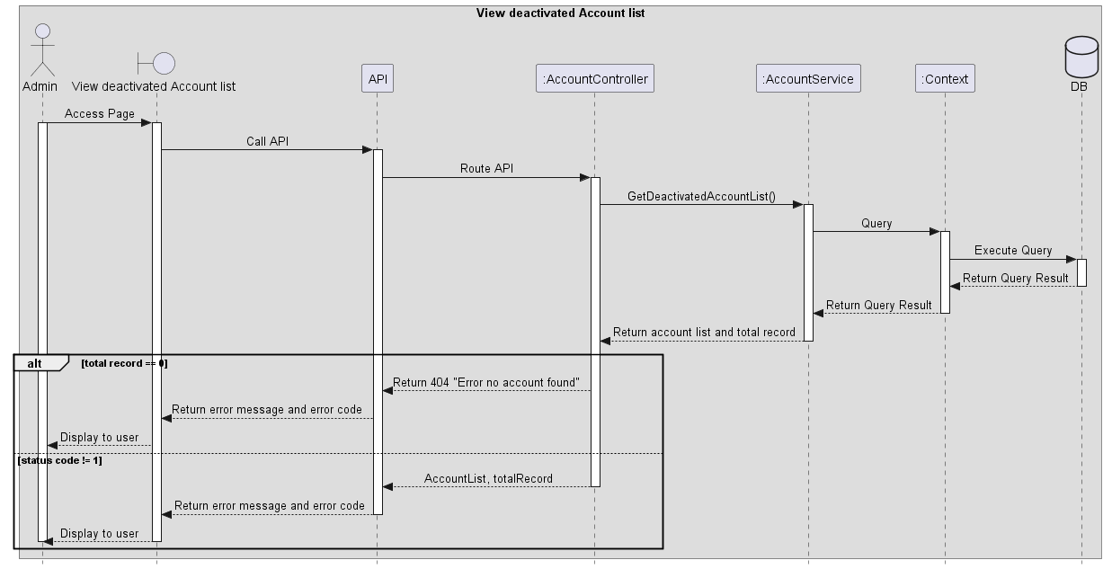
Figure 97. View deactivated account list

Create Module
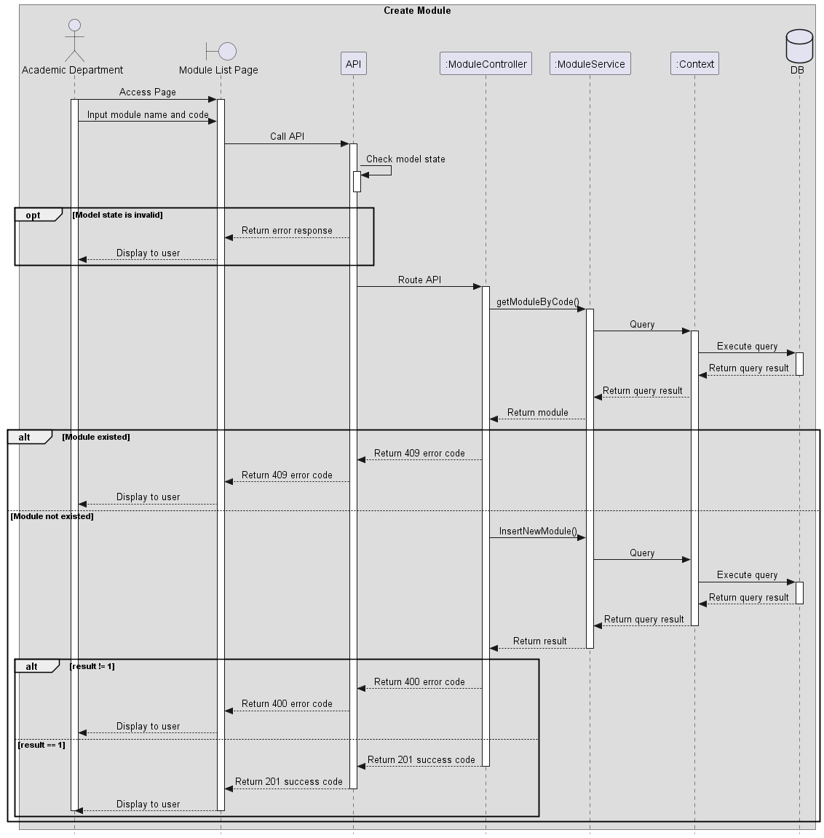
Figure 98. Create Module

View Module list
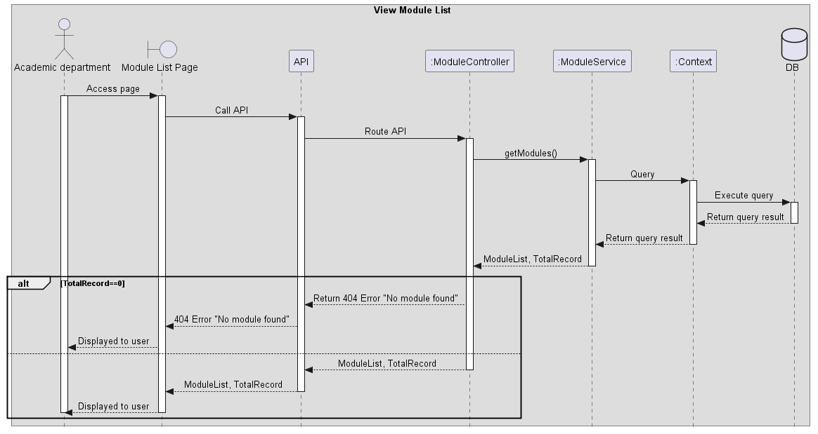
Figure 99. View Module list

Update Module
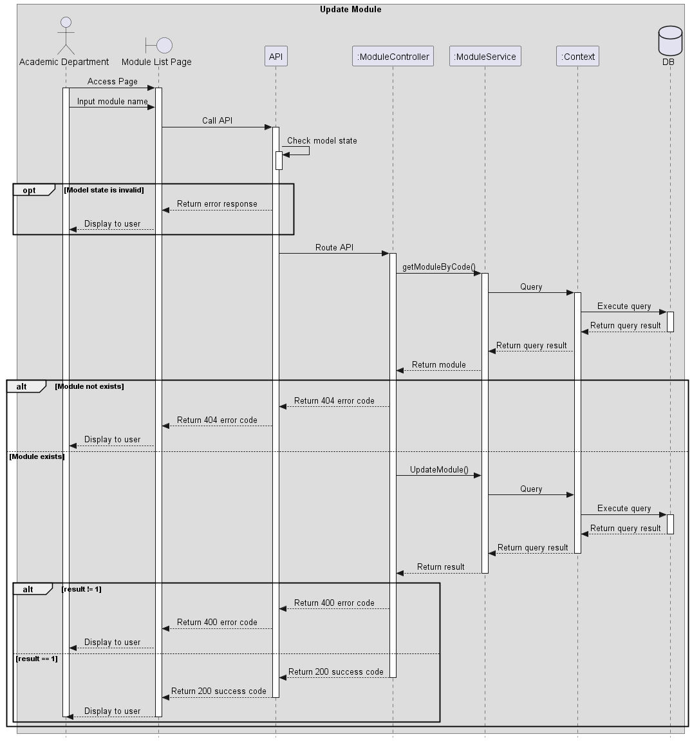
Figure 100. Update Module

Delete Module
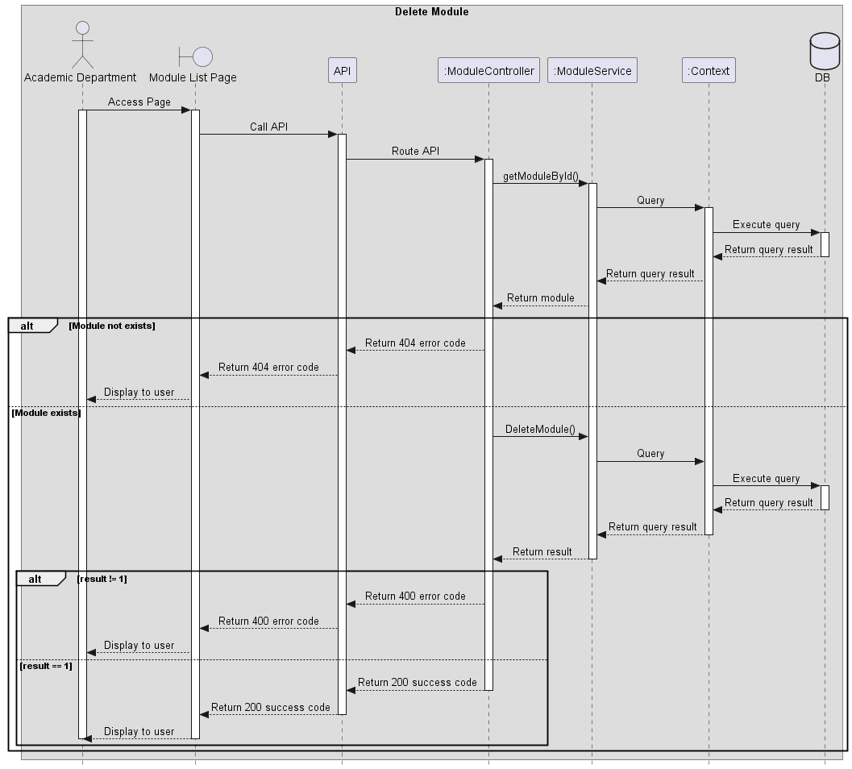
Figure 101. Delete Module

Create Class
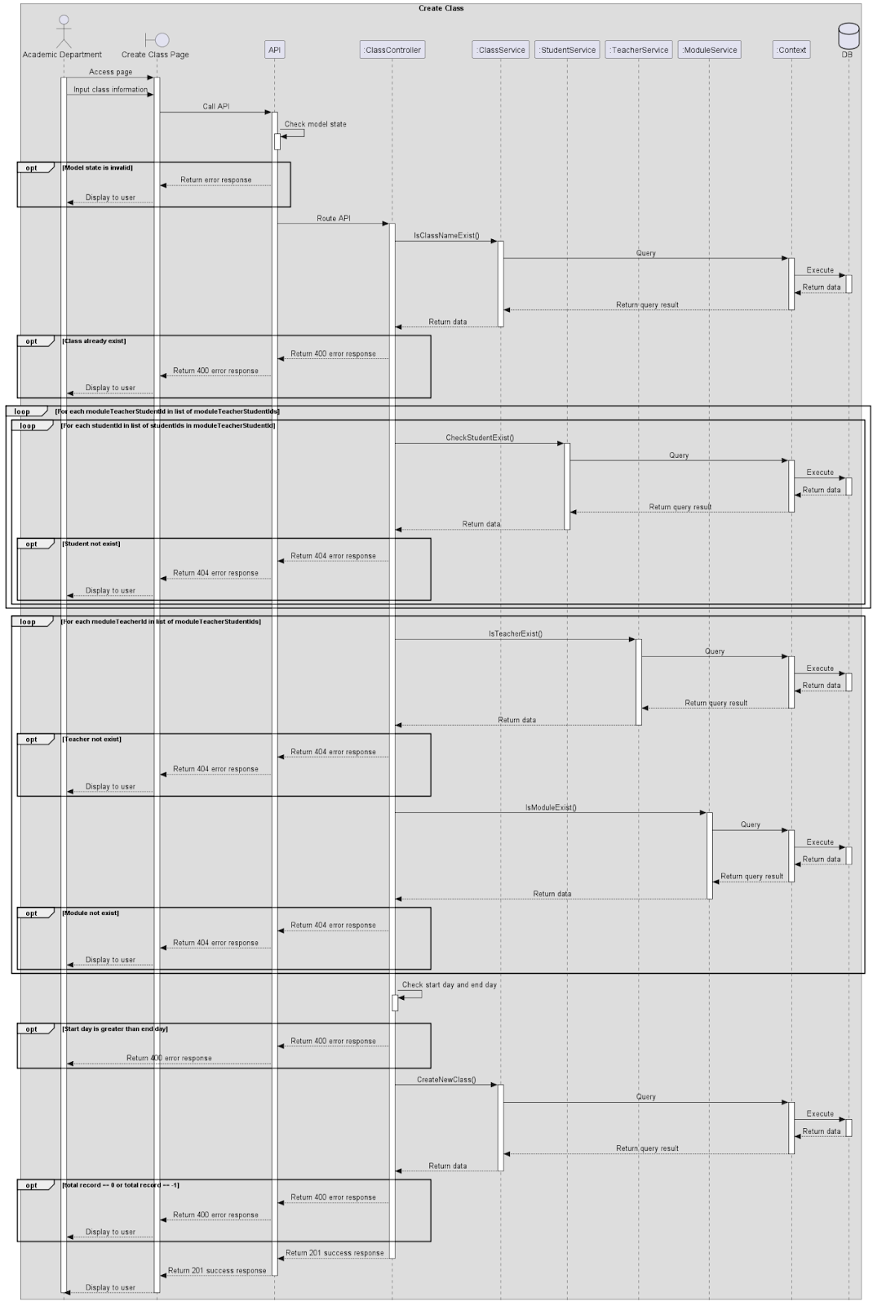
Figure 102. Create Class

View Class List (Academic Department)
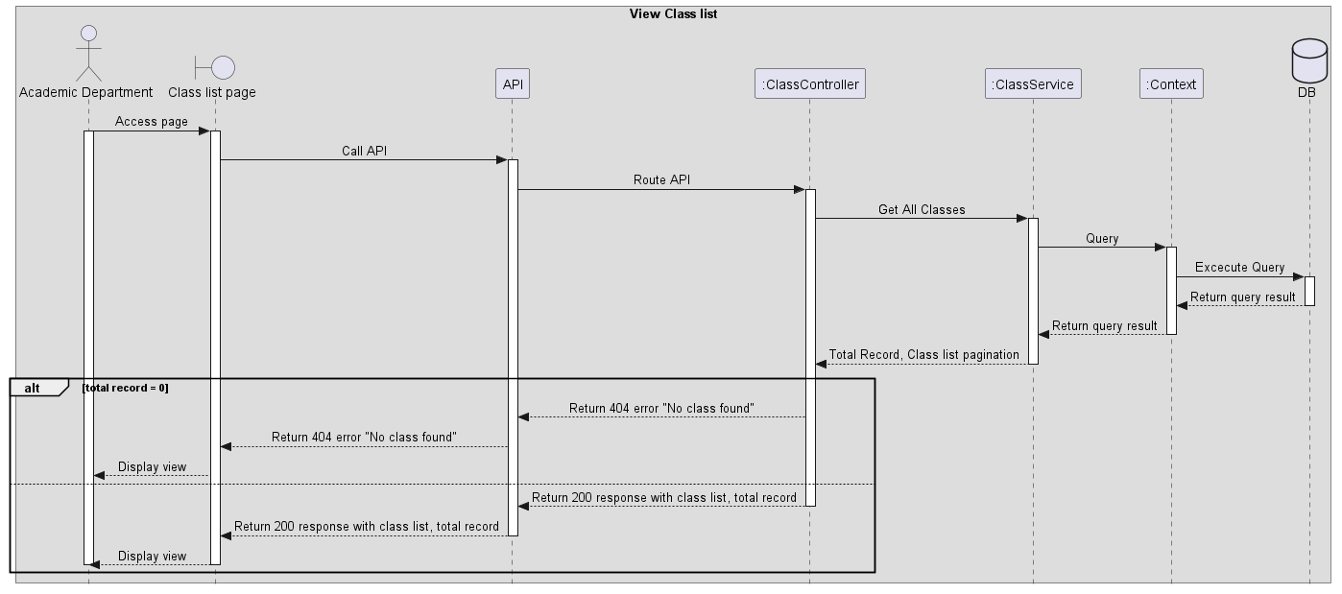
Figure 103. View Class List

Update Class (Academic department)
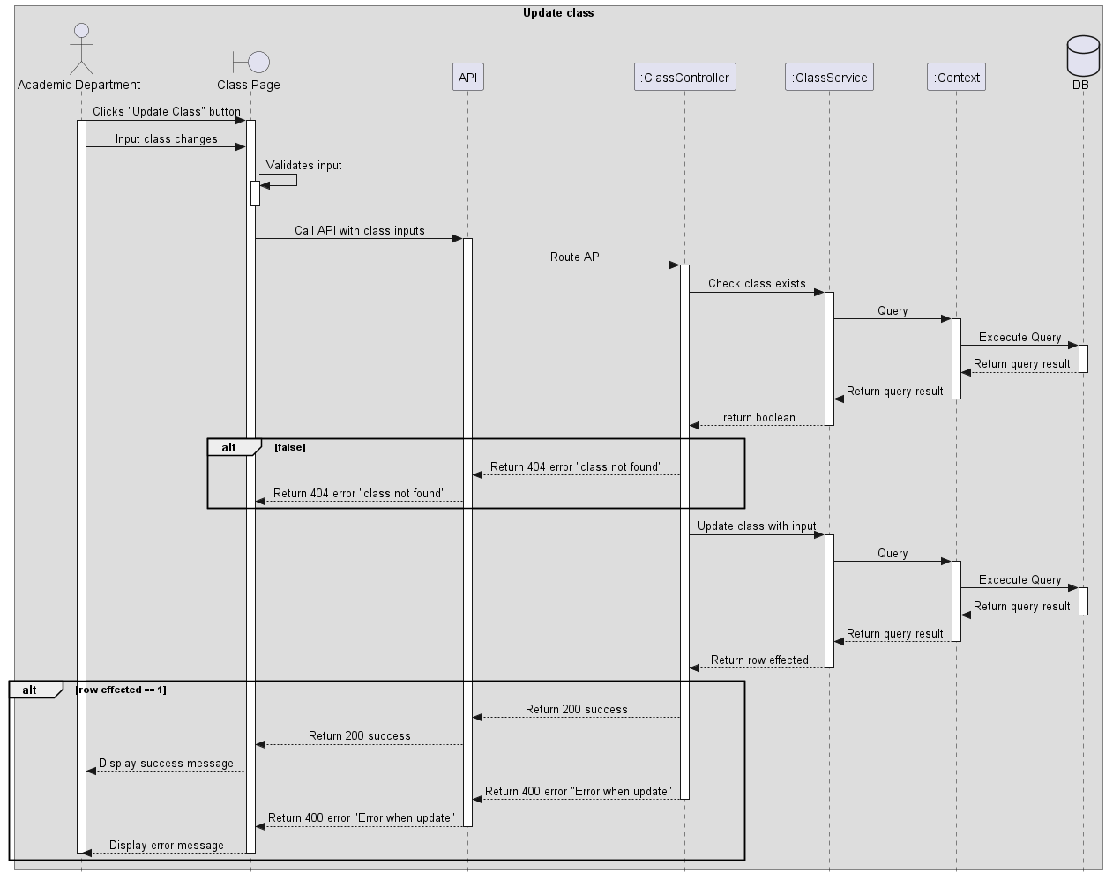
Figure 104. Update Class

Create Final Exam
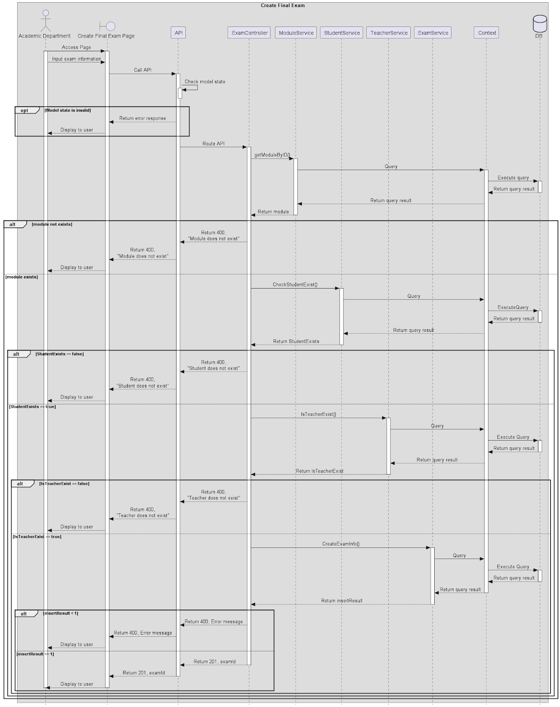
Figure 105. Create Final Exam

View Exam List
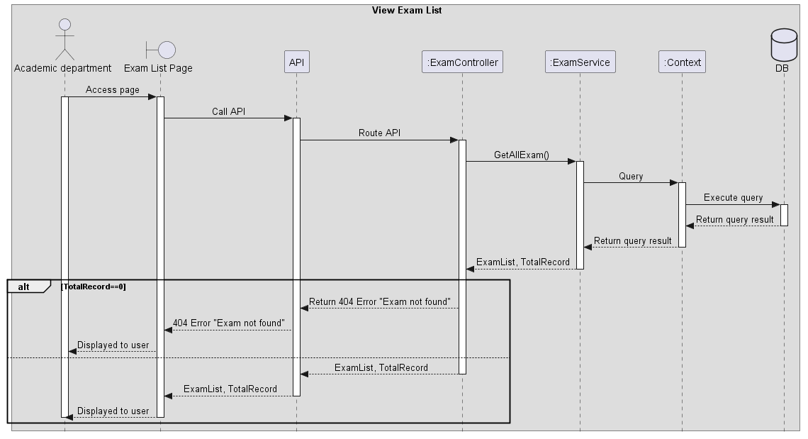
Figure 106. View Exam List

Update Final Exam
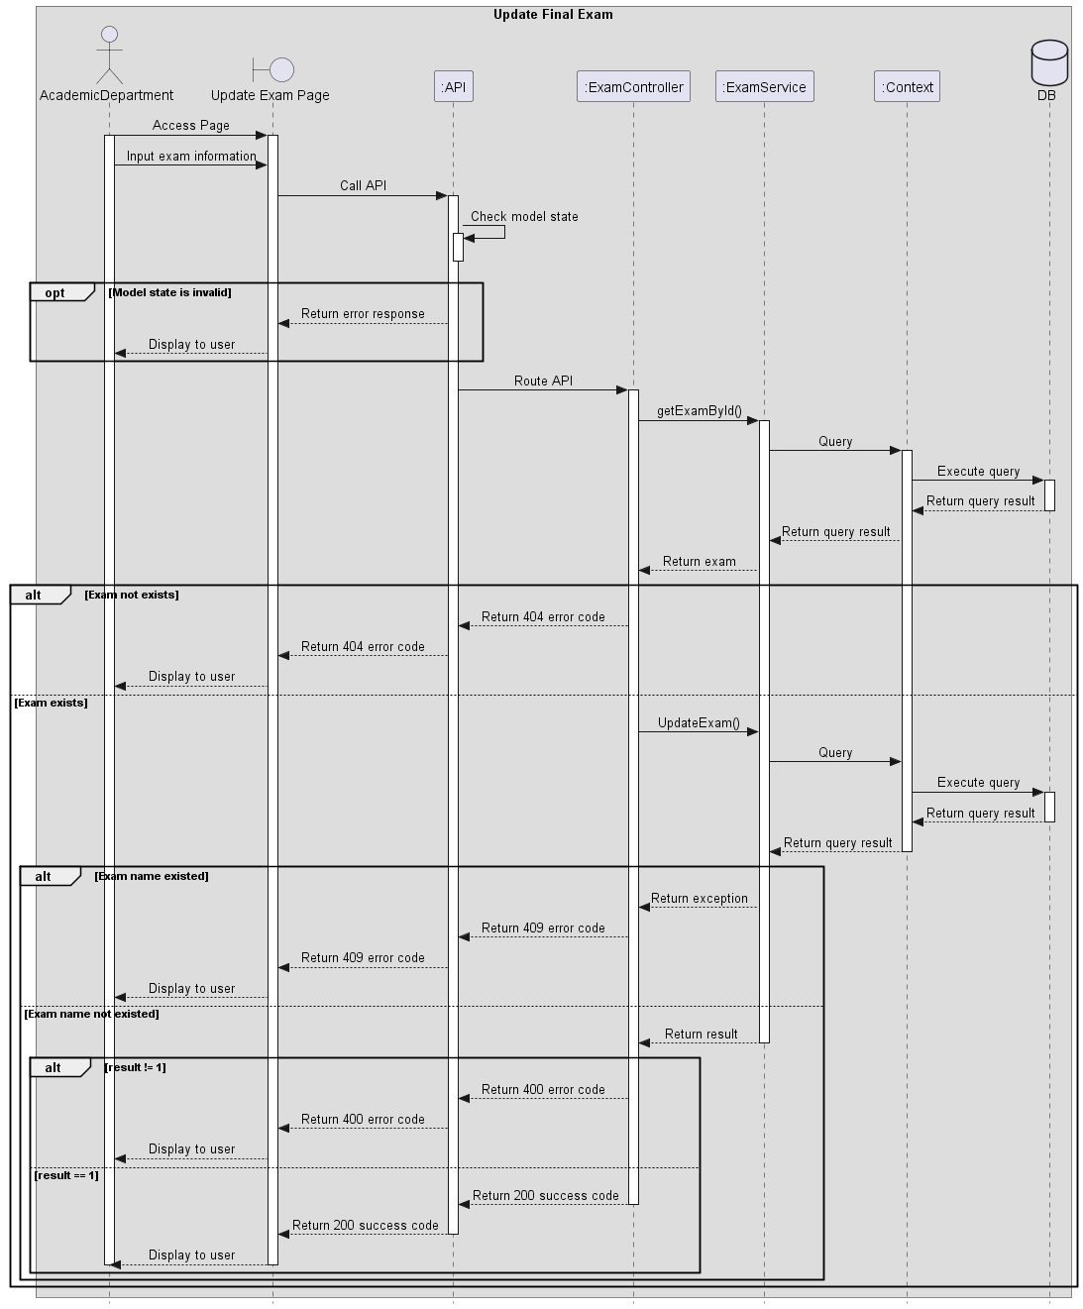
Figure 107. Update Final Exam

Delete Exam (Academic Role)
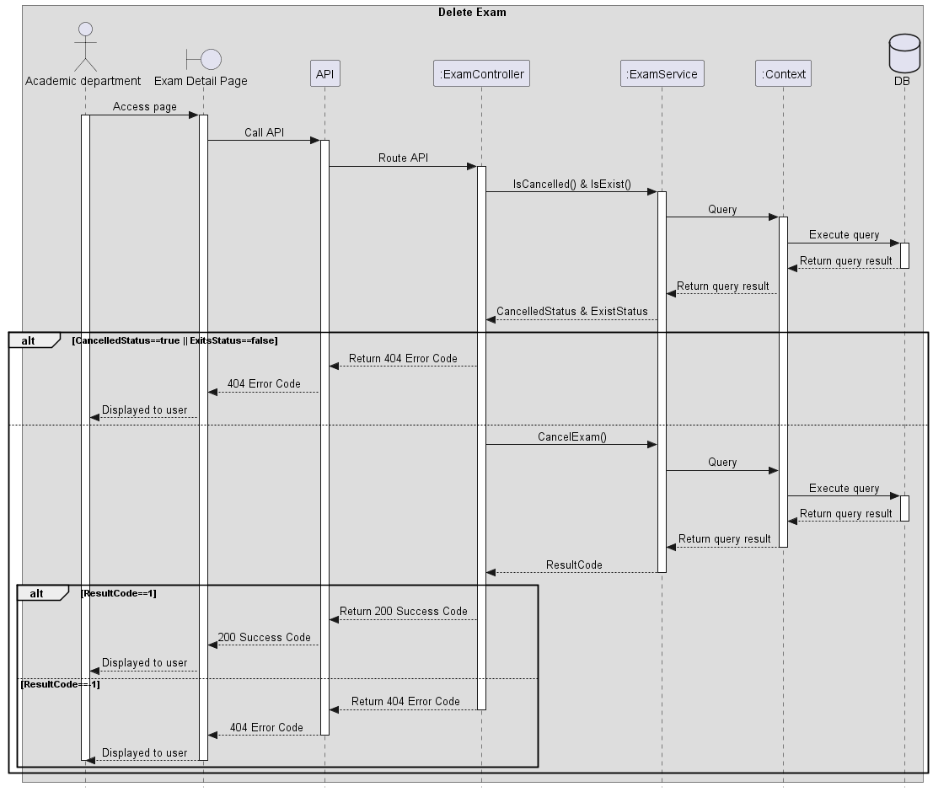
Figure 108. Delete Exam

View module list
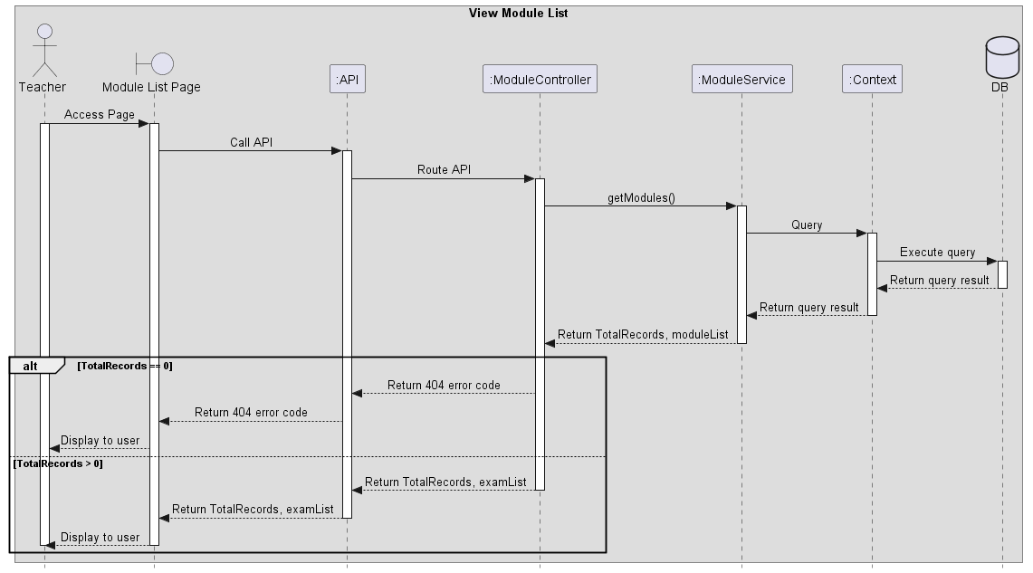
Figure 109. View module list

Create Exam

Figure 110. Create Exam

View Exam List
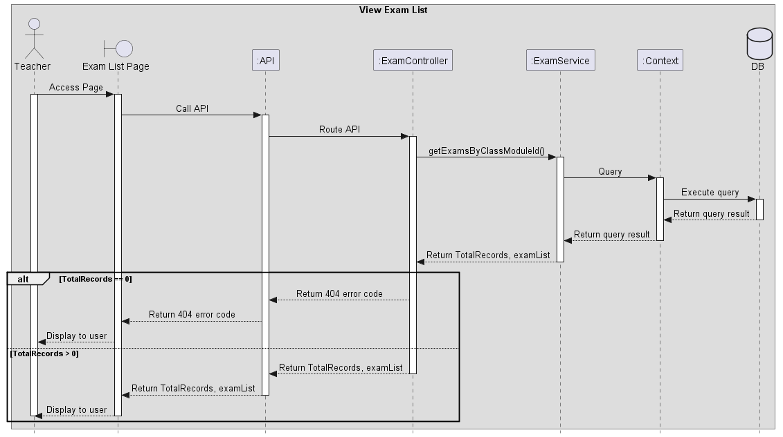
Figure 111. View Exam List

Update Exam
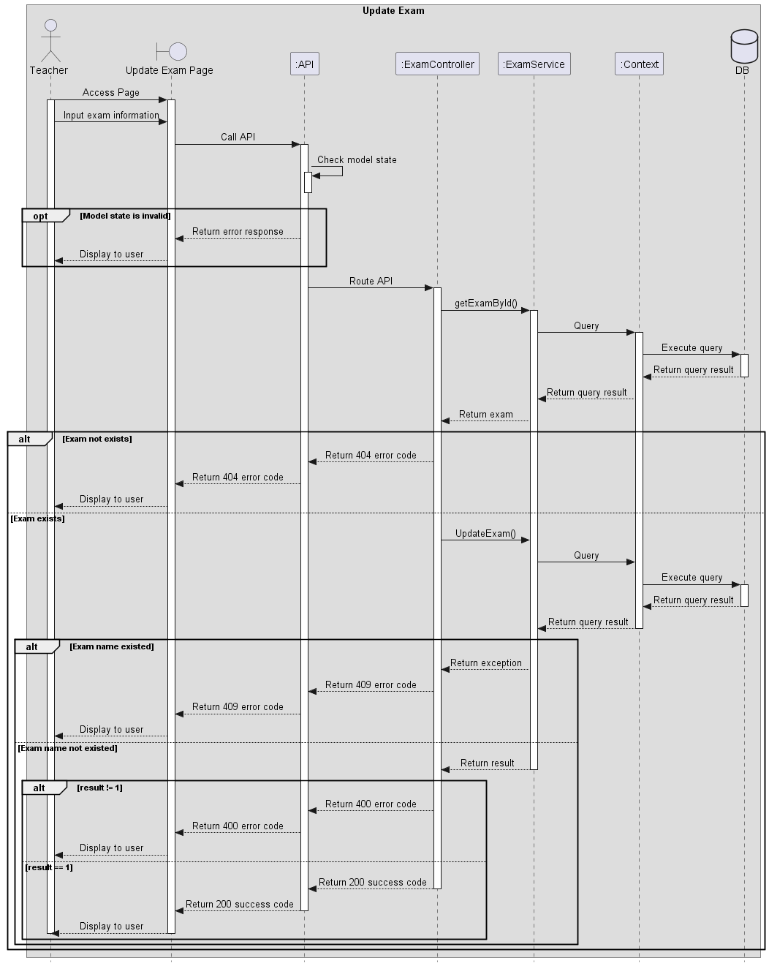
Figure 112. Update Exam

Delete Exam (Teacher Role)
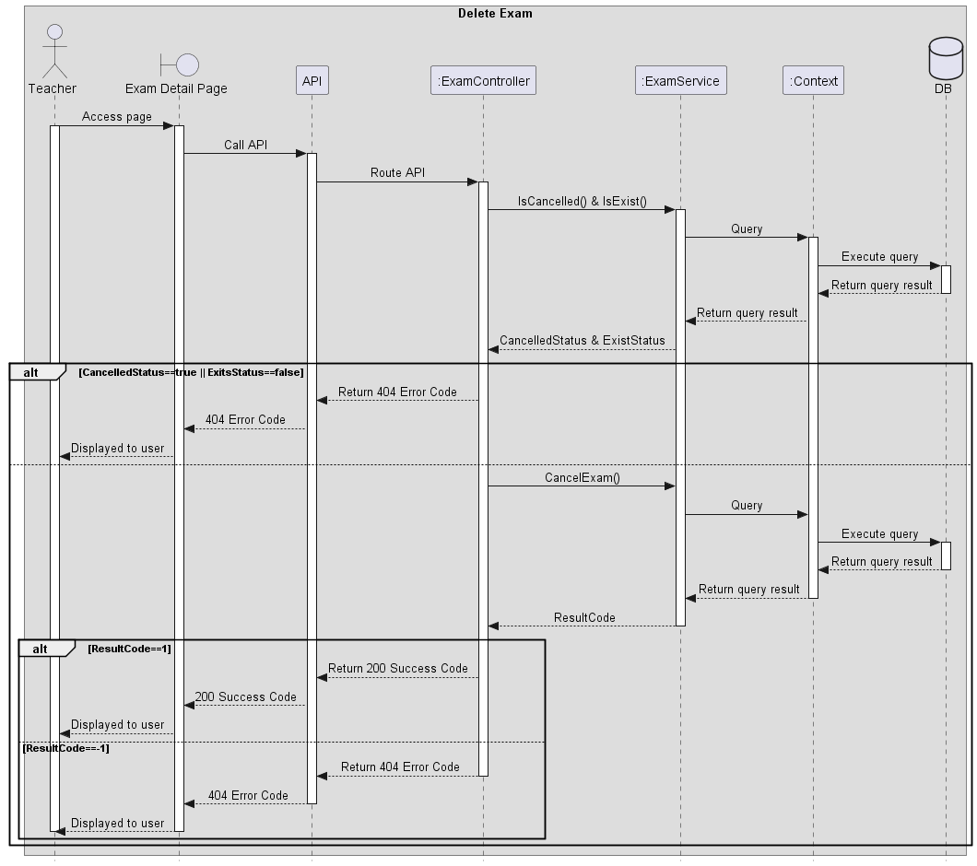
Figure 113. Delete Exam

Export excel module’s exam results (Teacher)
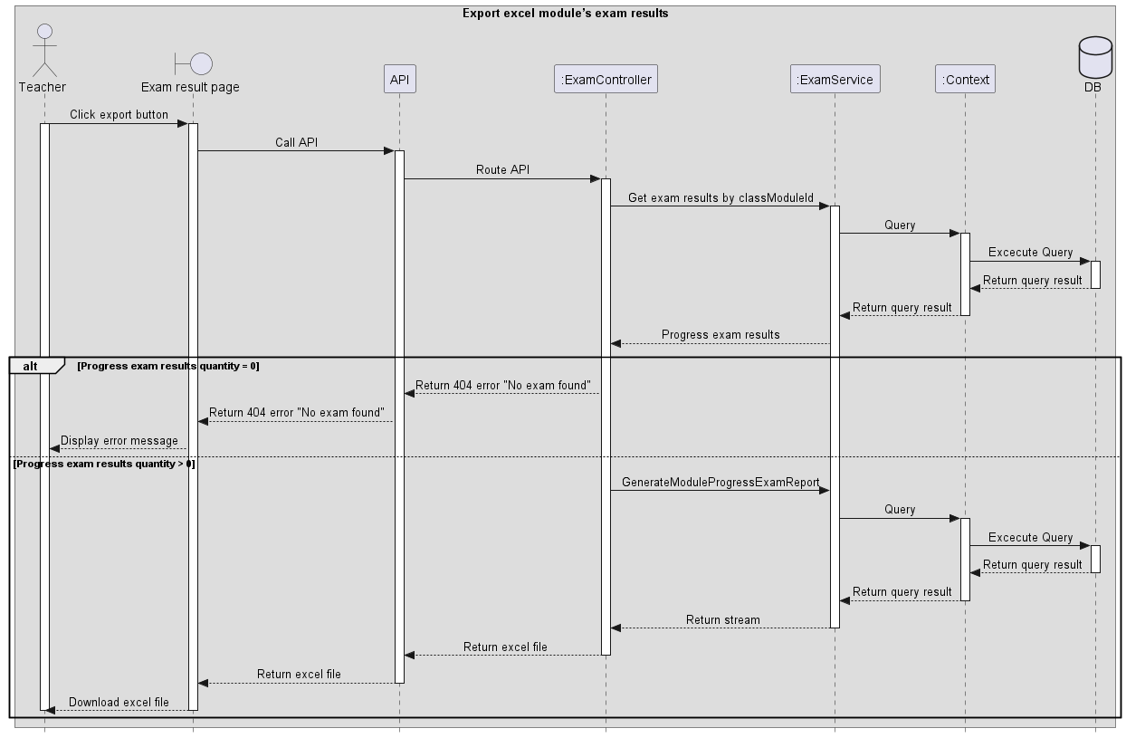
Figure 114. Export excel module’s exam results

View exam result, analysis
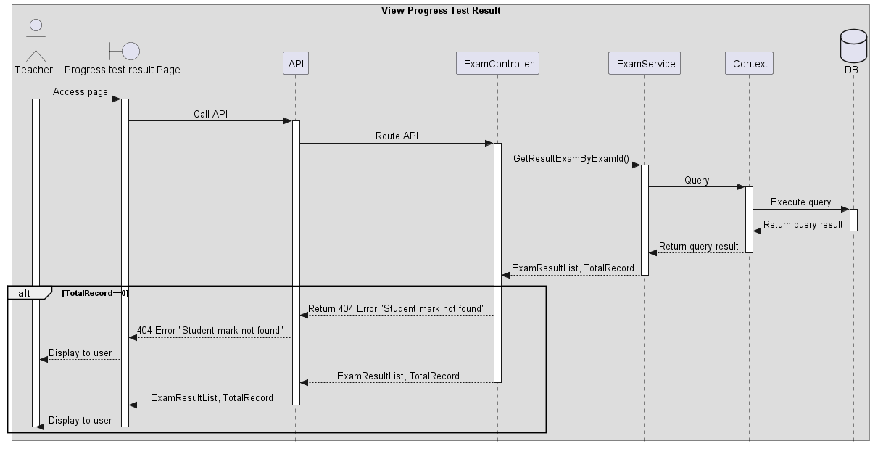
Figure 115. View exam result, analysis

Create exam paper
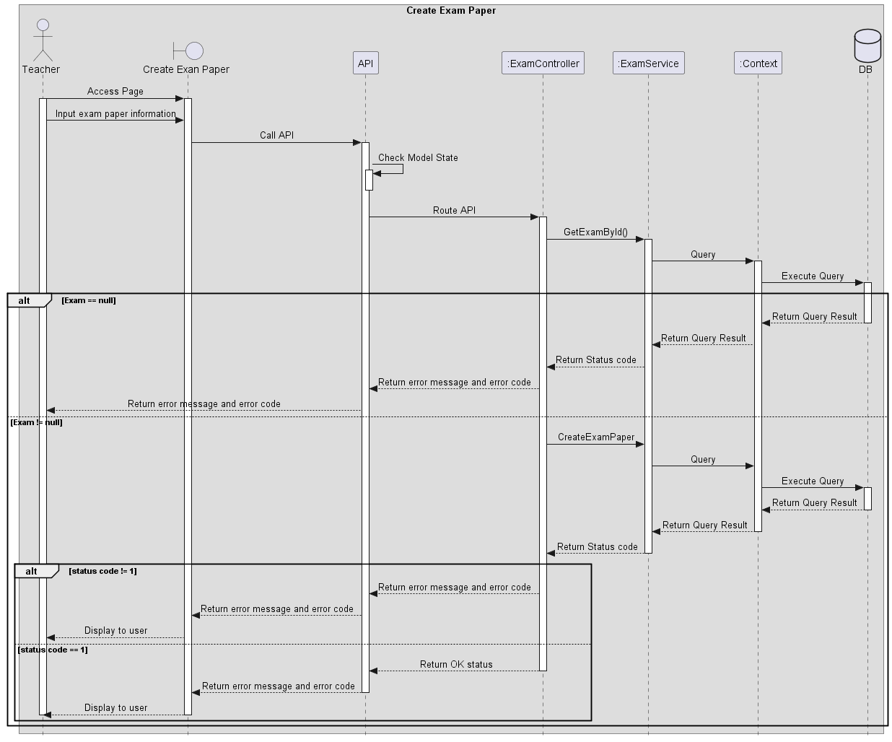
Figure 116. Create exam paper

Grade written questions (Teacher)
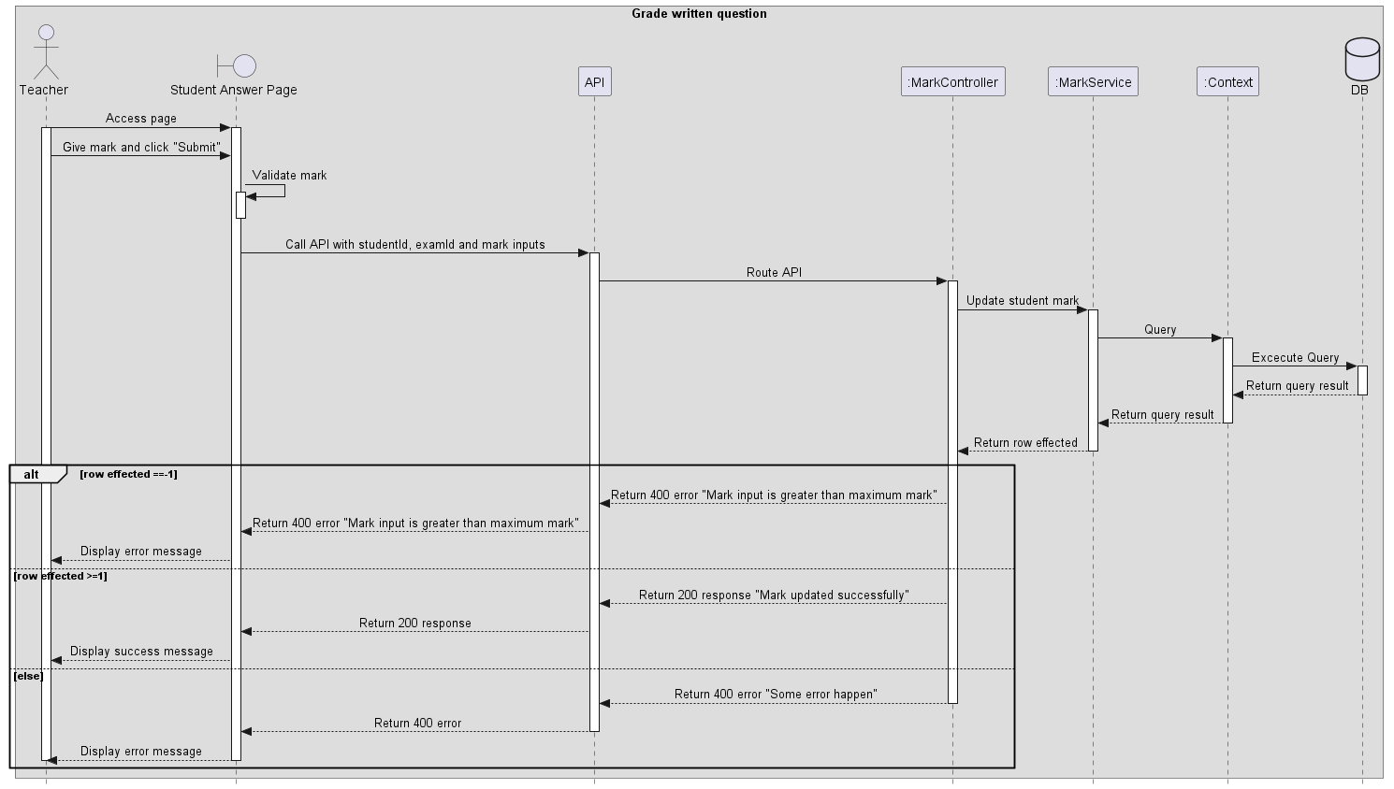
Figure 117. Grade written questions

View all requests add question bank
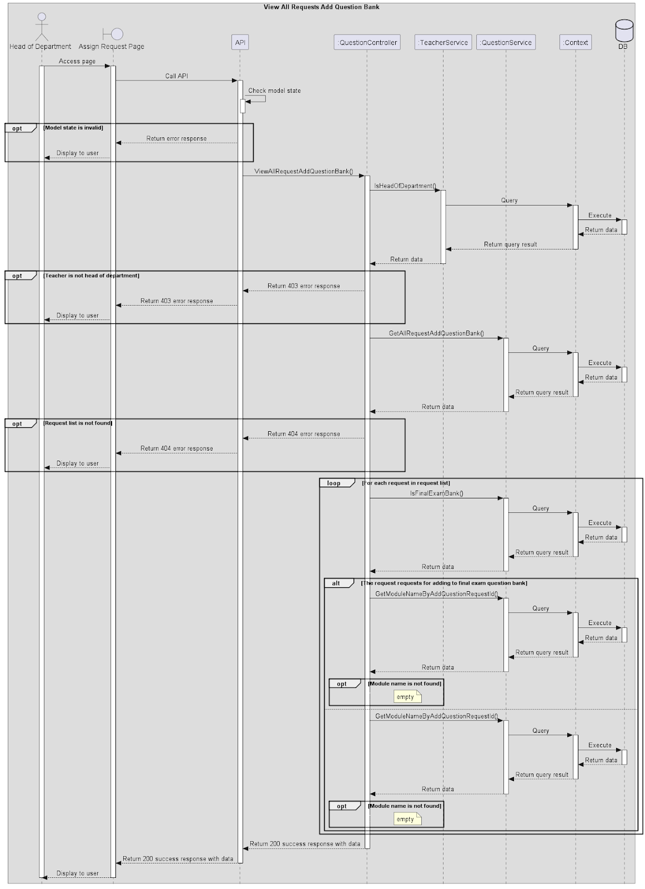
Figure 118. View all requests add question bank

Approve/Reject request to add question
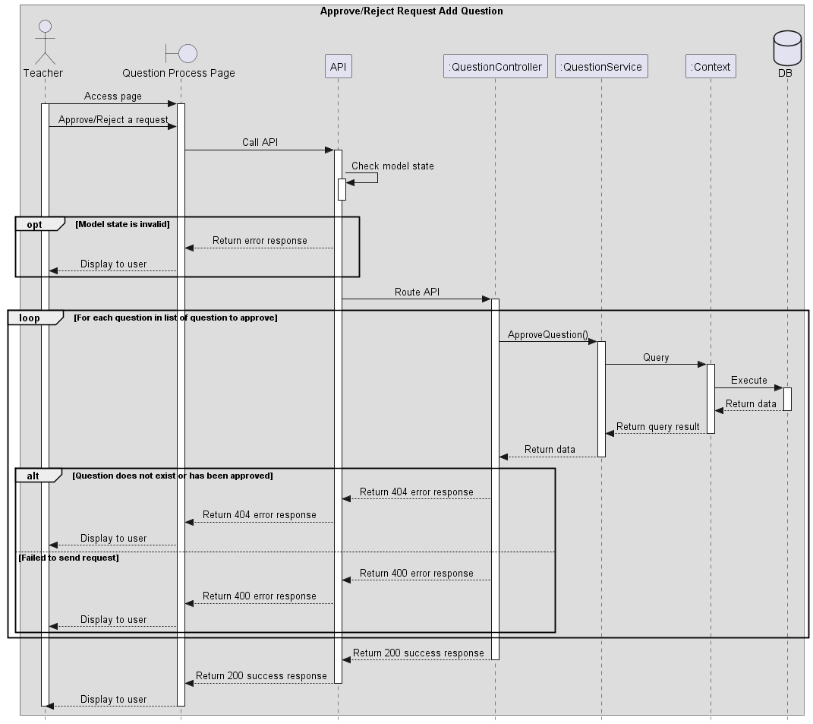
Figure 119. Approve/Reject request to add question

Request add new question to question bank
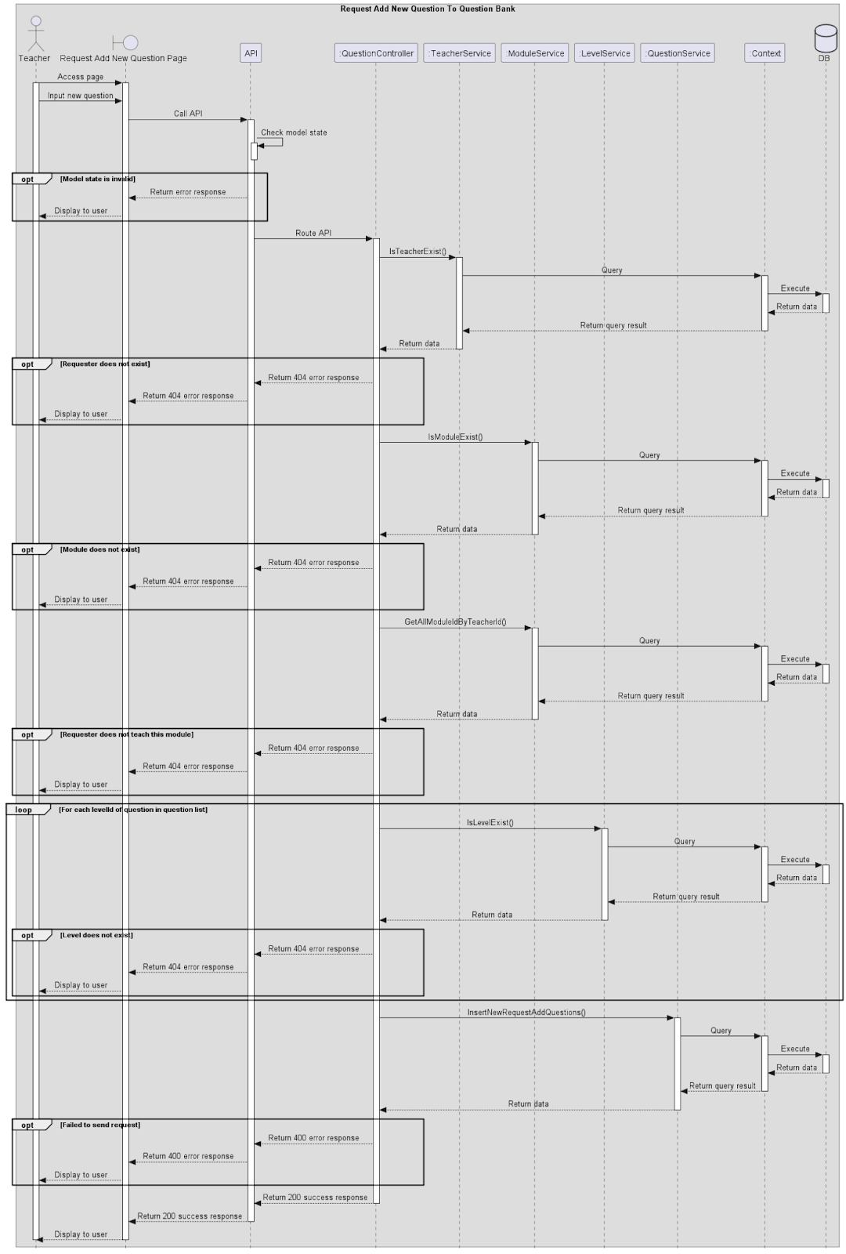
Figure 120. Request add new question to question bank

Assign teacher to process add question request
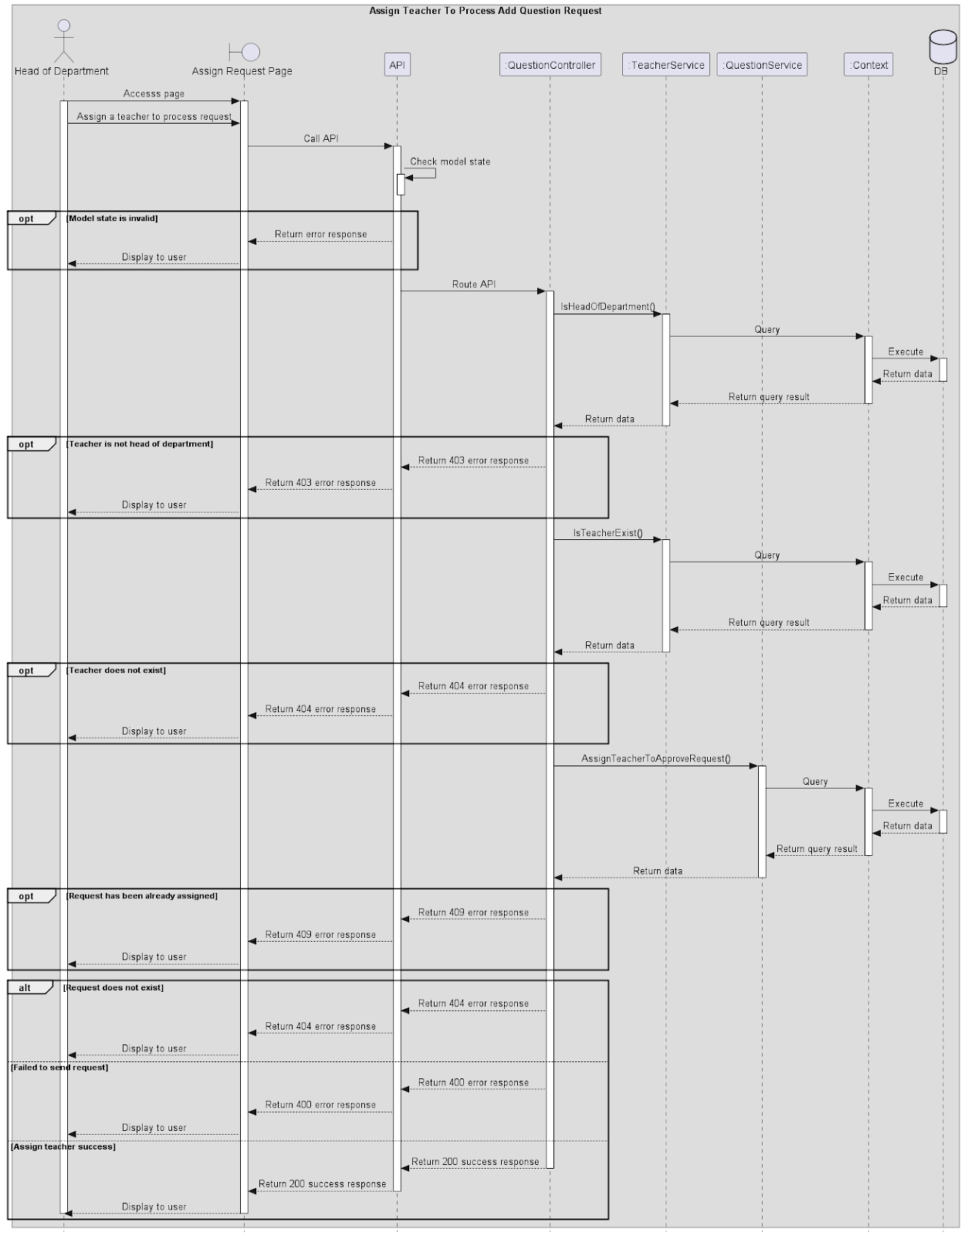
Figure 121. Assign teacher to process add question request

View exam schedule (Student)
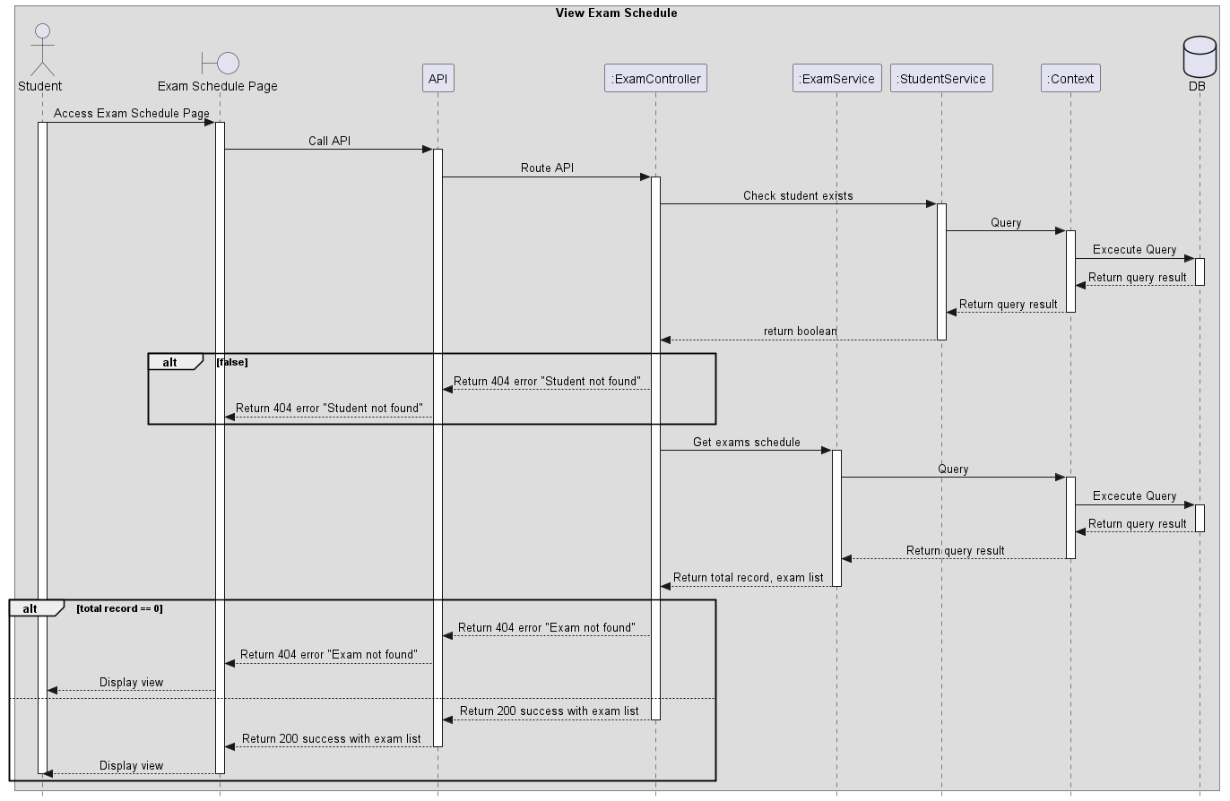
Figure 122. View exam schedule

View exam questions
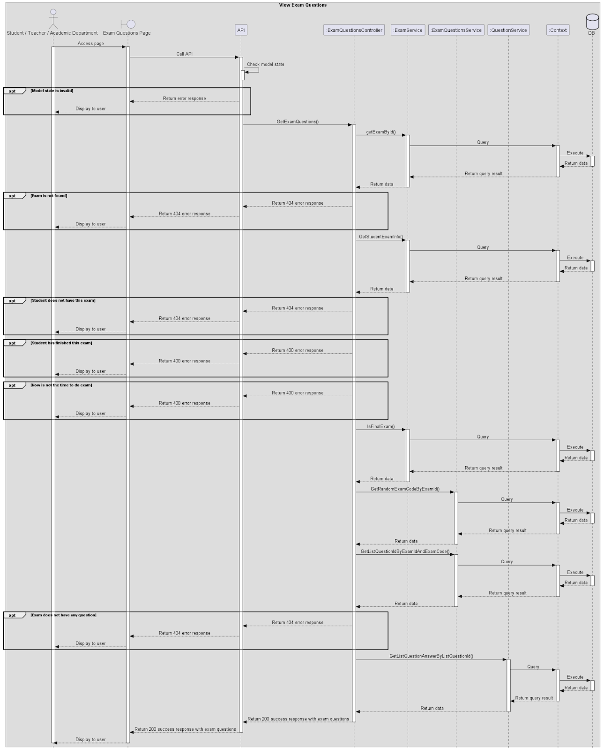
Figure 123. View exam questions

Submit exam (Student)
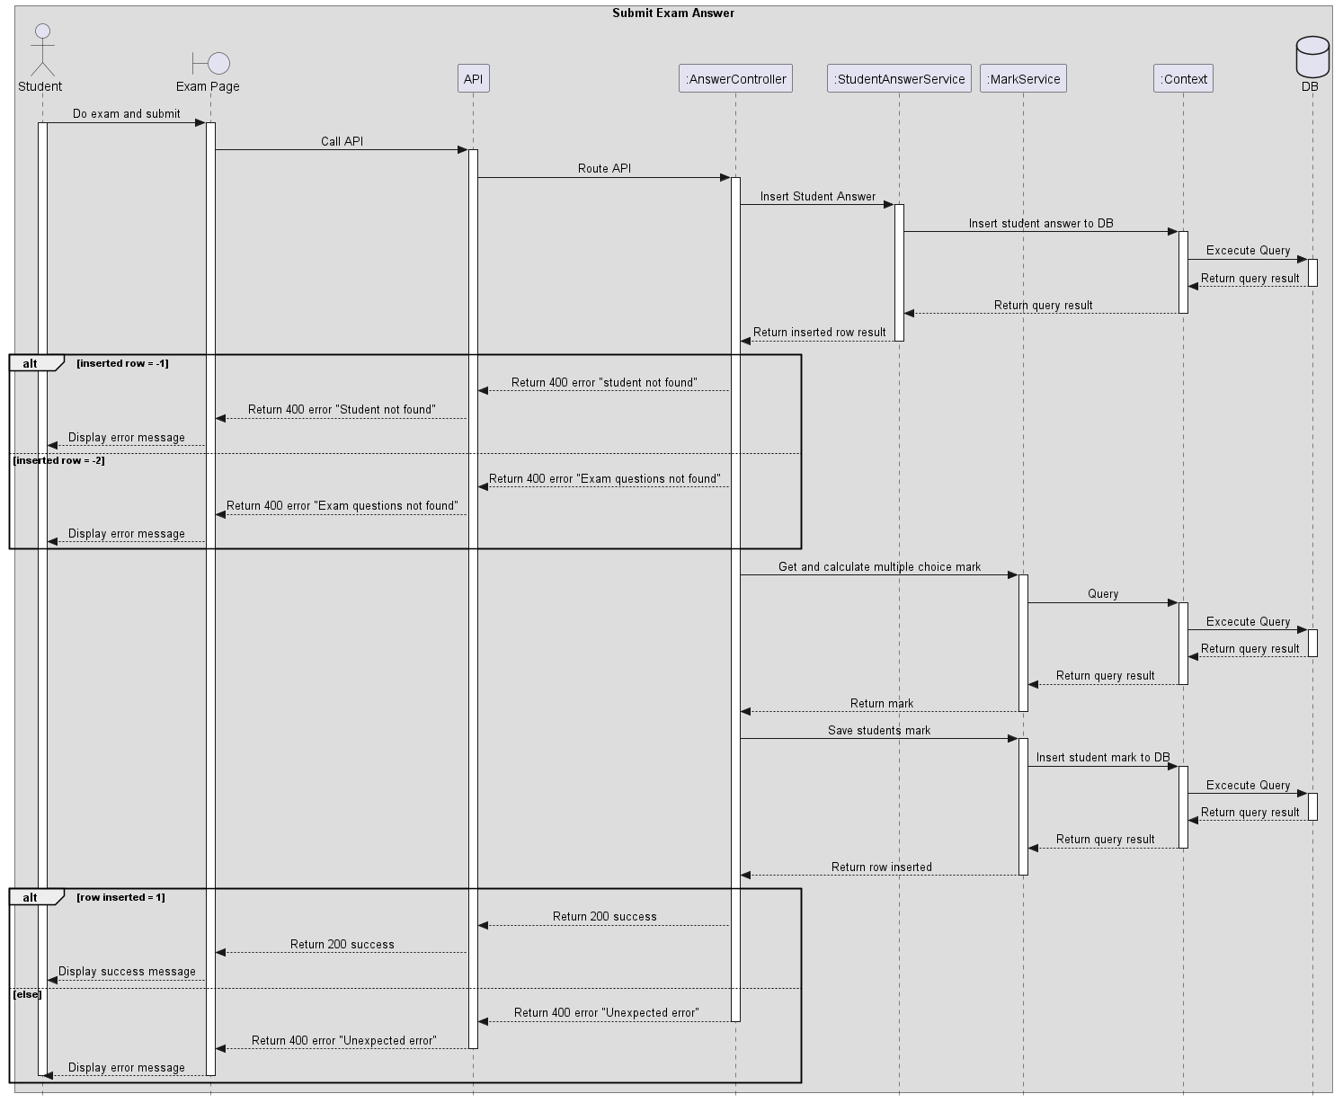
Figure 124. Submit exam

Mark report
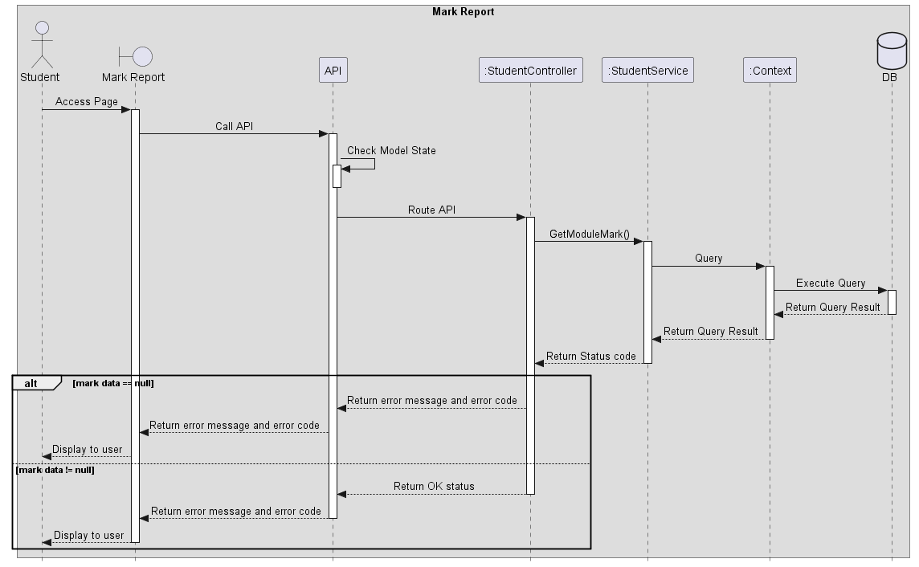
Figure 125. Mark report

View module list by Student
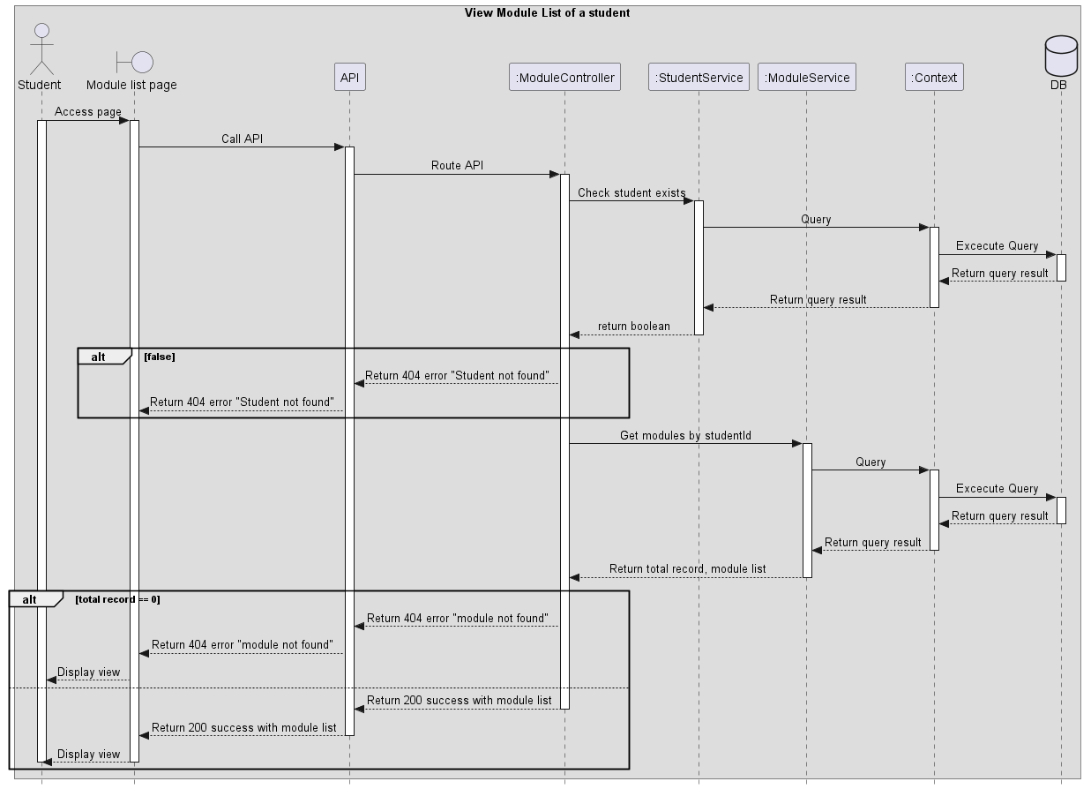
Figure 126. View module list

Invigilate
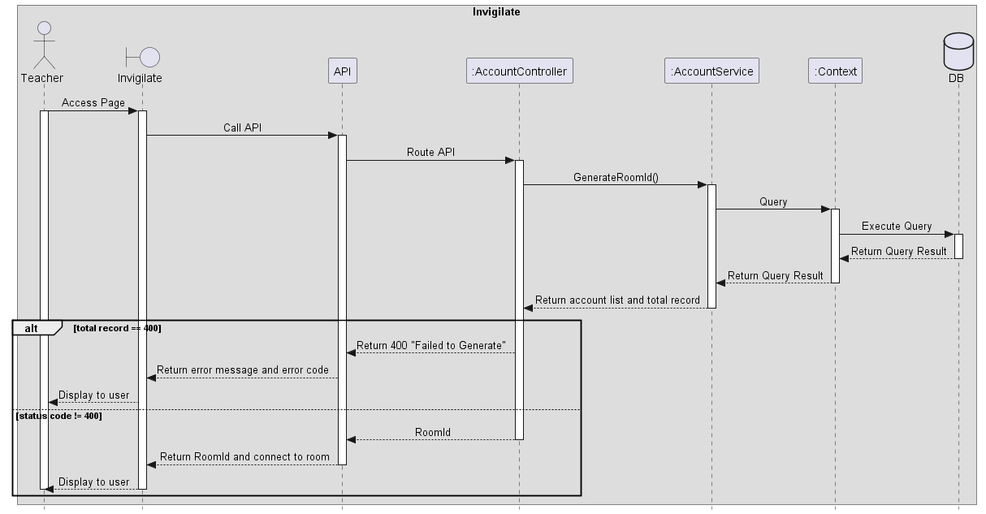
Figure 127. Invigilate

4. Class Specification

4.1 AcademicDepartmentController Class

4.1.1 Class Methods
No | Method | Description
1 | GetAcademicDepartmentList | Get a list of Academic Department.

4.1.2 Attributes of the Class
No | Attribute | Type
1 | _mapper | IMapper
2 | _academicDepartmentService | IAcademicDepartmentService

4.2 AccountController Class

4.2.1 Class Methods
No | Method | Description
1 | AccountController | Class constructor, used to instantiate the controller and bind necessary attributes through dependency injection.
2 | GetAccountList | A method for administrators to get a list of all activated accounts with pagination support.  function GetAccountList(Argument paginationParameter){  retrieve a list of all activated accounts and total record with paginationParameter  if there is no total record then return “Search email not found” error message  return a success message with a list of all activated accounts and total record in the pagination format  }
3 | GetDeactivatedAccountList | A method for administrators to get a list of all deactivated accounts with pagination support.  function GetDeactivatedAccountList(Argument paginationParameter){  retrieve a list of all deactivated accounts and total record with paginationParameter  if there is no total record then return “Search email not found” error message  return a success message with a list of all deactivated accounts and total record in the pagination format  }
4 | CreateNewAccount | A method for administrators to create a new account and send an email contains password to user’s email address.  function CreateNewAccount(Argument accountInput){  insert a new account to database and send an email contains password to user’s email address  if insert fail then return “Email is already existed” error message  if unexpected error occur then return “Something went wrong. Please try again” error message  return a success message  }
5 | CreateNewAccountByExcel | A method for administrator to create multiple accounts simultaneously from an excel file and send an email contains password to each user’s email address.  function CreateNewAccountByExcel(Argument excelFile, Argument roleId){  convert excel file to a list of account information  if the excel file contains any error cell then return an error message with a list of error cell information  loop through each item of the account information list and assign roleId to each account  insert the list of account to database and send send an email contains password to each user’s email address  if any cell contain an existed email then return an error message with a list of error cell information  if inserting all accounts success then return “Successfully inserted” success message  return “Error when inserted, upload again for more detail” error message  }
6 | DeactivateAccount | A method for administrator to deactivate an account.  function DeactivateAccount(Argument id, Argument role){  deactivate account in the database by it’s id and role  if the account’s id is not existed in the database then return “Id not found!” error message  if unexpected error occur then “Deactivate failed” error message  return “Account has been deactived successfully!” success message  }
7 | GetAccountInforByEmail | A method for administrator to get all informations of an account by it’s email.  function GetAccountInforByEmail(Argument email){  retrieve all account’s information from database by it’s email  if account is not existed in the database then return “Account not exist” error message  return success message with all the account’s information  }
8 | UpdateAccount | A method for administrator to update an account’s information.  function UpdateAccount(Argument roleId, Argument currentEmail, Argument accountInput){  retrieve account information from database by currentEmail  if account does not exist then return “Account not exist” error message  if administrator does not change any account information then return “Update account success” success message  update account information in the database  if account does not exist then return “Account not exist” error message  else if updating fail then return “Something went wrong. Update account failed” error message  else return “Update account success” success message

4.2.2 Attributes of the Class
No | Attribute | Type
1 | _accountService | IAccountService
2 | _mapper | IMapper
3 | _studentService | IStudentService
4 | _teacherService | ITeacherService
5 | _academicDepartmentService | IAcademicDepartmentService
6 | _administratorService | IAdministratorService

4.3 AnswerController Class

4.3.1 Class Methods
No | Method | Description
1 | AnswerController | Class constructor, used to instantiate the controller and bind necessary attributes through dependency injection.
2 | SubmitAnswer | A method for students to submit their answers in an exam  function SubmitAnswer(Argument answerInputs, Argument examId, Argument studentId){  insert student’s answers into the database  if fails then return appropriate error message  else {  grade the student’s answer  insert the student’s grade into the database  if insert successfully then return a message with the grade included  else return error message  }  }
3 | SubmitFEAnswer | A method for students to submit their answers in a final exam  function SubmitFEAnswer(Argument answerInputs, Argument examId, Argument studentId){  insert student’s answers into the database  if fails then return appropriate error message  else {  grade the student’s answer  insert the student’s grade into the database  if insert successfully then return a message with the grade included  else return error message  }  }
4 | ViewStudentTextAnswer | A method to retrieve a student’s written answer in an exam  function ViewStudentTextAnswer(Argument studentId, Argument examId){  retrieve student’s written answers from the appropriate question bank  if student does not have written answers then return “Student don’t have text answer” error message  else return the written answers  }

4.3.2 Attributes of the class
No | Attribute | Type
1 | _studentAnswerService | IStudentAnswerService
2 | _mapper | IMapper
3 | _markService | IMarkService
4 | _examService | IExamService

4.4 AuthenticationController Class

4.4.1 Class Methods
No | Method | Description
1 | AuthenticationController | Class constructor, used to instantiate the controller and bind necessary attributes through dependency injection.
2 | Login | A method for user to log in to ExamEdu in order to use all functions based on the user's role.  function Login(Argument loginInput){  retrieve account information from database by user’s email address  if cannot find the account in the database then return “Wrong credentials or account has been deactivated” error message  verify password of user  if result of verification is false then return “Wrong credentials” error message  retrieve role name from database  create claims including email and role for adding to payload in access token  generate access token and refresh token  if fail then return “Token generate fail” error message  add refresh token to cookies  add access token to the response data  return success message and user data  }
3 | Logout | A method for user to log out from ExamEdu.  function Logout(){  get refresh token from cookies  if fail then return “No cookies found!” error message  retrieve user’s email from the refresh token  remove the refresh token by user’s email  catch any exception and return “Fail to remove refresh token.” error message  return “Logout success!” success message  }
4 | ForgotPassword | A method for user to reset account password and receive a newly generated password by email.  function ForgotPassword(Argument email){  retrieve account information by email  if account information is null then return “Email does not exist or has been deactivated” error message  update password of user’s account to database and send an email contain new password to user’s email address  if success then return “An email contains new password has been sent to your email address. Please check your email to get the new password.” success message  else return “Reset password fail. Please try again.” error message  }

4.4.2 Attributes of the Class
No | Attribute | Type
1 | _mapper | IMapper
2 | _accountService | IAccountService
3 | _jwtGenerator | IJwtGenerator
4 | _refreshToken | IRefreshToken

4.5 CheatController Class

4.5.1 Class Methods
No | Method | Description
1 | CheatController | Class constructor, used to instantiate the controller and bind necessary attributes through dependency injection.
2 | CheatingTypeList | A method to retrieve all cheating types available in the system.  function CheatingTypeList()  {  retrieve all cheating types  if cheating type list is null or empty then return error message  else return a list of cheating types  }
3 | StudentCheating | function StudentCheating(Argument studentCheatingInput)  {  if studentId or examId not valid  then return error message  insert StudentCheating to database  if unexpected error happen then return error message  else return success message  }

4.5.2 Attributes of the Class
No | Attribute | Type
1 | _cheatService | ICheatService
2 | _studentService | IStudentService
3 | _mapper | IMapper
4 | _examService | IExamService

4.6 ClassController Class

4.6.1 Class Methods
No | Method | Description
1 | ClassController | Constructor of the class.
2 | GetClasses | This is a method used to return all the classes that belong to a module of a teacher.
3 | GetAllClasses | This is a method used to return all the class that the system have.
4 | GetAllStudentOfClass | This is a method used to return all students of a class.
5 | CreateNewClass | This is a method used to create a new class for the system.
6 | GetClass | This is a method used to return the basic information of a class.
7 | UpdateClassBasicInfor | This is a method used to update basic information of a class.

4.6.2 Attributes of the Class
No | Attribute | Type
1 | _classService | IClassService
2 | _classModuleService | IClassModuleService
3 | _mapper | _mapper
4 | _moduleService | _moduleService
5 | _teacherService | _teacherService
6 | _studentService | _studentService

4.7 ClassModuleController Class

4.7.1 Class Methods
No | Method | Description
1 | ModuleController | Class constructor, used to instantiate the controller and bind necessary attributes through dependency injection.
2 | ViewModuleStudentHaveLearn | A method to get all module student learned through student Id  function ViewModuleStudentHaveLearn(Argument studentId, Argument paginationParameter){  if studentId does not exist in database then return “student not exist” error message  retrieve class module information  if retrieved module list is null then return “No module found” message  else return module list in pagination  }
3 | ViewAllModule | A method to get all module  function ViewAllModule(Argument paginationParameter){  retrieve all module by paginationParameter  if module list is null then return “No module found” message  else return module in pagination  }
4 | GetModules | A method to get a list of module through teacher Id  function GetModules(Argument teacherId, Argument paginationParameter){  if teacherId does not exist in database then return “teacher not exist” error message  retrieve module list by teacherId and paginationParameter  if module list is null then return “No module found” message  else return module list in pagination  }
5 | CreateModule | A method to create module  function CreateModule(Argument moduleInput){  if module input code exist in database then return “module already exists” error message  insert module to database  if unexpected error happen then return “Something went wrong” message  else return success message  }
6 | UpdateModule | A method to update module  function updateModule(Argument moduleInput){  if module input code does not exist in database then return “module not found” error message  update module from database  if unexpected error happen then return “Something went wrong” message  else return success message  }
 | DeleteModule | A method to delete module  function CreateModule(Argument moduleId){  if module id does not exist in database then return “module not found” error message  delete module from database  if unexpected error happen then return “Something went wrong” message  else return success message  }

4.7.2 Attributes of the class
No | Attribute | Type
1 | _studentService | IStudentService
2 | _mapper | IMapper
3 | _teacherService | ITeacherService
4 | _moduleService | IModuleService

4.8 ExamController Class

4.8.1 Class Methods
No | Method | Description
1 | ExamController | Class constructor, used to instantiate the controller and bind necessary attributes through dependency injection.
2 | GetExamScheduleByStudenId | A method to retrieve exam schedules of a student by their id  function GetExamScheduleByStudentId(Argument studentId, Argument paginationParameter){  if studentId does not exist in database then return “student not found” error message  retrieve student’s exam schedule  if student does not have any exams scheduled then return “student does not have exam scheduled” message  else return paginated exam schedule based on paginationParameter  }
3 | CreateExamByHand | A method to manually choose sets of questions for an exam  function CreateExamByHand(Argument input){  if exam does not exist then return “Exam not existed” error message  insert question sets into the exam  if insert succeed then return message “Successfully inserted”  else return error messages  }
4 | CreateExamAuto | A method to automatically generate sets of questions for an exam  function CreateExamAuto(Argument input){  if exam does not exist then return “Exam not existed” error message  generate and insert sets of questions for the exam based on input  if success then return message “Successfully inserted”  else return error messages  }
5 | GetExamById | A method to retrieve information about an exam  function GetExamById(Argument id){  retrieve the exam using the provided id  if exam does not exist then return “Exam not found” error  else return the exam’s information  }
6 | GetProgressExam | A method to retrieve information about a set of non-final exams for a class  function GetProgressExam(Argument classModuleId, Argument moduleId, Argument pagination parameter){  retrieve information about the set of non-final exams using the provided classModuleId and moduleId  if there are no exams then return “Exam not found” error  else return the paginated set of non-final exams  }
7 | CreateExamInfo | A method to create an exam’s information such as date, time, duration, students involved,...  function CreateExamInfo(input)  {  validate existence of related information in the input  if validation fails then return an appropriate “Not found” error message  else create the exam  if fail then return error message  else return success message and the exam’s id  }
8 | GetResultExam | A method to retrieve the result of an exam  function GetResultExam(Argument examId, Argument paginationParameter){  retrieve the result of an exam using examId  if there are no result then return “Student mark not found” error message  else return the paginated result  }
9 | ExportExamMarkReport | A method to export the marks of an exam into .xslx format  function ExportExamMarkReport(Argument examId, Argument classModuleId){  retrieve a list of mark based on examId  if the list is empty then return error message  else generate the report using the retrieved list and classModuleId and return the report  }
10 | UpdateExam | A method to update the information of an exam  function UpdateExam(Argument input){  if exam does not exist then return error message  else update the exam’s information  if success then return “Exam successfully updated” message  else return error message  }
11 | GetAllExam | A method to retrieve a list of all existing exams  function GetAllExam(Argument paginationParameter){  retrieve all existing exams  if list is empty then return “Exam not found” error message  else return the paginated list of exams  }
12 | GetExamInfoToUpdate | A method to retrieve information about an exam for updating purpose  function GetExamInfoToUpdate(Argument examId){  retrieve the exam’s information using examId  if exam does not exist then return “Exam not found” error message  else return the exam’s information  }
13 | CancelExam | A method to cancel a scheduled exam  function CancelExam(Argument examId){  if exam does not exist or is canceled then return error message  else cancel the exam  if success then return affirmation message  else return error messages  }
14 | ExportModuleProgressTest | A method to export all exam results of a class into .xlsx format  function ExportModuleProgressTest(Argument classModuleId, Argument moduleId){  retrieve a list containing all exam results of a class  if list is empty then return error message  else generate a report using the list and moduleId and return said report  }
15 | GetExamDetailById | A method to retrieve detail information about an exam  function GetExamDetailById(Argument exmId){  retrieve detail information about an exam using examId  if exam does not exist then return “Exam not found” error  else return the information  }
16 | GetExamByProctorId | A method to retrieve a list of exams of a proctor  function GetExamByProctorId(Argument proctorId, Argument paginationParameter){  retrieve a list of exams of a proctor  if list is empty then return “Not found” error message  else return the list of exams  }

4.8.2 Attributes of the class
No | Attribute | Type
1 | _mapper | IMapper
2 | _studentService | IStudentService
3 | _teacherService | ITeacherService
4 | _examService | IExamService
5 | _moduleService | IModuleService

4.9 ExamQuestionsController Class

4.9.1 Class Methods
No | Method | Description
1 | GetExamQuestions | Get the exam questions of an exam.  function GetExamQuestions(Argument examId, Argument studentId)  {  retrieve exam based on exam Id  if the exam does not exist return “Exam cannot be found!” error message  retrieve GetStudentExamInfo  if StudentExamInfo not exist return “Students do not have this exam” error message  if studentExamInfo.FinishAt != null return “You have done this exam before” error message  if ExamDay > now return “It is not time to do the exam” error message  retrieve question list  return question list  }
2 | GetExamQuestionsForExamDetail | Get a list of the questions and answers for an exam.  function GetExamQuestionsForExamDetail(Argument examId)  {  if the exam does not exist return “Exam does not exist.” error message  retrieve questionId list  if questionId list not exist return “This exam does not have any question” error message  retrieve question and answer list  return question and answer list  }

4.9.2 Attributes of the Class
No | Attribute | Type
1 | _mapper | IMapper
2 | _examQuestionsService | IExamQuestionsService
3 | _studentService | IStudentService
4 | _teacherService | ITeacherService
5 | _examService | IExamService
6 | _questionService | IQuestionService

4.10 InvigilateController Class

4.10.1 Class Methods
No | Method | Description
1 | GenerateRoomId | Generate a unique ID for the invigilating room.  function GenerateRoomId(Argument examRoomInfor)  {  retrieve exam info  if retrieve fail then return “Exam does not exist” error message  if examRoomId exist then invoke “restartConnection” function at client and return “Exam has been generated room” error message  generate examId  update examId to database  return Ok  }
2 | GetRoomId | Get room ID based on exam ID.  function GetRoomId(Argument examId)  {  retrieve exam info  if retrieve fail then return “Exam does not exist” error message  return roomId  }
3 | StartRoom | Start the Invigilating room.  function StartRoom(Argument ExamId)  {  invoke method ForceJoinRoom at client with the same ExamId  }
4 | StudentDisconnectNotify | Make a student call window disappear when they disconnect.  function StudentDisconnectNotify( Argument examRoomInfor)  {  Invoke method StudentDisconnect at client  }

4.10.2 Attributes of the Class
No | Attribute | Type
1 | _notifyHub | IHubContext<NotifyHub>
2 | _examService | IExamService

4.11 MarkController Class

4.11.1 Class Methods
No | Method | Description
1 | UpdateMarkByTextAnswer | Update student’s text answer mark.  function UpdateMarkByTextAnswer(Argument studentId, ArgumentexamId, Argument markInputs)  {  UpdateStudentMarkByTextAnswer  if success return success code  else return error message “Some error happen”  }

4.11.2 Attributes of the Class
No | Attribute | Type
1 | _markService | IMarkService

4.12 ModuleController Class

4.12.1 Class Methods
No | Method | Description
1 | ClassModuleController | Class constructor, used to instantiate the controller and bind necessary attributes through dependency injection.
2 | GetClassModuleInfo | A method to get a class module information through Id  function GetClassModuleInfo(Argument classModuleId){  retrieve class module information  if class module is null then return “No class module found” message  else return class module information  }
3 | GetClassModules | A method to get a list of class module through teacher Id and module Id  function GetClassModules(Argument teacherId, Argument moduleId, Argument paginationParameter){  if teacherId does not exist in database then return “teacher not exist” error message  if moduleId does not exist in database then return “module not exist” error message  retrieve class module list by teacherId, moduleId and paginationParameter  if class module list is null then return “No class module found” message  else return class module in pagination  }
4 | GetClassModules | A method to get a list of class module through module Id  function GetClassModules(Argument moduleId, Argument paginationParameter){  if moduleId does not exist in database then return “module not exist” error message  retrieve class module list by moduleId and paginationParameter  if class module list is null then return “No class module found” message  else return class module in pagination  }
5 | GetClassModulesWithStudent | A method to get a class module including students through class Id and module Id  function GetClassModules(Argument classId, Argument moduleId){  if classId does not exist in database then return “class not exist” error message  if moduleId does not exist in database then return “module not exist” error message  retrieve class module and students in this by classId and moduleId  if class module is null then return “No class module found” message  else return class module and students  }
6 | UpdateStudentListAndTeacher | A method to update student and teacher of a class module through classModuleId  function GetClassModules(Argument classModuleId, Argument teacherStudentInput){  if teacherId does not exist in database then return “teacher not exist” error message  if classModuleId does not exist in database then return “ClassModule not exist” error message  if student list input is empty then return “Student list input is empty” error message  update student and teacher in class module  return success message  }

4.12.2 Attributes of the class
No | Attribute | Type
1 | _classModuleService | IClassModuleService
2 | _mapper | IMapper
3 | _teacherService | ITeacherService
4 | _moduleService | IModuleService
5 | _classService | IClassService

4.13 NotifyController Class

4.13.1 Class Methods
No | Method | Description
1 | NotifyController | Class constructor, used to instantiate the controller and bind necessary attributes through dependency injection.
2 | SendTraineeNotification | A method to invoke function ReceiveNotification (SignalR) and send data to trainee  function SendTraineeNotification(Argument notifyMessage){  Send data to trainee  return success message  }
3 | SendHistory | A method to invoke function ReceiveHistory and send data  function SendHistory(Argument email, Argument paginationParameter){  retrieve history notification  if history is null then return “History not found” error message  else return history notification in pagination  }
4 | SetSeen | A method to set notifications have been seen  function SetSeen(Argument email){  if email does not exist in database then return “email not found” error message  retrieve history notification  if history is null then return “History not found” error message  set seen for notification  return success message  }

4.13.2 Attributes of the class
No | Attribute | Type
1 | _classService | IClassService
2 | _notifyHub | IHubContext<NotifyHub>
3 | _cacheProvider | ICacheProvider

4.14 QuestionController Class

4.14.1 Class Methods
No | Method | Description
1 | QuestionController | Constructor of the class.
2 | ViewQuestionBank | This is a method used to return the questions by the module, level of the question and the type of question bank.
3 | RequestAddQuestionToBank | This is a method used to create a request to add new question to the question bank.
4 | ViewAllRequestAddQuestionBank | This is a method used to return all the request to add new question to the question bank.
5 | AssignTeacherToApproveRequest | This is a method used to assign a teacher to execute the request to add new question to the question bank.
6 | ViewRequestAddQuestionDetail | This is a method used to return the detail information of a request to add question to the question bank.
7 | ApproveRequestAddQuestion | This is a method used to approve or Reject the add question to the question bank request.
8 | ViewAllRequestAddQuestionBankByApproverId | This is a method used to return all the requests that has been assigned to a teacher.
9 | UploadImage | This is a method used to upload Image of the question to add question to the question bank request.

4.14.2 Attributes of the Class
No | Attribute | Type
1 | _questionService | IQuestionService
2 | _moduleService | IModuleService
3 | _levelService | ILevelService
4 | _teacherService | ITeacherService
5 | _mapper | IMapper
6 | _imgHelper | IImgHelper

4.15 StudentController Class

4.15.1 Class Methods
No | Method | Description
1 | StudentController | Class constructor, used to instantiate the controller and bind necessary attributes through dependency injection.
2 | MarkReport | A method to get student mark of a module through student Id and module Id  function MarkReport(Argument studentId, Argument moduleId){  retrieve student mark of a module  if mark list is null then return “Student does not have mark” message  else return mark list of the module  }
3 | GetStudents | A method to get a list of student in a module through teacher Id and module Id  function GetStudents(Argument teacherId, Argument moduleId, Argument paginationParameter){  if teacherId does not exist in database then return “teacher not exist” error message  if moduleId does not exist in database then return “module not exist” error message  retrieve student list by teacherId, moduleId and paginationParameter  if student list is null then return “No student found” message  else return student list in pagination  }
4 | GetStudentsByModule | A method to get a list of student through module Id  function GetStudentsByModule(Argument moduleId, Argument paginationParameter){  if moduleId does not exist in database then return “module not exist” error message  retrieve student list by moduleId and paginationParameter  if student list is null then return “No student found” message  else return student list in pagination  }
5 | GetStudentByClassModule | A method to get a student list through classModule Id  function GetStudentByClassModule(Argument classModuleId, Argument paginationParameter){  retrieve student list by classModuleId and paginationParameter  if student list is null then return “No student found” message  else return students list in pagination  }
6 | GetAllStudent | A method to get all student  function GetAllStudent(Argument paginationParameter){  retrieve student list by paginationParameter  if student list is null then return “No student found” message  else return student list in pagination  }
7 | GetStudentNotInClassModule | A method to get all student don’t have class module  function GetStudentNotInClassModule(Argument classId, Argument moduleId, Argument paginationParameter){  retrieve student list by classId, moduleId and paginationParameter  if student list is null then return “No student found” message  else return student list in pagination  }

4.15.2 Attributes of the class
No | Attribute | Type
1 | _studentService | IStudentService
2 | _mapper | IMapper
3 | _teacherService | ITeacherService
4 | _moduleService | IModuleService

4.16 TeacherController Class

4.16.1 Class Methods
No | Method | Description
1 | GetClassModuleOfTeacher | This is a method used to return all Class Module of a Teacher.
2 | GetAllTeacherIdAndName | This is a method used to return Id and Name of all teacher.
3 | IsHeadOfDepartment | This is a method used to return result of the check if a user is the Head of Department.

4.16.2 Attributes of the Class
No | Attribute | Type
1 | _teacherService | ITeacherService
2 | _classModuleService | IClassModuleService
3 | _moduleService | IModuleService
4 | _mapper | IMapper

4.17 TokenController Class

4.17.1 Class Methods
No | Method | Description
1 | TokenController | Class constructor, used to instantiate the controller and bind necessary attributes through dependency injection.
2 | RefreshAccessToken | A method for user to refresh access token by using refresh token stored in cookies.  function RefreshAccessToken(){  get access token from request header  get payload data from the expired access token  get email and role name from the payload data  retrieve account information from database by email  if the account is null or role name is different then return “Invalid access token” error message  get refresh token from cookies  if fail then return “Invalid token request” error message  get user’s email by refresh token  if the email is null then return “Invalid client request” error message  generate a new access token  return a success message with the new access token  catch any exception and return “Invalid access token” error message  }

4.17.2 Attributes of the Class
No | Attribute | Type
1 | _refreshToken | IRefreshToken
2 | _jwtGenerator | IJwtGenerator
3 | _accountService | IAccountService
4 | _mapper | IMapper

5. Data & Database Design

5.1 Database Design
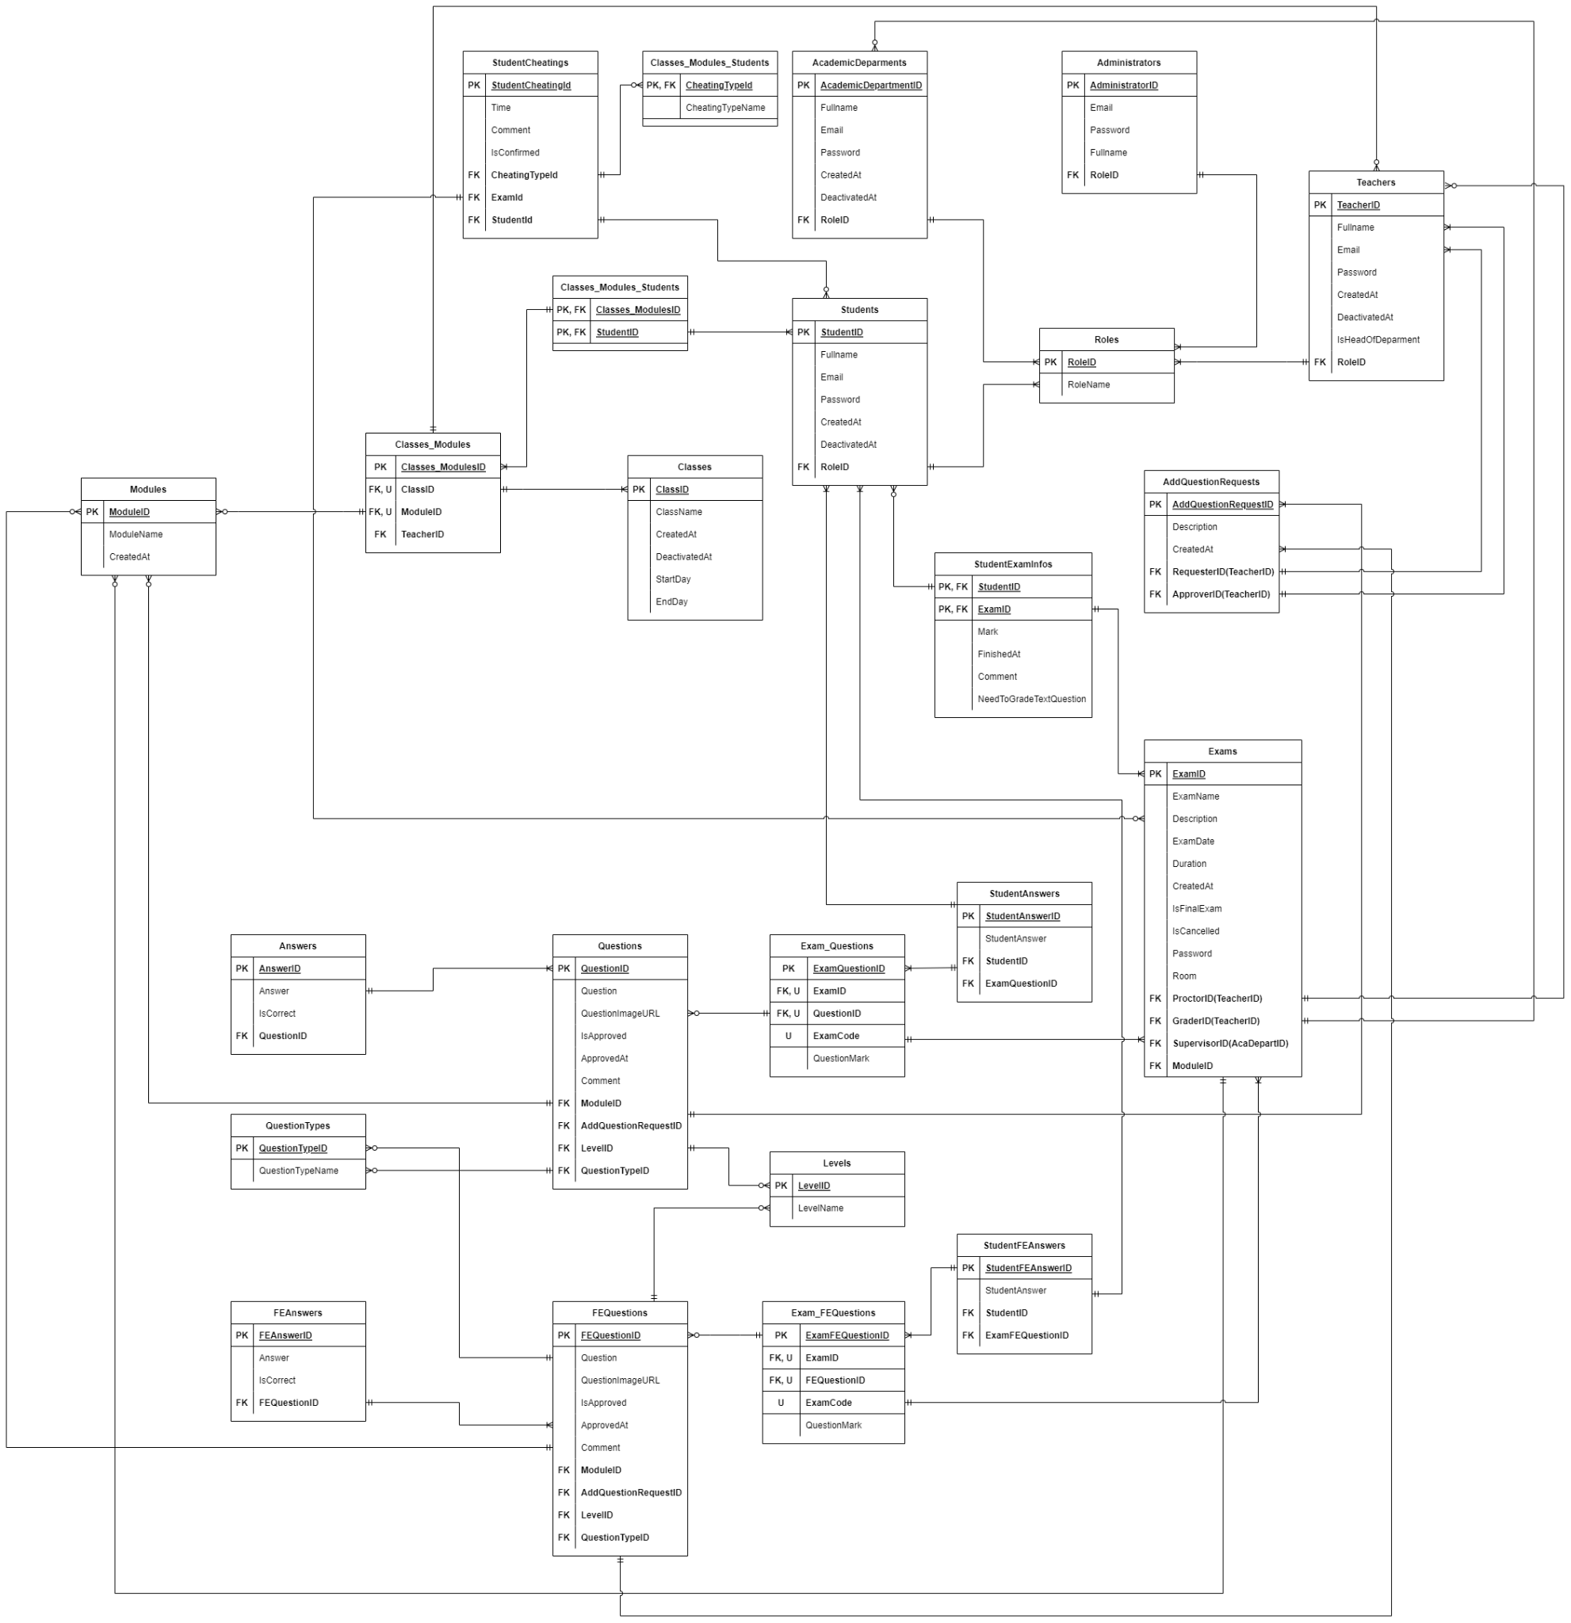
Figure 128. Database Design Diagram

a. AcademicDeparment Table
# | Field name | Type | Size | Unique | Not Null | PK/FK | Notes
1 | AcademicDepartmentId | SERIAL |  | ✓ | ✓ | PK
2 | Fullname | TEXT
3 | Email | TEXT
4 | Password | TEXT
5 | CreatedAt | TIMESTAMP |  |  | ✓
6 | DeactivatedAt | TIMESTAMP
7 | RoleId | INTEGER |  |  | ✓ | FK

b. AddQuestionRequest Table
# | Field name | Type | Size | Unique | Not Null | PK/FK | Notes
1 | AddQuestionRequestId | SERIAL |  | ✓ | ✓ | PK
2 | Description | TEXT
3 | CreatedAt | TIMESTAMP
4 | RequesterId | INTEGER |  |  | ✓ | FK
5 | ApproverId | INTEGER |  |  |  | FK

c. Administartor Table
# | Field name | Type | Size | Unique | Not Null | PK/FK | Notes
1 | AdministratorId | SERIAL |  |  | ✓ | PK
2 | Email | TEXT
3 | Password | TEXT
4 | Fullname | TEXT
5 | RoleId | INTEGER |  |  | ✓ | FK

d. Answer Table
# | Field name | Type | Size | Unique | Not Null | PK/FK | Notes
1 | AnswerId | SERIAL |  | ✓ | ✓ | PK
2 | QuestionId | INTEGER |  | ✓ | ✓ | FK
3 | AnswerContent | TEXT |  |  | ✓
4 | isCorrect | BOOL |  |  | ✓

e. CheatingType Table
# | Field name | Type | Size | Unique | Not Null | PK/FK | Notes
 | CheatingTypeId | INTEGER |  | ✓ | ✓ | PK
 | CheatingTypeName | TEXT |  | ✓ | ✓

f. ClassModuleStudent Table
# | Field name | Type | Size | Unique | Not Null | PK/FK | Notes
1 | Classes_ModuleId | INTEGER |  |  | ✓ | PK, FK
2 | StudentId | INTEGER |  |  | ✓ | PK, FK

g. Class Table
# | Field name | Type | Size | Unique | Not Null | PK/FK | Notes
1 | ClassId | INTEGER |  | ✓ | ✓ | PK
2 | ClassName | TEXT |  |  | ✓
3 | CreatedAt | TIMESTAMP |  |  | ✓
4 | StartDay | TIMESTAMP |  |  | ✓
5 | EndDay | TIMESTAMP |  |  | ✓
6 | DeactivatedAt | TIMESTAMP

h. ClassModule Table
# | Field name | Type | Size | Unique | Not Null | PK/FK | Notes
1 | ClassModuleId | SERIAL |  | ✓ | ✓ | PK
2 | ClassId | INTEGER |  | ✓ | ✓ | FK
3 | ModuleId | INTEGER |  | ✓ | ✓ | FK
4 | TeacherId | INTEGER |  |  | ✓ | FK

i. ExamFEQuestion Table
# | Field name | Type | Size | Unique | Not Null | PK/FK | Notes
1 | ExamFEQuestionId | SERIAL |  | ✓ | ✓ | PK
2 | ExamId | INTEGER |  | ✓ | ✓ | FK
3 | FEQuestionId | INTEGER |  | ✓ | ✓ | FK
4 | ExamCode | INTEGER |  | ✓ | ✓
5 | QuestionMark | REAL |  |  | ✓

j. Exam Table
# | Field name | Type | Size | Unique | Not Null | PK/FK | Notes
1 | ExamId | SERIAL |  |  | ✓ | PK
2 | ExamName | TEXT
3 | Description | TEXT
4 | ExamDay | TIMESTAMP |  |  | ✓
5 | DurationInMinute | INTEGER |  |  | ✓
6 | CreatedAt | TIMESTAMP |  |  | ✓
7 | IsFinalExam | BOOL |  |  | ✓
8 | IsCancelled | BOOL |  |  | ✓
9 | Password | TEXT
10 | Room | TEXT
11 | ProctorId | INTEGER |  |  | ✓ | FK
12 | GraderId | INTEGER |  |  | ✓ | FK
13 | SupervisorId | INTEGER |  |  | ✓ | FK
14 | ModuleId | INTEGER |  |  | ✓ | FK

k. ExamQuestion Table
# | Field name | Type | Size | Unique | Not Null | PK/FK | Notes
1 | ExamQuestionId | SERIAL |  | ✓ | ✓ | PK
2 | ExamId | INTEGER |  | ✓ | ✓ | FK
3 | QuestionId | INTEGER |  | ✓ | ✓ | FK
4 | ExamCode | INTEGER |  | ✓ | ✓
5 | QuestionMark | REAL |  |  | ✓

l. FEAnswer Table
# | Field name | Type | Size | Unique | Not Null | PK/FK | Notes
1 | FEAnswerId | INTEGER |  | ✓ | ✓ | PK
2 | FEQuestionId | INTEGER |  | ✓ | ✓ | FK
3 | AnswerContent | TEXT |  |  | ✓
4 | isCorrect | BOOL |  |  | ✓

m. FEQuestion Table
# | Field name | Type | Size | Unique | Not Null | PK/FK | Notes
1 | FEQuestionId | SERIAL |  | ✓ | ✓ | PK
2 | QuestionContent | TEXT
3 | QuestionImageURL | TEXT
4 | isApproved | BOOL
5 | ApproveAt | TIMESTAMP
6 | LevelId | INTEGER |  |  | ✓ | FK
7 | ModuleId | INTEGER |  |  | ✓ | FK
8 | QuestionTypeId | INTEGER |  |  | ✓ | FK
9 | AddQuestionRequestId | INTEGER |  |  | ✓ | FK

n. Level Table
# | Field name | Type | Size | Unique | Not Null | PK/FK | Notes
1 | LevelId | INTEGER |  | ✓ | ✓ | PK
2 | LevelName | TEXT |  |  | ✓

o. Module Table
# | Field name | Type | Size | Unique | Not Null | PK/FK | Notes
1 | ModuleId | SERIAL |  |  | ✓ | PK
2 | ModuleName | TEXT
3 | CreatedAt | TIMESTAMP |  |  | ✓
4 | ModuleCode | TEXT |  | ✓

p. Question Table
# | Field name | Type | Size | Unique | Not Null | PK/FK | Notes
1 | QuestionID | SERIAL |  |  | ✓ | PK
2 | QuestionContent | TEXT
3 | QuestionImageURL | TEXT
4 | ApproveAt | TIMESTAMP
5 | Comment | TEXT
6 | LevelId | INTEGER |  |  | ✓ | FK
7 | ModuleId | INTEGER |  |  | ✓ | FK
8 | QuestionTypeId | INTEGER |  |  | ✓ | FK
9 | AddQuestionRequestId | INTEGER |  |  | ✓ | FK
10 | isApproved | BOOL

q. QuestionType Table
# | Field name | Type | Size | Unique | Not Null | PK/FK | Notes
1 | QuestionTypeId | SERIAL |  |  | ✓ | PK
2 | QuestionTypeName | TEXT

r. Role Table
# | Field name | Type | Size | Unique | Not Null | PK/FK | Notes
1 | RoleId | INTEGER |  | ✓ | ✓ | PK
2 | RoleName | TEXT |  |  | ✓

s. Student Table
# | Field name | Type | Size | Unique | Not Null | PK/FK | Notes
1 | StudentId | INTEGER |  | ✓ | ✓ | PK
2 | Email | TEXT |  | ✓ | ✓
3 | Password | TEXT |  |  | ✓
4 | Fullname | TEXT |  |  | ✓
5 | CreatedAt | TIMESTAMP |  |  | ✓
6 | DeactivatedAt | TIMESTAMP
7 | RoleId | INTEGER |  |  | ✓ | FK
8 | ClassId | INTEGER |  |  | ✓ | FK

t. StudentAnswer Table
# | Field name | Type | Size | Unique | Not Null | PK/FK | Notes
1 | StudentAnswerId | SERIAL |  | ✓ | ✓ | PK
2 | StudentAnswerContent | TEXT
3 | ExamQuestionId | INTEGER |  |  | ✓ | FK
4 | StudentId | INTEGER |  |  | ✓ | FK

u. StudentCheating Table
# | Field name | Type | Size | Unique | Not Null | PK/FK | Notes
1 | StudentCheatingId | INTEGER |  | ✓ | ✓ | PK
2 | ExamId | INTEGER |  |  | ✓ | FK
3 | StudentId | INTEGER |  |  | ✓ | FK
4 | Time | TIMESTAMP |  |  | ✓
5 | Comment | TEXT
6 | IsConfirmed | BOOL |  |  | ✓
7 | CheatingTypeId | INTEGER |  |  | ✓ | FK

v. StudentExamInfos Table
# | Field name | Type | Size | Unique | Not Null | PK/FK | Notes
1 | ExamId | INTEGER |  | ✓ | ✓ | PK, FK
2 | StudentId | INTEGER |  | ✓ | ✓ | PK, FK
3 | Mark | FLOAT
4 | FinishAt | TIMESTAMP
5 | Comment | TEXT
6 | NeedToGradeTextQuestion | BOOL |  |  | ✓

w. StudentFEAnswer Table
# | Field name | Type | Size | Unique | Not Null | PK/FK | Notes
1 | StudentFEAnswerId | INTEGER |  | ✓ | ✓ | PK
2 | StudentAnswerContent | TEXT
3 | ExamFEQuestionId | INTEGER |  |  | ✓ | FK
4 | StudentId | INTEGER |  |  | ✓ | FK

x. Teachers Table
# | Field name | Type | Size | Unique | Not Null | PK/FK | Notes
1 | TeacherId | SERIAL |  | ✓ | ✓ | PK
2 | Email | TEXT |  | ✓
3 | Password | TEXT
4 | Fullname | TEXT
5 | isHeadOfDepartment | BOOL |  |  | ✓
6 | CreatedAt | TIMESTAMP |  |  | ✓
7 | DeactivatedAt | TIMESTAMP
8 | RoleId | INTEGER |  |  | ✓ | FK

V. Software Testing Documentation

1. Overall Description

1.1 Test Model
Because we use the Agile software development life cycle, Agile testing is the testing model we utilize in our project. Agile testing follows the rule of Agile, which is also known as an iterative and incremental model. We test various functionalities in every iteration and develop more completed deliverables after each one. If there are errors or unexpected changes, fixing bugs is essential along with evolving our product, which makes our web application comfortable and satisfying to users in the final release.

1.2 Testing Levels
Quality management is crucial in software development. Its primary purpose is to ensure the project meets all user requirements for software, success criteria, and quality standards. Quality management impacts all aspects of a software project, so it must be done precisely and carefully.
To ensure that our project quality meets the expectation, we use the following quality management method:
- Defect Prevention: Defect prevention is a technique that must be conducted early (especially in the design and implementation phase) throughout the software development lifecycle and by every team member, regardless of role. A minor defect can lead to a significant failure of the system. To prevent defects, all team members must participate in the requirement phase and communicate effectively to point out any misunderstanding or gap between their expectations and the software requirement. The team must also establish a convention for all software development life cycles (coding convention, communication convention).

- Reviewing: Reviewing can prevent defects and errors from becoming failures and help make maintenance easier. In this phase, the team members will analyse each other's code to find any defect, error, or violation in the coding convention. Reviewing saves the project a significant amount of resources by discovering any misunderstandings in the document and design phase (which cause defects). Based on this phase, the team members can learn early on from their mistakes and improve overall project quality.

- Unit testing: Aim for testing the smallest piece of code, this stage is conducted right after the programmer finishes coding a task, and it is a condition to move to integration testing. Unit testing helps the programmer or tester find the bug in the early stage and prevent them from causing severe failure in the future, reducing the cost of fixing the bug.

- Integration testing: Integration testing is conducted after unit testing and mainly focuses on testing logically combined modules or components of the software. After unit testing, the defect may remain in the software and lead to failure. As a combination of more than one module or component, a function (which is being tested) can be the work of a variety of team members so that misunderstanding can happen, and the function may not work as expected (although each unit is working correctly).

- System testing: In this stage, the system will be tested as fully functional software. System testing is black-box testing and must include a fully integrated system including environment and external peripherals. Its aim is to test the interaction between modules in the system and the interaction between the function being tested with the system as a whole.

- User acceptance testing: It is the last test phase before moving the application to production. User acceptance testing is conducted in real environments where the software will be used by its intended user, aiming for testing end-to-end business flow.

1.3 Testing Types
Functional testing is to test all the functionality of the system by providing input and validate the output. The purpose of functional testing is to make the software system become more stable and make sure all the functions are working as expected. This type of testing focus on testing all the main functions of the application, basic usability testing, it also check the accessibility of the system and the error condition to make sure the error message are displayed properly.
Interface testing is to make sure that the system have a good design structure which will make the user interface and the user experience work as expected. Interface testing include guaranteeing that clients have no problems when utilizing the software system and whether the errors are handled in a proper way. It also check the security when connecting all the components of the software system.

2. Test Plan

2.1 Test Stages
Type of Test | Stage of Test
 | Unit | Integration | System | Acceptance
Function Test | X | X | X | X
User Interface test |  |  | X | X
Performance Tests |  |  | X | X

2.2 Resources

a. Human Resources
Worker/Doer | Role | Specific Responsibilities/Comments
MinhDN | Tester | Responsible for testing system Server API and Web UI
KhangTD | Tester | Responsible for testing system Server API and Web UI
MinhHK | Tester | Responsible for testing system Server API and Web UI
ThoTA | Tester | Responsible for testing system Server API and Web UI
ToanTK | Tester | Responsible for testing system Server API and Web UI

b. Environment
Purpose | Tool | Provider | Version
Unit Testing | Nunit | .NET Foundation | 2.6.4
Integration Testing | Manual | Team
System Testing | Manual | Team
Acceptance Testing | Manual | User

2.3 Test Milestones
Milestone Task | Effort (md) | Start Date | End Date
Complete the Unit Test | 10 | 1/11/2022 | 11/11/2022
Complete the Integration Test | 3 | 11/11/2022 | 14/11/2022
Complete the System testing | 3 | 14/11/2022 | 17/11/2022
Complete the Acceptance testing | 3 | 17/11/2022 | 20/11/2022

2.4 Deliverables
No | Deliverables | Due Date
1 | Complete the Unit Test report | 20/11/2022
2 | Complete the Integration Test report | 20/11/2022
3 | Complete the System Testing report | 20/11/2022
4 | Complete the Acceptance Testing report | 20/11/2022

3. Test Cases
- Unit Test Cases: Report5_Unit Test Case.xls
- Other Test Cases: Report5_ Test Case.xls

4. Test Reports

Unit Test Case
Figure 129. Unit test report

Other Test Cases
Figure 130. Other test case report

VI. Release Package & User Guides

1. Deliverable Package

1.1 Source codes & documents
No. | Items | Sub-Items | Type | Version
Code Package
1 | ExamEdu system | ExamEdu Web | New | 1.0
 |  | ExamEdu API | New | 1.0
2 | ExamEdu Cheating Prediction | ExamEdu Prediction Model | New | 1.0
 |  | ExamEdu Training Code | New | 1.0
Database
1 | Tables | ExamEdu.tar | New | 1.0
Documents
1 | Report 1 |  | New | 1.0
2 | Report 2 |  | New | 1.0
3 | Report 3 |  | New | 1.0
4 | Report 4 |  | New | 1.0
5 | Report 5 |  | New | 1.0
6 | Report 6 |  | New | 1.0
7 | Report 7 |  | New | 1.0

1.2 Known Issues, Limitations & Restrictions
- The ExamEdu web application needs to use the Safe Exam Browser to take the exam.
- The system needs to be connected to the internet during use.

2. Installation Guides

2.1 System Requirements
For server:
- Operating system: Windows 10
- Interpreter/compiler: Python 3.8, .NET 5
- Storage: 40GB HDD available
- RAM: 4GB or higher
- CPU: Intel Core i5-825U or higher
- Database: PostgreSQL 14 or newer
For web client:
- Operating system: Windows 10, macOS 10.13
- Browser: Google Chrome 90, Safari 14.0.3 (macOS), Safari 14 (iOS), Microsoft Edge 89.0 or newer.

2.2 Setup Files
- examedu.zip
- examedu-client.zip
- examedu.tar
- DeepLearningAPI.zip
- .vsconfig

2.3 Installation Instruction
- Install PgAdmin and PostgreSQL
Download PostgreSQL version 15 at Download Page, run the installer to complete the setup.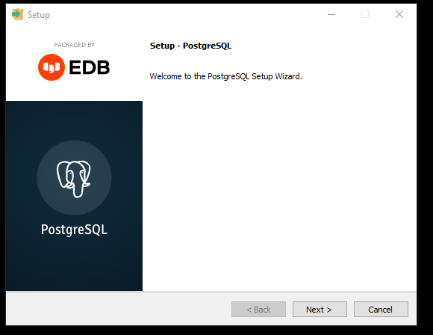
Figure 131. Setup PostgreSQL
Then continue to install the Stack Builder to complete your PostgreSQL installation.
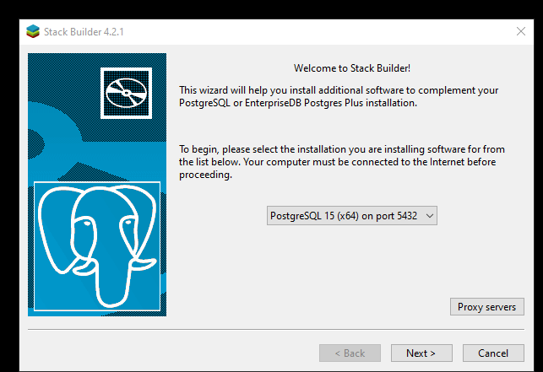
Figure 132. Setup StackBuilder
Next, download pgAdmin 4 at the Download page and run the installer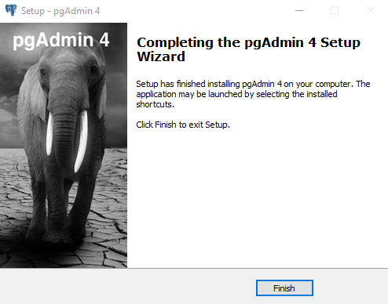
Figure 133. Setup pgAdmin 4
Open pgAdmin 4 and set the software password.
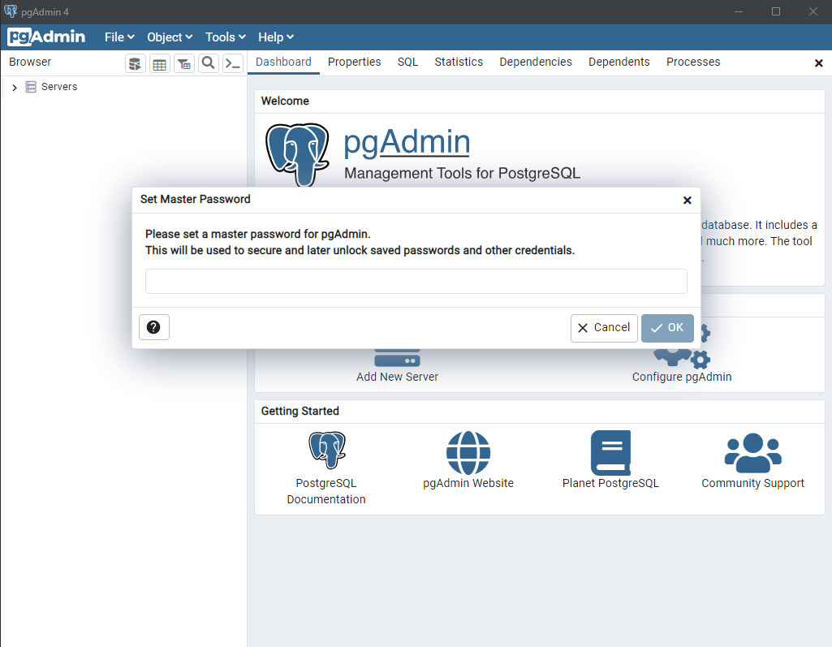
Figure 134. Create password for pgAdmin 4
Create a local database on pgAdmin, remember to put localhost in the Host Name field, then click “Save”.
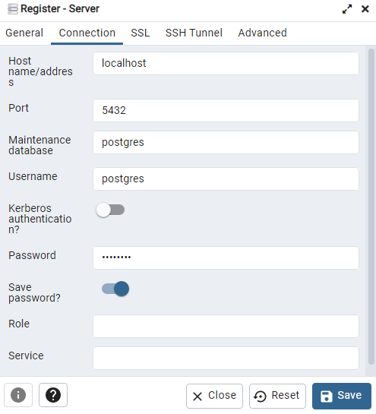
Figure 135. Setup new database properties
Import the database schema into the just-created database. In the Filename field, select the .tar file to restore the database. After you completed that, hit “Restore”.
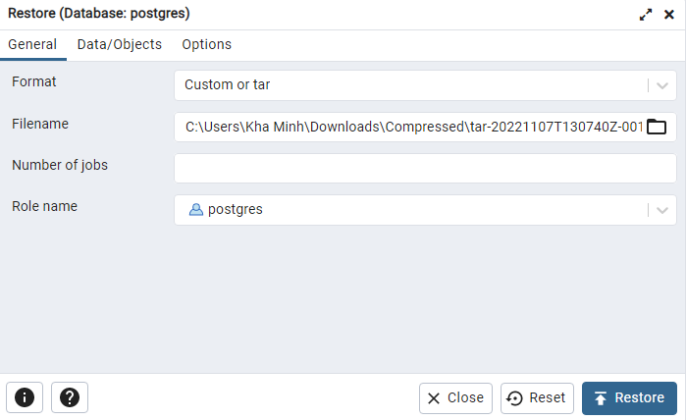
Figure 136. Restore database
- Install Model AI
Download Windows installer (64-bit) from here, run the installer and click next on the installer until finishes to install Python.
Extract the DeepLearningAPI.zip and install these dependencies:
fastapim uvicorn, numpy, tensorflow-cpu, python-multipart, pillow
Open a terminal inside the extracted folder and run the following command in terminal to install dependencies: python -m pip install -r requirements.txt
Run the follow command to start the server: uvicorn main:app --host 0.0.0.0 --port 80
Your deep learning server is now running on http://0.0.0.0:80
- Install Visual Studio 2022
Download the Visiual Studio 2022 Installer at the Download Page, open the installer, in the “More” button of the Visual Studio Community 2022 tab, select import configuration in order to auto select the right environment for the projects, select the vsConfig file to start the auto downloading and installation.
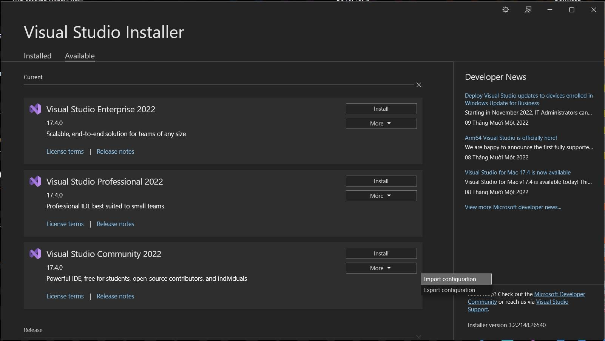
Figure 137. Choose import configuration
- Install the Nodejs Environment
Download the installer at the Downloads page, run the installer to compete the installation.
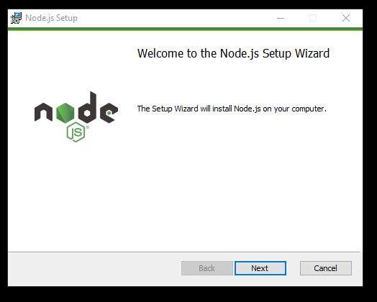
Figure 138. Setup Node Js

- Open the API project and the client project on Visual Studio 2022
Remember to extract the examedu.zip and examedu-client.zip.
First, open Visual Studio 2022, choose the “Open a project or solution”, then choose the ExamEdu.sln file in the ExamEdu folder, after that, click the “IIS Express” button to run the API project.
Next, open another Visual Studio 2022 window, choose the “Open a local folder”, then choose the ExamEdu-Client folder.
Wait for the project to load, right click on the package.json file, choose the NPM section and click the Install missing npm package, wait for it to complete.
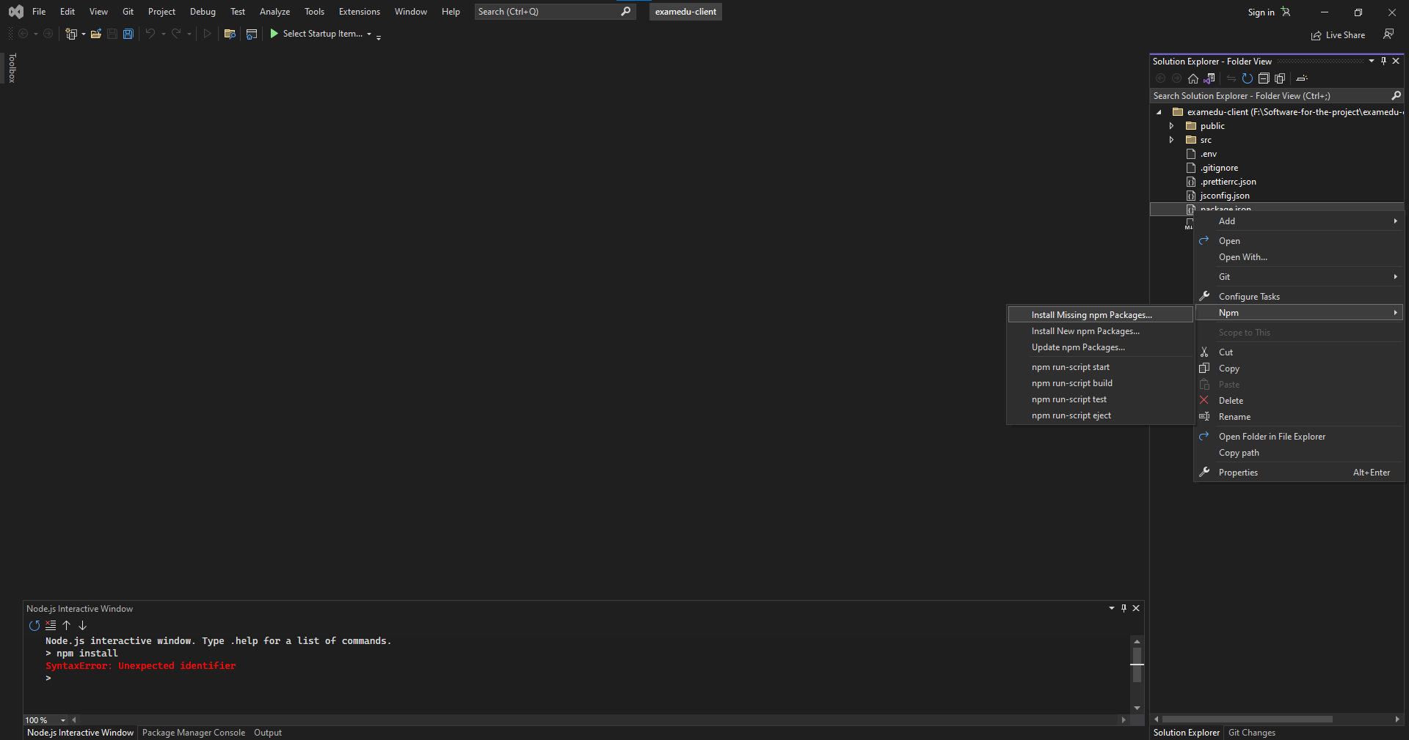
Figure 139. Install the missing package
In the Pakage Manager Console, type in “npm start” to run the client project.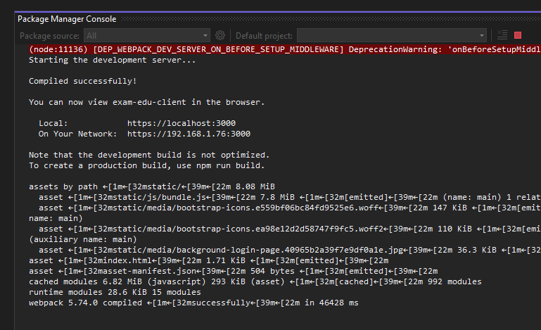
Figure 140. Run the project
After completion, your application should be ready on port 3000.

3. User Manual

3.1 Terms and definitions
No | Term and definition | Description
1 | User | All users in the system, including administrator, academic department, student, teacher, and head of department.
2 | Administrator | An user who has the role of administrator and is allowed to manage user accounts of the system.
3 | Academic Department | An user who has the role of academic department and is responsible for managing classes, modules, exams,...
4 | Student | An user who has the role of student and is allowed to take exams, and view their mark report.
5 | Teacher | An user who has the role of teacher and is responsible for managing their class, create exam,...
6 | Head of Department | An user who has the role of head of department who just like the role of teacher but also are responsible for assigning teacher to execute the add question to the question bank.

3.2 System requirements
For server:
- Operating system: Windows 10
- Interpreter/compiler: Python 3.8, .NET 5
- Storage: 40GB HDD available
- RAM: 4GB or higher
- CPU: Intel Core i5-825U or higher
- Database: PostgreSQL 14 or newer
For web client:
- Operating system: Windows 10, macOS 10.13
- Browser: Google Chrome 90, Safari 14.0.3 (macOS), Safari 14 (iOS), Microsoft Edge 89.0 or newer.

3.3 Application Usage

a. Overview
Our system has 5 roles (Administrator, Academic Department, Student, Teacher, and Head of Department). All the users have all of the following features:
- Login
- Logout
- Forgot password
An Administrator is the actor who can perform all of the following features:
- Manage system’s account
- View deactivated account list
An Academic Department is the actor who can perform all of the following features:
- Manage Class
- Manage Module
- Manage Exam
A Teacher is the actor who can perform all of the following features:
- View module list
- Manage Exam
- Export excel module’s exam results
- View exam result, analysis
- Create exam paper
- Grade written questions
- View request Add question bank
- Approve/Reject request to add question
- Request add new question to question bank
A Student is the actor who can perform all of the following features:
- View exam schedule
- View exam questions
- Submit exam
- Mark report
- View module list
A Head of Department is the actor who can perform all of Teacher’s features and the following features:
- Assign teacher to process add question request

b. Authentication
- Login
Before using any system feature, the user must log in first. When a user accesses the system, a login page will be shown up as a default page (Figure 141) and allow them to input their email and password.

Figure 141. The login page
If user leaves the input field blank or tries to log in with an invalid account, the system will show a corresponding error message (Figure 142, 143, 144, 145).

Figure 142. Error displayed when user does not inputs

Figure 143. Error displayed when user inputs invalid email format
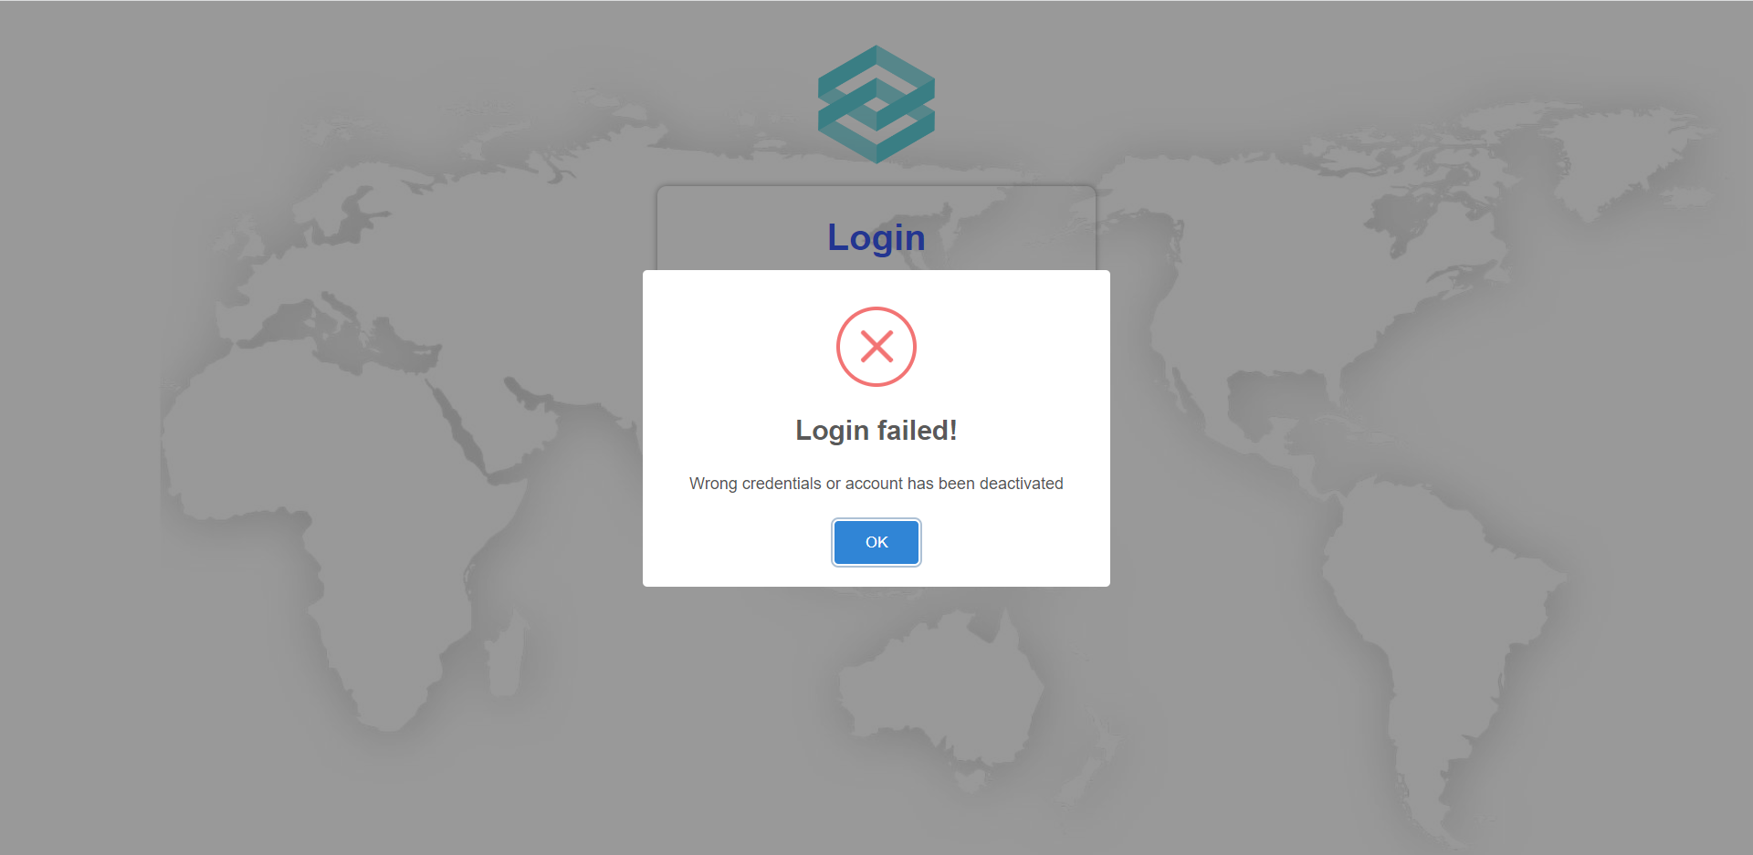
Figure 144. Error displayed when user inputs wrong email or password


Figure 145. Error displayed when user logs in with a deactivated account
After user enters a valid account and clicks on the “Login” button, the system will direct user to main page based on their account role.
- Logout
When user wants to log out from the system and go back to the login page, they can click on the logout icon in the top right corner regardless of the page they are using (Figure 146).

Figure 146. The logout icon
- Forgot password
User can click on the “Forgot Password?” link on the login page to be redirected to the forgot password page in order to reset their password and receive a newly generated password in their email (Figure 147, 148).

Figure 147. The “Forgot Password?” link

Figure 148. The forgot password page
If user leaves the input field blank or tries to log in with an invalid email address, the system will show a corresponding error message (Figure 149, 150, 151).

Figure 149. Error displayed when user does not input

Figure 150. Error displayed when user inputs invalid email format
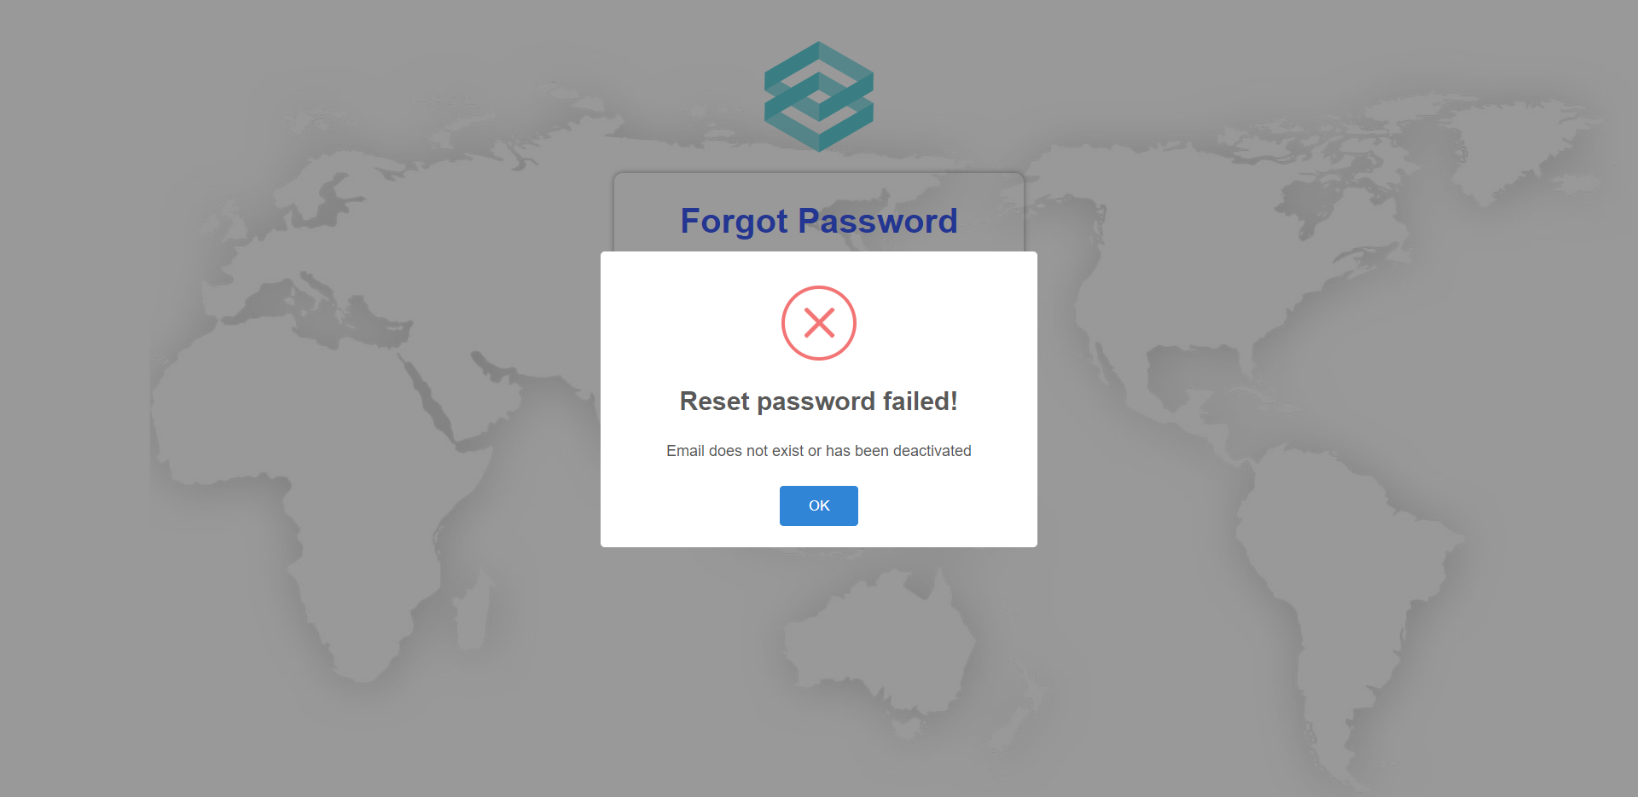
Figure 151. Error displayed when user inputs email not exist
If user inputs a valid email address and click “Get New Password” button, system will send an email containing a newly generated password to the user’s email address and show a success message (Figure 152).
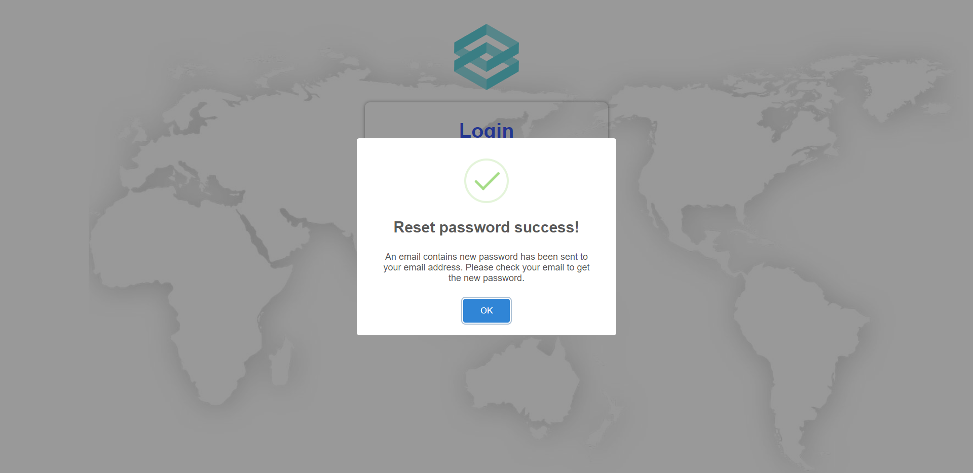
Figure 152. The reset password success message

c. Role Administrator
- Manage Account
1.1 View Account List
- After login as Administrator, an Account List will be displayed.

Figure 153. Account list page
1.2 Update Account
-On the main page (Account List Page) click on the [Update account] icon.
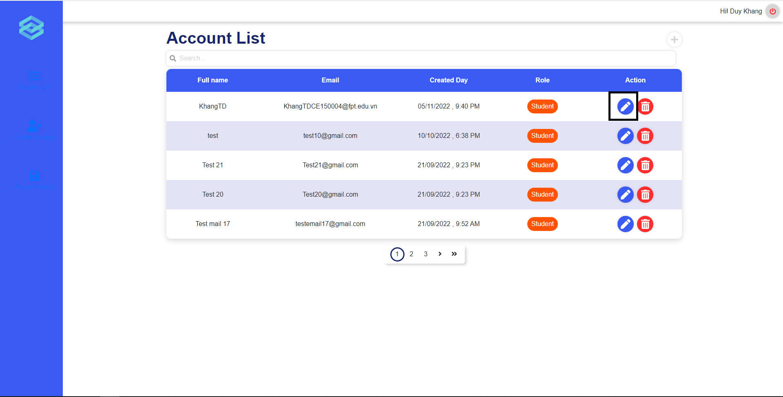
Figure 154. Edit button on Account list page
-A popup will be shown, from which you can change information in the full name and email field of the popup, and click the [Save change] button to update account information.
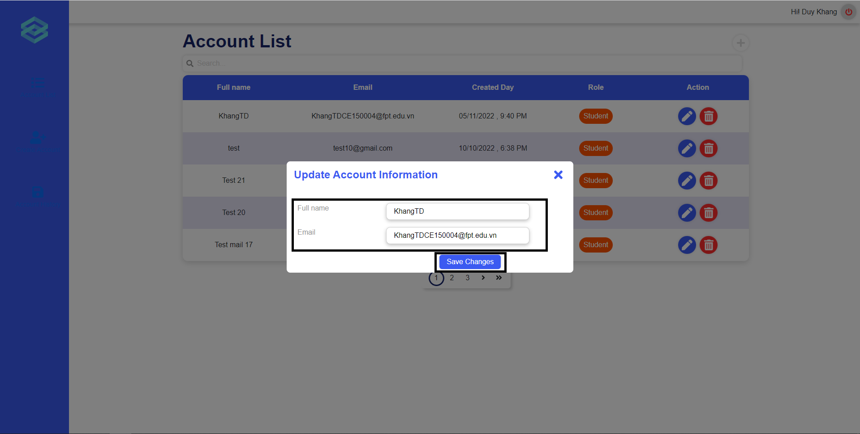
Figure 155. Update account page
1.3 Delete Account
-On the main page (Account List Page) click on the [Delete account] icon
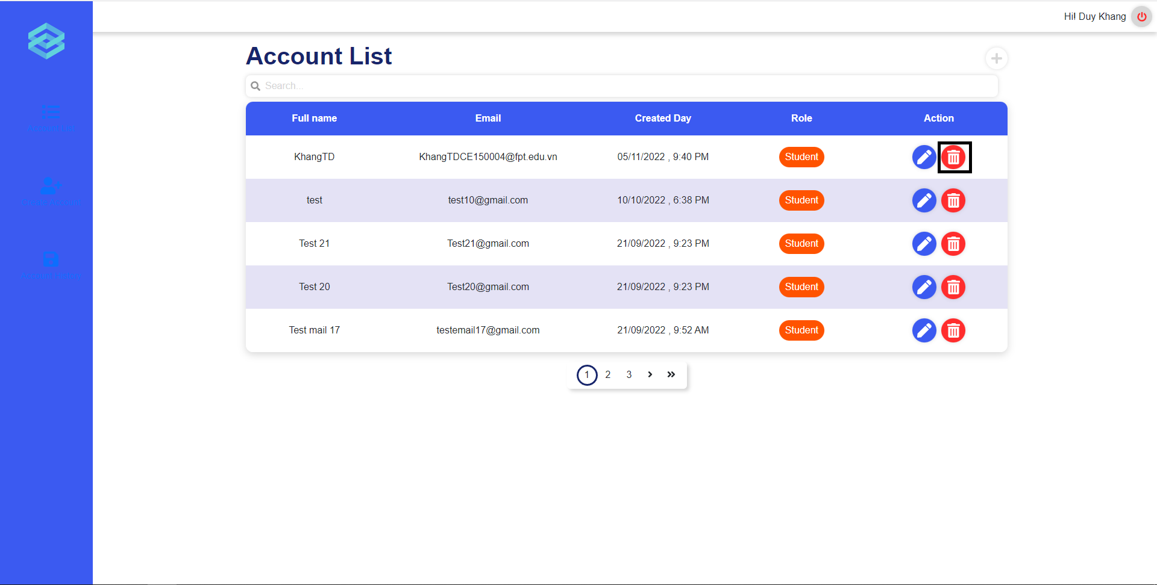
Figure 156. Delete button on Account page
-A popup will be shown, from which you can confirm before deleting. Click on [Confirm] button to delete the account, [Cancel] button to close the popup and cancel the delete.
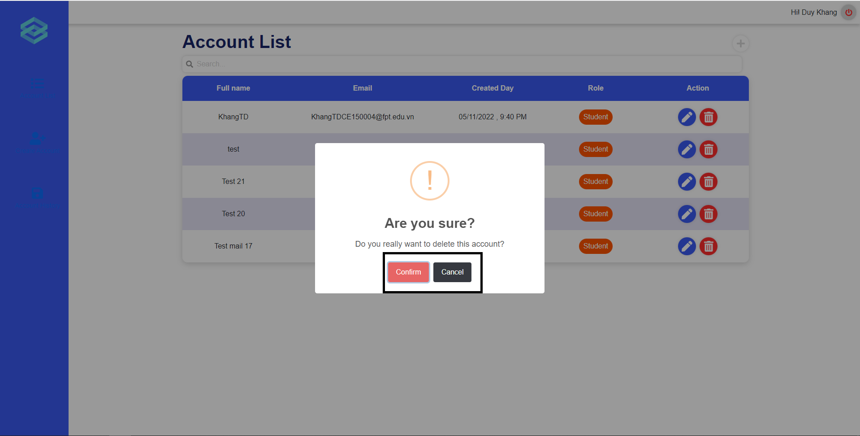
Figure 157. Delete account confirm
1.4 Create Account
-Click on the [Create Account] button on the left vertical navigation bar
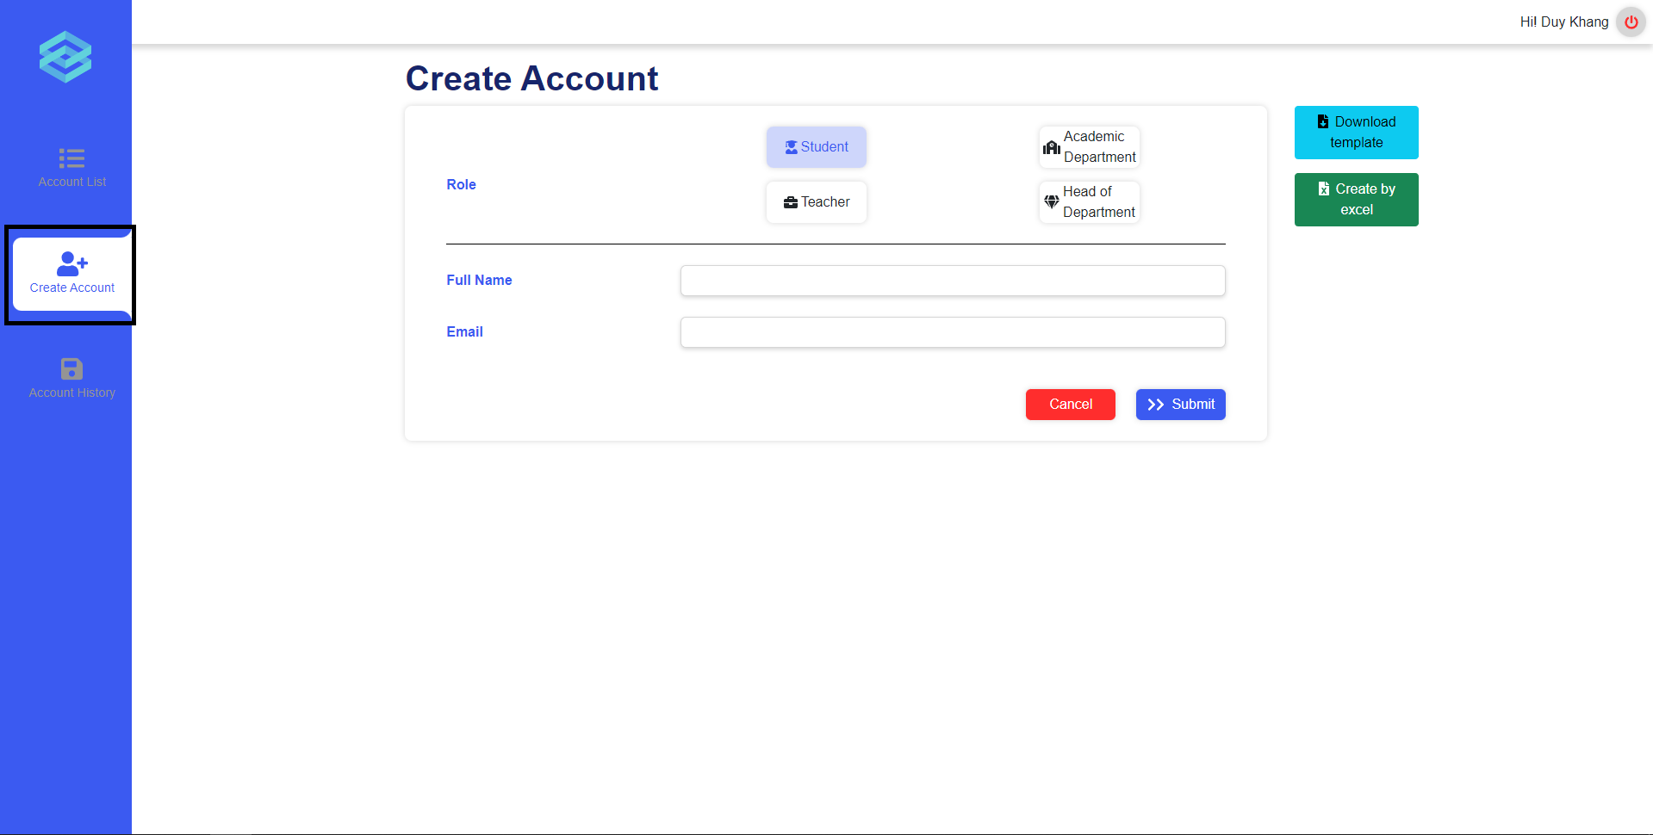
Figure 158. Create new accounts page
-Fill in all the information and click the [submit] button to create a new account.
- View Deactivated Account
-Click on the [ Account History] button on the left vertical navigation bar
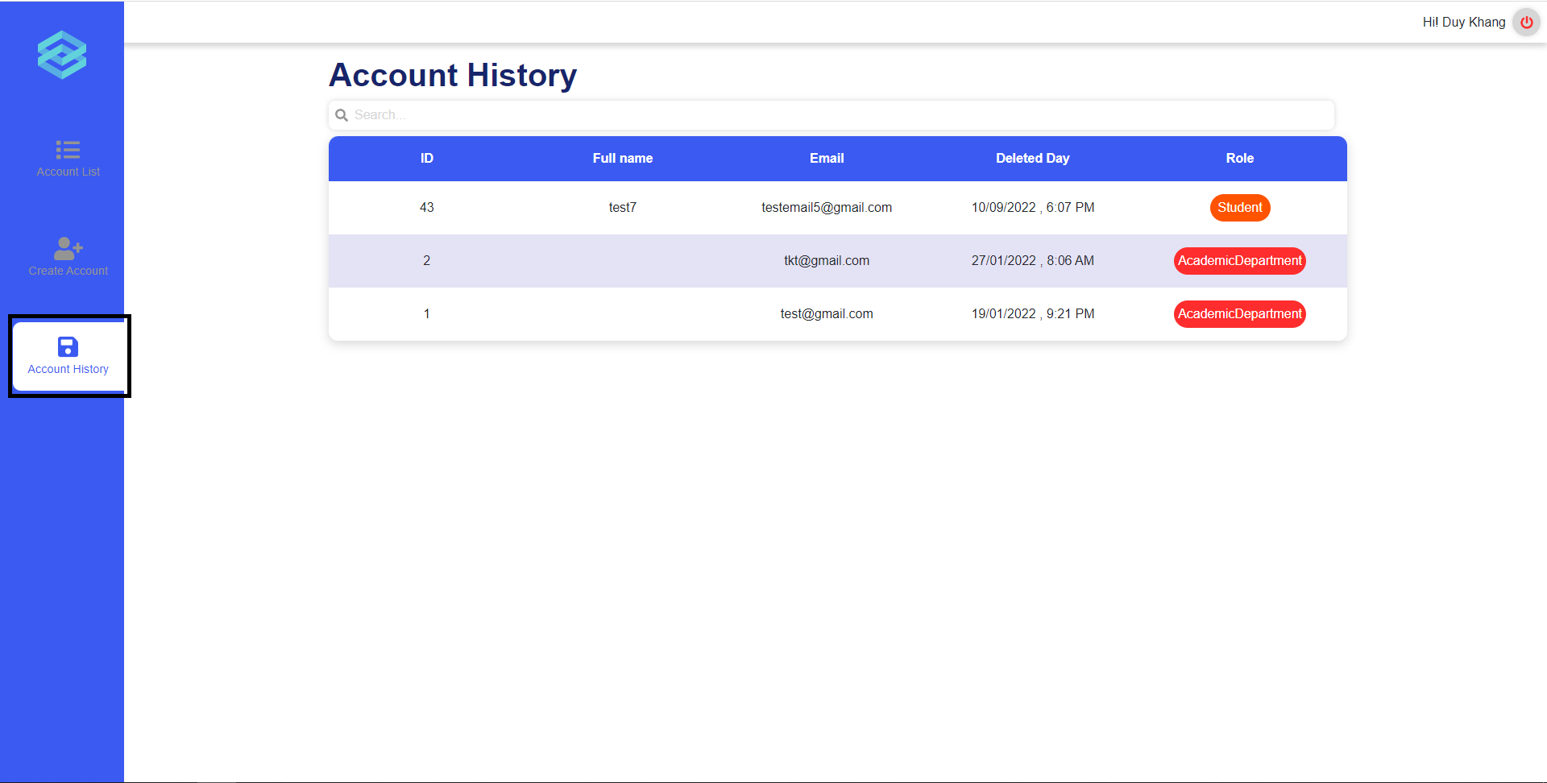
Figure 159. Account history page
- Create account by excel
-Click on the [Create Account] button on the left vertical navigation bar

Figure 160. Create account by excel
-Click on the [Download template] button to download the excel template
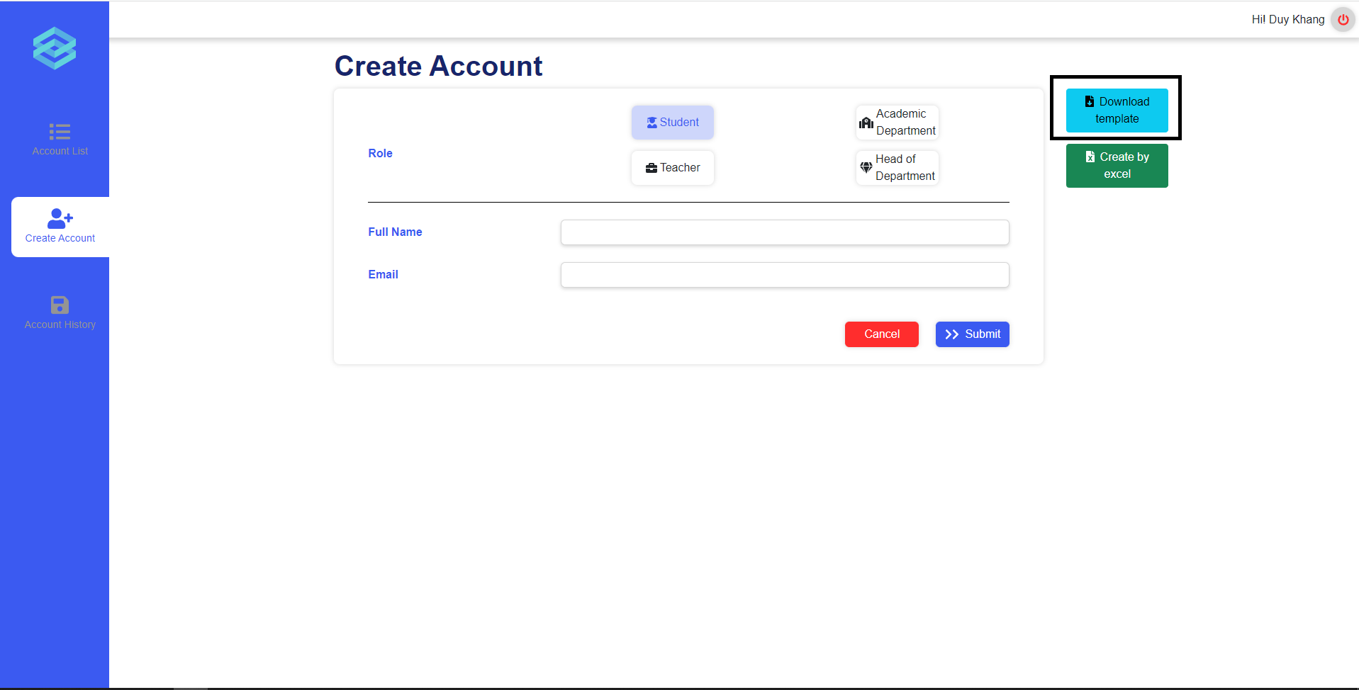
Figure 161. Download button on create account page
-Fill in all the information in excel template and click on the [Create By Excel] button.
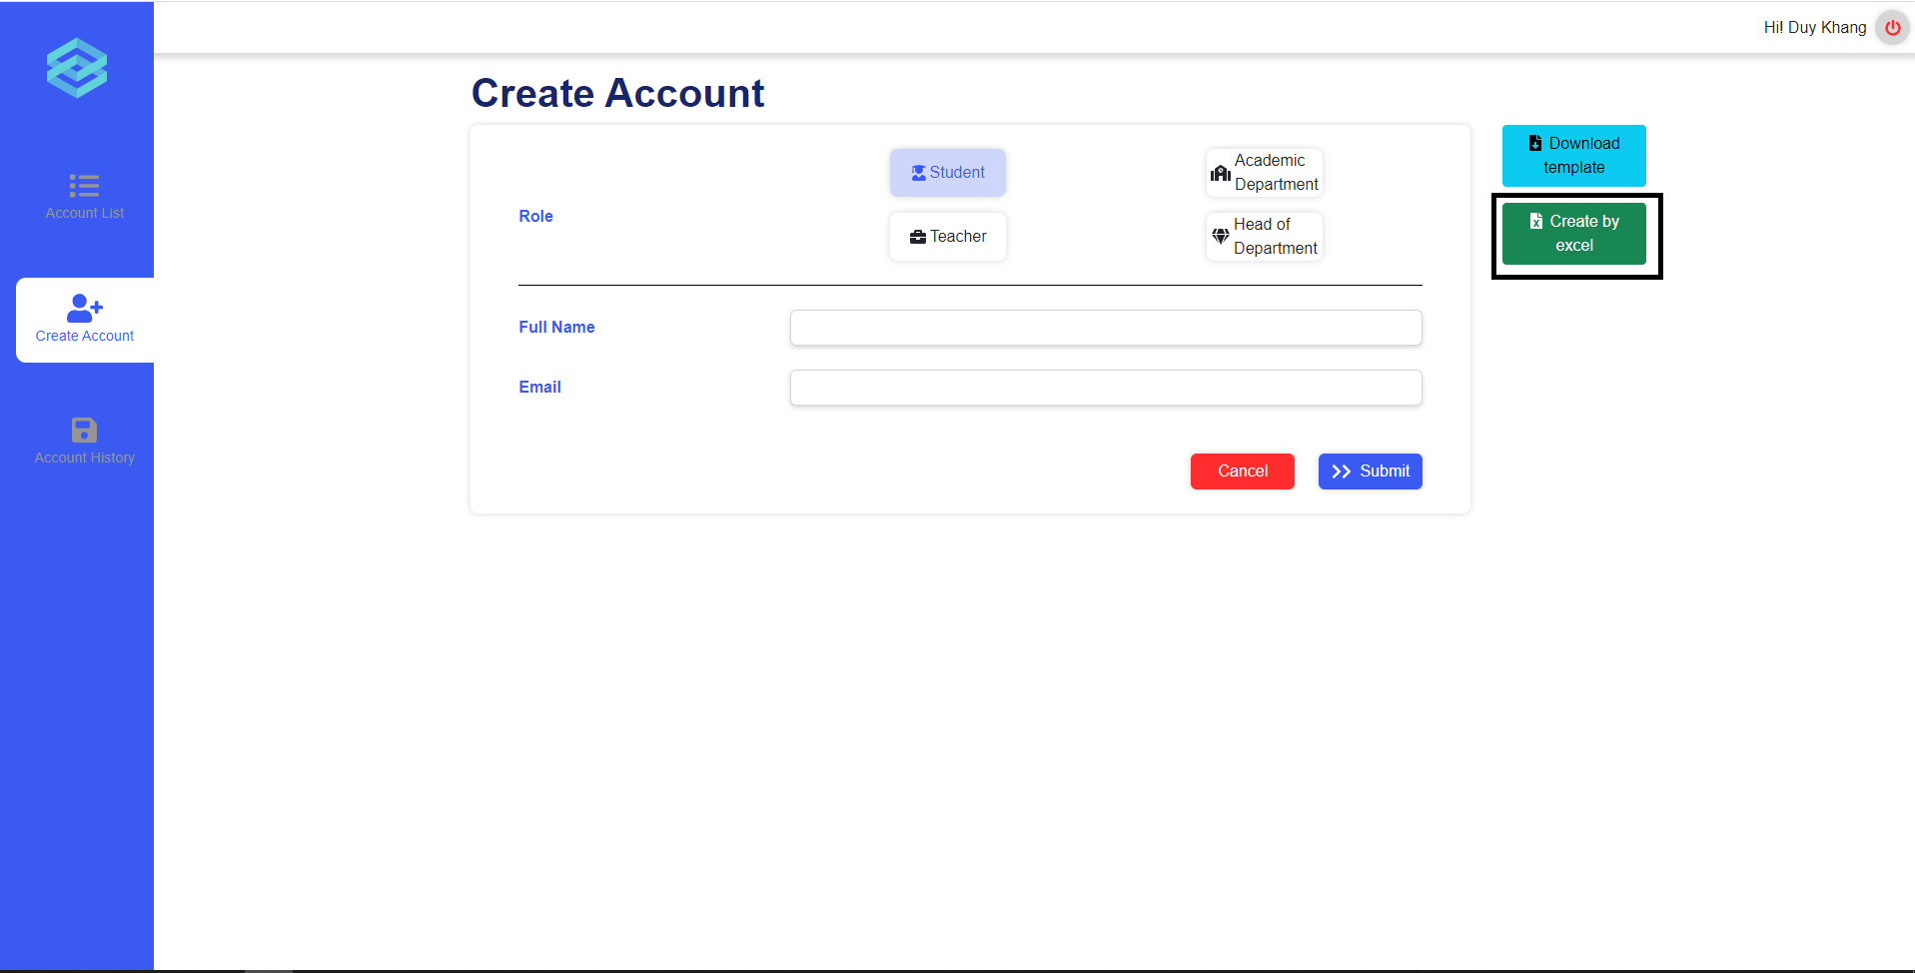
Figure 162. Excel upload button on create account page
-A popup will show. Click on the [Choose file] button and choose the excel file you have filled in in the previous step, after that click on the [submit] button.
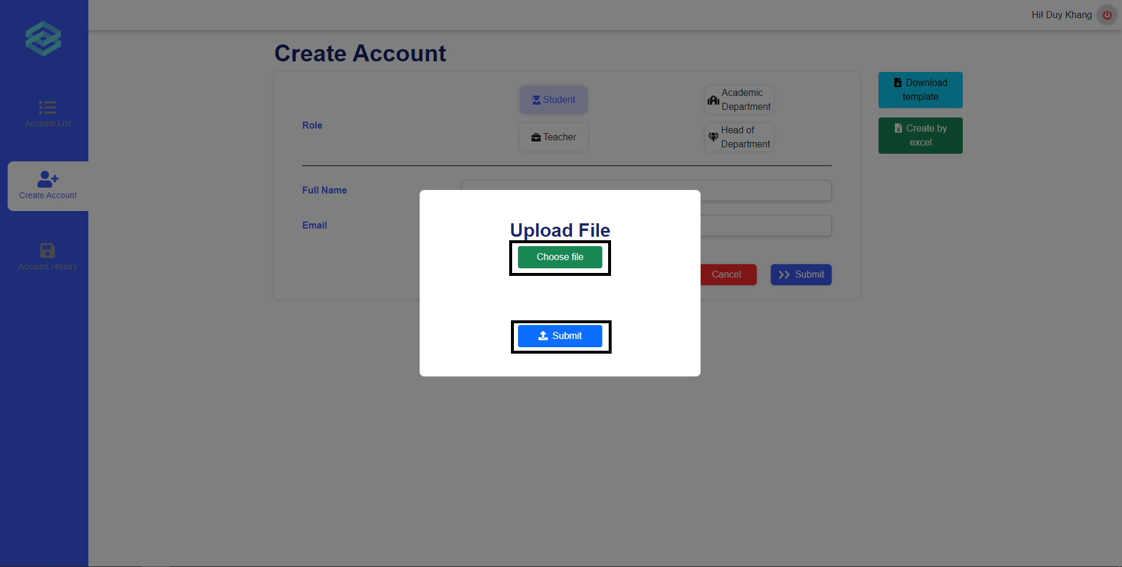
Figure 163. Upload file

d. Role Academic department
- Manage modules
The academic department can perform module related activities from the module list page.

Figure 164. Create module button
They can click on the plus icon to start creating a new module.

Figure 165. Create module form
After they click the plus icon, a pop up will appear prompting them to input the new module’s code and module’s name. They can then click Confirm to create a new module.

Figure 166. Create module confirm
After clicking confirm, a pop up will appear asking for confirmation. If the user clicks “Yes”, a new module will be created. If the user clicks “Cancel”, they will exit the pop ups.

Figure 167. Module list page
The user can start updating a module by clicking on the edit icon in the actions column for a specific module.

Figure 168. Update module form
After clicking the edit icon, a popup will appear, allowing the user to enter a new module’s name. The user can then click Confirm to proceed.

Figure 169. Update module confirm
After clicking confirm, a popup will appear asking for the user’s confirmation. If the user clicks “Yes”, then the module will be updated. If the user clicks “Cancel” then they will exit the popups.
- Manage classes
Users can perform create new class from the class list page by clicking on the plus icon at the top-right of the page.
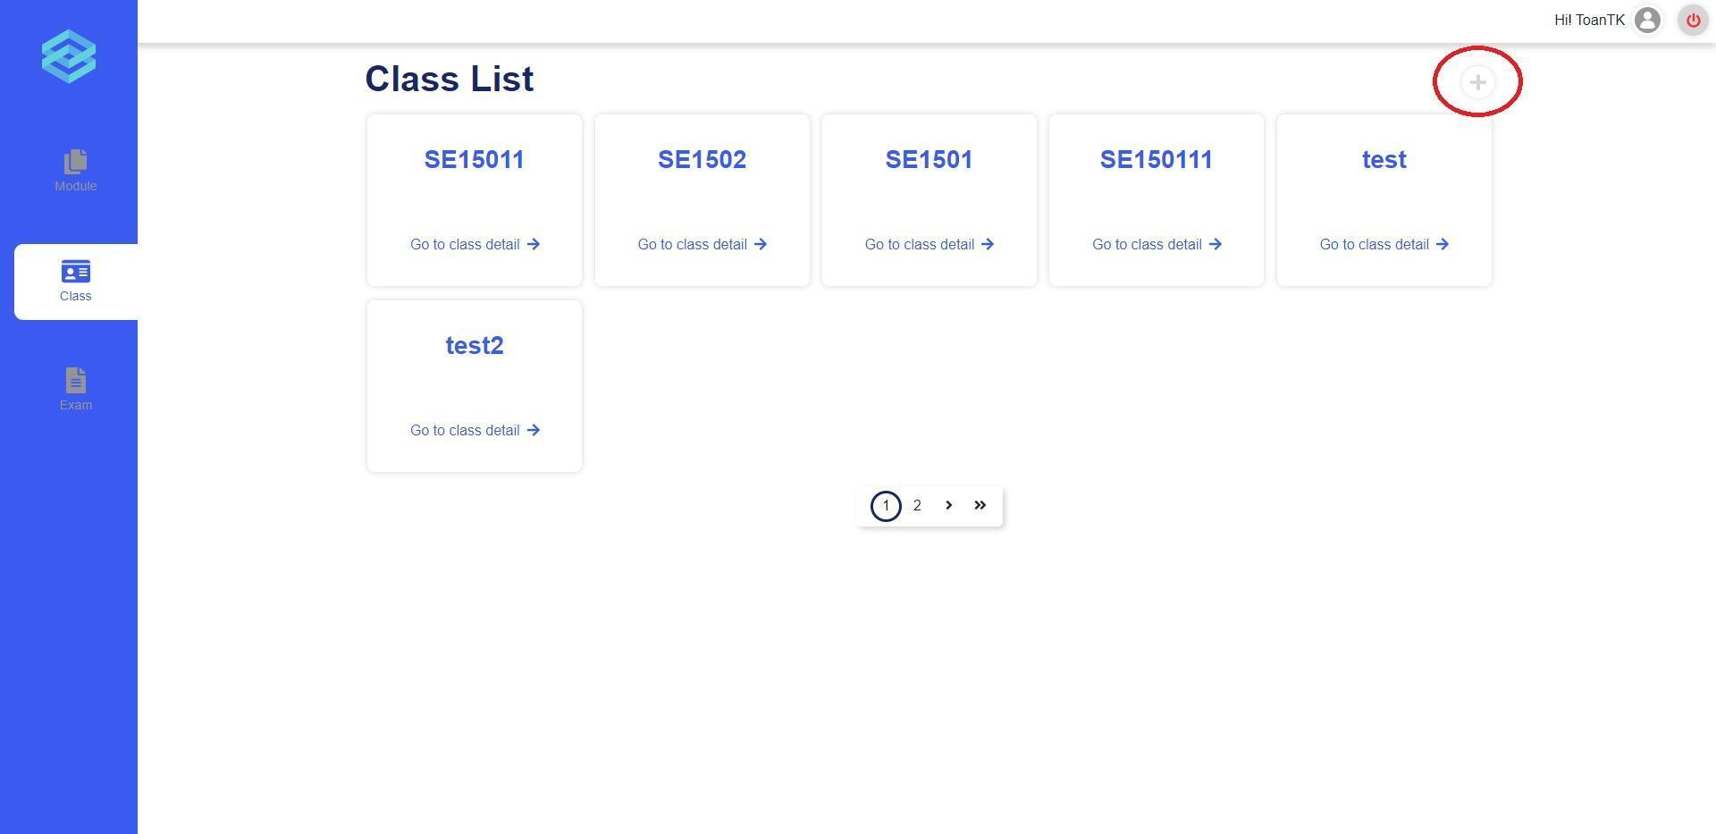
Figure 170. Create class button
The create class form is a multi-level form, user need to fill in all the input fields of all section on the left hand side.
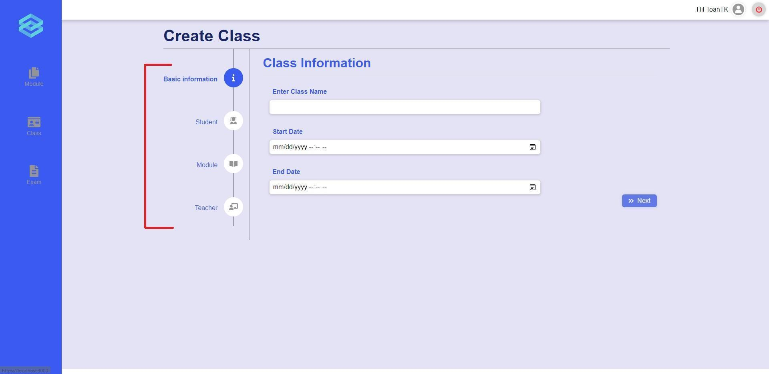
Figure 171. Create class form
Otherwise, by clicking on each class, users are provided a class detail page where all the class information is displayed. User can choose to Update class information or go into detail of each module of the class.
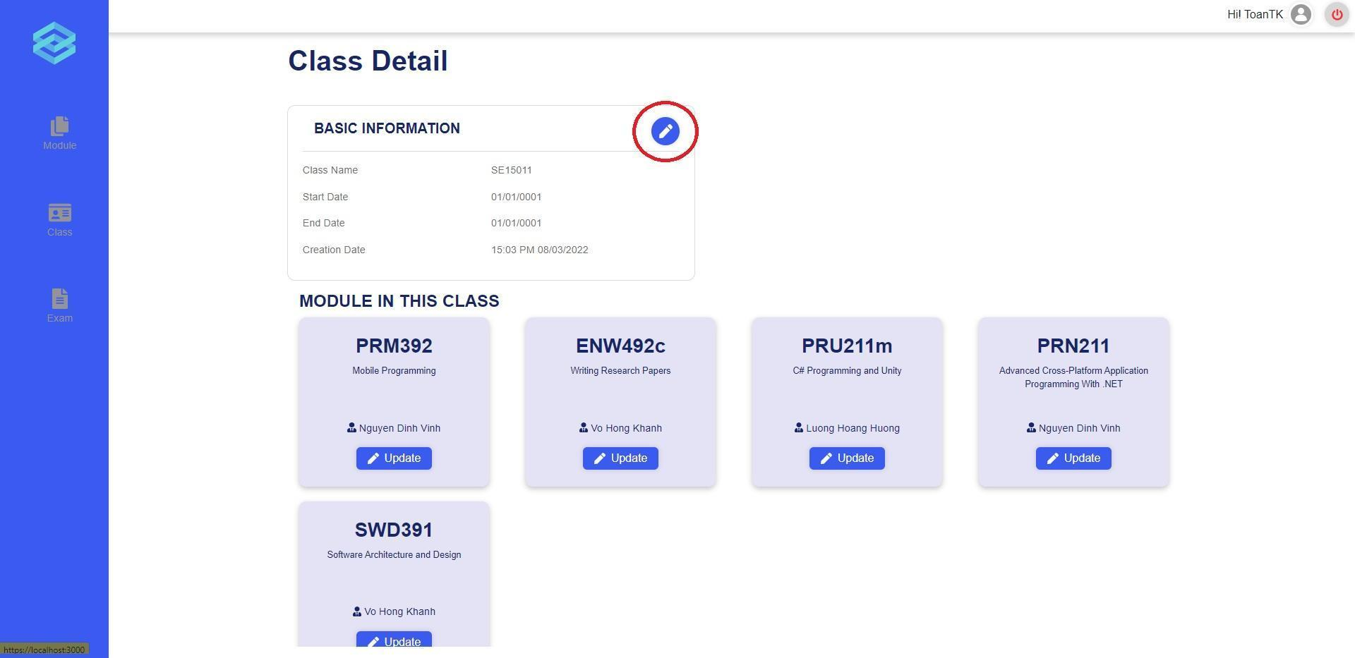
Figure 172. Update class button
To update class information, user just need to edit the text in the input and click “Save Change” to confirm when user is done.
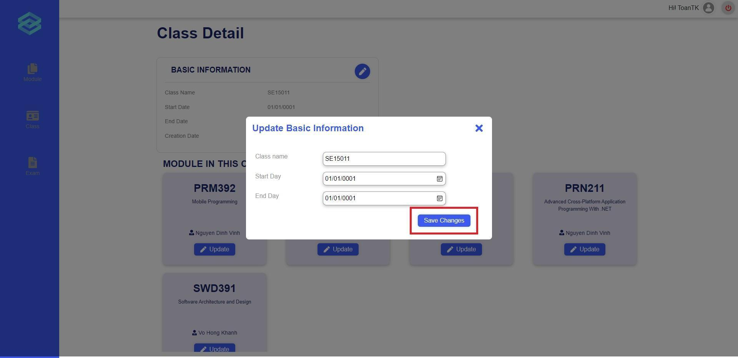
Figure 173. Update class button
- Manage exams
User can start performing exam related activities from the Exam list page.

Figure 174. Create Exam button
The user can start creating a new exam by clicking on the plus icon.

Figure 175. Create Exam button
After clicking the plus icon, the user will be redirected to the create exam page. Here, the user are prompted to input the required information in 4 steps. Step 1, they are required to fill in the Exam Name, Duration and Date. The fields description, room and password are not required. Only if the user has filled all required fields, will the “Next” button be lit up and the user can click on it to proceed.
After successfully filling all the information, the user can click the submit button to create the exam. The program will show a popup asking for the user’s confirmation. If the user agrees to proceed, the exam will be created and they will be redirected to start creating the problem sets for the exam.

Figure 176. Exam detail page
The user can also access the detail page by clicking on the “Detail” button in the “Action” column for a specific exam. After clicking on the “Detail” button, the user will be redirected to the Detail page. Here the user can view the detail of the exam, and they can also update the exam’s information or cancel the exam.

e. Role Teacher
- Manage exams
1.1. Create exam
After login in successfully with the teacher’s account, user can click on the “Create Exam” icon on the vertical navigation bar to go to a create exam page (Figure 177).
Here, user is prompted to input the required information in 3 steps:
- Step 1, user is required to fill in the Exam Name, Duration, and Date. The fields description, room, and password are not required. Only if the user has filled all required fields, will the “Next” button be lit up and the user can click on it to proceed (Figure 177).

Figure 177. The create exam page in step 1
- Step 2, user is required to select a module for the exam, every time they choose a module in the list, that module code and name will be displayed on the “Chosen Module” tab. After choosing the module, the “Next” button will be lit up and user can click on it to proceed (Figure 178).

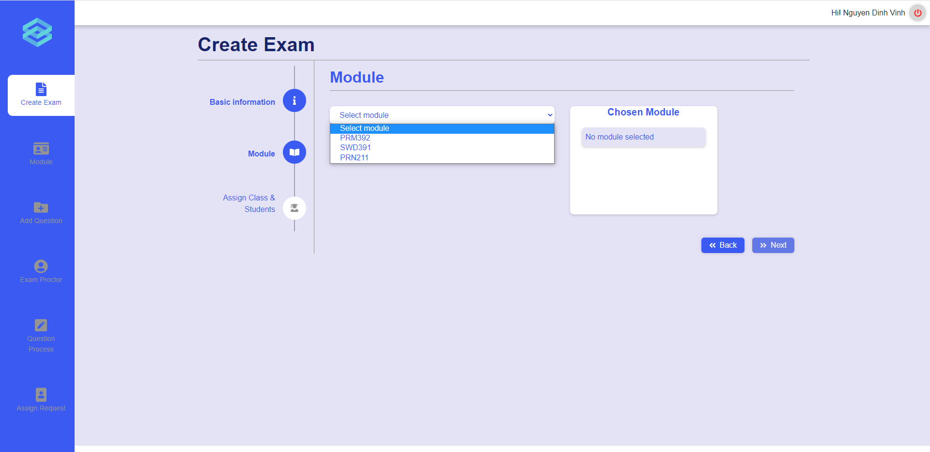
Figure 178. The create exam page in step 2
- Step 3, user is required to assign a class or students to take the exam. User can click on the tab “Class” or “Student” to switch between assigning a class or students. Every time user chooses a class or students, similar to step 2, the name of that class or students will be displayed on the right tab (Figure 179, 180). User is able to assign one class and one or multiple students to take the exam.
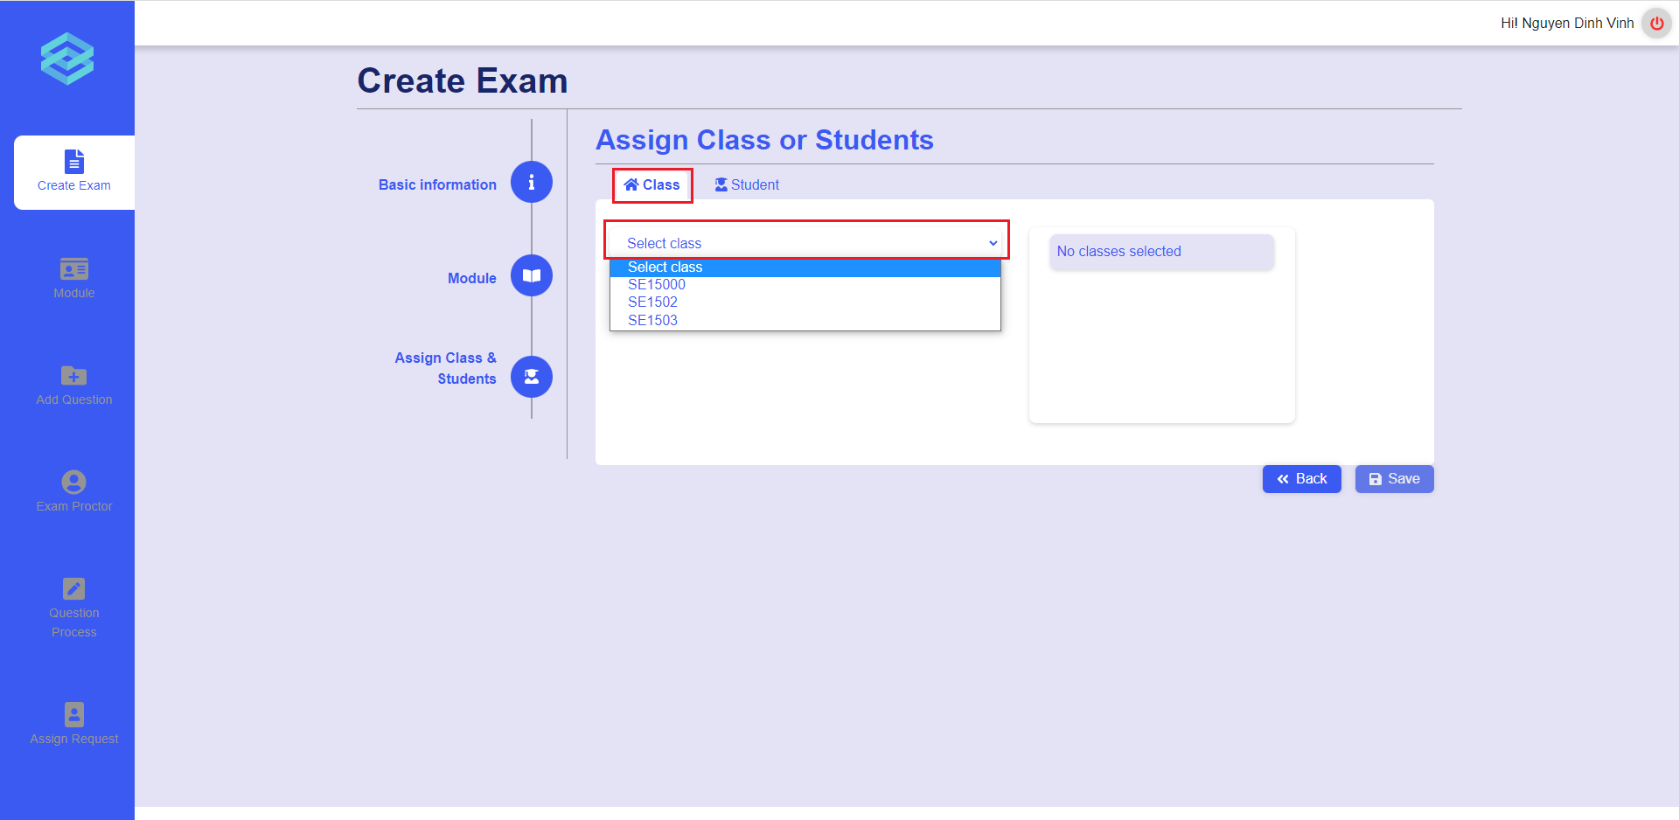
Figure 179. The create exam page in step 3 with class selection
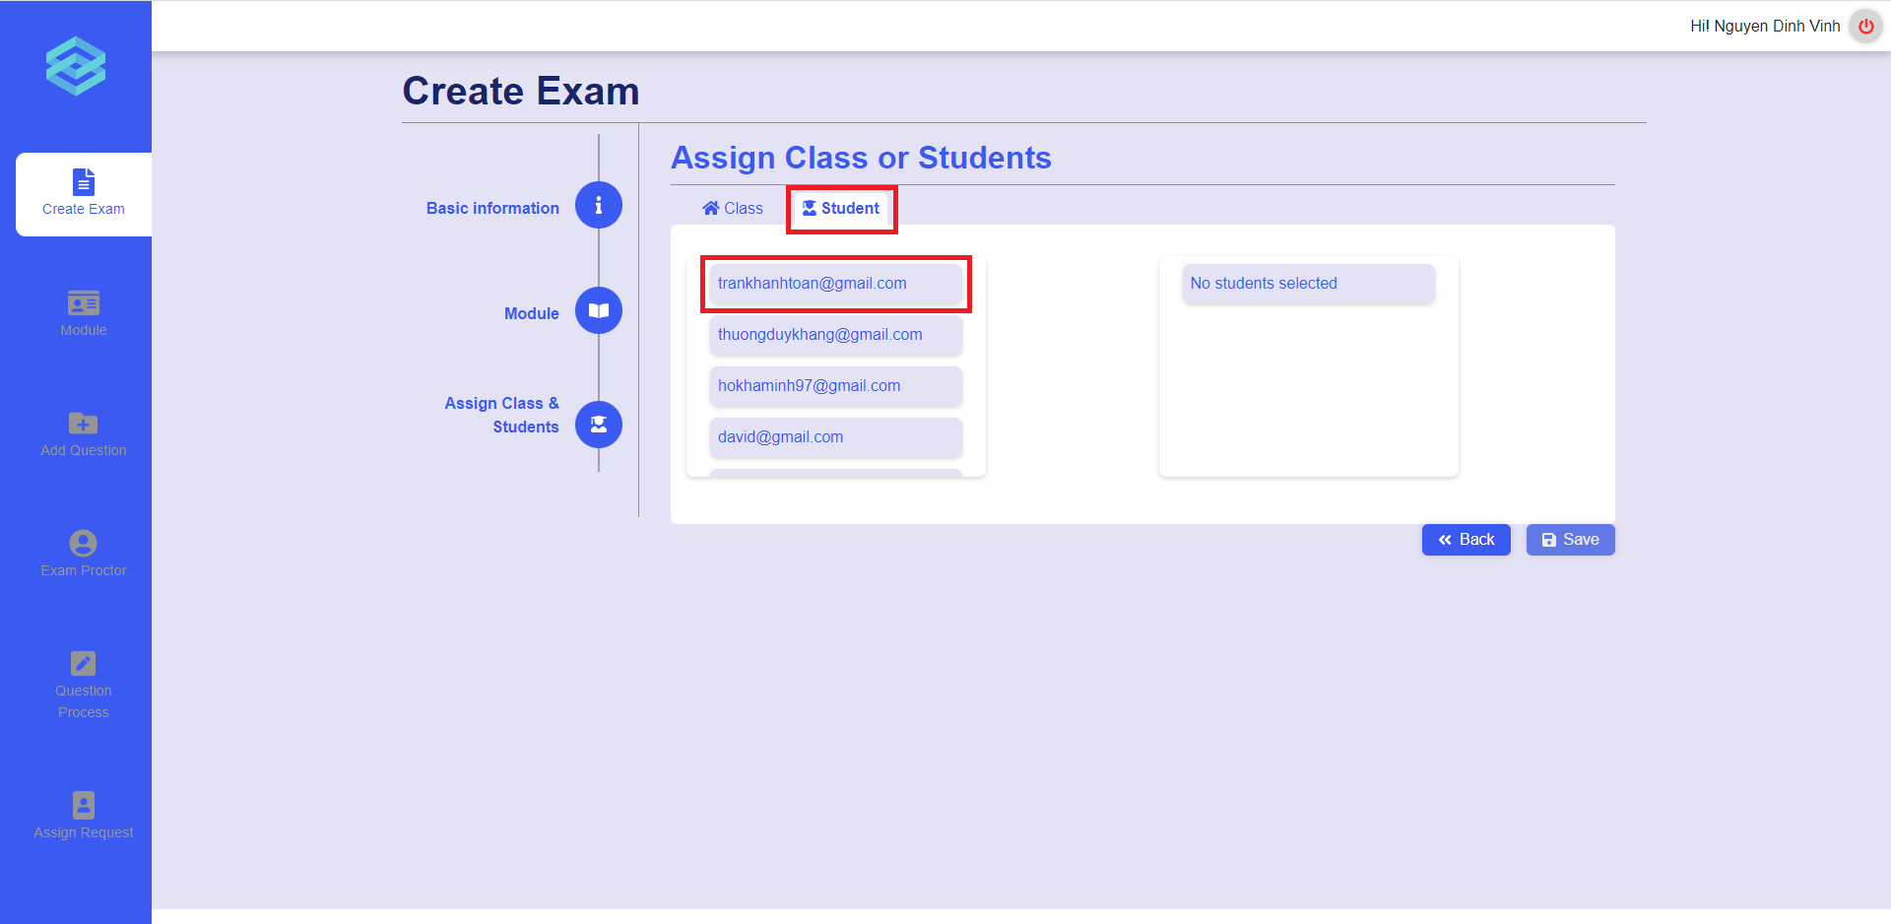
Figure 180. The create exam page in step 3 with student selection
After successfully filling in all the information, the user can click the “Save” button to create the exam. The program will show a popup asking for the user’s confirmation (Figure 181). If the user agrees to proceed, the exam will be created and they will be redirected to start creating the problem sets for the exam.
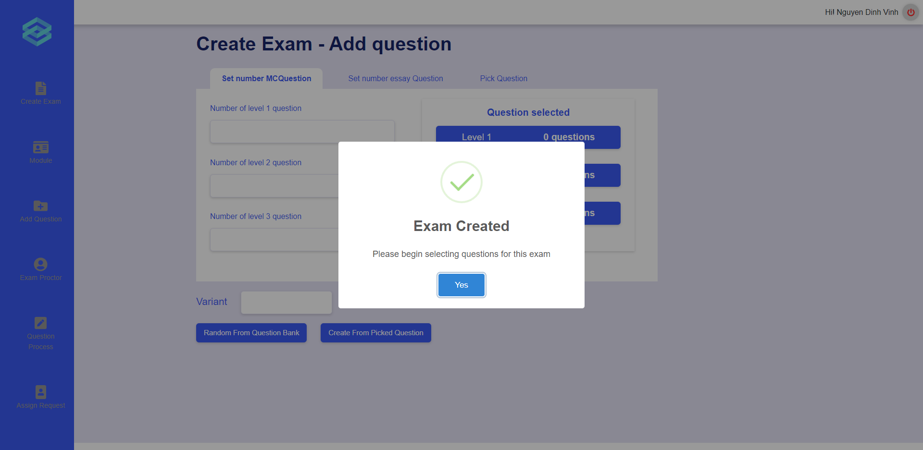
Figure 181. Popup after creating exam successfully
When creating the problem sets for the exam, user can choose to get questions randomly from the question bank or to pick questions by hand. If user wants to get random questions from the question bank, user needs to enter the number of multiple choice questions or essay questions in each level and then click on the “Random from question bank” button to create the problem sets automatically (Figure 182, 183). Otherwise, if user wants to pick questions from the question bank by hand, user can click on the “Pick Question” tab and click on each question to choose, then they can click on the “Create from picked question” button to create the problem sets from those picked questions (Figure 184). Furthermore, user can enter the number of variants so that the system can swap questions randomly to generate the corresponding number of problem sets.
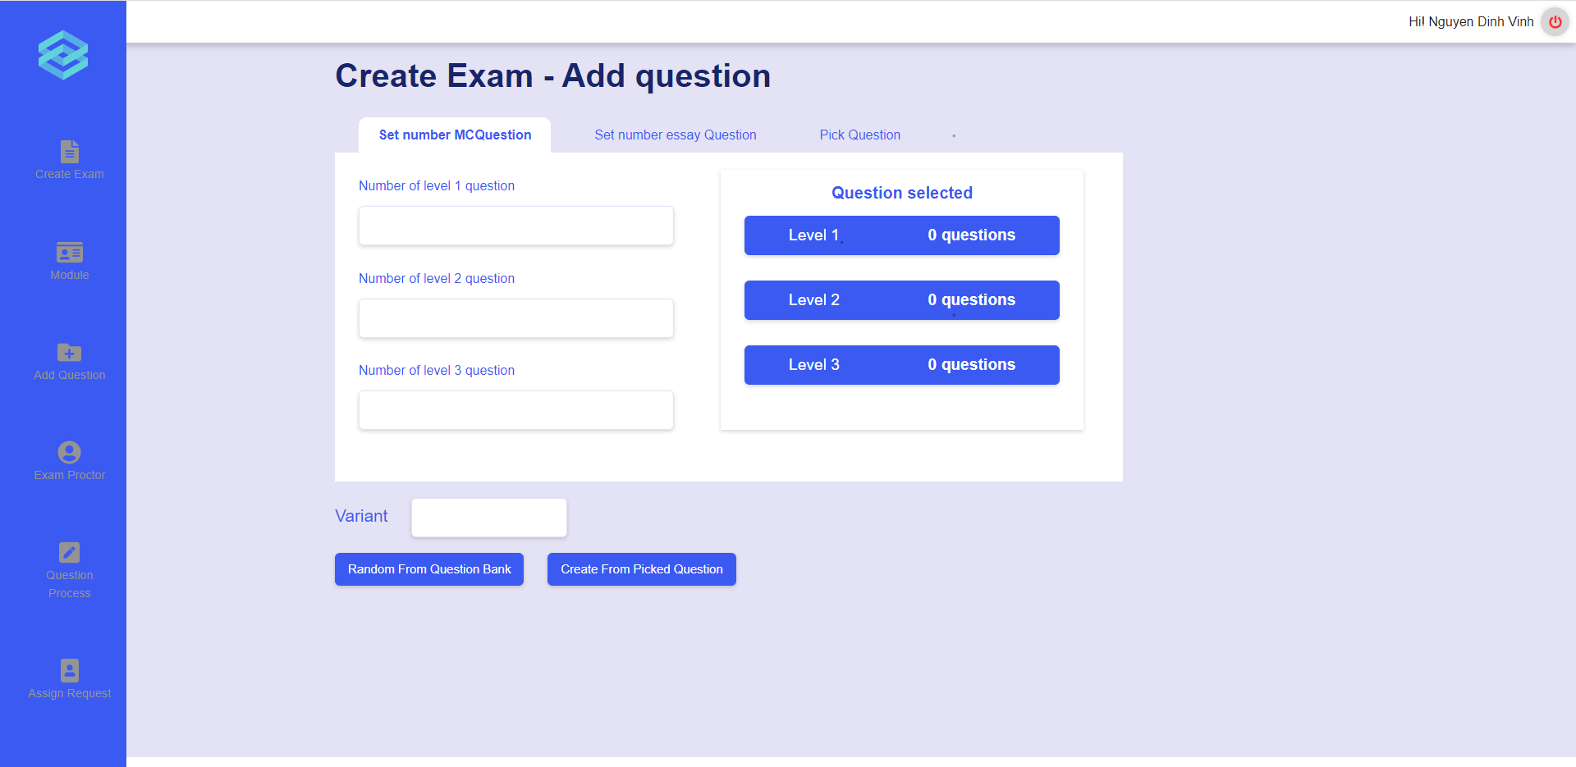
Figure 182. Set number of multiple choice questions
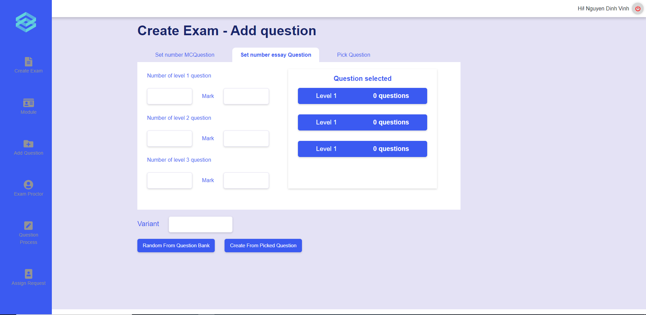
Figure 183. Set number of essay questions
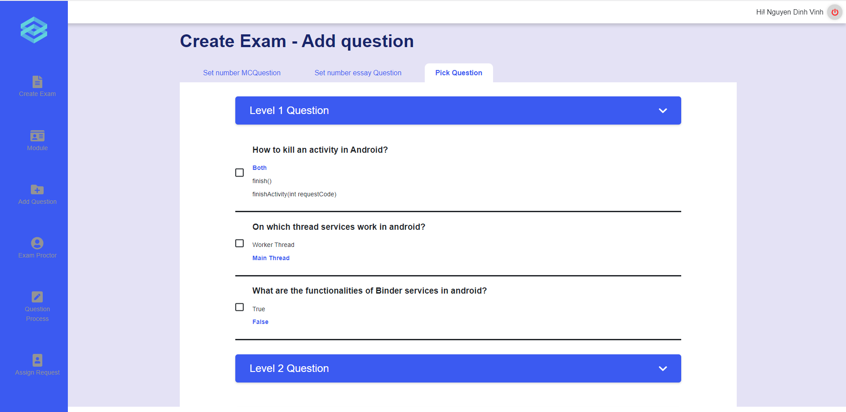
Figure 184. Pick questions from question bank
1.2. View exam list
User can click on the “Module” icon on the vertical navigation bar to go to the module list page, click on the module tab to expand it, and click on the appropriate class under each module tab to go to the exam list (Figure 185, 186).

Figure 185. The module list page

Figure 186. The exam list page and the “Detail” button
1.3. View exam detail
User can click on the “Detail” button in the exam card to view all details of the exam (Figure 186, 187).
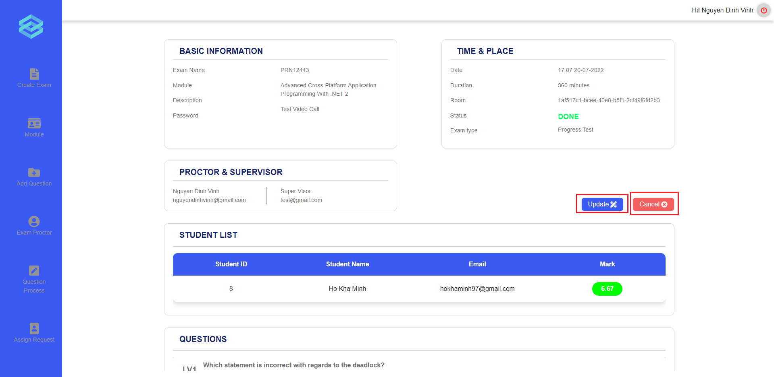
Figure 187. The exam details page with the “Update” and “Cancel” button
1.4. Update exam
User can click on the “Update” button on the exam details page to go to the update exam page (Figure 187). In the update exam page, user can update all the basic information of the exam (Firgure 188).
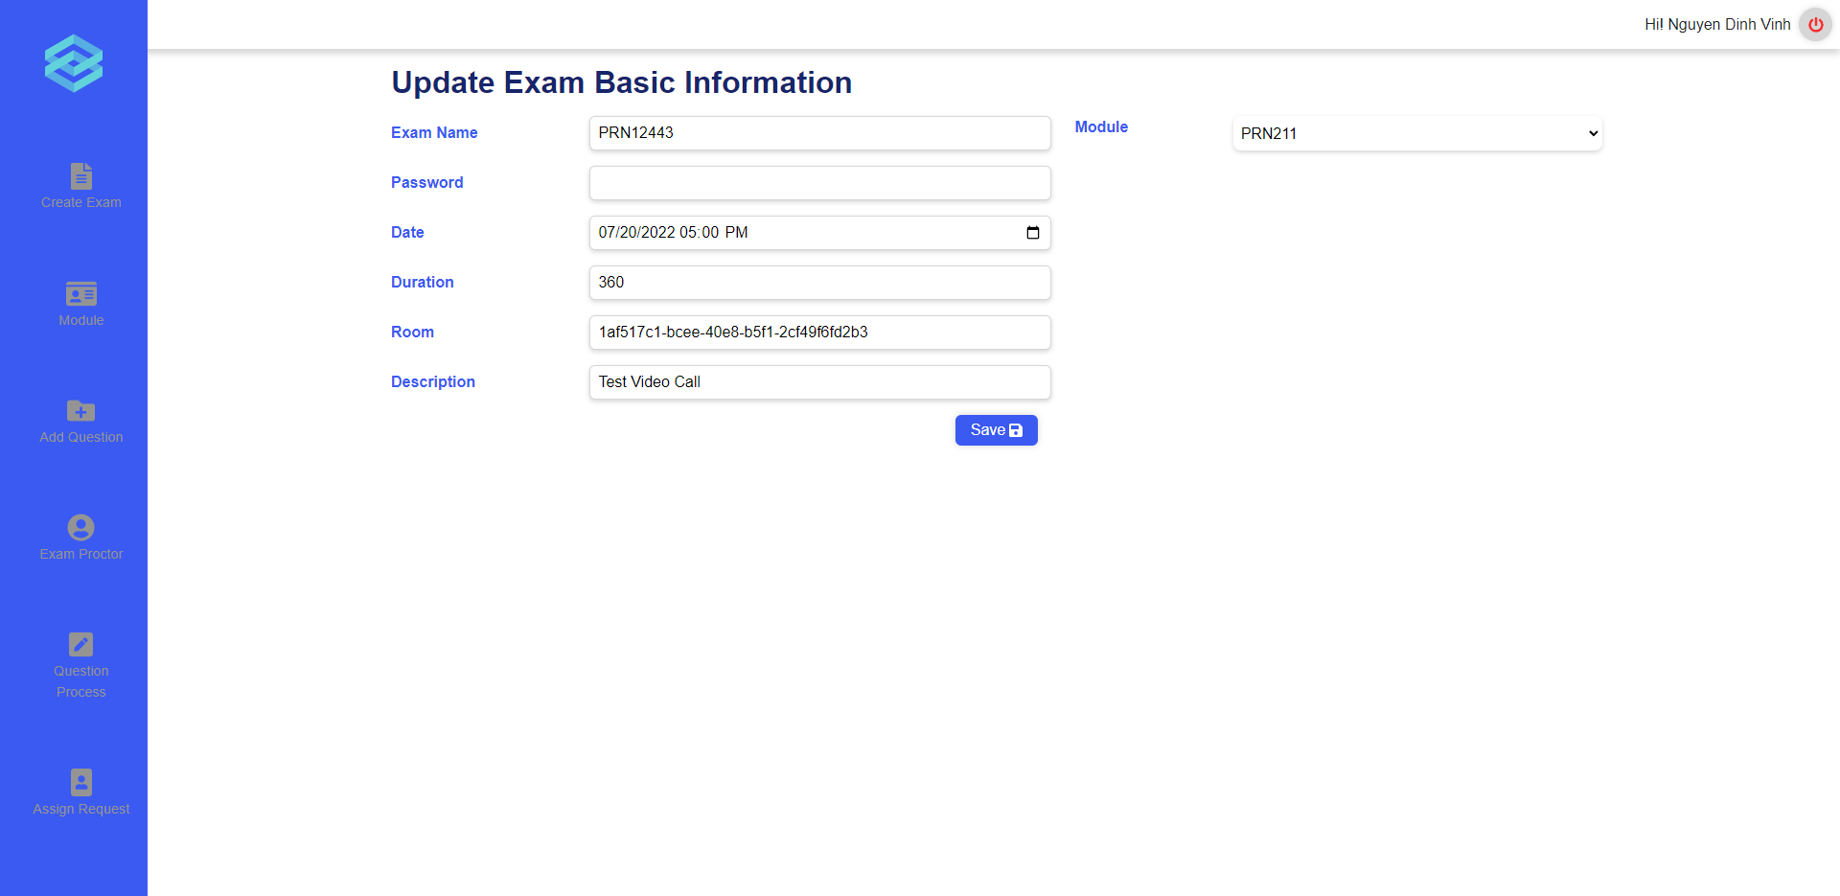
Figure 188. The update exam page
1.5. Cancel exam
User can click on the “Cancel” button on the exam details page to cancel an exam (Figure 187). User can only cancel the exam which has not taken place. After clicking the “Cancel” button, system will show a popup to confirm the cancellation and if user click on “Ok”, the status of that exam will be changed to “Cancelled” (Figure 189, 190).
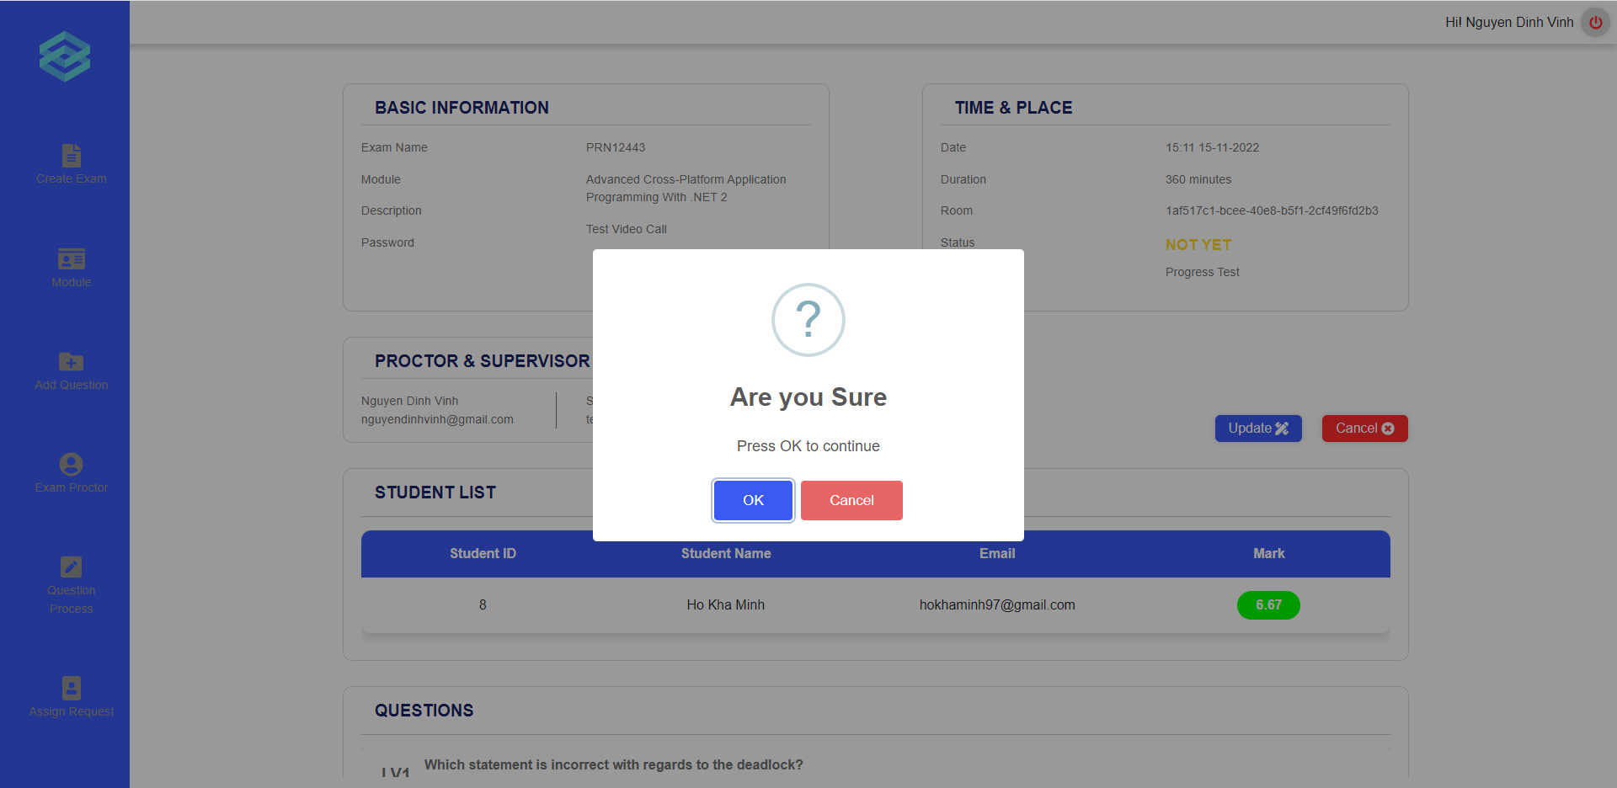
Figure 189. Popup to confirm the exam cancellation
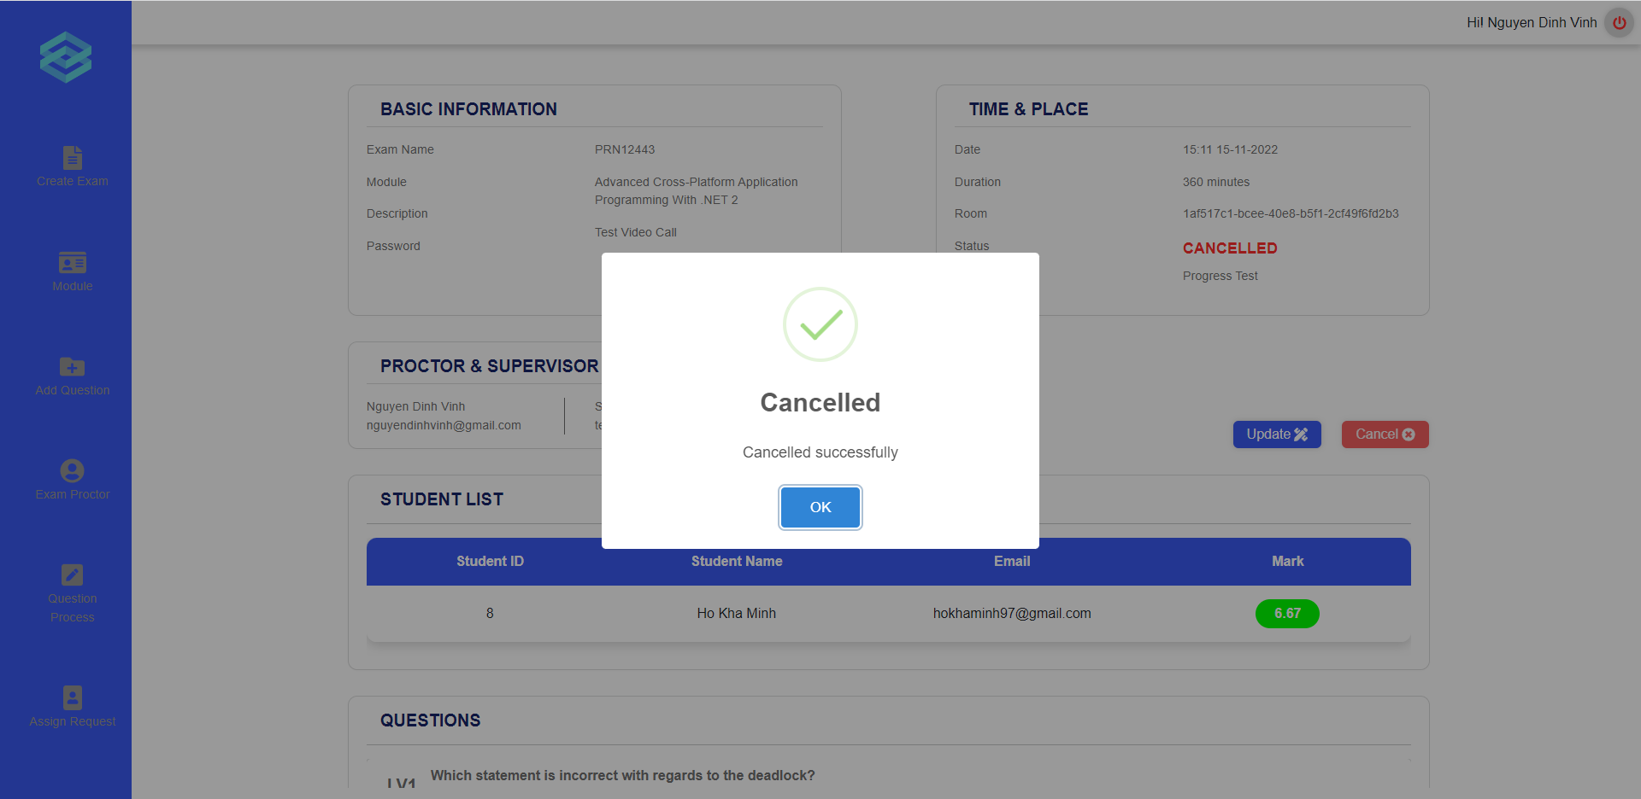
Figure 190. Popup show the successful cancellation message
- Grade written question
Before grading written question, teachers need to find exactly the module and class to see the right exam result.

Figure 191. Click on a class

Figure 192. Click on result of an exam
After clicking “Result” button, a list of student results will be displayed and there is a clickable “grade” icon if the student exams have writting question and need to be graded.

Figure 193. Grade wrtitten question
A pop up modal will appear and show the student writing answers, teacher can inputs valid scores to the forms. If the given scores is invalid, warning message will be displayed to the user.

Figure 194. Insert score for the answer

Figure 195. Validation error


Figure 196. Error pop up

- Approve/reject to add questions

Figure 197. Request add question list
Users can start to approve or reject requests to add questions from the Request add question list page. From this page, the user can click on the arrow icon in the Detail column for a specific request to start reviewing the requested questions.

Figure 198. Approve or reject page
After clicking the arrow icon, the user will be redirected to the Approve queued Questions page. In this page the user will be presented with a set of questions that was requested by another user. The user can scroll through the questions and review them. If they choose to approve of a question, they can click on the checkbox located at the bottom right of each question to indicate that they approve of said question. Any questions left unchecked will be considered as unapproved and will not be added to the question bank. After which, the user can click the submit button to finish approving the questions.
- Request add new question to question bank
Users can start to request add new question to the question bank from “Add question” page. From this page, users can choose which modules, question types (multiple choice or text), type of banks (progress test or final exam). Each question needs to be choosed the difficulty level. Users can add question contents, answers, add new questions or delete questions, add question images if necessary. For multiple choice type, users need to decide which answer is right by checking the radio button.

Figure 199. Request add question form

Figure 200. Request add question form
After that, users can click “Send request” button and confirm to finish creating request add new question.

Figure 201. Request add question confirm

f. Role Student
- Take and submit Exam
First, users must login to ExamEdu by Safe Exam Browser to take exam. If there are exams for students, they will appear on the Exam Schedule page. After clicking Start button and typing password (if necessary), it will redirect to Student Waiting room. The invigilator will start room and then student can join to see the exam question and begin doing exam.

Figure 202. Start an exam

Figure 203. Waiting room


Figure 204. Take an exam
A pop up modal will be displayed to show multiple choice mark and redirect to Student Mark Report page.

Figure 205. Score notification after exam
- Mark report
- Click on the [Mark Report] button on the left vertical navigation bar
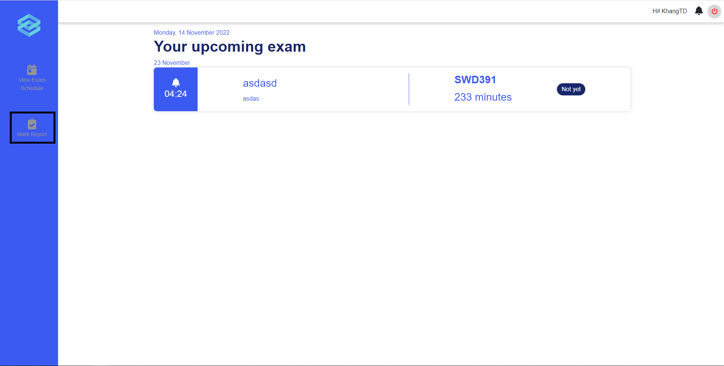
Figure 206. Mark report
-A list of module will be displayed, click on the [View examination result] button to view mark report
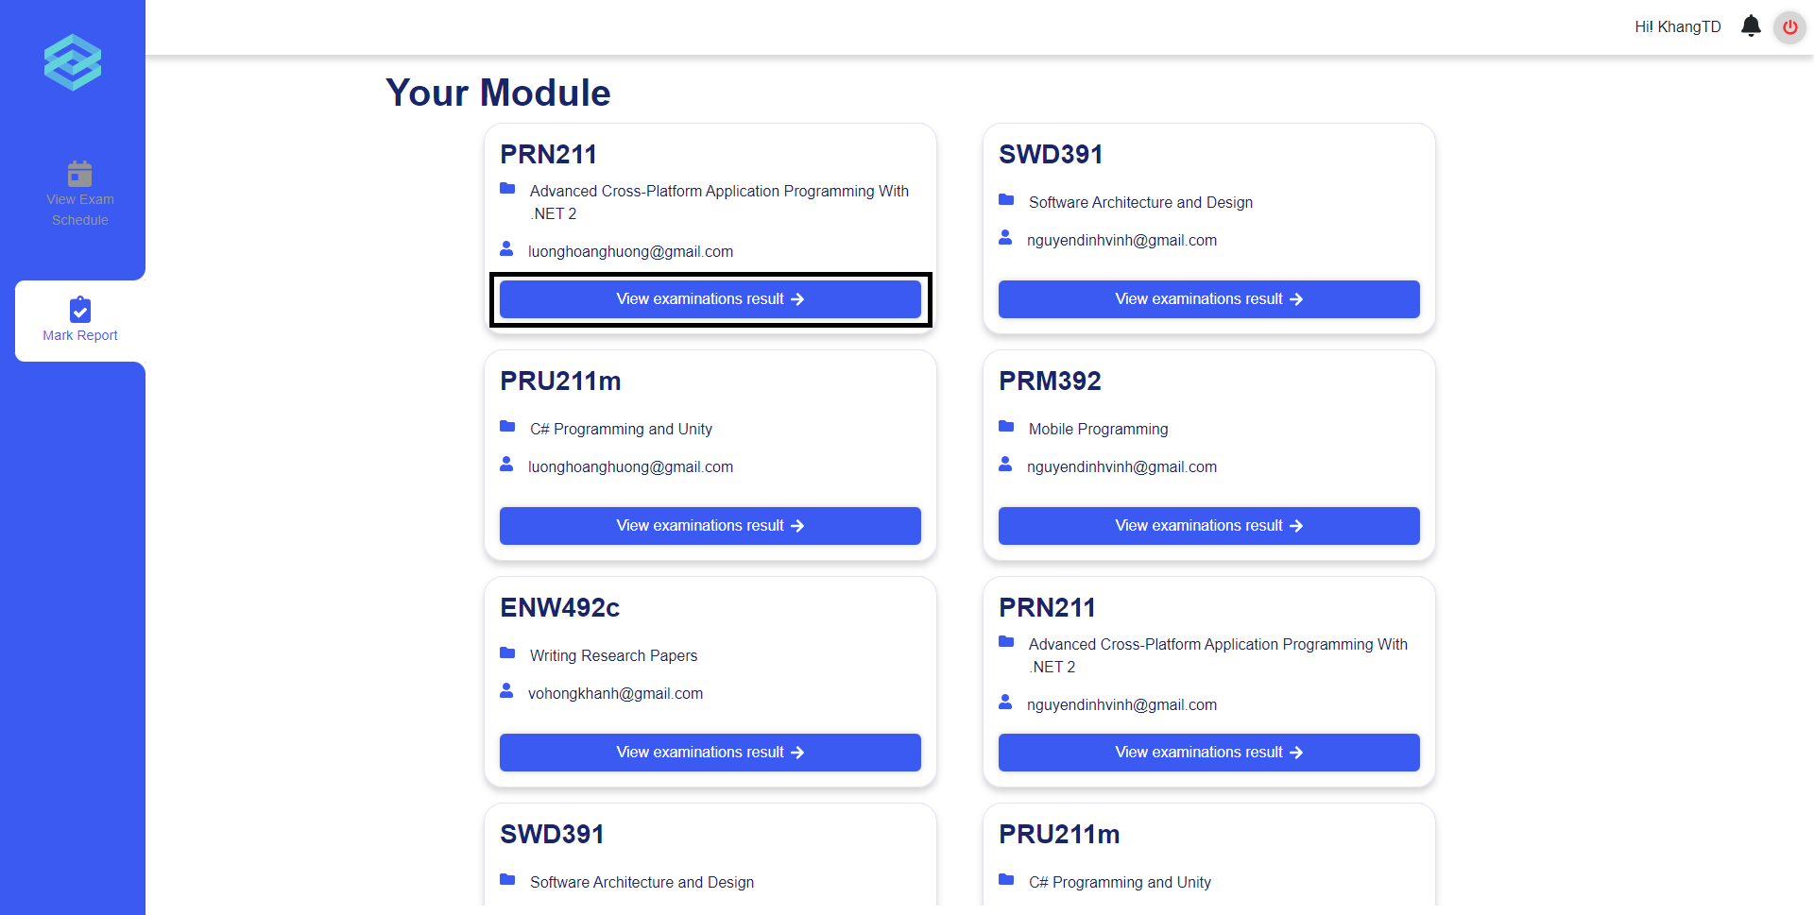
Figure 207. Mark report of the module

VII. Appendix

1. References
[1] Amr Jadi: New Detection Cheating Method of Online-Exams during COVID-19 Pandemic. International Journal of Computer Science and Network Security. 21(4), 123–130 (2021)
[2] Sara EL KOHLI, Youssef JANNAJ, Mehdi MAANAN1, Has-san RHINANE: DEEP LEARNING: NEW APPROACH FOR DETECTING SCHOLAR EXAMS FRAUD. The International Archives of the Photogrammetry, Remote Sensing and Spatial Information Sciences 46(4), 103–107 (2021). https://doi.org/10.5194/isprs-archives-XLVI-4-W3-2021-103-2022
[3] T Kamalov, F., Sulieman, H., Santandreu Calonge, D.: Machine learning based approach to exam cheating detection. PLOS ONE 16(8), 1–15 (2021). https://doi.org/10.1371/journal.pone.0254340
[4] Bawarith, R., Basuhail, D.A., Fattouh, D.A., Gamalel-Din, P.D.S.: E-exam cheating detection system. International Journal of Advanced Computer Science and Applications 8(4) (2017). https://doi.org/10.14569/JACSA.2017.080425
[5] Ahmad, I., AlQurashi, F., Abozinadah, E., Mehmood, R.: A novel deep learning-based online proctoring system using face recognition, eye blinking, and object detection techniques. International Journal of Advanced Computer Science and Applications 12(10) (2021). http://dx.doi.org/10.14569/IJACSA.2021.0121094

https://www.javatpoint.com/artificial-neural-network
https://www.simplilearn.com/tutorials/deep-learning-tutorial/convolutional-neural-network
https://arxiv.org/abs/1512.03385
https://niftypm.com/blog/manage-sprint-cycle/
Data flow diagram
Use Case of Student
Use case Teacher and Head of Department
Use Case of Academic Department
Use Case of Administrators
Screen Flow
ERD Diagram
Class Diagram - ViewerDiagram
Login – Google Drive
Forgot Password – Google Drive
Update Account – Google Drive
Create Module – Google Drive
Update Module – Google Drive
Delete Module – Google Drive
Create Class - Google Drive
ViewClassList(Aca).png
Update Class – Google Drive
Create Final Exam – Google Drive
Update Final Exam – Google Drive
Delete Exam – Google Drive
Create Exam – Google Drive
Update Exam – Google Drive
Delete Exam – Google Drive
ExportModuleExamResult - Google Drive
Create exam paper – Google Drive
View all requests add question bank – Google Drive
Request add new question to question bank – Google Drive
Assign teacher to process add question request – Google Drive
View exam questions – Google Drive
Submit Exam – Google Drive
Database Design Diagram - ViewerDiagram

